Oracle® Imaging and Process Management
Application Link Installation and User Guide
Version 7.7

May 2007

Oracle Imaging and Process Management ERP Integration Suite, Application Link Installation and User Guide, Version 7.7
Copyright © 1998, 2007, Oracle. All rights reserved.
Primary Author: Amy Willard
The Programs (which include both the software and documentation) contain proprietary information; they are provided under a license agreement containing restrictions on use and disclosure and are also protected by copyright, patent, and other intellectual and industrial property laws. Reverse engineering, disassembly, or decompilation of the Programs, except to the extent required to obtain interoperability with other independently created software or as specified by law, is prohibited.
The information contained in this document is subject to change without notice. If you find any problems in the documentation, please report them to us in writing. This document is not warranted to be error-free. Except as may be expressly permitted in your license agreement for these Programs, no part of these Programs may be reproduced or transmitted in any form or by any means, electronic or mechanical, for any purpose.
If the Programs are delivered to the United States Government or anyone licensing or using the Programs on behalf of the United States Government, the following notice is applicable:
U.S. GOVERNMENT RIGHTS Programs, software, databases, and related documentation and technical data delivered to U.S. Government customers are "commercial computer software" or "commercial technical data" pursuant to the applicable Federal Acquisition Regulation and agency-specific supplemental regulations. As such, use, duplication, disclosure, modification, and adaptation of the Programs, including documentation and technical data, shall be subject to the licensing restrictions set forth in the applicable Oracle license agreement, and, to the extent applicable, the additional rights set forth in FAR 52.227-19, Commercial Computer Software--Restricted Rights (June 1987). Oracle USA, Inc., 500 Oracle Parkway, Redwood City, CA 94065.
The Programs are not intended for use in any nuclear, aviation, mass transit, medical, or other inherently dangerous applications. It shall be the licensee's responsibility to take all appropriate fail-safe, backup, redundancy and other measures to ensure the safe use of such applications if the Programs are used for such purposes, and we disclaim liability for any damages caused by such use of the Programs.
Oracle, JD Edwards, PeopleSoft, and Siebel are registered trademarks of Oracle Corporation and/or its affiliates. Other names may be trademarks of their respective owners.
The Programs may provide links to Web sites and access to content, products, and services from third parties. Oracle is not responsible for the availability of, or any content provided on, third-party Web sites. You bear all risks associated with the use of such content. If you choose to purchase any products or services from a third party, the relationship is directly between you and the third party. Oracle is not responsible for: (a) the quality of third-party products or services; or (b) fulfilling any of the terms of the agreement with the third party, including delivery of products or services and warranty obligations related to purchased products or services. Oracle is not responsible for any loss or damage of any sort that you may incur from dealing with any third party.

Application Link
Installation and User’s Guide
Table of Contents

Introduction 4
What is Application Link 4
What are Application Link Services 4
Design Overview 4
Assumptions 4
Installing Application Link 4
Application Link Maps 4
Creating an Application Link Map 7
Command Line Syntax 9
Executing a Command Line Transaction 12
Using the COM Interface 12
Creating a Map Group 13
Use of Application Link Services 14
Application Link Command Definition 15
Command Definitions for use by the Application Link Appliction Bar (JD Edwards World and HLLAPI systems) 16
Application Link Service Templates 18
Map Security for Application Link maps used by Command Defintions 19
Application Link Application Bar 20

Introduction

What is Application Link
Application Link is a component of the ERP Integration Suite (EIS) that manages the movement of data between Application Link Services. Application Link typically is used with line of business (LOB) applications. Please refer to the Release Notes on the Oracle Imaging and Process Management CD for a complete list of system specifications and prerequisites.

What are Application Link Services
An Application Link Service is a module that performs actions on data. See the Application Link Maps section for more detail on Services.

Design Overview
Application Link is designed to use Application Link Services that retrieve, modify, or deliver data. Application Link uses a Map to determine the data flow. The Map is created using the Map Tool, which is an Administrative tool in the Oracle I/PM Windows Client. See the User.PDF help file for information about the Map Tool.
There are two ways to launch Application Link. It may be launched by running a command line executable, LOBLink.exe. This command line can be further defined by a series of command line parameters.
Application Link may also be launched by creating and calling an OLE Object. If the line of business application supports OLE automation, the second method, using an OLE object, is better because more error and response checking can be done by calling a OLE method rather than an executable.

Assumptions
Application Link program installation requires awareness of command line executables and search characteristics. Although Application Link can be activated directly from the desktop command line, it is likely that a command button or menu will be used to activate the program. An understanding of form controls and their creation for the specific LOB application in use is necessary for complete installation.

Installing Application Link
Please refer to the “Installation and Upgrade” section in the EIS.chm for installation instructions.

Application Link Maps
Application Link uses the Application Link Map to determine how to handle retrieval, modification and delivery of data. The Application Link Map is divided into Stages. Each Stage has a specific Application Link Service associated with it. Each Application Link Service performs an action with the data.
Available Services:
- JDE OneWorld Data – Retrieves data from the JDE OneWorld client.
- JDE OneWorld Update – Passes data into the JDE OneWorld client.
- GUI400 Data – Retrieves data from the GUI/400 panel.
- GUI400 Update – Passes data into the GUI/400 panel.
- HLLAPI Data – Retrieves data from a HLLAPI compliant terminal emulator screen.
- HLLAPI Update – Passes data into a HLLAPI compliant terminal emulator screen.
- Great Plains Data – Retrieves data from a Great Plains (eEnterprise) window.
- Great Plains Update – Passes data into a Great Plains (eEnterprise) window.
- Imaging Update – Updates an index within Imaging.
- Imaging Client Search – Executes a Saved Search within the Oracle I/PM Client.
- Imaging Client Process Data – Retrieves the Package data from a Package loaded in the Package Viewer Tool of the Oracle I/PM Client.
- Imaging Client Process Update – Updates the Package data of a Package loaded in the Package Viewer Tool of the Oracle I/PM Client.
- Process Data – Retrieves Package data from a specified Package.
- Process update – Updates Package Data for Web integrations.
- eCapture Update – Passes data to the eCapture client.
- Imaging Web Client Search – Executes a Saved Search within the Oracle I/PM Web client.
- Imaging PkgBar Dtaa
- Imaging PkgBar Update
- Oracle Apps Data – References Package data for a specified Package for Oracle Apps.
- Context Document Retrieval – Retrieves documents from the Imaging database.
- Peoplesoft Data – Retrieves Package data for a specified Package for Peoplesoft Apps.
- JDE EnterpriseOne Data – Retrieves Package data for a specified Package for JDE Web Apps.
- JDE EnterpriseOne App Link Data – Retrieves data from JDE EnterpriseOne Unicode client.
- JDE EnerpriseOne App Link Update – Passes data into JDE EnterpriseOne Unicode client.
Each Application Link Service specifies the input and output data that it is compatible with. Each Stage of a Map has an input pipe and an output pipe for data. Each input item for a Service can be mapped to an item in the input pipe for the Stage. Also, each output item for a Service can be carried over into the output pipe of the Stage. The output pipe for a Stage is also the input pipe of the next stage of the Map.

In the diagram above, the data is passed into Service 1. Service 1 completes its action on the data and makes 3 output items available. The items in the output pipe are added to the items that are in the data pipe. The input for Service 2 is pulled from the data pipe and sent to Service 2. Service 2 completes its action on the data and makes 1 output item available. The data pipe is now returned to the calling application.

Creating an Application Link Map
After Installing EIS, the Administrator may add the Map Tool to a gallery.
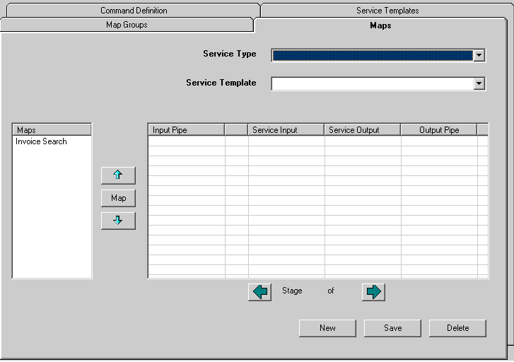

When the Map Tool is opened, 4 tabs will display, Map Groups, Maps, Command Definitions, and Service Templates. Select the Maps tab to create the Application Link Maps. To create a new Map, click the New button.
Select the Service to act on the data. To select the Service, use the drop-down box labeled Service Type. For this example we will select Imaging Client Search.

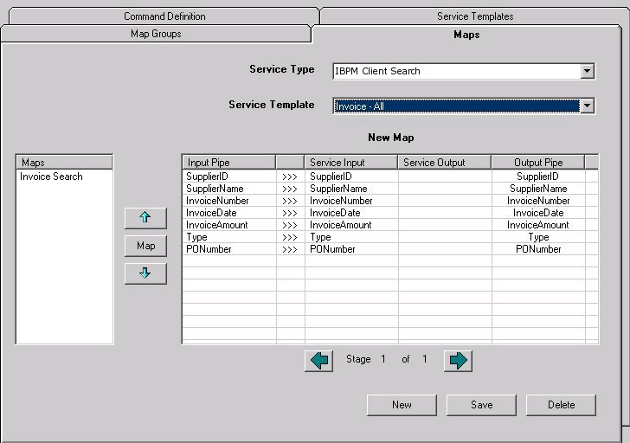

Now select a Saved Search that the Imaging Client Search Service is to execute. Select this from the drop-down labeled Service Template. We selected Invoice - All. Notice that all of the Saved Search prompts are displayed in the Service Input column. This column is the input for the Service. The Service Output column is the output from the Service. Since this Service will execute a Saved Search, there is no output from the Service.
By default all of the input fields are displayed in the input pipe and mapped to the appropriate input. Also, all of the data in the input pipe is carried over to the output pipe. If the names in the input pipe are incorrect, right click to select Insert Pipe Item and enter the desired name. Un-map the Service Input item from the old input pipe item and map the new input item to the appropriate Service input item.
Since we are not going to use this data in any future map stages, we will drop the data from the output pipe. To do this, right click on the grid and select Drop All. This will drop all of the data from the output pipe.

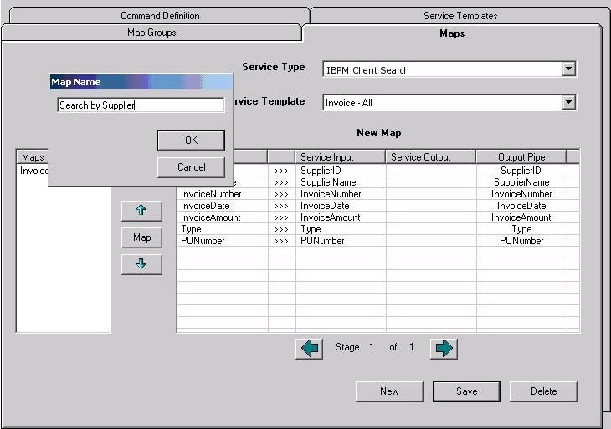

Now save this map. Click the Save button and a Map Name dialog will appear. Enter a name for the map. We entered Search by Supplier for ours.
Now click the OK button. Your search will appear in the Maps list on the left side of the tool. Now the Map may be executed.

Command Line Syntax
The command line is case sensitive.

Command Line Parameters and Their Uses
LOBLink.EXE –u=USERNAME [– g=GROUPNAME] [–m=MAPNAME] [-InputPipeItem1=InputPipeItemData1][-InputPipeItem2=InputPipeItemData2][…]
LOBLink.EXE | The complete path to the LOBLink executable is required. This program and its supporting files are installed to the SourceFiles directory on the DSMS server so that it is automatically downloaded when SEISStartup is run. See the bottom of this table for an example used in a command line.
USERNAME | Silent Login  When Application Link is launched for the first time, if the Oracle I/PM Client is running, it will acquire the current login from the Oracle I/PM Client. If the Oracle I/PM Client is not currently running the standard Oracle I/PM login dialog box is displayed. The user is prompted for an Oracle I/PM username, password and a domain. After successfully logging in, this information is encrypted and stored in the system registry on the user’s machine under the Oracle I/PM key. Upon subsequent logins, Application Link verifies the user name with the registry list and authorizes access accordingly. This feature is called a silent login.  If the username is present in the registry, but does not successfully log in to Oracle I/PM, due to a changed or expired password, then the Oracle I/PM login dialog box appears and the new login parameters are saved to the registry. The user will also be prompted for a login every time if the username is left blank on the command line.  Because of different security environments, three options are included for what can be passed in the username field:  Synchronized Usernames  IBPM security is based on Windows NT security. If the Application Link uses Windows NT security then the actual username can be passed to Oracle I/PM and be used to login.  This option allows the Application Link and the host application to use the same username and password. The passwords must be synchronized. If the password is changed in Oracle I/PM but not changed in the Application Link, access is denied.  Non-Synchronized Usernames  If the application Link is not synchronized with Windows NT (and therefore not synchronized with IBPM), a different username, called the Host Username, is the only one known to the Application Link and the only one that can be passed through.  Host Username that points to an NT username is supported. The NT username then has a password allowing Oracle I/PM login. This option allows the host user access to the Application Link procedure with a username and password different from those used to access IBPM.  Generic / Constant / Unknown Usernames  In some Application Link Services, the username may not be available to pass to Application Link. A generic or constant username may be created to support these situations.  A security breach may exist when using a generic or constant username because everybody logging in to the Application Link on a particular station would appear to be the same user to the Application Link. Thus, the potential would exist for multiple logins by the same person.  There may be circumstances where tracking usernames for a large number of persons accessing the Applications Link searches is not considered practical or desired.  Extreme caution should be exercised when using this option since the security becomes physical in nature. If someone has physical access to a logged in system, they will have possibly unauthorized access to the entire database. Another option is to specify a blank user name which will cause the system to prompt for a login. This will force the user to login before using the system. This option maintains good security practices across the system.  See the bottom of this table for an example of a synchronized UserName used in a command line.
GROUPNAME | The GROUPNAME parameter identifies which Application Link map group to display.  This displays all of the Application Link maps that are contained within the specified map group. The user may choose one of the maps to be executed by the Application Link.  This parameter is not supplied if the MAPNAME parameter is supplied.
MAPNAME | The MAPNAME parameter identifies which Application Link map to execute.  This parameter is not supplied if the GROUPNAME parameter is supplied.
[Variable Parameters]  [-InputPipeItem1=InputPipeItemData1] | Input pipe items are the items in the input pipe of the 1st stage of the specified map. If a map group is supplied, make sure that all of the maps within the map group have the input pipe items specified. If an input pipe item is specified that does not exist in the first stage of the map, the item will be ignored.
Sample Command Line
C:\Program Files\Stellent\IBPM\LobLink.exe –u=JohnD –m=“Invoice Search” –InvNum=XYZ100

Executing a Command Line Transaction
Make sure that you are in a gallery that has the Search tools in the Oracle I/PM Client. From the command line navigate to the directory that LOBLink.exe is installed. Enter
LOBLink.exe –u=UserName -m=”Search by Supplier” –SupplierID=ABC –InvoiceNumber=123
Remember that your Map Name, UserName and input pipe fields will be different from this example. The field names are case sensitive.
When the Map is executed, if this is the first time you executed Application Link, a login dialog will display. Enter your Oracle I/PM login and password. You can also choose for Application Link to remember your password and silently log you in next time. If the Oracle I/PM Client is not up it will be launched and the Saved Search will be executed with the data you entered in the command line.
This was an example of a Single Stage Map. To do more with the data after running the search, press the green arrow that points to the right to move to the next Stage. From here we can select another Service and do more with our data.
Remember that the data in the output pipe of a Stage is the data that is in the input pipe of the next Stage. For efficiency you should only have data in the output pipe that you are going to use in the next Stages. If you have data going across Stages that you are not using, the transaction will take longer than is needed.

Using the COM Interface
Two interfaces are provided for LOBLink, an exe interface and a dll interface. Most users will want to use the exe interface to take advantage of the login features provided (alias login, silent login) and the performance caching. The dll version requires a user token as a parameter and the login process will have to be handled by the user. Also, the dll version rebuilds the needed information for each instance, i.e. pulling down the maps/user info and slowing down the system.
The COM interface for LOBLink is very similar to the command line interface with a few exceptions. When using the exe COM interface and calling the Execute function the following must be provided: a map name, a map group, an input and an output. The COM object will use either a map name or a map group but not both. The only way to use a map group is by passing in an empty map name or a space for the map name. In all other cases it will use the provided map name.
The input is a data dictionary that contains all the input information for the Map that is defined in the desktop client tool. The output is a data dictionary that contains all the output information retrieved from the execute command. Once the execute command has been called the user is created and logged into the system. This is done by first testing for the presence of a silent login, if one is not present, the mapped login will be used for the execute. Upon success, the output data dictionary contains all the requested information and a successful execution flag is returned to the user.

Creating a Map Group
If multiple Maps are to be grouped together add them to a Map Group. Select the Map Groups tab on the Map Tool. If the Maps are not present in the Available Maps list, click the Refresh button to refresh the list.
To create a new Map Group, click the New button. A Map Group Name dialog will appear. Enter the name of the Map Group to be created. We entered Search Group.

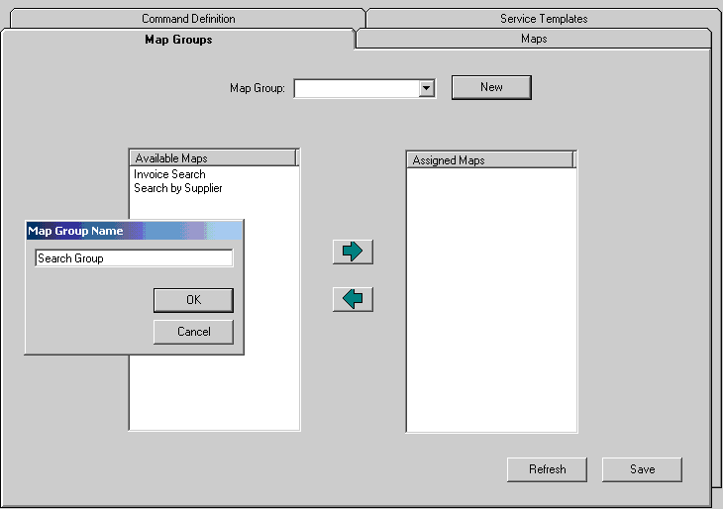

Now assign the Maps to be included in this group by selecting the Map and clicking the green arrow that points to the right or by double clicking the Map name. The Map will appear in the Assigned Maps list. When you are finished assigning Maps click the “Save” button.
Now try the Map Group. From the command line navigate to the directory that LOBLink.exe is installed. Enter
LOBLink.exe –u=UserName -g=Search Group –SupplierID=ABC –InvoiceNumber=123
Remember that your Map Group Name, UserName and input pipe fields will be different from this example. A dialog appears allowing the selection of the Map to be executed. The Maps displayed in the dialog are the Maps that were assigned to the Map Group that were included in the command line. In our example we had 2 Maps that took the same input (SupplierID and InvoiceNumber). If you have Maps in your Map Group that take different input, be sure to include tags for each possibility.
For example, if you have a Map that uses SupplierID and InvoiceNumber as input and another that uses PONumber and Type as input and they are grouped in the same Map Group, enter the following as your command line.
LOBLink.exe –u=UserName -g=Search Group –SupplierID=ABC –InvoiceNumber=123 –PONumber=ABC –Type=123
If the Map does not have the field mapped it will ignore the data in the input pipe, so this command line will pass the proper parameters to any Map chosen from the Map group.

Use of Application Link Services
JDE OneWorld Data – Retrieves data from the JDE OneWorld client.
JDE OneWorld Data Service is installed with 3 JDE OneWorld Data Structures (AP Short, AR Short, and GN Short). If starting your transaction from the JDE OneWorld client (i.e. Pressing the Search Oracle I/PM Button), then this Service will be the first stage of your map. Make sure to have OneWorld Data in the in pipe and mapped to the Input of the Service. Carry over the data, from the output of the Service, that is to be moved to the next stage.
JDE OneWorld Update – Passes data into the JDE OneWorld client.
This Service is to be used for delivering data to the OneWorld Client or Populate functionality. This will typically be the Service in the last stage of the map. Make sure that the OneWorld Data in the output of the Service is carried over into the output pipe for this functionality to work.
GUI400 Data – Retrieves Data from the GUI/400 panel.
To Map with this Service first navigate to your defined panel with your GUI/400,RTSPro software. The name of panel that you have navigated to will be the only choice in the Service Template drop down. When you select the panel from Service Template, the fields defined in the panel will be output fields for the Service.
GUI400 Update – Passes data into the GUI/400 panel.
This Service will typically be in the last Stage of the Map. This Service provides the Populate functionality for GUI/400. To Map with this Service first navigate to your defined panel with your GUI/400,RTSPro software. The name of the panel that you have navigated to will be the only choice in the Service Template drop-down. The fields defined in the panel will be input items for the Service.
HLLAPI Data – Retrieves data from a HLLAPI compliant terminal emulator screen.
HLLAPI Update – Passes data into a HLLAPI compliant terminal emulator screen.
Great Plains Data – Retrieves data from a Great Plains (eEnterprise) window.
Great Plains Update – Passes data into a Great Plains (eEnterprise) window.
Imaging Update – Updates an index within Oracle I/PM Context.
This Service updates the indexes of an Oracle I/PM Object. The inputs for this Service are the indexes and the index id. The Service Template will be a choice from the Schema objects of the Oracle I/PM system. There are no outputs.
Imaging Client Search – Executes a Saved Search within the Oracle I/PM Client.
This Service executes a Saved Search within the Oracle I/PM Client. The Service Template for this Service will be the Saved Searches in the Oracle I/PM System. The inputs will be the Saved Search fields. There are no outputs.
Imaging Client Process Data – Retrieves the Package data from a Package loaded in the Package Viewer Tool of the Oracle I/PM Client.
This Service retrieves the package data from the package that is loaded in the package viewer. There are no inputs. The outputs are the fields within the package template. The Service Template will be all of the Package Templates within Process.
Imaging Client Process Update – Updates the Package data of a Package loaded in the Package Viewer Tool of the Oracle I/PM Client.
This Service updates the data of the package that is loaded in the Package Viewer tool within the Oracle I/PM Client. The inputs are the fields of the package template. There are no outputs. The Service Template will be all of the Package Templates within Process.
Process Data – Retrieves Package data from a specified Package.
This Service retrieves the data a specified package. The input is the package id. The outputs are the fields of the package template. The Service Template is all of the Package Templates in Process.
eCapture Update – Passes data to the eCapture client.
This Service updates index data in eCapture. The eCapture client must have a batch open a map is created. The Service Template will be the current batch that eCapture has open. The input will be the fields in the current batch that eCapture has open. There are no outputs.

Application Link Command Definition
Application Link Command Definitions provide the ability to configure the run-time invocation of certain Application Link Maps. Currently, this functionality is only available for JD Edwards World, HLLAPI terminal emulator, and Great Plains integrations. Great Plains uses these Command Definitions to dynamically build Oracle I/PM integration points (commands) in the Great Plains system at run-time. JD Edwards World and HLLAPI systems take advantage of this functionality through the Oracle I/PM Application Link Application Bar, which runs independently from the line of business system as an Oracle I/PM Windows client tool.
This section will detail the construction of Command Definitions for the Great Plains, JD Edwards World, and HLLAPI integrations. For further information on implementing one of these specific integrations, refer to the document specific to that integration.
Figure 1 below shows the Command Definitions tab on the Map Tool. This tab provides the ability to create and order commands for a given Application Link system and template.
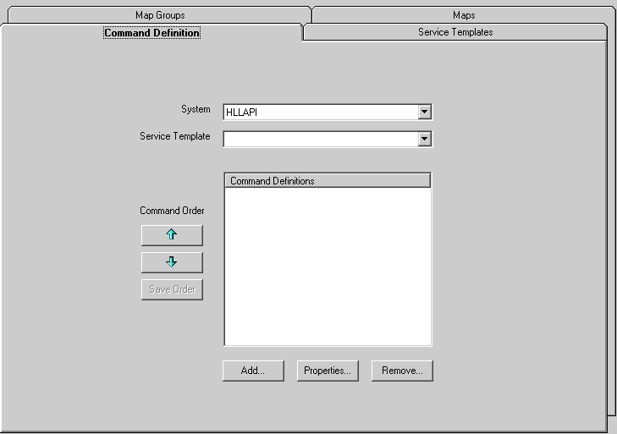
Figure 1 - Command Definition tab on the Map Tool
The System combo box will be populated with only the systems that are properly licensed and capable of supporting command definitions. The “HLLAPI” system is the appropriate selection for JD Edwards World integrations as well as other HLLAPI system integrations. “Great Plains” is the other system that may appear in this list at this time.
The Service Template combo box will list the templates for the selected LOB system that has one or more Maps defined for them. Once a System and Service Template have been selected, the “Add…” button may be clicked to create a new Command Definition for this System Service Template.

Command Definitions for use by the Application Link Appliction Bar (JD Edwards World and HLLAPI systems)
Figure 2 below shows the “Add Button Definition” dialog for JD Edwards World or HLLAPI based systems.
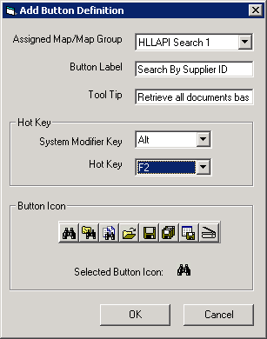
Figure 2 - Add Button Definition dialog for JD Edwards World or HLLAPI based systems
JD Edwards World and HLLAPI based systems use the Application Link Application Bar to executed Command Definitions at run-time. The Application Bar will contain a toolbar for each Service Template that has Command Definitions defined. Inside of each toolbar will be a button for each Command Definition for which the user has been assigned security rights to the underlying Map (or group of maps in the case of a Map Group). Please see the next section on configuring map security for more information on this.
The Application Link Application Bar also supports button labels, tool tips, icons, and associated hot-keys. The Add Button Definition dialog for JD Edwards World and HLLAPI based systems provides functionality to do the following:
- Assign a Map/Map Group to the Command Definition. This Map or Map Group will be executed when the command is selected at run-time. If a Map Group is selected, and the user has security rights to all of the Maps within the Map Group, execution of this command will result in a dialog box appearing in which the user must select which Map to execute. Note that all the Maps in the Map Group must reference the given Service Template in order to appear in this list.
- Assign a button label to the Application Bar button. This label may be shown or hidden by the user by using the right-click “Show Text” option on the Application Bar.
- Assign a tool tip to the Application Bar button. This tool tip will appear when the user rests the mouse over the Application Bar button.
- Assign a hot key to the Application Bar button. The hot key consists of two parts, the system modifier key and the hot key. The system modifier is optional and, if used, may be set to Alt, Ctrl, or Shift. If it is not to be used, it should be set to “None”. The hot key is the key which, when pressed in combination with the system modifier key, will have the same effect as clicking the Application Bar button. Currently for JD Edwards World and HLLAPI based systems, the hot key may be any of the 12 function keys (F1 through F12).
- Assign an icon to the Application Bar button. This icon will appear in combination with the label on the Application Bar button. The icons have suggested uses in their tool tips. These suggested uses may be viewed by resting the mouse over the icon. Note that these tool tips are for administrative cues only, the actual icon tool tip used by the Application Bar will be the text entered in #3 above. To select an icon, click on the desired image. The Application Link Application Bar requires that an icon is selected for each command definition.

Application Link Service Templates
Each Application Link Service publishes a set of Service Templates that define the data to be processed by the Service. It is these Service Templates that determine the data that can be mapped in the Map tool. This allows Services to be created that are capable of processing a type of data, and defer the specifics of the data to the Service Template.
For example, the Imaging Client Search Service is capable of executing Saved Searches through the Oracle I/PM Client. The data used to execute the Saved Search is the set of promptable search fields that make up the Saved Search definition. The Imaging Client Search Service publishes a set of Service Templates, where each Service Template represents a Saved Search definition. Each Imaging Client Search Service Template defines its data as the promptable search fields derived from the associated Named Search definition. Likewise the Process Services process data associated with Process Package Template fields and publish Service Templates associated with the available Process Package Templates.
Certain Services, like the two described above, publish their Service Templates based on system configuration information. Other Services however require their Service Templates to be defined more directly. Typically these Services are those that interact with the ERP or LOB application client, and their Service Templates describe data contained within a client screen. For these types of Services, a Business Analyst or System Administrator must define the contents of the Service Template.
The Application Link Service Templates tab within the Map tool provides the ability to create user defined Service Templates. The J.D. Edwards World and HLLAPI integration Service Templates are administered using the HLLAPI Screen Definition Tool. Please refer to the “HLLAPI Screen Definition Tool – Users Guide” document for detailed instructions on creating these Service Templates.
Figure 3 below shows the Service Templates tab within the Map tool. This tab provides the ability to create and edit Service Templates for a given Application Link System.
The System combo box will be populated with only the systems that are properly licensed and capable of supporting user defined Service Templates. For details about creating templates for available systems (GreatPlains, Oracle, Peoplesoft etc) please refer to corresponding sections in EIS.chm.
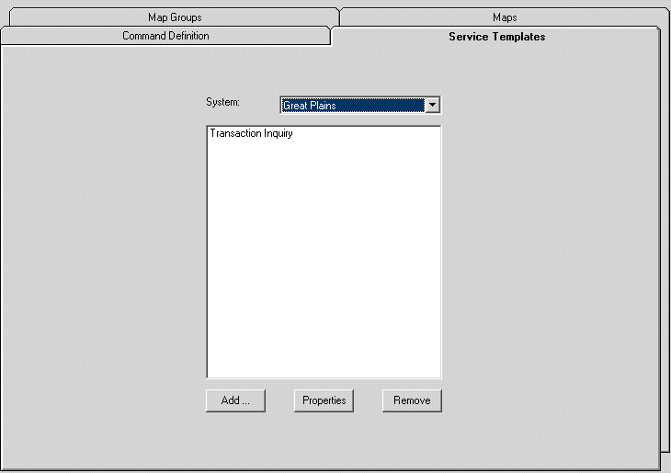
Figure 3 - Service Templates tab on the Map Tool

Map Security for Application Link maps used by Command Defintions
Maps referenced by Application Link Command Definitions need to be administered through the Oracle I/PM Windows client “Security Administration Tool”. In the Maps tab, Application Link map execution rights may be granted to groups of users. At run-time, a user must belong to at least one group that has been granted Map execution rights in order for the corresponding Command Definition to be available. For the execution of Map Groups through Command Definitions, permission to all Maps within the Map Group must exist. Note that this functionality is currently specific to the execution of Maps through Application Link Command Definitions and is neither required nor available for other uses of the EIS. The available Maps list will show only Maps that may be configured for Command Definitions (i.e. those that reference a supported system). Additionally, if a license to a supported system is not found, this entire tab will be disabled.
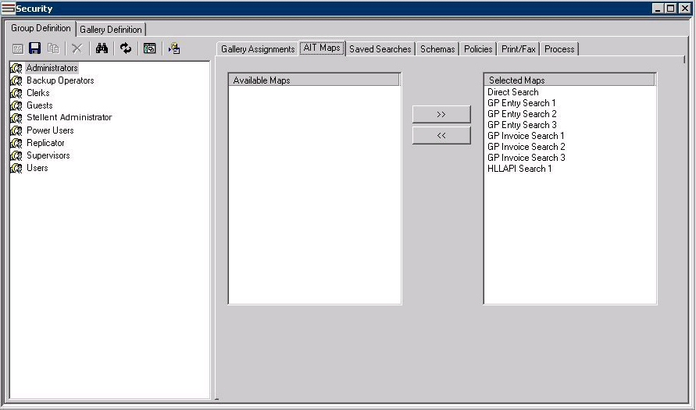
Figure 4 - Maps tab in the Security Administration tool
To grant Application Link Map execution rights to a given group, simply select the group, select the Map from the “Available Maps” list, and click the >> button. To revoke Map execution rights for a given group, select the group, select the Map from the “Selected Maps” list, and click the << button. Note that a user will have access to the “aggregate” set of Maps across all groups to which they belong.

Application Link Application Bar
The Application Link Application Bar is an Oracle I/PM Windows client tool that runs as a standard Application Bar within the Windows desktop environment. The Application Bar supports the execution of Application Link Maps that perform integration transactions between the Oracle I/PM Windows client and certain line of business system clients. Currently, the systems that are supported by the Application Link Application Bar include JD Edwards World and other HLLAPI based systems. In the future, other line of business systems may be supported as well.
The advantage of the Application Link Application Bar is that it allows integration points to be configured completely independently from the line of business system. This means that there is no impact at all to the line of business system’s application code or user interface.
To configure the Application Link Application Bar, the following steps are required:
- Configure the Service Templates for the line of business application. For J.D. Edwards World and other HLLAPI based systems, refer to the “HLLAPI Screen Definition Tool – Users Guide” document for detailed instructions on creating Service Templates.
- Create the Application Link Maps that use the Service Templates created in step 1. Refer to the beginning of this document for instructions on this process.
- Grant Application Link Map execution privileges to the appropriate user groups for the Maps created in step 2. Refer to the previous section of this document for instructions on this process.
- Add the “App Bar Tool” to the galleries for which it should be available. See Figure 5 below.
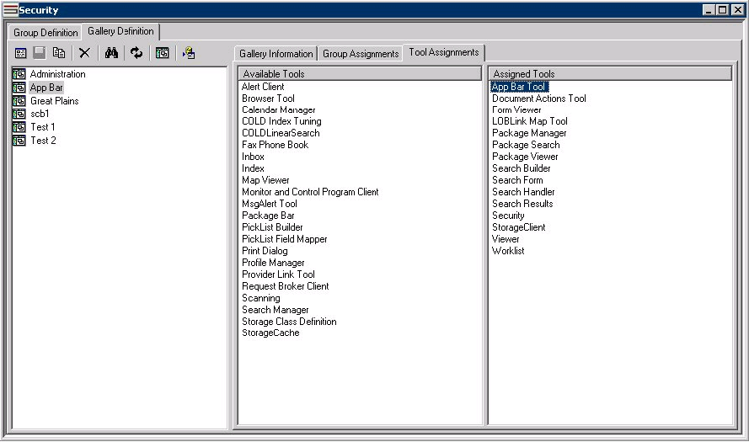
Figure 5 - Add the App Bar Tool to the appropriate galleries
- Login to a gallery configured in step 4 as a user belonging to a group configured in step 3.
When a user logs into a gallery containing the Application Link Application Bar, the Application Bar will create a toolbar inside of itself for each Service Template that contains Command Definitions. Toolbars corresponding to Service Templates that are currently available in the line of business system (i.e. the corresponding screen is open in the terminal emulator session) will be visible on the Application Bar. Toolbars corresponding to Service Templates that are not currently available in the line of business system (i.e. the corresponding screen is not open in the terminal emulator session) will not be visible on the Application Bar.
As new line of business screens are opened, the Application Link Application Bar will respond dynamically and show only those buttons that are applicable to the open screens. When multiple sessions are opened, the Application Bar will inspect all open sessions and the buttons will be shown/hidden accordingly. If two or more sessions are open to the same screen, the Command Definitions for that screen will appear only once on the Application Bar. When the command is executed, the user will be prompted to select the session from which they would like to use for the Application Link transaction.
The Application Link Application Bar may be dragged & docked to any of the four side of the desktop. Each individual toolbar within the Application Bar may be minimized to show only the Service Template title (with a drop-down list of commands) or maximized to show each command button. The buttons themselves may be configured to show or hide their label with the right-click “Show Text” command.

