DOCUMENT CONTROL PRODUCTION RELEASED

5200 Paramount Parkway
Morrisville, NC 27560
919.460.5500
THIS DOCUMENT AND THE DATA DISCLOSED HEREIN OR HEREWITH IS PROPRIETARY AND IS NOT TO BE REPRODUCED, USED OR DISCLOSED IN WHOLE OR IN PART TO ANYONE WITHOUT THE WRITTEN PERMISSION OF TEKELEC. COPYRIGHT, © TEKELEC 2026

Title: | WORK INSTRUCTIONS,UNPACKING, VERTICAL SHIPPING CRATE, HEAVY DUTY, EAGLE
Part Number: |  | 822-0094-02 | Revision: | B | ECN | 17393

CHANGE HISTORY
Date | Revision | Author | Revision Description | Approve
4/2002 | A | Chris Moakley | New Release | Yes
4/25/2007 | B | J. Hensley | Ref. Changes in Appendix A | Yes

1.0 PURPOSE:
To provide a general work instructions for Packaging the Tekelec EAGLE Frame Assemblies into the Vertical Heavy Duty Shipping Crate.

2.0 SCOPE:
This document establishes the workmanship requirements and general work instructions.

3.0 REFERENCES:
3.1 LIST OF DOCUMENTS: (Use latest revision.)

WI005750 Procedure, Packaging and Shipping
PD005481 Procedure, ESD Protection

- DEFINITIONS:
  - None

- RESPONSIBILITIES:
5.1 All responsibilities herein are the responsibility of the shipping department.

6.0 PROCEDURE:
6.1 REQUIREMENTS
6.1.1 ESD Working Environment: The working area shall be static free.

6.1.2 Equipment

6.1.2.1 Mechanical assembly equipment:

The following tools are required for mechanical assembly:
- #1 slotted screwdriver
- 3/8 drive ratchet
- 9/16” 3/8 drive socket
- 15/16” 3/8 drive socket

6.1.2.2 Test equipment: No Testing is required at this time.

6.2 REUSABLE CONTAINER: This Shipping Container is a reusable crate. Crate Dolly wheels, Brace and hardware should be returned to Tekelec. Dolly Wheels are to be secured in original position using the original 15/16” hardware to secure parts to the base of crate. Foam Dunnage blocks may by loose within the crate.

SUGGESTED SEQUENCE OF REMOVAL: Refer to pictorial sequence starting on page 3.

- RECORDS:
7.1 None.

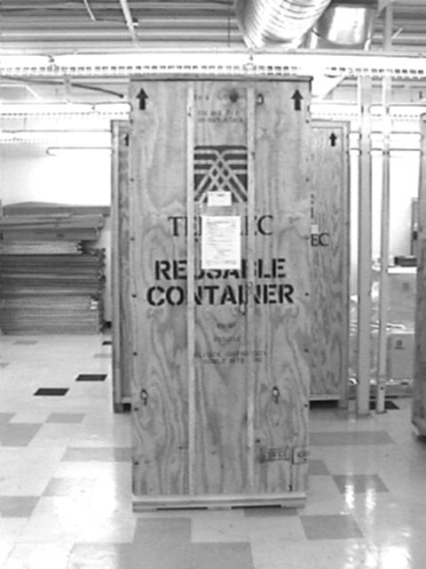
1.) Inspect received system for evidence of any damage to crate that may have occurred during the shipping process. Provide a minimum of 12 feet of clear floor space in front of the crate to allow for the ramp, and unpacking of the system. The crate is approximately 40” wide and requires 3 feet per side to access Carriage bolts. Allow at least 3 feet behind the crate for rear access panel Two sets of Unpacking Instructions (822-0094-02) come with each system. One set of Instructions is applied to the front of the crate.
Unpacking
Instructions

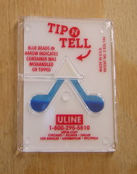
2.) Examine “Tip-N-Tell” indicators on rear panel and side panels of crate. If the Crate shows signs of damage or the “Tiltwatch” reflect an incident, do not unpack system and contact Tekelec’s Traffic Supervisor (818) 880-7940.

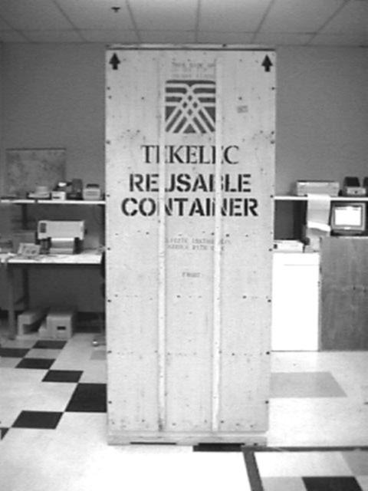
Carriage
bolts
3.) The front Panel is secured by 14 Carriage bolts, flat washers and nuts. Using the ratchet and 9/16” socket remove the nuts and washers.

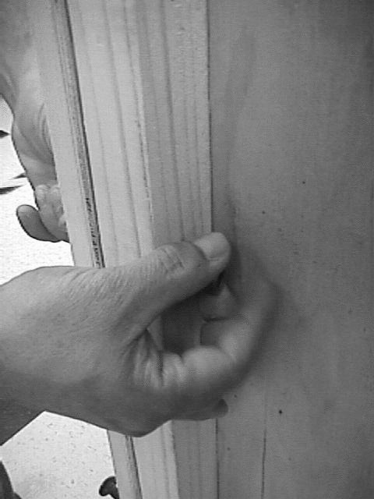
4.) Save all nuts washers and Carriage bolts.

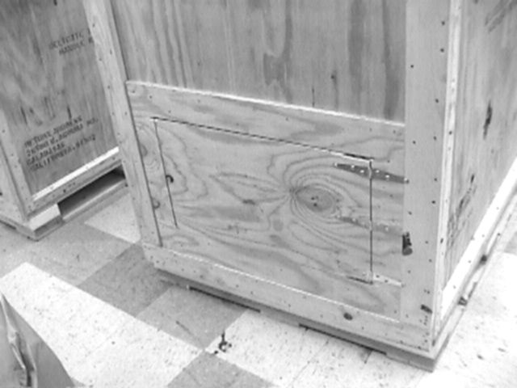
9/16” bolt
5.) Using the 3/8” ratchet and 9/16” socket remove the bolt securing rear access door.

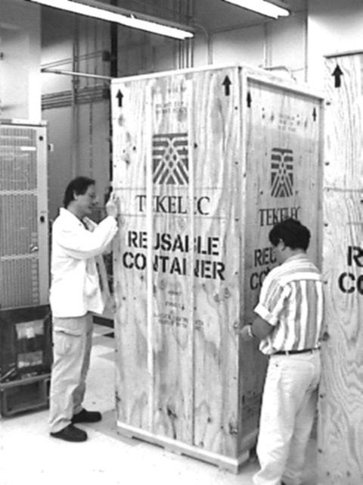
6.) CAUTION: To avoid injury or damage to equipment, this step requires two people.
Lift front panel out and away from crate.

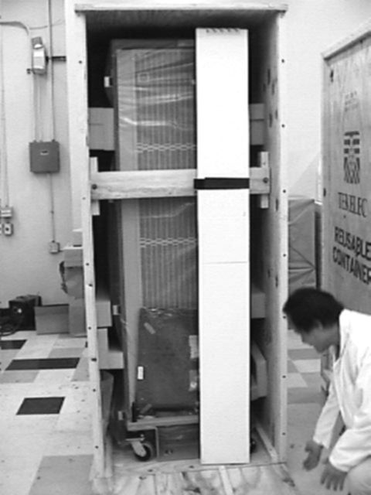
7.) Front Panel serves as the Loading / Unloading ramp. Position Ramp Text side up. Guide rails are on this top surface.

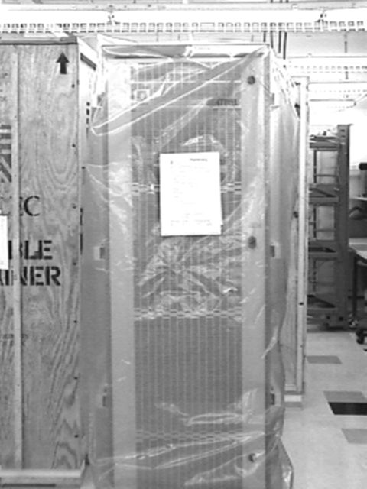
8.) The second set of Unpacking Instructions (822-0094-02) is applied to the front of the system.
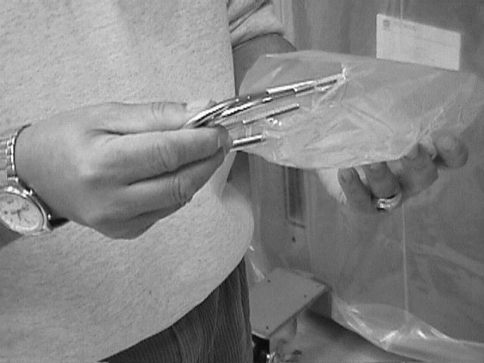
9.) Obtain the 2 “U” shaped keeper rings from the hardware bag attached to the inside wall of the crate.

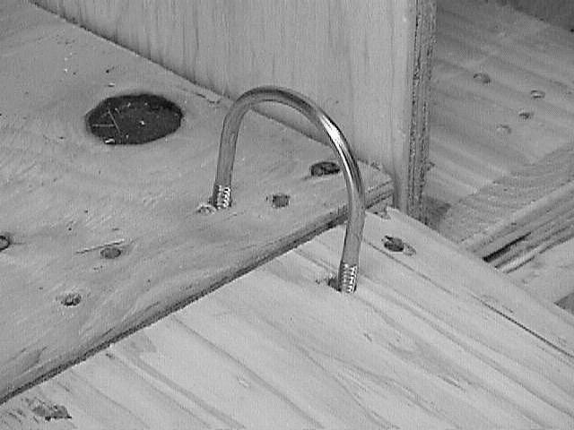
10.). Position keeper rings as shown to prevent ramp movement during loading.

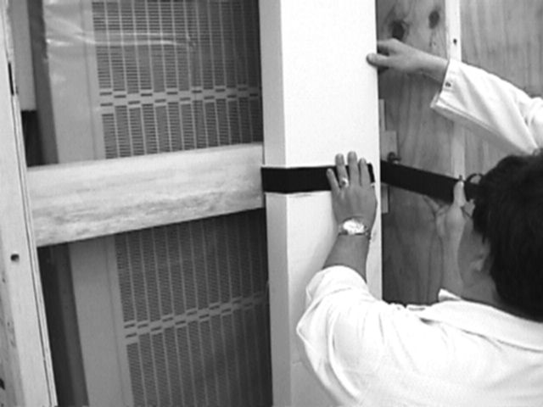
11.) Remove Separation Panel if optioned. Carton is secured to brace with Velcro strap.

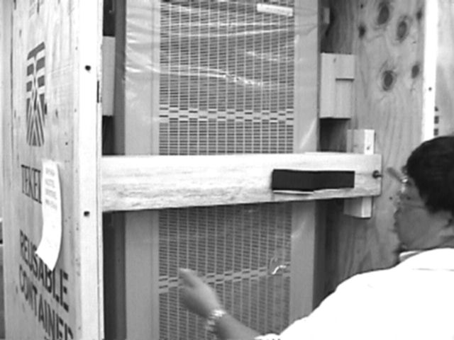
9/16” bolts
12.) Using the Ratchet and 9/16” socket remove the two nuts securing the brace.

Dunnage blocks
13.) Systems shipped without side panels will have dunnage blocks. Remove and save these blocks.

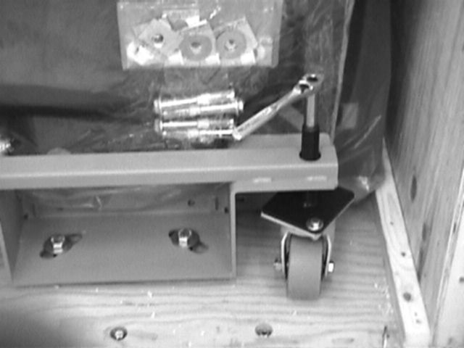
15/16” Bolts

14.) The system is secured to the base of the crate by 4 15/16” bolts Using Ratchet and 15/16” socket remove and save this hardware.

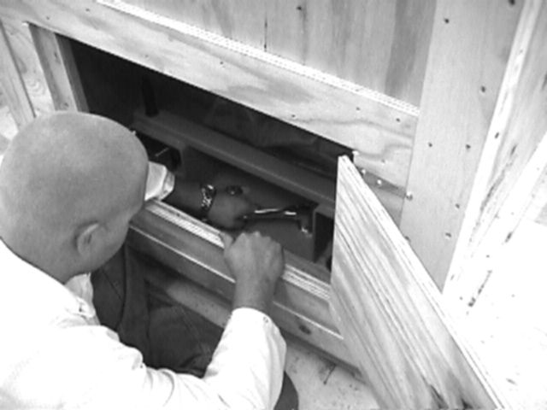
15.) Rear 15/16” bolts are accessed via the rear panel.

Jack Screw
16.) Raise system from floor of the crate by clockwise rotation of jackscrews. Use ratchet and 9/16” socket. NOTE: System must be raised in an even fashion. Bring each corner up no more than ½ inch at a time.

17.) Rear dolly jackscrews are accessed via the rear access panel on the crate. NOTE: System must be raised in an even fashion. Bring each corner up no more than ½ inch at a time

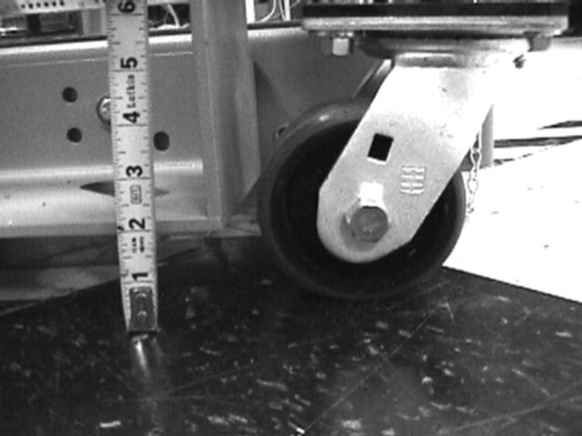
1 ½”
18.) Note the system must be at a height of 1-½ to 1 ¾ inches from the floor for loading or unloading. System should be level during any type of movement.

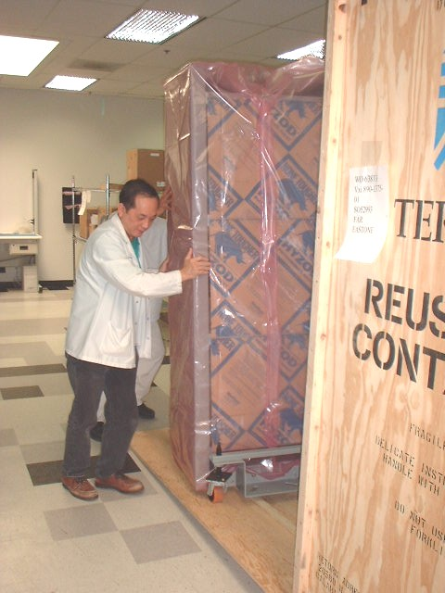
Rails
19.) CAUTION: To avoid injury or damage to equipment, this step requires two people.
Lift Guide dolly wheels outboard of rails on the ramp. Slowly bring system down ramp.

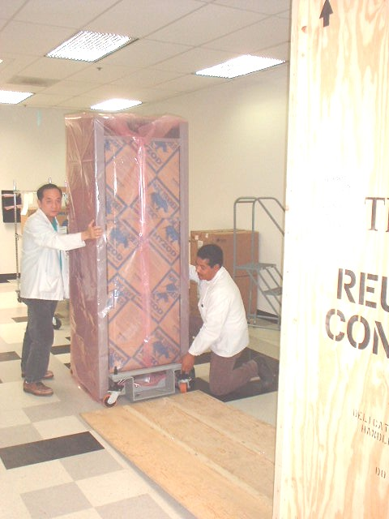
20.) System is to be carefully moved down the ramp onto facility floor.

Note: With system positioned as desired for Final installation Dolly wheels can be removed. Instructions for removal only apply if final installation with supplied installation kit is taking place. This document does not cover installation kit application.
Steps 20, 21, and 22 only apply if dolly wheel assemblies are removed.

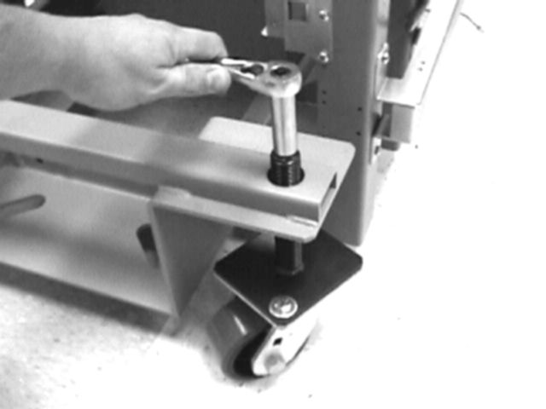
Base surface

21.) Lower system from floor of the crate by counter clockwise rotation of jackscrews. Use ratchet and 9/16” socket. NOTE: System must be raised in an even fashion. Bring each corner down no more than ½ inch at a time. Lower until all of the weight is in the dolly bracket base surface and wheels are off the floor.

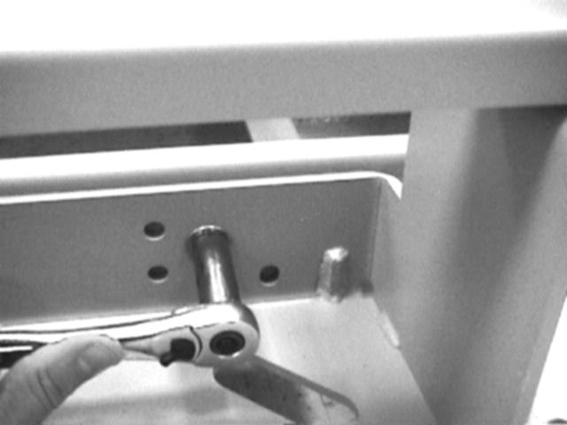
22.) Remove the 9/16” bolt that secure the dolly assemblies to the system frame. Two bolts secure each dolly.

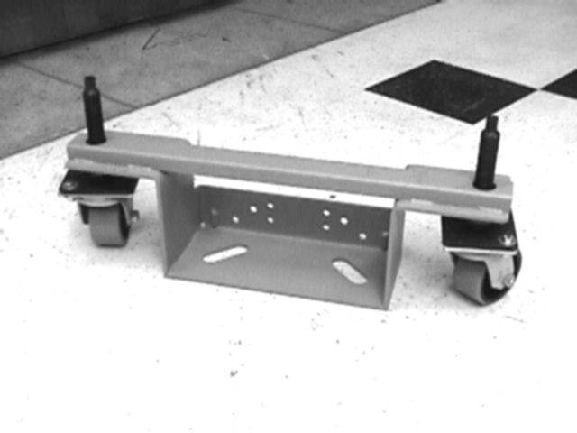
23.) Each dolly assembly weighs in excess of 40lbs. Exercise safe lifting technique and caution to avoid any lifting injures.

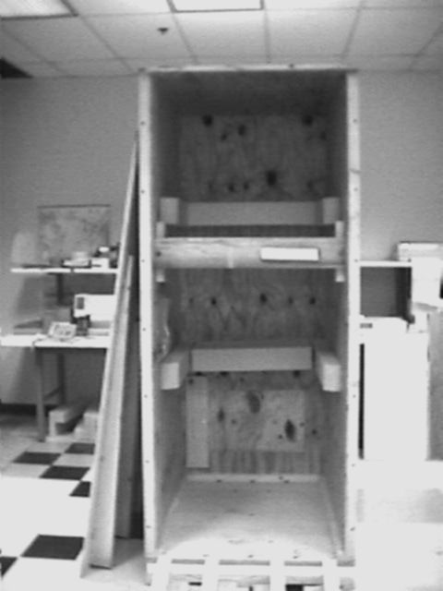
24) Replace brace and secure using the 9/16” hardware.

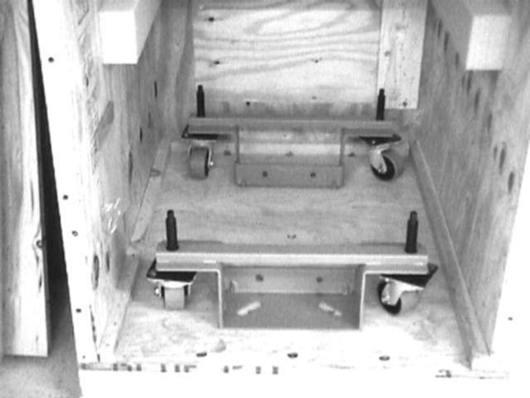
25) If Dolly wheels are no longer needed secure them to the base of the crate in the original positions using the 15/16” hardware.
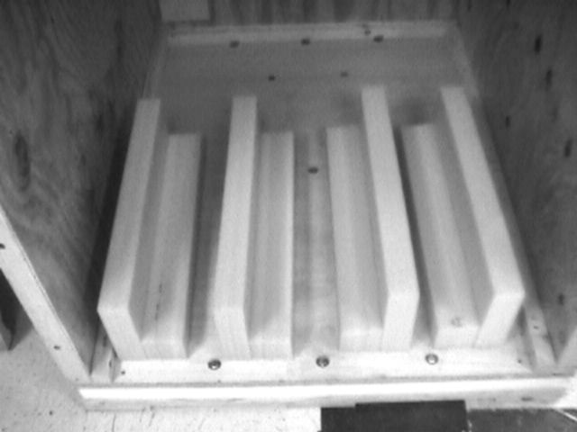
26.) Foam dunnage blocks should be placed back in crate.

27) Place 2 “U” shaped keeper rings into a bag attached to the inside wall of the crate. If the Dolly Wheels stay with the system retain the 15/16 bolts and washers in the bag.

28.) Ensure that Rear access panel is closed and secured using the original 9/16” hardware.

29.) CAUTION: To avoid injury or damage to equipment, this step requires two people.
Lift front panel of crate into place. Center the front panel on the crate. Securely place against the crate, between the ledges that extend above and below the panel.

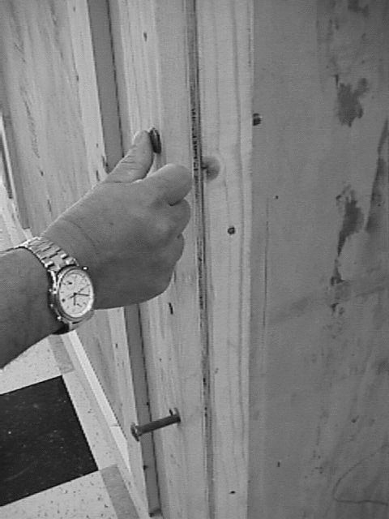
30.) Insert lag bolts through 14 holes (7 on each side) that hold the front panel in place.

31.) Crate shown closed, and prepared for return shipment to:

Tekelec
Attention: Traffic Supervisor
5200 Paramount Parkway
Morrisville, NC 919-388-1455
Appendix A: REVIEW SUMMARIES

Review #: 1
Document: 822-0094-02_rev_B.doc
Date: 4/25/07
Author: Jerry Hensley
Moderator: Richard Carino
Recorder: Jerry Hensley

Quorum:

Traffic Dave Tenorio 30 min. Vote 3
Quality Mary Anne Broers 20 min. Vote 3
Reliability Richard Carino 15 min. Vote 3
Shipping Henry Hall 20 min. Vote 3
Ops Eng. Mike Campbell 20 min. Vote 3

Voting Result: 3

Actions:
- Updated header/footer w/new rev and ECO number
- Updated section 3.1 to include new PD number that replaced 907-0485-01 document.
- Deleted “transport CO” in section 5.1
- Deleted section 6.1.3 Working Temp.
- Photo #2, changed “Tilt-Watch” to “Tip-N-Tell” indicator.
- Updated Tekelec ship to address along with current phone number for the Traffic Supervisor.

