Oracle® Communications

**User Data Repository**

**OCUDR Network Impact Report**

Release 10.0

E58607-01

September 2015



Oracle Communications User Data Repository OCUDR Network Impact Report, Release 10.0

Copyright © 2013, 2015 Oracle and/or its affiliates. All rights reserved.

This software and related documentation are provided under a license agreement containing restrictions on use and disclosure and are protected by intellectual property laws. Except as expressly permitted in your license agreement or allowed by law, you may not use, copy, reproduce, translate, broadcast, modify, license, transmit, distribute, exhibit, perform, publish, or display any part, in any form, or by any means. Reverse engineering, disassembly, or decompilation of this software, unless required by law for interoperability, is prohibited.

The information contained herein is subject to change without notice and is not warranted to be error-free. If you find any errors, please report them to us in writing.

If this is software or related documentation that is delivered to the U.S. Government or anyone licensing it on behalf of the U.S. Government, the following notice is applicable:

U.S. GOVERNMENT END USERS: Oracle programs, including any operating system, integrated software, any programs installed on the hardware, and/or documentation, delivered to U.S. Government end users are "commercial computer software" pursuant to the applicable Federal Acquisition Regulation and agency-specific supplemental regulations. As such, use, duplication, disclosure, modification, and adaptation of the programs, including any operating system, integrated software, any programs installed on the hardware, and/or documentation, shall be subject to license terms and license restrictions applicable to the programs. No other rights are granted to the U.S. Government.

This software or hardware is developed for general use in a variety of information management applications. It is not developed or intended for use in any inherently dangerous applications, including applications that may create a risk of personal injury. If you use this software or hardware in dangerous applications, then you shall be responsible to take all appropriate fail-safe, backup, redundancy, and other measures to ensure its safe use. Oracle Corporation and its affiliates disclaim any liability for any damages caused by use of this software or hardware in dangerous applications.

Oracle and Java are registered trademarks of Oracle and/or its affiliates. Other names may be trademarks of their respective owners.

Intel and Intel Xeon are trademarks or registered trademarks of Intel Corporation. All SPARC trademarks are used under license and are trademarks or registered trademarks of SPARC International, Inc. AMD, Opteron, the AMD logo, and the AMD Opteron logo are trademarks or registered trademarks of Advanced Micro Devices. UNIX is a registered trademark of The Open Group.

This software or hardware and documentation may provide access to or information on content, products, and services from third parties. Oracle Corporation and its affiliates are not responsible for and expressly disclaim all warranties of any kind with respect to third-party content, products, and services. Oracle Corporation and its affiliates will not be responsible for any loss, costs, or damages incurred due to your access to or use of third-party content, products, or services.

TABLE OF CONTENTS

1 Introduction 6

***1.1*** ***Purpose/Scope*** 6

***1.2*** ***Disclaimers*** 6

2 Overview of OCUDR 10.0 Features 7

**2.1** **OCUDR 10.0 New Features** 7

**2.2** **Hardware Changes** 8

**2.3** **Software Changes** 9

**2.4** **Firmware Changes** 10

**2.5** **Installation Overview** 11

**2.6** **NOAMP VIP** 12

**2.7** **Migration Tool** 12

3 OCUDR 10.0 GUI Functions 13

**3.1** **UDR Menu Options** 13

**3.2** **Provisioning Option** 14

**3.3** **Provisioning Connections** 16

**3.4** **Diameter Connections** 16

**3.5** **Connections** 17

**3.6** **Command Log** 17

**3.7** **Export Schedule** 17

**3.8** **Import Status** 17

4 Operational Functions 19

**4.1** **Diameter Connections** 19

**4.1.1** **Add Legacy SPR 9.x Diameter Connections** 19

**4.1.2** **Add OCUDR 10.0 Diameter Connections** 22

**4.1.2.1** **Insert Local Node** 22

**4.1.2.2** **Insert Peer Node** 22

**4.1.2.3** **Create Connection Configuration** 23

**4.2** **Import/Export** 23

**4.2.1** **Legacy SPR 9.x Import/Export** 23

**4.2.2** **OCUDR 10.0 Import/Export** 24

**4.3** **Backup** 26

**4.3.1** **Legacy SPR 9.x Backup** 26

**4.3.2** **OCUDR 10.0 Backup** 27

**4.4** **Subscriber query** 28

**4.4.1** **Legacy SPR 9.x Subscriber query** 28

**4.4.2** **OCUDR 10.0 Subscriber query** 30

**4.5** **Failover** 32

**4.5.1** **Legacy SPR 9.x Failover** 32

**4.5.2** **OCUDR 10.0 Failover** 33

**4.6** **Alarms** 33

**4.6.1** **Legacy SPR 9.x Alarms** 33

**4.6.2** **OCUDR 10.0 Alarms** 35

**4.7** **Provisioning Methods** 35

**4.7.1** **Legacy SPR 9.x** 35

**4.7.2** **OCUDR 10.0** 35

5 OCUDR 10.0 Summary 36

**5.1** **Alarms** 36

**5.2** **Measurements** 38

**5.3** **KPIs** 44

**5.4** **Events** 47

6 Reference List 49

**LIST OF TERMS**

Entity An entity is a managed element in the Subscription Entity Configuration Database. In terms of SPR, this means Quota, State, or Dynamic Quota.

GUI Graphical User Interface

MP Message Processor

NOAM&P Network Operations and Management Platform

OAM Operations and Management

OAMP Operations and Management Platform

PCC Policy Charging and Control

PCEF Policy and Charging Enforcement Function

PCRF Policy and Charging Rule Function

RAS REST Application Server

REST Representational State Transfer. A type of Northbound provisioning interface.

SDM Subscriber Data Management

Sh A type of Southbound, signaling interface

SOAM System Operation, Administration, and Maintenance

SOAP Simple Object Access Protocol

Subscriber A single person/devise/user. A Subscriber may have many identities (such as IMSI(s), MSISDN(s) and NAI(s) and all of these identities refer to this single instance.

UDR User Data Repository

UDR App The application responsible for processing create, read, update, and delete entity requests received from MPs.

VIP Vertuial IP Address

xgSDM Next Generation SDM

xgSPR Next Generation SPR

XML Extensible Markup Language

1. **Introduction**
   1. ***Purpose/Scope***

Purpose of this Feature Guide document is to highlight the changes of the product that may have impact on the customer network operations, and should be considered by the customer during planning for this release.

The scope of this document is limited to the changes between Legacy SPR 9.x and OCUDR10.0

* 1. ***Disclaimers***

This document summarizes Release 10.0 new and enhancement features as compared to Legacy SPR 9.x, and the operations impacts of these features, at a high level. The Feature Requirements (FRS) documents remain the defining source for the expected behavior of these features.

*Note that feature implementations may change slightly during product test.*

1. **Overview of OCUDR 10.0 Features**

This section provides an overview of the OCUDR 10.0 release features that may impact OAM interfaces and activities.

* 1. **OCUDR 10.0 New Features**

OCUDR 10.0 introduces the following new Features.

|  |  |  |
| --- | --- | --- |
| Name | Description | Scope |
| SPR Application Definition and System Requirements for xgSDM (PR 218039, PR217047) | The SPR Application for UDR migrates SPR capabilities supported by legacy SPR application on the SDM product to the UDR product. The SPR is a system used for the storage and management of subscriber policy control data. It functions as a centralized repository of subscriber data for the PCRF. SPR includes interfaces for manipulating subscriber information, which can be used to retrieve, create, update or delete subscriber data. | Major feature |
| Provisioning Interfaces for xgSDM Product (PR 218040) | The SPR application for the UDR product provides the storage and management of subscriber policy control and pool data. Subscriber and pool data is created/retrieved/modified or deleted through the Provisioning Interfaces. UDR product supports two primary interfaces that are used for Subscriber Provisioning: XML-REST and XML-SOAP. | Major feature |
| OAM for xgSDM (PR 218223) | OAMP interfaces will be provided via the network-OAMP components, feature focuses on the base OAM capabilities, along with the requirements for performance management, alarms, and events. | Major feature |
| Diameter Interfaces for xgSDM Platform (PR 218041) | Diameter Sh interface support for the UDR with primary purpose to evolve the Subscriber Data Management(SDM) applications to leverage Tekelec’s internal platform for messaging and database. Eliminate third-party software dependencies (such as HP stack Diameter licences) that have proven problematic both in terms in scaling as well as overall robustness at high traffic levels. Create the underlying database and messaging platform, on to which the SPR application will be migrated and to evolve a scalable and robust database solution. | Major feature |
| Accelerated Provisioning Option (Bug 19563391) | The SPR application for the UDR provides a hidden provision option “Allow Accelerated Response” that indicates if provisioning requests are acknowledged to the OSS before waiting for the completion of data durability checks. This functionality is used by all supported provisioning interfaces (REST/XML or SOAP/XML). | Minor feature |
| Display number of provisioned subscribers (Bug 19563513) | The UDR GUI allow the user to view database statistics on the Main Menu | Minor feature |
| Automatic NOAMP Failover inherited from new Platform 6.7 functionality | NOAMPs are monitored and assigned a health score. The NOAMP with the best health score becomes the Active NOAMP and receives the NOAMP provisioning VIP address. | Major Feature |

* 1. **Hardware Changes**
     1. **Hardware Supported**

|  |  |
| --- | --- |
| **Hardware** | **Comment** |
| HP BL460c Gen8 | c-Class |
| HP 3020, 6125 (1G) | Enclosure Switch |
| HP 6120XG, 6125XLG | Enclosure Switch |
| Cisco 4948 | Enclosure Switch |

Note: mixed Sun/HP deployments are not generally supported.

* 1. **Software Changes**

Software change include a new release of the software Platform components, and new OCUDR release.

* + 1. **Platform 6.7**

Platform Release 6.7 inherits all the functionality of Release 6.5.

Platform 6.7 Component Versions

|  |  |
| --- | --- |
| Component | Release |
| TPD 64 Bit | 6.7.0.0.1-84.20.0 |
| COMCOL | 6.3p230 |
| PM&C | 5.7.0.0.1-57.17.1 |
| TVOE | 2.7.0.0.0-84.20.0 |
| AppWorks | 5.7.0-57.31.0 |
| EXGSTACK | 6.7.0_67.26.0 |
| DPI | 6.0.0-60.28.0 |
| Firmware | Refer to 919-6929-001 Rev A for current firmware requirements. |

* + 1. **OCUDR Release 10.0**

OCUDR Release 10.0 inherits all functionality from SPR Release 9.0 with the exception of 'cmdfileloader'.

|  |  |
| --- | --- |
| Component | Release |
| OCUDR Release | 10.0.0-10.16.0 |

* 1. **Firmware Changes**

Below is a summary of the recommended firmware levels provided in the recent FUP Releases.

*For details on FUP release 2.2.6, please reference:*

*Oracle® Communications*

*HP Solutions Firmware Upgrade Pack -- Release Notes*

*Release 2.2.6*

*E54547 Revision 01*

|  |  |  |  |
| --- | --- | --- | --- |
| **Firmware** | **FUP 2.2.4** | **FUP 2.2.5** | **FUP 2.2.6** |
| G8 Blades | System: ProLiant BL460c Gen8  ROM version: I31 03/01/2013  Disc Cntrler: 3.42  iLo Firmware Revision = 1.20  NIC firmware-version: bc 7.4.22 | System: ProLiant BL460c Gen8  ROM version: I31 09/08/2013  Disc Cntrler: 4.68  iLo Firmware Revision = 1.30  NIC firmware-version: bc 7.4.22 | System: ProLiant BL460c Gen8  ROM version : I31 12/20/2013  Disc Cntrler: 5.22  iLo Firmware Revision = 1.40  NIC firmware-version: bc 7.8.79 |
| Onboard Administrator | 3.71 | 4.01 | 4.21 |
| PM&C Server | System: ProLiant DL380p Gen8  ROM version: P70 12/14/2012  Disc Cntrler: 3.42  ILo Firmware Revision = 1.20  NIC firmware-version: 5719-v1.31  System: ProLiant DL380p Gen6  ROM version : P70 12/14/2012  Disc Cntrler: 3.42  ILo Firmware Revision = 1.20  NIC firmware-version: 5719-v1.31 | System: ProLiant DL380p Gen8  ROM version: P70 09/08/2013  Disc Cntrler: 4.68  ILo Firmware Revision = 1.30  NIC firmware-version: 5719-v1.33  System: ProLiant DL380p Gen6  ROM version : P70 09/08/2013  Disc Cntrler: 4.68  ILo Firmware Revision = 1.30  NIC firmware-version: 5719-v1.33 | System: ProLiant DL380p Gen8  ROM version: P70 09/08/2013  Disc Cntrler: 4.68  ILo Firmware Revision = 1.30  NIC firmware-version: 5719-v1.37  System: ProLiant DL380p Gen6  ROM version : P70 09/08/2013  Disc Cntrler: 4.68  ILo Firmware Revision = 1.30  NIC firmware-version: 5719-v1.37 |

* 1. **Installation Overview**

This section provides an overview of the Fresh Installation activities for Release 10.0.

* + 1. **Order of Installation**

1. Firmware Upgrade
2. Platform components
   1. PM&C latest release install
   2. TVOE latest release install
3. OCUDR Install in the following sequence –
   1. NOAM / DR-NOAM
   2. SOAM and site SOAM managed servers (site-at-a-time)
4. Configure for new OCUDR features
   * 1. **Servers support**

OCUDR 10.0 supports the following server configurations

| **Name** | **Site Hardware** | **Redundancy Type** | **Server Types** | **Sh TPS Capacity** | **Number of Subscribers** | **Capacity Notes** |
| --- | --- | --- | --- | --- | --- | --- |
| OneSiteHighCapacityBlade | 4 servers and  2 storage arrays per site | HA Redundancy | 2 Blade1  2 Blade2  2 StorageArray | 25K TPS | 58M, no subscribers is a member of a pool | Maintained with single server failure |
| 35M, average 2 members per pool |
| TwoSitesHighCapacityBlade | 4 servers and  2 storage arrays per site | Geographic Redundancy | 4 Blade1  4 Blade2  4 StorageArray | 50K TPS | 96M, no subscribers is a member of a pool | Maintained with single server or single site failure |
| 59M, average 2 members per pool |
| OneSiteLabBlade | 2 servers/site | Non-HA Redundancy | 2 Blade1 | n/a |  |  |
| OneSiteLowCapacityBlade | 4 servers/site | HA Redundancy | 4 Blade1 | n/a |  |  |

* 1. **NOAMP VIP**

The primary NOAMP has its own VIP address, while the DR NOAMP has its own VIP address. Only one VIP is active at a time. The NOAMP that has spares will only enable its VIP address after the spares become Active. The customer provisioning system will need to ensure that it is connected to OCUDR using the appropriate VIP address.

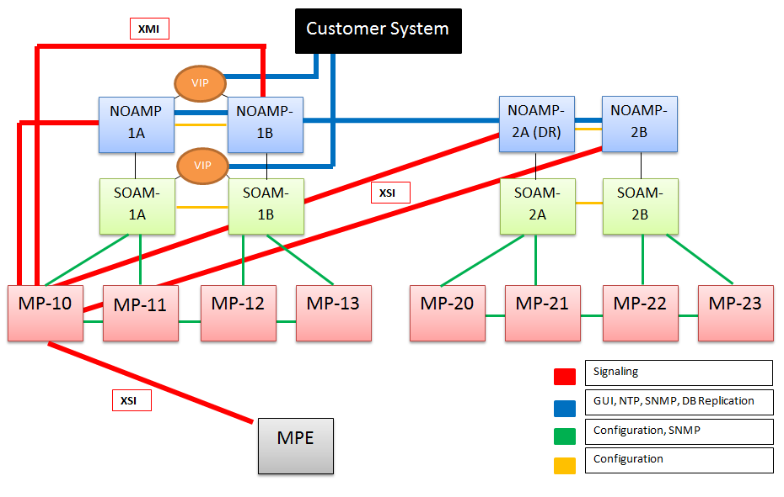

* 1. **Migration Tool**

The SPR to OCUDR subscriber migration tool allows subscribers to be migrated from a production SPR database to a new OCUDR database. This is a streaming process that allows provisioning and signaling traffic to continue to run while the migration is underway. All aspects of the subscriber are migrated, including subscriptions from PCRF elements.

1. **OCUDR 10.0 GUI Functions**

OAM include: User Interfaces (NO GUI, SO GUI), Measurements Reports, Alarms, and KPIs. This section describes the NO GUI – UDR menu. All menu options for UDR are contained under *Main Menu*. All menu items are further categorized under one of the three sub-menus: *Configuration*, *Subscriber Entity Configuration, and Maintenance*.

* 1. **UDR Menu Options**

The following screenshot is a composite menu of all UDR menu options, fully expanded.

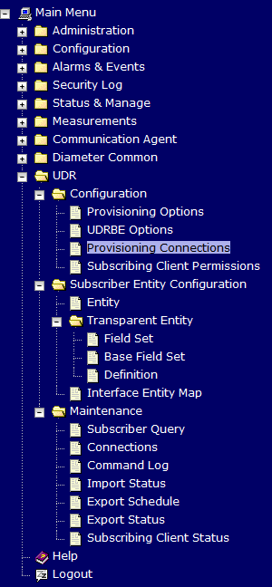

* 1. **Provisioning Option**

Provisioning Options control how provisioning interfaces (REST/SOAP, etc.) work.

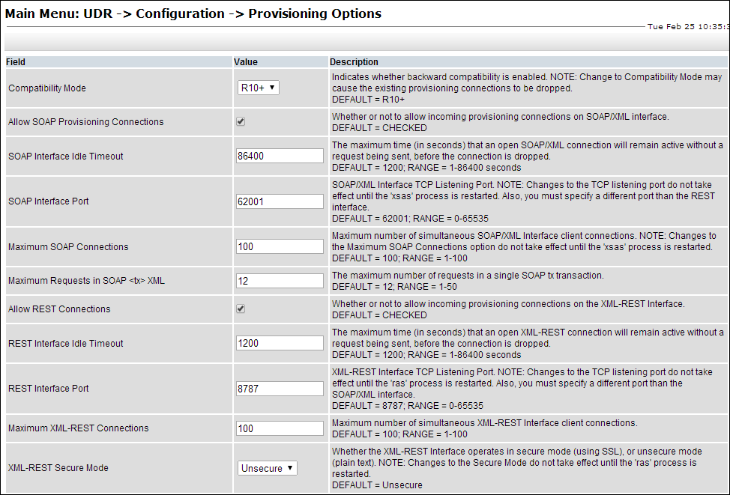

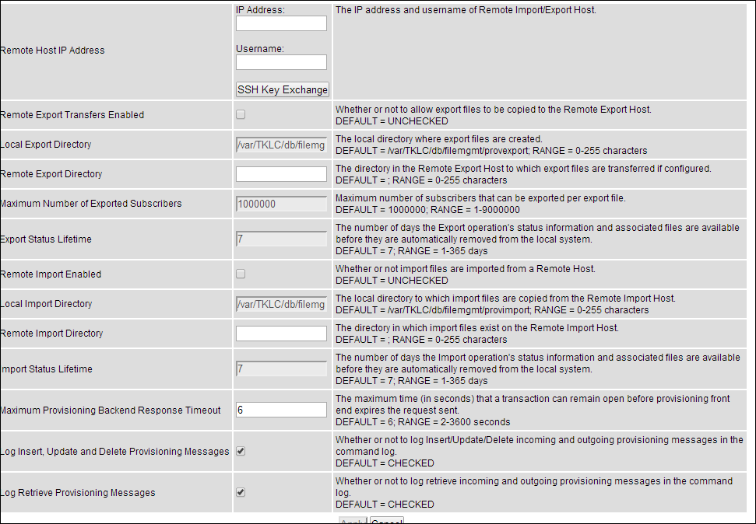

* 1. **Provisioning Connections**

Connections GUI determines a “white list” of all possible remote connections. Only servers listed in the Connections list are allowed to remotely connect to the Primary Provisioning Site’s NOAMP Server and execute commands.

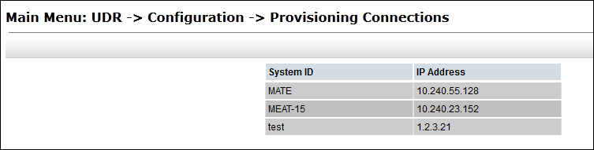

* 1. **Diameter Connections**

On SOAM VIP the Connections screen under “Diameter - Maintenance” facilitates a user to monitor and see the status of established diameter connections with PCRF MP.

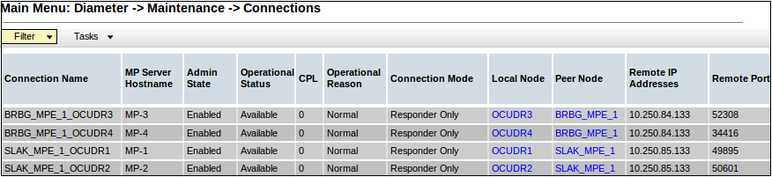

* 1. **Connections**

Connections screen under “Maintenance” facilitates a user to monitor and see the status of established connections. It provides a list of Remote IP addresses/ports along with details on the timestamp at which the connection was established.

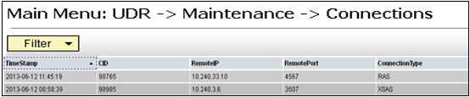

* 1. **Command Log**

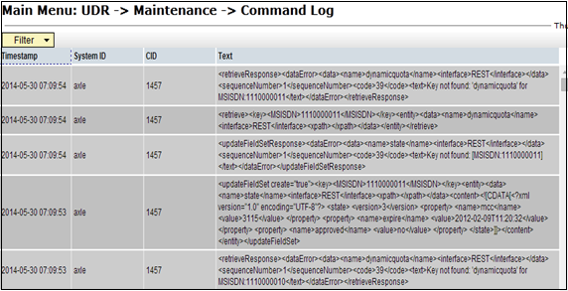

* 1. **Export Schedule**

Export Schedule screen under “Maintenance” facilitates a user toview when the export is schedule, User can also modify the schdule from this screen.

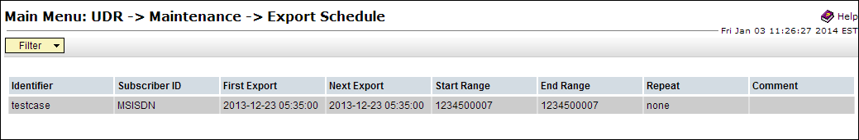

* 1. **Import Status**

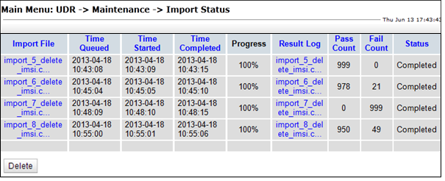

1. **Operational Functions**

This section will shows the GUI correspondence between legacy SPR 9.x and OCUDR 10.0 common daily operations. This content is not intended to replace the customer User Guidess. The User Guides for each product contain detailed instructions for these operations.

* 1. **Diameter Connections**
     1. **Add Legacy SPR 9.x Diameter Connections**

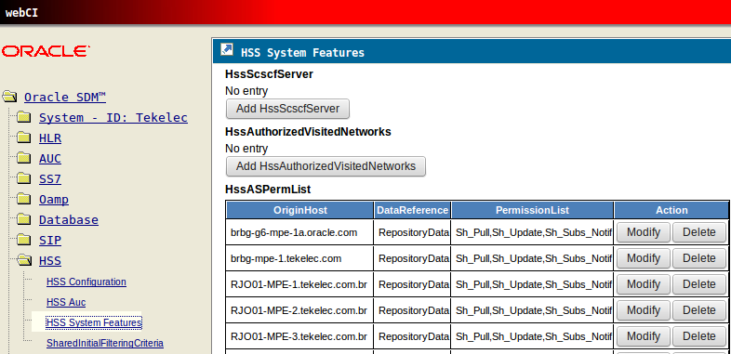

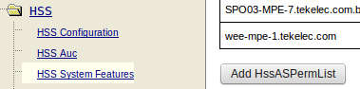

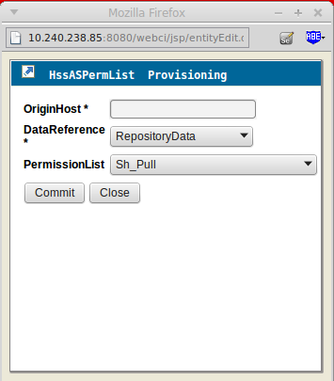

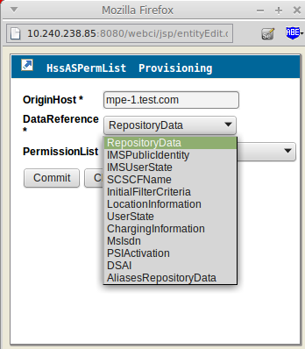

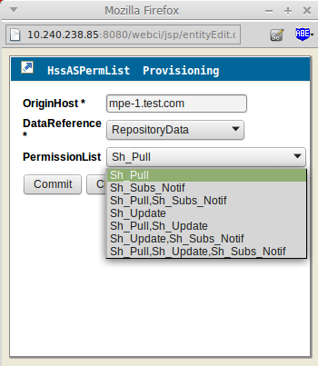

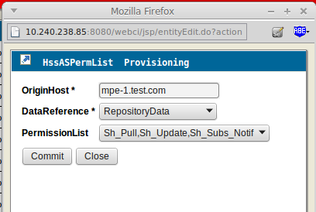

* + 1. **Add OCUDR 10.0 Diameter Connections**

To add diameter connections:

* + - 1. **Insert Local Node**

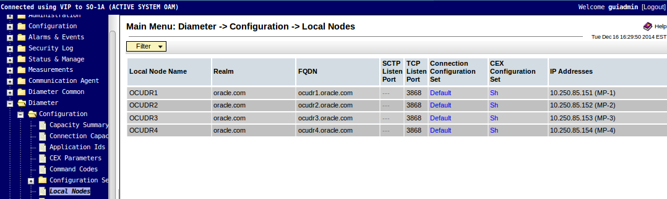

* + - 1. **Insert Peer Node**

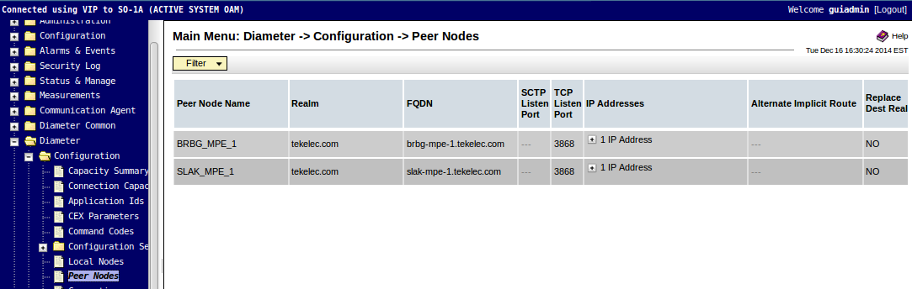

* + - 1. **Create Connection Configuration**

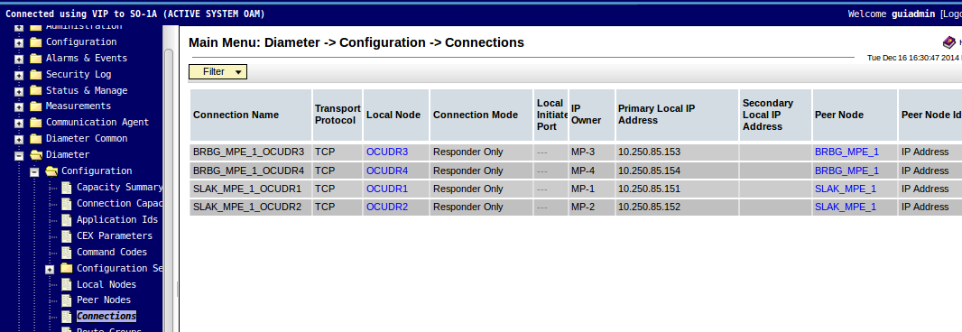

* 1. **Import/Export**
     1. **Legacy SPR 9.x Import/Export**

Legacy SPR uses the ‘cmdfileloader’ command line utility to import data, although it is limited when compared to OCUDR 10.0, which can import large blocks of data.

* + 1. **OCUDR 10.0 Import/Export**

On NOAMP VIP user can Import and Export data.

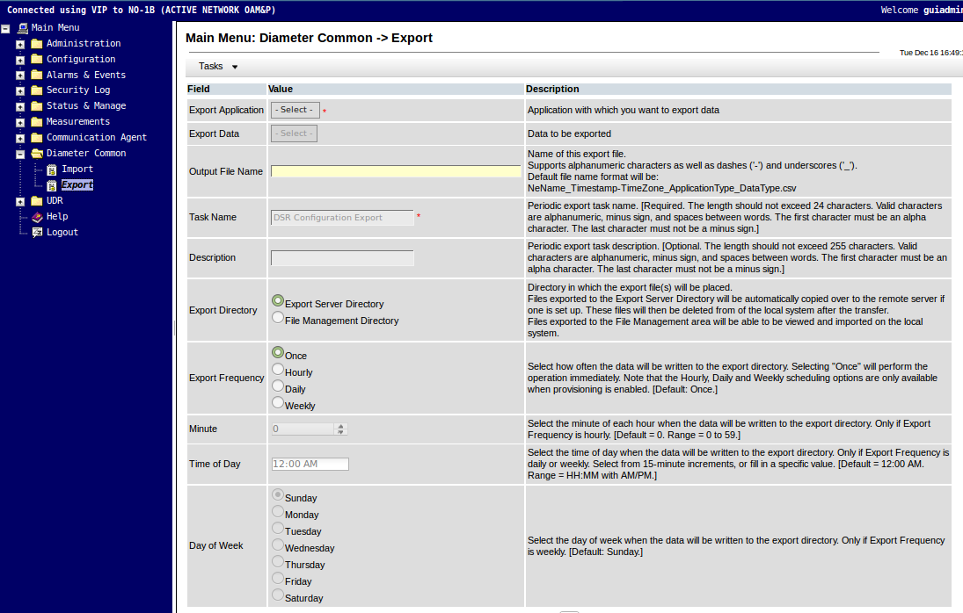

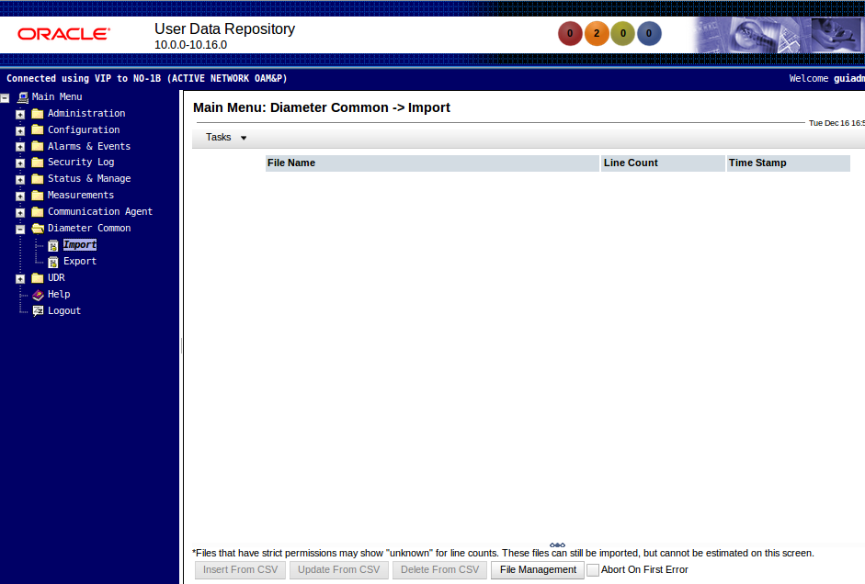

* 1. **Backup**
     1. **Legacy SPR 9.x Backup**

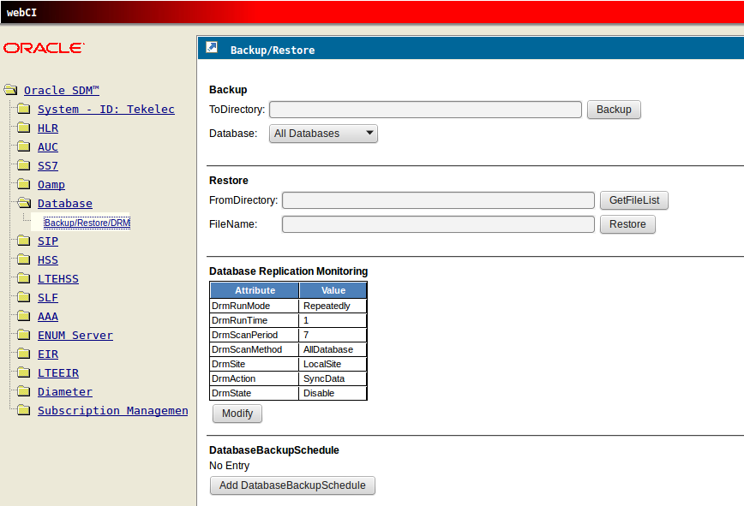

* + 1. **OCUDR 10.0 Backup**

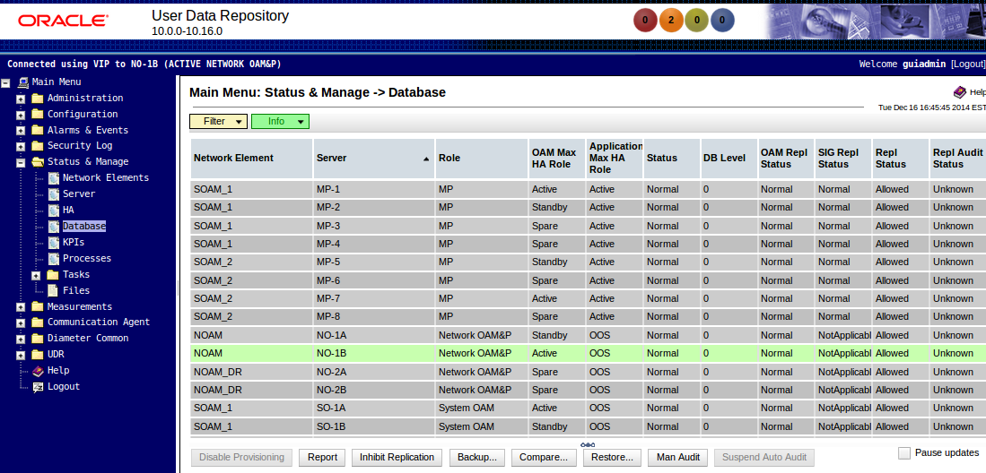

Note: User is not required to backups as every night system does the backup.

* 1. **Subscriber query**
     1. **Legacy SPR 9.x Subscriber query**

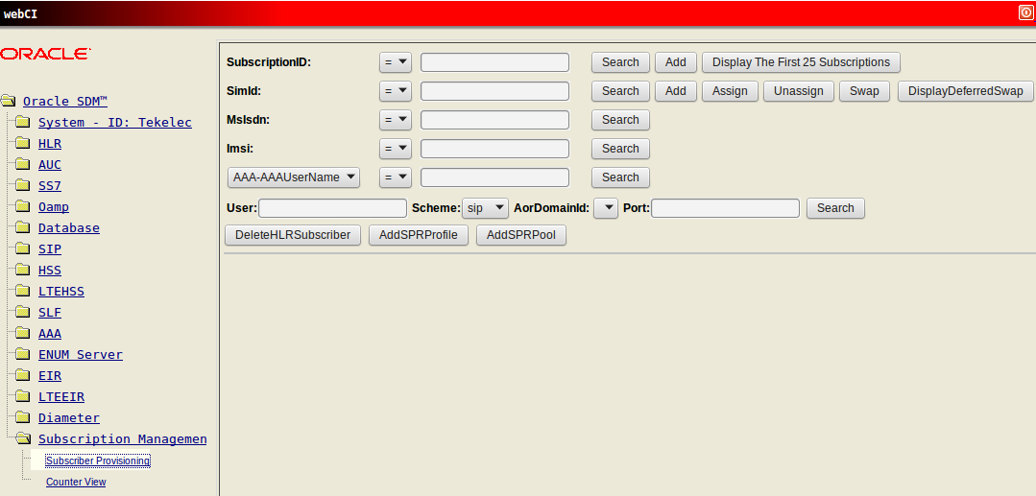

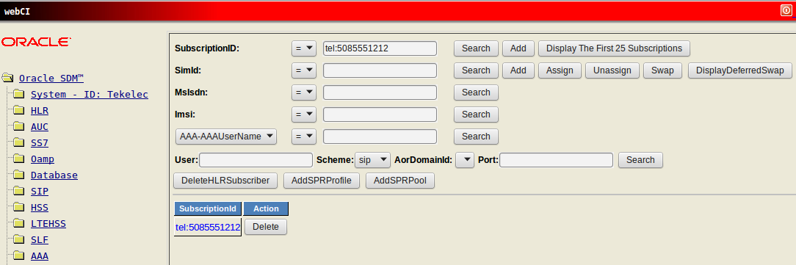

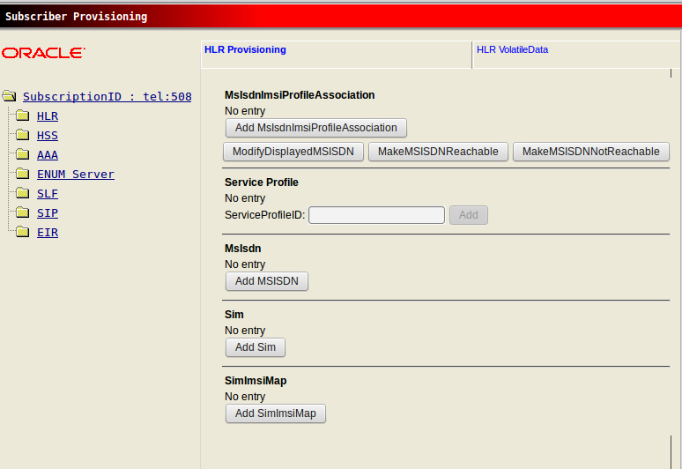

* + 1. **OCUDR 10.0 Subscriber query**

Note: The database statistics are always displayed and are refreshed whenever the screen is refreshed or the *Submit* button is pressed

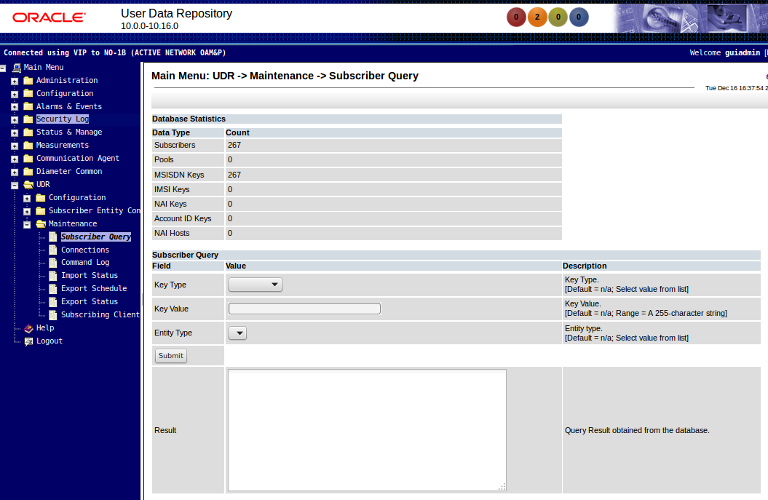

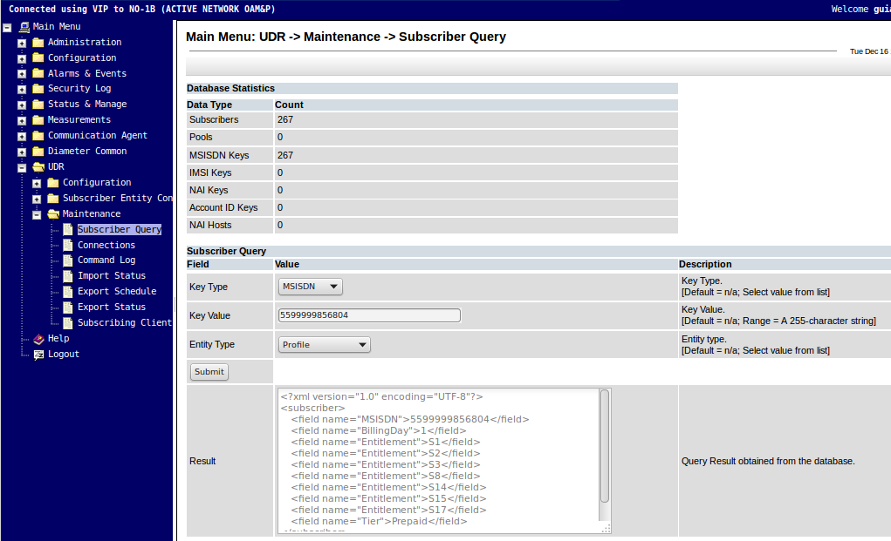

* 1. **Failover**
     1. **Legacy SPR 9.x Failover**

To create failover on legacy SPR, press the SWO button on the Database line

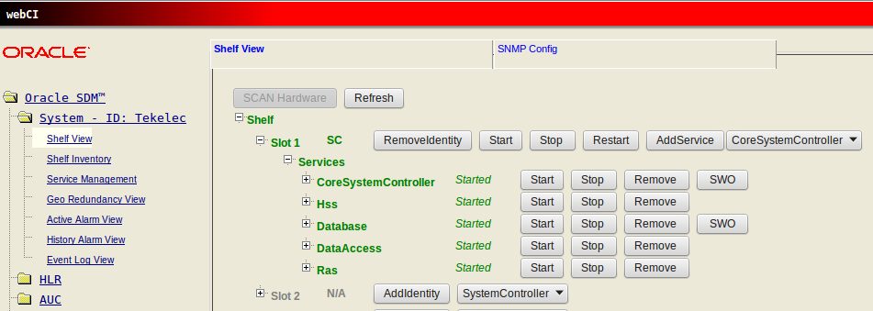

* + 1. **OCUDR 10.0 Failover**

To create manual failover on NOAMP/SOAMP, set the active NOAMP Max HA value to Standby. The Standby NOAMP will become active . The same procedure can be used with the SOAMP servers.

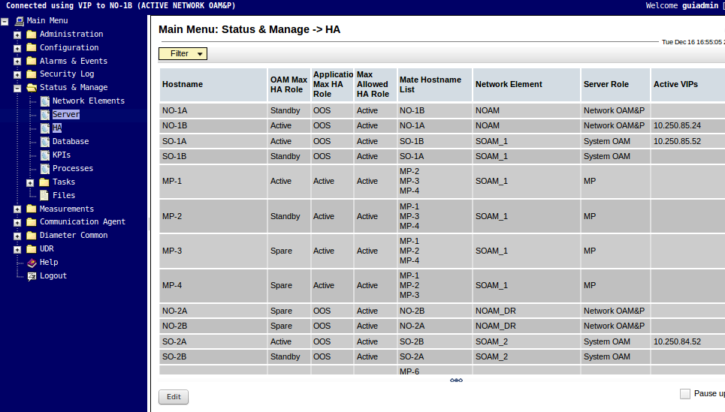

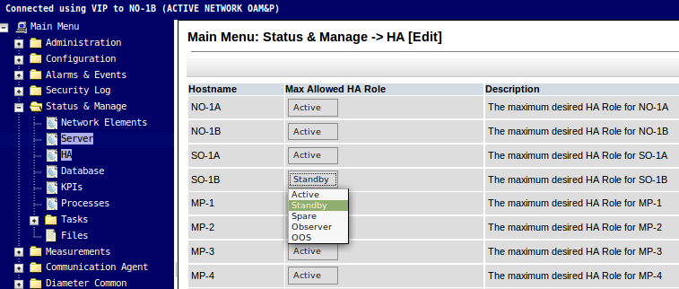

* 1. **Alarms**
     1. **Legacy SPR 9.x Alarms**

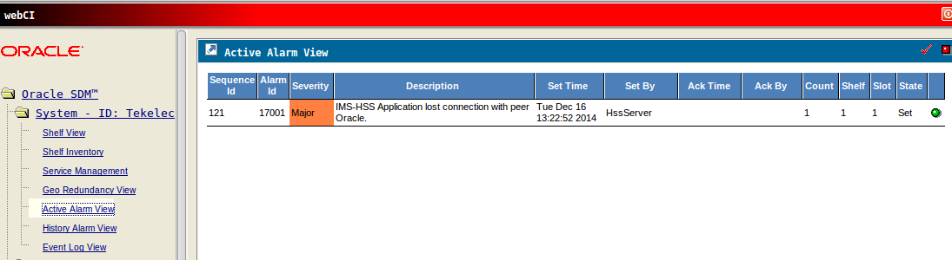

* + 1. **OCUDR 10.0 Alarms**

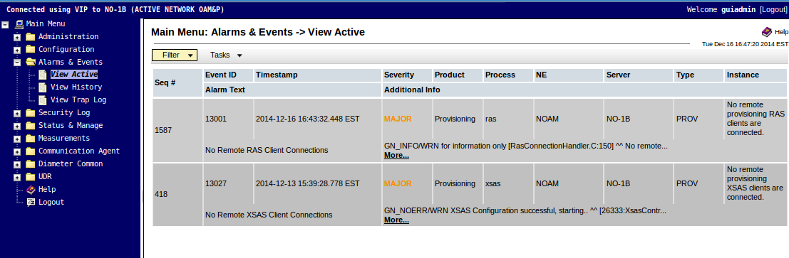

* 1. **Provisioning Methods**
     1. **Legacy SPR 9.x**

Lagacy SPR has four provisioning methods.

* SOAP interface
* REST (RAS service) interface
* Direct XML interface (asyncronus API’s that uses same format as SOAP UI)
* ‘cmdfileloader’ command line utility
  + 1. **OCUDR 10.0**

OCUDR 10.0 has three provisioning methods

* SOAP Interface
  + Reference TR007195
* REST Interface
  + Reference TR007198
* Bulk Import Utility
  + Refer 4.1.3.2 OCUDR 10.0 Import/Export

1. **OCUDR 10.0 Summary**

This section will summarize the Alarms, Measurements, KPIs and Events.

* 1. **Alarms**

| **Alarm ID** | | **Alarm Name** | **Severity** | **HA Score** | **MIB Required (Y/N)** |
| --- | --- | --- | --- | --- | --- |
| **Provisioning Interface Alarms** | | | | |
| 13000 | RAS Interface Disabled | Critical | Normal | Yes |
| 13001 | No Remote RAS Client Connections | Major | Normal | Yes |
| 13002 | RAS Connection Failed | Major | Normal | Yes |
| 13003 | Invalid RAS Provisioning Configuration | Major | Normal | Yes |
| 13026 | XSAS Interface Disabled | Critical | Normal | Yes |
| 13027 | No Remote XSAS Client Connections | Major | Normal | Yes |
| 13028 | XSAS Connection Failed | Major | Normal | Yes |
| 13029 | Invalid XSAS Provisioning Configuration | Major | Normal | Yes |
| 13051 | Import Throttled | Minor | Normal | Yes |
| 13052 | Import Initialization Failed | Major | Normal | Yes |
| 13053 | Import Generation Failed | Major | Normal | Yes |
| 13054 | Import Transfer Failed | Major | Normal | Yes |
| 13056 | Export Initialization Failed | Major | Normal | Yes |
| 13057 | Export Generation Failed | Major | Normal | Yes |
| 13058 | Export Transfer Failed | Major | Normal | Yes |
| 13061 | ERA ResponderFailed | Major | Normal | Yes |
| **xgSDM SPR Alarms** | | | | | |
| 13254 | | AS Unavailable | Major | Normal | Yes |
| 13255 | | Notification Table Full | Minor, Major, Critical | Normal | Yes |
| 13354 | | UDRBE Provisioning Task Message Queue Utilization | Minor, Major, Critical | Normal | Yes |
| 13355 | | UDRBE Notification Task Event Queue Utilization | Minor, Major, Critical | Normal | Yes |
| 13356 | | UDRBE Udr Task Event Queue Utilization | Minor, Major, Critical | Normal | Yes |
| 13357 | | UDRBE Subscription Task Event Queue Utilization | Minor, Major, Critical | Normal | Yes |
| 13358 | | UDRBE Auto Enrollment Task Event Queue Utilization | Minor, Major, Critical | Normal | Yes |
| 13359 | | Failed to register as a Routed Service user with ComAgent | Critical | Normal | Yes |
| **xgSDM Process-Based Alarms** | | | | | |
| 13062 | | RAS Process CPU Utilization Threshold Exceeded | Minor, Major, Critical | Normal | Yes |
| 13063 | | RAS Process Memory Utilization Threshold Exceeded | Minor, Major, Critical | Normal | Yes |
| 13064 | | XSAS Process CPU Utilization Threshold Exceeded | Minor, Major, Critical | Normal | Yes |
| 13065 | | XSAS Process Memory Utilization Threshold Exceeded | Minor, Major, Critical | Normal | Yes |
| 13360 | | UDRBE Process CPU Utilization Threshold Exceeded | Minor, Major, Critical | Normal | Yes |
| 13361 | | UDRBE Process Memory Utilization Threshold Exceeded | Minor, Major, Critical | Normal | Yes |
| 13367 | | UDRBE System Memory Utilization Threshold Exceeded | Minor, Major, Critical | Normal | Yes |
| 13410 | | UDR Process CPU Utilization Threshold Exceeded | Minor, Major, Critical | Normal | Yes |
| **UDRFE Alarms** | | | | | |
| 13403 | | Diameter Application ComAgent Event Queue Utilization | Minor, Major, Critical | Normal | Yes |
| 13404 | | ComAgent Registration Failure | Critical | Normal | Yes |
| 13405 | | Diameter Application Unavailable | Critical | Normal | Yes |
| 13406 | | Diameter Application Degraded | Major | Normal | Yes |
| 13407 | | Diameter Application Request Task Queue Utilization | Minor, Major, Critical | Normal | Yes |
| 13408 | | Diameter Application Answer Task Queue Utilization | Minor, Major, Critical | Normal | Yes |
| 13409 | | Diameter Application Ingress Message Rate Exceeded. | Minor, Major, Critical | Normal | Yes |

* 1. **Measurements**

Measurements are A level measurements aggregated at NOAMP and viewable from NOAMP GUI.

Measurement IDs are categorized using a 3-character prefix in the Measurement ID name as follows:

* “Rx”: The measurement is associated with the processing of an incoming message event. This can be the actual count of a particular message received or an event associated with processing of an incoming message.
* “Tx”: The measurement is associated with the processing of an outgoing message event. This can be the actual count of a particular message sent or an event associated with the outgoing message.
* “Tm”: The measurement is associated with the total duration of a particular condition or state during the measurement interval or the min/max/average duration of individual occurrences of a particular condition or state. All Tm measurement values are reported in microseconds.
* “Ev”: The measurement is associated with an event which is not predominantly associated with incoming or outgoing message processing.

Please see the Documentation for these new features for information on the available Measurements.

| **ID** | | **Tag** | | **Group** | | | **Collect**  **Interval** | **Description** |
| --- | --- | --- | --- | --- | --- | --- | --- | --- |
| 3000 | | RxRasProvConnectsAttempted | | Provisioning Performance | | | 5 min | The total number of client initiated connect attempts to establish a connection with the server. |
| 3001 | | RxRasProvConnectsAccepted | | Provisioning Performance | | | 5 min | The total number of client initiated connect attempts that have been accepted. |
| 3002 | | RxRasProvConnectsDenied | | Provisioning Exceptions | | | 5 min | The total number of client initiated connect attempts that have been denied due to clients not running on an authorized server, maximum number of allowed connections already established. |
| 3004 | | RxRasProvConnectionIdleTimeouts | | Provisioning Exceptions | | | 5 min | Total number of connections that have timed out and terminated due to idleness. |
| 3005 | | RxRasProvMsgsReceived | | Provisioning Performance | | | 5 min | The total number of provisioning messages that have been received. |
| 3006 | | RxRasProvMsgsSuccessful | | Provisioning Performance | | | 5 min | The total number of provisioning messages that have been successfully processed. |
| 3007 | | RxRasProvMsgsFailed | | Provisioning Exceptions | | | 5 min | The total number of provisioning messages that have failed to be processed due to errors. |
| 3008 | | RxRasProvMsgsSent | | Provisioning Performance | | | 5 min | The total number of provisioning messages that have been sent. |
| 3009 | | RxRasProvMsgsDiscarded | | Provisioning Exceptions | | | 5 min | The total number of provisioning messages that have been discarded due to the connection being shutdown, server being shutdown, server’s role switching from active to standby, or transaction not becoming durable within the allowed amount of time. |
| 3010 | | ProvTxnCommitted | | Provisioning Performance | | | 5 min | The total number of transactions that have been successfully committed to the database (memory and on disk) on the active server of the primary site. |
| 3011 | | TxProvTxnFailed | | Provisioning Exceptions | | | 5 min | The total number of transactions that have failed to be started or committed. |
| 3012 | | TxProvTxnAborted | | Provisioning Exceptions | | | 5 min | The total number of transactions that have been aborted after configured number of retries. |
| 3013 | | TxProvTxnTotal | | Provisioning Performance | | | 5 min | The total number of transactions that have been attempted. |
| 3014 | | TxProvTxnDurabilityTimeouts | | Provisioning Exceptions | | | 5 min | The total number of committed, non-durable transactions that have failed to become durable within the amount of time specified by Transaction Durability Timeout. |
| 3026 | | RxXsasProvConnectsAttempted | | Provisioning Performance | | | 5 min | The total number of client initiated connect attempts to establish a connection with the server. |
| 3027 | | RxXsasProvConnectsAccepted | | Provisioning Performance | | | 5 min | The total number of client initiated connect attempts that have been accepted. |
| 3028 | | RxXsasProvConnectsDenied | | Provisioning Exceptions | | | 5 min | The total number of client initiated connect attempts that have been denied due to clients not running on an authorized server, maximum number of allowed connections already established. |
| 3029 | | RxXsasProvConnectsFailed | | Provisioning Exceptions | | | 5 min | The total number of client initiated connect attempts that failed due to errors during initialization. |
| 3030 | | RxXsasProvConnectionIdleTimeouts | | Provisioning Exceptions | | | 5 min | Total number of connections that have timed out and terminated due to idleness. |
| 3031 | | RxXsasProvMsgsReceived | | Provisioning Performance | | | 5 min | The total number of provisioning messages that have been received. |
| 3032 | | RxXsasProvMsgsSuccessful | | Provisioning Performance | | | 5 min | The total number of provisioning messages that have been successfully processed. |
| 3033 | | RxXsasProvMsgsFailed | | Provisioning Exceptions | | | 5 min | The total number of provisioning messages that have failed to be processed due to errors. |
| 3034 | | RxXsasProvMsgsSent | | Provisioning Performance | | | 5 min | The total number of provisioning messages that have been sent. |
| 3035 | | RxXsasProvMsgsDiscarded | | Provisioning Exceptions | | | 5 min | The total number of provisioning messages that have been discarded due to the connection being shutdown, server being shutdown, server’s role switching from active to standby, or transaction not becoming durable within the allowed amount of time. |
| 3036 | | XsasProvTxnCommitted | | Provisioning Performance | | | 5 min | The total number of SOAP transactions that have been successfully committed to the database. |
| 3037 | | RxXsasProvTxnTotal | | Provisioning Performance | | | 5 min | The total number of SOAP Transactions that have been attempted. |
| 3038 | | TxXsasProvTxnFailed | | Provisioning Exceptions | | | 5 min | The total number of SOAP transactions that have failed to be started or committed. |
| 3039 | | TxXsasProvTxnAborted | | Provisioning Exceptions | | | 5 min | The total number of SOAP transactions that have been aborted after configured number of retries. |
| 3040 | | RxXsasProvTxnRequestsDiscarded | | Provisioning Exceptions | | | 5 min | The total number of SOAP transactions that have been discarded due to the connection being shutdown, server being shutdown, server’s role switching from active to standby, or transaction not becoming durable within the allowed amount of time. |
| 3051 | | RxProvImportFilesReceived | | Provisioning Performance | | | 5 min | The total number of provisioning files that have been received from an import operation. |
| 3052 | | RxProvImportFilesSuccessful | | Provisioning Performance | | | 5 min | The total number of files imported successfully. |
| 3053 | | RxProvImportFilesFailed | | Provisioning Exceptions | | | 5 min | The total number of files that failed to be imported due to errors |
| 3054 | | RxProvImportCmdsSuccessful | | Provisioning Performance | | | 5 min | The total number of commands that imported successfully |
| 3055 | | RxProvImportCmdsFailed | | Provisioning Exceptions | | | 5 min | The total number of commands that failed import. |
| 3056 | | TxProvImportResultFilesTransferred | | Provisioning Performance | | | 5 min | The total number of Result files transferred. |
| 3057 | | RxProvExportRequested | | Provisioning Performance | | | 5 min | The total number of Exports Requested |
| 3058 | | RxProvExportsSuccessful | | Provisioning Performance | | | 5 min | The total number of successful XML export requests. |
| 3059 | | RxProvExportsFailed | | Provisioning Exceptions | | | 5 min | The total number of XML export requests that have failed due to errors. |
| 3060 | | RxProvExportCmds | | Provisioning Performance | | | 5 min | The total number of commands exported |
| **UDRBE Performance Measurement Group** | | | | | | | | |
| 3151 | RxUdrBePnNonPooledEntity | | UDRBE Performance | | | | 5 min | Total number of update requests which generated notification(s) for non-pooled entity(s) |
| 3152 | RxUdrBePnPooledEntity | | UDRBE Performance | | | | 5 min | Total number of update requests which generated notifications(s) for pooled entity(s) |
| 3153 | RxUdrBeReadMsgs | | UDRBE Performance | | | | 5 min | Total number of read requests received |
| 3154 | TxUdrBeReadUnkSubscriber | | UDRBE Performance | | | | 5 min | Total number of read requests received where the subscriber was unknown |
| 3155 | TxUdrBeReadReqSuccess | | UDRBE Performance | | | | 5 min | Total number of successful read requests |
| 3156 | TxUdrBeReadReqFailed | | UDRBE Performance | | | | 5 min | Total number of failed read requests |
| 3157 | RxUdrBeUpdateMsgs | | UDRBE Performance | | | | 5 min | Total number of update requests received |
| 3158 | TxUdrBeUpdateUnkSubscriber | | UDRBE Performance | | | | 5 min | Total number of update requests received where the subscriber was unknown |
| 3159 | TxUdrBeUpdateInvalidEntity | | UDRBE Performance | | | | 5 min | Total number of update requests received where an unknown entity was encountered |
| 3160 | TxUdrBeUpdateNotPoolMember | | UDRBE Performance | | | | 5 min | Total number of update requests received where a pooled entity was being updated, but the subscriber was not a member of a pool |
| 3161 | TxUdrBeUpdateOutOfSync | | UDRBE Performance | | | | 5 min | Total number of update requests received where the incorrect sequence number to perform was supplied |
| 3162 | TxUdrBeUpdateReqSuccess | | UDRBE Performance | | | | 5 min | Total number of successful update requests |
| 3163 | TxUdrBeUpdateReqFailed | | UDRBE Performance | | | | 5 min | Total number of failed update requests |
| 3164 | TxUdrBeUpdateTooBusy | | UDRBE Performance | | | | 5 min | Total number of update requests which could not be processed because of congestion. |
| **Subscription Management Measurement Group** | | | | | | | | |
| 3252 | RxUdrSmSubscribeMsgs | | Subscription Management | | | 5 min | | Total number of subscribe requests received |
| 3253 | TxUdrSmSubscribeUnkSubscriber | | Subscription Management | | | 5 min | | Total number of subscribe requests received where the subscriber was unknown and was not added via auto-enrollment |
| 3255 | TxUdrSmSubscribeReqSuccess | | Subscription Management | | | 5 min | | Total number of successful subscribe requests |
| 3256 | TxUdrSmSubscribeReqFailed | | Subscription Management | | | 5 min | | Total number of failed subscribe requests |
| 3257 | RxUdrSmUnsubscribeMsgs | | Subscription Management | | | 5 min | | Total number of unsubscribe requests received |
| 3258 | TxUdrSmUnsubscribeUnkSubscriber | | Subscription Management | | | 5 min | | Total number of unsubscribe requests received where the subscriber was unknown |
| 3259 | RxUdrSmUnsubscribeNsNotFound | | Subscription Management | | | 5 min | | Total number of unsubscribe requests where the subscriber exists but the desired Notification Subscription does not exist |
| 3260 | TxUdrSmUnsubscribeReqSuccess | | Subscription Management | | | 5 min | | Total number of successful unsubscribe requests |
| 3261 | TxUdrSmUnsubscribeReqFailed | | Subscription Management | | | 5 min | | Total number of failed unsubscribe requests |
| **Notification Management Measurement Group** | | | | | | | | |
| 3281 | TxUdrNmNotifSent | | | | Notification Management | | 5 min | Total number of notification delivery requests sent |
| 3282 | RxUdrNmNotifAck | | | | Notification Management | | 5 min | Total number of notification delivery responses received |
| 3283 | RxUdrNmNotifAckNotSubscribed | | | | Notification Management | | 5 min | Total number of notification delivery responses received indicating that the AS was not subscribed to the subscriber |
| 3284 | RxUdrNmNotifAckTimeout | | | | Notification Management | | 5 min | Total number of notification delivery requests sent where a response was not received within the configured timeout interval |
| 3285 | TxUdrNmNotifExceededMaxTtl | | | | Notification Management | | 5 min | Total number of notifications which exceeded the maximum configured time to live |
| 3286 | TxUdrNmNotifExceededMaxDel | | | | Notification Management | | 5 min | Total number of notifications which exceeded the maximum configured number of delivery attempts allowed |
| 3287 | RxUdrNmNotifAckAsUnavailable | | | | Notification Management | | 5 min | Total number of notifications which failed to be sent to the AS (i.e. the AS did not receive the notification) |
| 3288 | RxUdrNmNotifAckAsAvailable | | | | Notification Management | | 5 min | Total number of notifications successfully sent the AS (i.e. the AS received the notification) |
| **Auto Enrollment Measurement Group** | | | | | | | | |
| 3181 | RxAeShSnrCreateMsgs | | | Auto Enrollment | | | 5 min | Total number of subscribe requests received via the Sh interface where the subscriber was unknown and auto-enrollment was triggered to create the subscriber |
| 3182 | RxAeShPurCreateMsgs | | | Auto Enrollment | | | 5 min | Total number of update requests received via the Sh interface where the subscriber was unknown and auto-enrollment was triggered to create the subscriber |
| 3183 | RxAeProvCreateMsgs | | | Auto Enrollment | | | 5 min | Total number of requests received via the provisioning interface where the subscriber was unknown and auto-enrollment was triggered to create the subscriber |
| 3184 | RxAeShCreateSubSuccess | | | Auto Enrollment | | | 5 min | Total number of auto-enrolled subscribers created via the Sh interface |
| 3186 | RxAeProvCreateSubSuccess | | | Auto Enrollment | | | 5 min | Total number of auto-enrolled subscribers created via the provisioning interface |
| 3188 | RxAeConvertToProvSubSuccess | | | Auto Enrollment | | | 5 min | Total number of auto-enrolled subscribers converted to being a provisioned subscriber |
| 3190 | RxAeShDeleteSubMsgs | | | Auto Enrollment | | | 5 min | Total number of unsubscribe requests received via the Sh interface that triggered the removal of an auto-enrolled subscriber |
| 3191 | RxAeShDeleteSubSuccess | | | Auto Enrollment | | | 5 min | Total number of auto-enrolled subscribers deleted via the Sh Interface |
| **UDRBE Exceptions Measurement Group** | | | | | | | | |
| 3251 | RxUdrSmSubscribeSnoFull | | | UDRBE Exceptions | | | 5 min | Total number of times when adding a new subscription, the subscription (SNO) record for the subscriber exceeded the maximum number of allowed subscriptions, and caused a subscription(s) to be removed. |
| 3289 | TxUdrNmNotifComAgentError | | | UDRBE Exceptions | | | 5 min | Total number of notification delivery requests sent which resulted in a ComAgent delivery failure of the notification delivery request |
| 3290 | TxUdrNmNotifDeletedTableFull | | | UDRBE Exceptions | | | 5 min | Total number of notifications which were deleted because the maximum configured number of outstanding notifications allowed has been exceeded |
| 3291 | RxUdrNmNotifAckLateResponse | | | UDRBE Exceptions | | | 5 min | Total number of notification delivery responses received after the delivery timeout period had expired |
| 3292 | TxUdrNmNotifNoValidEntity | | | UDRBE Exceptions | | | 5 min | Total number of notifications to be sent that does not consists of any valid entities |
| 3185 | EvAeShCreateSubFailed | | | UDRBE Exceptions | | | 5 min | Total number of failed attempts to create an auto-enrolled subscriber via the Sh interface |
| 3187 | EvAeProvCreateSubFailed | | | UDRBE Exceptions | | | 5 min | Total number of failed attempts to create an auto-enrolled subscriber via the provisioning interface |
| 3189 | EvAeConvertToProvSubFailed | | | UDRBE Exceptions | | | 5 min | Total number of failed attempts to convert an auto-enrolled subscribers to a provisioned subscriber |
| 3192 | EvAeShDeleteSubFailed | | | UDRBE Exceptions | | | 5 min | Total number of failed attempts to delete an auto-enrolled subscriber via the Sh interface |
| **Per Connection Measurements** | | | | | | | | |
| 3401 | TmResponseTimeSPR | | UDRFE Performance | | | | 5 min | Average Time from Request to Response |
| 3402 | RxRequestAll | | UDRFE Performance | | | | 5 min | Total Number of Requests received |
| 3403 | RxRequestUDR | | Sh Performance | | | | 5 min | Total Number of UDR Requests Requests Received |
| 3404 | RxRequestPUR | | Sh Performance | | | | 5 min | Total Number of PUR Requests Received |
| 3405 | RxRequestSNR | | Sh Performance | | | | 5 min | Total Number of SNR Requests Received |
| 3406 | RxResponsePNA | | Sh Performance | | | | 5 min | Total Number of PNA Responses Received |
| 3407 | TxResponseAll | | UDRFE Performance | | | | 5 min | Total Number of Responses sent |
| 3408 | TxResponseUDA | | Sh Performance | | | | 5 min | Total Number of UDA Responses Sent to PCRF |
| 3409 | TxResponsePUA | | Sh Performance | | | | 5 min | Total Number of PUA Responses Sent to PCRF |
| 3410 | TxResponseSNA | | Sh Performance | | | | 5 min | Total Number of SNA Responses Sent to PCRF |
| 3411 | TxRequestPNR | | Sh Performance | | | | 5 min | Total Number of PNR Requests Sent to PCRF |
| 3412 | RxRequestSuccessfulAll | | UDRFE Performance | | | | 5 min | Total Number of Requests successfully processed |
| 3413 | RxRequestSuccessfulUDR | | UDRFE Performance | | | | 5 min | Total Number of UDR Requests successfully processed |
| 3414 | RxRequestSuccessfulPUR | | UDRFE Performance | | | | 5 min | Total Number of PUR Requests successfully processed |
| 3415 | RxRequestSuccessfulSNR | | UDRFE Performance | | | | 5 min | Total Number of SNR Requests successfully processed |
| 3416 | TxRequestSuccessfulPNR | | UDRFE Performance | | | | 5 min | Total Number of PNR Requests successfully processed |
| 3417 | RxRequestFailedAll | | UDRFE Performance | | | | 5 min | Total number of requests that have failed to be processed due to errors |
| 3418 | RxRequestFailedUDR | | UDRFE Performance | | | | 5 min | Total number of UDR requests that have failed to be processed due to errors |
| 3419 | RxRequestFailedPUR | | UDRFE Performance | | | | 5 min | Total number of PUR requests that have failed to be processed due to errors |
| 3420 | RxRequestFailedSNR | | UDRFE Performance | | | | 5 min | Total number of SNR requests that have failed to be processed due to errors |
| 3421 | TxRequestFailedPNR | | UDRFE Performance | | | | 5 min | Total number of PNR requests that have failed to be processed due to errors |
| 3422 | RxRequestDiscarded | | UDRFE Exception | | | | 5 min | Total number of requests that have been discarded due to the signaling connection being shutdown, server being shutdown, or transaction not becoming durable within the allowed amount of time |
| 3423 | RxRequestRejectedUnknownUser | | UDRFE Performance | | | | 5 min | Total Number of Requests that cannot be processed due to unknown User |
| 3424 | RxRequestRejectedInvalidServiceInd | | Sh Performance | | | | 5 min | Total Number of Requests which cannot be processed due to invalid service indication |
| 3425 | RxRequestRejectedMessageDecodingFailed | | UDRFE Performance | | | | 5 min | Total Number of Requests which cannot be processed due to message decoding failure |
| 3426 | RxRequestRejectedComAgentError | | Sh Exceptions | | | | 5 min | Total Number of Requests which cannot be processed due to ComAgent Errors |
| 3429 | RxRequestRejectedPermissionsNotPresent | | Sh Exceptions | | | | 5 min | Total Number of Requests which cannot be processed as host does not have the permissions to execute the operation. |
| 3430 | RxResponseRejectedMessageDecodingFailed | | Sh Exceptions | | | | 5 min | Total Number of Responses which cannot be processed due to message decoding failure |
| 3431 | RxResponseRejectedUnknownApplicationId | | Sh Exceptions | | | | 5 min | Total Number of Responses which cannot be processed due to unknown application id |
| 3432 | RxResponseRejectedComAgentError | | Sh Exceptions | | | | 5 min | Total Number of Responses which cannot be processed due to ComAgent Errors |
| 3436 | TmPNAReceiveTimeOut | | Sh Exceptions | | | | 5 min | PNR is sent but transaction is timed out as PNA is not received in configured time |
| 3437 | TmResponseEventTimeOut | | Sh Exceptions | | | | 5 min | Request event is sent to UDRBE but transaction is timed out as UDRBE response event is not received in configured time |
| 3438 | TmUdrbeOrphanResponse | | Sh Exceptions | | | | 5 min | Response event is received from UDRBE for which no pending request event is found |
| 3439 | TmRemotePeerOrphanResponse | | Sh Exceptions | | | | 5 min | Response is received from Remote Diameter Peer for which no pending request event is found |
| 3440 | TmUdrAvgStkEventQ | | UDRFE Performance | | | | 5 min | Average UDR stack event queue utilization |
| 3441 | TmUdrPeakStkEventQ | | UDRFE Performance | | | | 5 min | Maximum UDR stack event queue size utilization |
| 3442 | RxInvalidDataRefValue | | Sh Exceptions | | | | 5 min | Total number of SNR, PUR or UDR requests that contained an invalid Data Reference AVP value |
| 3443 | RxInvalidExpTimeValue | | Sh Exceptions | | | | 5 min | Total number of SNR requests that contained an invalid ExpiryTime AVP value |
| 3444 | TxPnrCreateFailed | | Sh Exceptions | | | | 5 min | Total number of PNR requests that failed to build |
| 3445 | TxPnaAsUnavailable | | Sh Exceptions | | | | 5 min | Total number of PNA responses received indicating that an AS was unavailable |
| 3446 | RxTooMuchData | | Sh Exceptions | | | | 5 min | Total number of PUR requests that contained too much data to process |
| 3447 | RxInvalidDelete | | Sh Exceptions | | | | 5 min | Total number of PUR requests that contained a delete request with a sequence number of 0 |
| 3448 | RxRequestRejectedUnknownApplicationId | | Sh Exceptions | | | | 5 min | Total number of requests which cannot be processed due to unknown application Id |
| 3449 | TmUdrReqAvgQ | | UDRFE Performance | | | | 5 min | Average UDR Request queue utilization |
| 3450 | TmUdrReqPeakQ | | UDRFE Performance | | | | 5 min | Maximum UDR Request queue size utilization |
| 3451 | TmUdrAnsAvgQ | | UDRFE Performance | | | | 5 min | Average UDR Answer queue utilization |
| 3452 | TmUdrAnsPeakQ | | UDRFE Performance | | | | 5 min | Maximum UDR Answer queue size utilization |
| 3453 | RxResponseAll | | UDRFE Performance | | | | 5 min | Total Number of Responses received |
| 3454 | TxRequestAll | | UDRFE Performance | | | | 5 min | Total Number of Requests sent |
| 3455 | TxRequestSuccessfulAll | | UDRFE Performance | | | | 5 min | Total Number of Requests successfully processed |
| 3456 | TxRequestFailedAll | | UDRFE Performance | | | | 5 min | Total number of requests that have failed to be processed due to errors |

* 1. **KPIs**

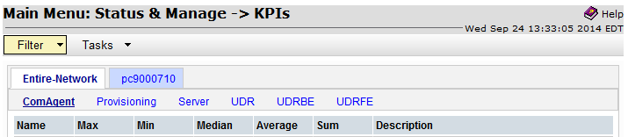

| **ID** | **Name** | **Avg.**  **Interval** | **Description** |
| --- | --- | --- | --- |
| 13000 | RxRasProvConnection | 60 sec | The number of provisioning client connections currently established. A single connection includes a client having successfully established a tcp/ip connection, sent a provisioning connect message, and having received a successful response. |
| 13001 | RxRasProvMsgsReceivedRate | 60 sec | The number of provisioning messages that have been received per second. |
| 13002 | RxRasProvMsgsSuccessfulRate | 60 sec | The number of provisioning messages that have been successfully processed per second. |
| 13003 | RxRasProvMsgsFailedRate | 60 sec | The number of provisioning messages that have failed to be processed due to errors per second. |
| 13004 | RxRasProvMsgsSentRate | 60 sec | The number of provisioning messages sent per second. |
| 13005 | RxRasProvMsgsDiscardedRate | 60 sec | The number of provisioning messages discarded per second. Provisioning messages being discarded is due to the connection being shutdown, server being shutdown, server’s role switching from active to standby, or transaction not becoming durable within the allowed amount of time. |
| 13006 | ProvTxnCommittedRate | 60 sec | The number of provisioning transactions that have been successfully committed per second to the database (memory and on disk) on the active server of the primary UDR cluster. |
| 13007 | TxProvTxnFailedRate | 60 sec | The number of provisioning transactions that have failed to be started or committed, due to errors per second. |
| 13008 | TxProvTxnAbortedRate | 60 sec | The number of provisioning transactions that were aborted due to retry limit per second. |
| 13009 | TxProvTxnNonDurable | 60 sec | The number of transactions that have been committed, but are not yet durable. Responses for the associated requests are not sent until the transaction has become durable. |
| 13026 | RxXsasProvConnection | 60 sec | The number of provisioning client connections currently established. A single connection includes a client having successfully established a tcp/ip connection, sent a provisioning connect message, and having received a successful response. |
| 13027 | RxXsasProvMsgsReceivedRate | 60 sec | The number of provisioning messages that have been received per second. |
| 13028 | RxXsasProvMsgsSuccessfulRate | 60 sec | The number of provisioning messages that have been successfully processed per second. |
| 13029 | RxXsasProvMsgsFailedRate | 60 sec | The number of provisioning messages that have failed to be processed due to errors per second. |
| 13030 | RxXsasProvMsgsSentRate | 60 sec | The number of provisioning messages sent per second. |
| 13031 | RxXsasProvMsgsDiscardedRate | 60 sec | The number of provisioning messages discarded per second. Provisioning messages being discarded is due to the connection being shutdown, server being shutdown, server’s role switching from active to standby, or transaction not becoming durable within the allowed amount of time. |
| 13032 | XsasProvTxnCommittedRate | 60 sec | The number of provisioning SOAP transactions that have been successfully committed per second to the database. |
| 13033 | RxXsasProvTxnTotalRate | 60 sec | The number of provisioning SOAP transactions received per second. |
| 13034 | TxXsasProvTxnFailedRate | 60 sec | The number of provisioning SOAP transactions that have failed to be started or committed, due to errors per second. |
| 13035 | TxXsasProvTxnAbortedRate | 60 sec | The number of provisioning SOAP transactions that were aborted due to retry limit per second. |
| 13051 | ProvMsgsImportedRate | 60 sec | The number of provisioning messages imported per second. |
| 13153 | RxUdrBeReadMsgsRate | 60 sec | The number of read requests (across all interfaces) that have been received per second. |
| 13155 | TxUdrBeReadReqSuccessRate | 60 sec | The number of read requests (across all interfaces) that have been successfully processed per second. |
| 13157 | RxUdrBeUpdateMsgsRate | 60 sec | The number of update requests (across all interfaces) that have been received per second. |
| 13162 | TxUdrBeUpdateReqSuccessRate | 60 sec | The number of update requests (across all interfaces) that have been successfully processed per second. |
| 13181 | RxAeShSnrCreateMsgsRate | 60 sec | Number of subscribe requests received via the Sh interface where the subscriber was unknown and auto-enrollment was triggered to create the subscriber per second |
| 13182 | RxAeShPurCreateMsgsRate | 60 sec | Number of update requests received via the Sh interface where the subscriber was unknown and auto-enrollment was triggered to create the subscriber per second |
| 13183 | RxAeProvCreateMsgsRate | 60 sec | Number of requests received via the provisioning interface where the subscriber was unknown and auto-enrollment was triggered to create the subscriber per second |
| 13184 | RxAeShCreateSubSuccessRate | 60 sec | Number of auto-enrolled subscribers created via the Sh interface per second. |
| 13186 | RxAeProvCreateSubSuccessRate | 60 sec | Number of auto-enrolled subscribers created while provisioning non-profile entity data per second. |
| 13190 | RxAeShDeleteSubMsgs | 60 sec | Number of unsubscribe requests received via the Sh interface that triggered the removal of an auto-enrolled subscriber per second |
| 13191 | RxAeShDeleteSubSuccess | 60 sec | Number of auto-enrolled subscribers deleted via the Sh Interface per second |
| 13252 | RxUdrSmSubscribeMsgsRate | 60 sec | The number of subscribe requests (across all interfaces) that have been received per second. |
| 13255 | TxUdrSmSubscribeReqSuccessRate | 60 sec | The number of subscribe requests (across all interfaces) that have been successfully processed per second. |
| 13257 | RxUdrSmUnsubscribeMsgsRate | 60 sec | The number of unsubscribe requests (across all interfaces) that have been received per second. |
| 13260 | TxUdrSmUnsubscribeReqSuccessRate | 60 sec | The number of unsubscribe requests (across all interfaces) that have been successfully processed per second. |
| 13281 | TxUdrNmNotifSentRate | 60 sec | The number of notification requests (across all interfaces) that have been sent per second. |
| 13287 | RxUdrNmNotifAckAsUnavailableRate | 60 sec | The number of notification requests (across all interfaces) that failed to be sent to the AS per second. |
| 13288 | RxUdrNmNotifAckAsAvailableRate | 60 sec | The number of notification requests (across all interfaces) that have been successfully sent to the AS per second. |
| 13391 | udr.Cpu | 60 sec | CPU usage of udr process |
| 13392 | udr.MemHeap | 60 sec | Heap memory usage of udr process |
| 13393 | udr.MemBasTotal | 60 sec | Memory usage of the udr process |
| 13394 | udr.MemPerTotal | 60 sec | Percent memory usage of udr process |
| 13396 | udrbe.Cpu | 60 sec | CPU usage of udrbe process |
| 13397 | udrbe.MemHeap | 60 sec | Heap memory usage of udrbe process |
| 13398 | udrbe.MemBasTotal | 60 sec | Memory usage of the udrbe process |
| 13399 | udrbe.MemPerTotal | 60 sec | Percent memory usage of udrbe process |
| 13091 | provimport.Cpu | 60 sec | CPU usage of provimport process |
| 13092 | provimport.MemHeap | 60 sec | Heap memory usage of provimport process |
| 13093 | provimport.MemBasTotal | 60 sec | Memory usage of the provimport process |
| 13094 | provimport.MemPerTotal | 60 sec | Percent memory usage of provimport process |
| 13096 | provexport.Cpu | 60 sec | CPU usage of provexport process |
| 13097 | provexport.MemHeap | 60 sec | Heap memory usage of provexport process |
| 13098 | provexport.MemBasTotal | 60 sec | Memory usage of the provexport process |
| 13099 | provexport.MemPerTotal | 60 sec | Percent memory usage of provexport process |
| 13021 | ras.Cpu | 60 sec | CPU usage of ras process |
| 13022 | ras.MemHeap | 60 sec | Heap memory usage of ras process |
| 13023 | ras.MemBasTotal | 60 sec | Memory usage of the ras process |
| 13024 | ras.MemPerTotal | 60 sec | Percent memory usage of ras process |
| 13046 | xsas.Cpu | 60 sec | CPU usage of xsas process |
| 13047 | xsas.MemHeap | 60 sec | Heap memory usage of xsas process |
| 13048 | xsas.MemBasTotal | 60 sec | Memory usage of the xsas process |
| 13049 | xsas.MemPerTotal | 60 sec | Percent memory usage of xsas process |
| 13086 | era.Cpu | 60 sec | CPU usage of era process |
| 13087 | era.MemHeap | 60 sec | Heap memory usage of era process |
| 13088 | era.MemBasTotal | 60 sec | Memory usage of the era process |
| 13089 | era.MemPerTotal | 60 sec | Percent memory usage of era process |
| 13401 | RxRequestAllRate | 60 sec | The number of signaling requests that have been received per second. |
| 13402 | RxRequestSuccessfulRate | 60 sec | The number of signaling requests that have been successfully processed and a Diameter Successful response (2001) was received per second. |
| 13403 | RxRequestFailedRate | 60 sec | The number of signaling requests that have failed to be processed due to errors and an error was returned per second |
| 13404 | TxResponseAllRate | 60 sec | The number of signaling responses sent per second. |
| 13406 | TxRequestAllRate | 60 sec | The number of signaling requests sent per second |
| 13407 | RxResponseAllRate | 60 sec | The number of signaling responses that have been received per second. |
| 13408 | TxRequestSuccessfulAllRate | 60 sec | The number of requests that have received successful responses per second. |
| 13409 | TxRequestFailedAllRate | 60 sec | The number of requests that have not received successful responses per second. |

* 1. **Events**

|  |  |  |  |  |  |
| --- | --- | --- | --- | --- | --- |
| **ID** | **Name/Descr Text** | | **Addl Info** | | **Description** |
| 13010 | RAS Connection Established | | Remote client connection established (CID *Connection ID,* IP*IP Address*) | | This event is generated each time a remote provisioning client has successfully established a REST connection. |
| 13011 | RAS Connection Terminated | | Remote client connection terminated (CID *Connection ID*,IP *IP Address*) | | This event is generated each time a remote provisioning client connection terminates. |
| 13012 | RAS Connection Denied | |  | | This event is generated each time a local or remote provisioning client initiated connection establishment is denied due to 1) connection originating from an unauthorized IP address; 2) maximum number of allowed remote client connections have been reached;. |
| Connection Unauthorized | |
| Too Many Connections | |
|  | |
| 13035 | XSAS Connection Established | | Remote client connection established (CID *Connection ID,* IP*IP Address*) | | This event is generated each time a remote provisioning client has successfully established a SOAP connection. |
| 13036 | XSAS Connection Terminated | | Remote client connection terminated (CID *Connection ID*,IP *IP Address*) | | This event is generated each time a remote provisioning client connection terminates. |
| 13037 | XSAS Connection Denied | |  | | This event is generated each time a local or remote provisioning client initiated connection establishment is denied due to 1) connection originating from an unauthorized IP address; 2) maximum number of allowed remote client connections have been reached; |
| Connection Unauthorized | |
| Too Many Connections | |
|  | |
| 13055 | Import Successful | | See XML Import screen for details. | | This event is generated each time an XML import is successful. |
| 13059 | Export Successful | | See XML Export screen for details. | | This event is generated each time an XML export is successful. |
| 13151 | | AE Sh Create Failed | | Failed to create Auto-Enrolled subscriber via an Sh interface request (Subscriber User Identity *UserIdentity*) | This event is generated each time an attempt to create an auto-enrolled subscriber via an Sh interface request fails. |
| 13152 | | AE Sh Delete Failed | | Failed to delete Auto-Enrolled subscriber via an Sh interface request (Subscriber User Identity *UserIdentity*) | This event is generated each time an attempt to delete an auto-enrolled subscriber via an Sh interface request fails. |
| 13153 | | AE Prov Create Failed | | Failed to create Auto-Enrolled subscriber by provisioning (Subscriber User Identity *UserIdentity*) | This event is generated each time an attempt to create an auto-enrolled subscriber during a provisioning request fails. |
| 13154 | | AE Convert Failed | | Failed to convert Auto-Enrolled subscriber to provisioned (Subscriber User Identity *UserIdentity*) | This event is generated each time an attempt to convert an auto-enrolled subscriber to a provisioned subscriber fails. |
| 13251 | | Subscription Record Full | | Subscription record exceeded maximum number of allowed NSs (Subscriber User Identity *UserIdentity*, SDO ID *SDOID*) | This event is generated each time when adding a new subscription, the subscription record for the subscriber exceeded the maximum number of allowed subscriptions, and caused a subscription(s) to be removed. |
| 13252 | | Notification Late Response | | Notification delivery response received after timeout expired (AS Address *Address*, Subscriber User Identity *UserIdentity*, Response Time *TimeSeconds*) | This event is generated each time a notification delivery response is received after the delivery timeout period had expired. |
| 13253 | | Notification No Valid Entity | | Notification contains no valid entities (AS Address *Address*, Subscriber User Identity *UserIdentity*) | This event is generated each time a notification to be sent does not consists of any valid entities |
| 13351 | | SNO Audit Complete | | The audit report format is defined in **.** FD-218039-SPR-2009 | This event is generated each time an SNO audit completes. Statistics for each pass are given, and are reset for each pass of the audit. |
| 13352 | | SDO Audit Complete | | The audit report format is defined in FD-218039-SPR-2009 | This event is generated each time an SDO audit completes. Statistics for each pass are given, and are reset for each pass of the audit. |
| 13451 | Message Decoding Failure | | - | | Message received was rejected because of a decoding failure  OID value: SprfeMessageDecodingFailure |
| 13452 | Unknown Command Code | | - | | 1) Message could not be routed because the Diameter Command Code in the ingress request message is not supported and the Routing Exception was configured to send an Answer response.  2) Response could not be sent because the Diameter Command Code in the response message is not supported.  OID value: SprfeUnknownCommandCode |
| 13453 | ComAgent Error | | - | | This event occurs each time when UDRFE application receives a ComAgent Error (timeout, congestion or queue full) for the sent SprEvent.  OID value: SprfeComAgentErrorComAgentComAgent |
| 13456 | Invalid Service Indication | | - | | Message received from a peer that was rejected because no register id could be mapped due to service indication received in request is not supported by SPR application.  OID value: SprfeInvalidServiceIndication |
| 13457 | Orphan Response Event Received from UDRBE | | - | | A response event was received from UDRBE for which no pending request transaction existed resulting in the response event being discarded.  OID value: SprfeOrphanResponseEventRcvdFromUdrbe |
| 13458 | Orphan Response Received from peer | | - | | An Answer message was received from peer for whom no pending request transaction existed resulting in the Answer message being discarded.  OID value: SprfeOrphanResponseRcvdFromPeer |
| 13459 | Sending Client Invalid | | - | | This event is generated each time a client sends a request that it is not permitted to send. This could be because a) the AS was not present in the Subscribing Client Permissions Table; b) the AS was present in the Subscribing Client Permissions Table, but was not authorized to send the Sh Operation (PNR, SNR or UDR); c) The DataReference value supplied was not 0 (i.e. RepositoryData).  OID value: SprfeSendingClientInvalid |
| 13460 | Client Not Subscribed | | - | | This event is generated each time a PNR is sent to an AS, and the AS responds with a PNA indicating that it was not subscribed to receive notifications for the subscriber to which it was notified.  OID Value: SprfeClientNotSubscribed |
| 13461 | Invalid Parameter Value | | - | | This event is generated each time an AS sends PUR, SNR, or UDR that contains a parameter that fails application validation.  OID Value: SprfeInvalidParameterValue |
| 13462 | PNR Create Failed | | - | | This event is generated each time a PNR request fails to be created.  OID Value: SprfePnrCreateFailed |
| 13463 | Diameter Application Enabled | | - | | Diameter’s Application’s Admin State was changed to ‘enabled’.  OID Value: DiameterAppEnabled |
| 13464 | Diameter Application Disabled | | - | | Diameter’s Application’s Admin State was changed to ‘disabled’. |

1. **Reference List**

**OCUDR 10.0 User Guides (see customer documentation)**

<http://docs.oracle.com/cd/E58598_01/index.htm>

* *OCUDR 10.0 Release Notice*
* *Operation, Administration, and Maintenance User’s Guide*
* *Communication Agent User’s Guide*
* *Diameter Common User’s Guide*
* *Diameter User Guide*
* *Enhanced Subscriber Profile Repository User’s Guide*
* *Alarms,KPI’s and Measurements Reference*
* *SOAP Provisioning Interface Reference*
* *REST Provisioning Interface Reference*
* *Import / Export File Interface Reference*
* *Network Interconnect Reference*
* *Hardware Documentation Roadmap Reference*
* *Related Publications Reference*

***OCUDR Installation and Disaster Recovery***

* *UDR Installation and Configuration Procedure*

*Disaster Recovery Guide*