

**Oracle® COMMUNICATIONS**

Diameter Signaling Router   
DSR Network Impact Report

Release 8.1

E80120-01

July 2017

Oracle Diameter Signaling Router DSR Network Impact Report, Release 8.1

Copyright © 2017 Oracle and/or its affiliates. All rights reserved.

This software and related documentation are provided under a license agreement containing restrictions on use and disclosure and are protected by intellectual property laws. Except as expressly permitted in your license agreement or allowed by law, you may not use, copy, reproduce, translate, broadcast, modify, license, transmit, distribute, exhibit, perform, publish, or display any part, in any form, or by any means. Reverse engineering, disassembly, or decompilation of this software, unless required by law for interoperability, is prohibited.

The information contained herein is subject to change without notice and is not warranted to be error-free. If you find any errors, please report them to us in writing.

If this is software or related documentation that is delivered to the U.S. Government or anyone licensing it on behalf of the U.S. Government, the following notice is applicable:

U.S. GOVERNMENT END USERS: Oracle programs, including any operating system, integrated software, any programs installed on the hardware, and/or documentation, delivered to U.S. Government end users are "commercial computer software" pursuant to the applicable Federal Acquisition Regulation and agency-specific supplemental regulations. As such, use, duplication, disclosure, modification, and adaptation of the programs, including any operating system, integrated software, any programs installed on the hardware, and/or documentation, shall be subject to license terms and license restrictions applicable to the programs. No other rights are granted to the U.S. Government.

This software or hardware is developed for general use in a variety of information management applications. It is not developed or intended for use in any inherently dangerous applications, including applications that may create a risk of personal injury. If you use this software or hardware in dangerous applications, then you shall be responsible to take all appropriate fail-safe, backup, redundancy, and other measures to ensure its safe use. Oracle Corporation and its affiliates disclaim any liability for any damages caused by use of this software or hardware in dangerous applications.

Oracle and Java are registered trademarks of Oracle and/or its affiliates. Other names may be trademarks of their respective owners.

Intel and Intel Xeon are trademarks or registered trademarks of Intel Corporation. All SPARC trademarks are used under license and are trademarks or registered trademarks of SPARC International, Inc. AMD, Opteron, the AMD logo, and the AMD Opteron logo are trademarks or registered trademarks of Advanced Micro Devices. UNIX is a registered trademark of The Open Group.

This software or hardware and documentation may provide access to or information on content, products, and services from third parties. Oracle Corporation and its affiliates are not responsible for and expressly disclaim all warranties of any kind with respect to third-party content, products, and services. Oracle Corporation and its affiliates will not be responsible for any loss, costs, or damages incurred due to your access to or use of third-party content, products, or services except as set forth in an applicable agreement between you and Oracle.

**TABLE OF CONTENTS**

Oracle® COMMUNICATIONS 1

Diameter Signaling Router DSR Network Impact Report 1

1.0 Introduction 6

1.1 Purpose/Scope 6

1.2 Compatibility 6

1.3 Disclaimers 6

2.0 Overview of DSR 8.1 Features 7

2.1 enhancements to DSR 8.1 functionality by category 8

2.2 Accessibility 9

2.3 Automatic Site Upgrade Enhancements for DSR and SDS 9

2.4 Diameter Answer message back from different connections 9

2.5 DRMP and 16 Priorities 10

2.6 DSR Route Group Measurements 10

2.7 Feature MMI Updates 11

2.8 Gen9 V2 Performance Enhancements 11

2.9 SDS Add Functionality 12

2.10 Support for 64 Mediation Template 12

2.11 Virtual Signaling Transfer Point (vSTP) 13

2.21 hardware Changes 14

2.22 software Changes 14

2.23 firmware Changes 15

2.24 upgrade Overview 16

2.25 migration of DSR Data 17

3.0 Feature OAM Changes 18

3.1 Accessibility 18

3.2 Automatic Site Upgrade Enhancements for DSR and SDS 21

3.3 Diameter Answer message back from different connections 22

3.4 Diameter Routing Message Priority (DRMP) and 16 Priorities 23

3.5 DSR Route Group Measurements 25

3.6 Feature machine-to-machine (MMI) Updates 27

3.7 Gen9 V2 Performance Enhancements 29

4.0 MEAL INSERTS 32

This section will summarize the changes to Alarms, Measurements, KPIs and MIBs. In the following inserts pertain to a DSR release 8.1 MEAL Snapshot and deltas to earlier releases 7.0.1, 7.1, 7.1.1, 7.2, 7.3 & 8.0 . 32

The DSR 8.1 GA Release is dsr-8.1.0.0.0-81.20.0 32

4.1 DSR/SDS 8.1 MEAL Snapshot 32

4.2 Meal Deltas (8.0) 32

4.3 Meal Deltas (7.3) 32

4.4 Meal Deltas (7.2) 32

4.5 Meal Deltas (7.1.1) 32

4.6 Meal Deltas (7.1) 32

4.7 Meal Deltas (DSR 7.0.1, SDS 5.0.1) 33

5.0 reference list 34

***Figure 1 – DSR Upgrade Paths*** 16

***Figure 2 – SDS Upgrade Paths*** 16

***Figure 3 – IDIH Upgrade Paths*** 17

***Figure 4 – Alarm Banner Change*** 18

***Figure 5 – Pre-Release 8.1 ComAgent Remote Server Screen*** 19

***Figure 6 – Release 8.1 ComAgent Remote Server Screen*** 20

***Figure 7 – SDS Auto Site Upgrade Screen*** 21

***Figure 8 – Peer Node Answer On Any Connection Configuration*** 22

***Figure 9 – Set “Answer Priority Mode” and/or enable “16 Priority Admin State”*** 23

***Figure 10 – Configure system-wide “Enhanced Overload Control Function” for PCA*** 24

***Figure 11 – PCA Configure System Option “ETG Mode” for Egress Throttle Groups.*** 24

***Figure 12 – Configure DSR Route Group Measurements*** 25

***Figure 13 – MMI API Guide Location on DSR GUI*** 28

***Figure 14 – Gen9V2 MP Profile Configuration*** 29

***Figure 15 – vSTP Server Group Screen*** 31

**LIST OF TERMS**

ASGU …………………….Automated Server Group Upgrade

ASU ……………………….Automated Site Upgrade

AVP ………………………Attribute Value Pair

CLI ………………………..Command Line Interface

DRMP ……………………Diameter Routing Message Priority

GUI ……………………….Graphical User Interface

HSS .....................................Home Subscriber Server

iLO ………………………..Integrated Lights Out

IMI ......................................Internal Management Interface

IOT ………………………..Interoperability Tests

KPI ………………………..Key Performance Indicator

LTE ……………………….Long Term Evolution

MEAL..................................Measurements, Events, Alarms, and Logging

MME ……………………...Mobility Management Entity

MMI ……………………...Man Machine Interface

MP.......................................Message Processor

MPS ………………………Messages per Second

NE ………………………...Network Element

NMS ………………………Network Management System

OAG………………………Oracle Accessibility Guidelines

OAM……………………...Operations, Administration, Maintenance

OAM&P .............................Operations, Administration, Maintenance and Provisioning

PDRA ……………………..Policy Diameter Relay Agent

PCRF ……………………..DSR Control and Charging Rules Function

PCIMC.................................Per Connection Ingress Message Control

PDU ………………………Protocol Data Unit

PM&C …………………….Platform, Management and Control

PS………………………….Priority Service (NGN-PS)

ROS ……………………….Routing Option Set

TPD ……………………….ORACLE Platform Distribution

VIP ......................................Virtual IP Address

VSTP ......................................Virtual SS7 Signal Transfer Point

XMI......................................External Management Interface

XSI.......................................External Signaling Interface

# Introduction

## Purpose/Scope

Purpose of this document is to highlight the changes of the product that may have impact on the customer network operations, and should be considered by the customer during planning for this release.

## Compatibility

### Product Compatibility

DSR 8.1 is compatible with IDIH 7.0, 7.1, 7.2, 7.3, 7.4 and 8.0

DSR 8.1 is compatible with SDS 5.0.1, 7.1, 7.2, 7.3, 7.4 and 8.0

DSR 8.1 is compatible with Platform 7.4

## Disclaimers

This document summarizes Release 8.1 new and enhancement features as compared to Release 8.0, and the operations impacts of these features, at a high level. The Feature Requirements (FRS) documents remain the defining source for the expected behavior of these features.

*Note that feature implementations may change slightly during product test.*

# Overview of DSR 8.1 Features

This section provides a high-level overview of the DSR 8.1 release features that may impact OAM interfaces and activities.

For a list of all features, please see Release Notes for DSR 8.1 found at the following link:

**<http://docs.oracle.com/en/industries/communications/diameter-signaling-router/index.html>**

For additional details of the various features, please refer to the “DSR 8.1 Feature Guide” found at the following link:

[**http://docs.oracle.com/en/industries/communications/diameter-signaling-router/index.html**](http://docs.oracle.com/en/industries/communications/diameter-signaling-router/index.html)

**NOTE**: Upon completion of an upgrade of a pre 6.2 release PM&C to any release 6.2 or later, the GUI administrative user formerly known as "pmacadmin" will become "guiadmin". This is only a renaming of the standard administrative account, not a different account; the account access privileges will be retained from the “pmacadmin” account.



## enhancements to DSR 8.1 functionality by category

Note: For information on upgrade planning and required steps before upgrade, please refer to the DSR 8.1 Software Upgrade Guide on the public Oracle Documentation Site:

Docs.oracle.com → Industries → Oracle Communications documentation → Diameter Signaling Router → Release 8.1.

Table 1 DSR 8.1 New Features/Enhancements

|  |
| --- |
| **DSR 8.1 Feature/Enhancement Name** |
|
| AccessibilityDCA |
| Automatic Site Upgrade Enhancements for DSR and SDS |
| Diameter Answer message back from different connections |
| Diameter Routing Message Priority(DRMP) and 16 PrioritiesMMIs |
| DSR Route Group MeasurementsAutomated Site Upgrade |
| Feature MMI UpdatesOracle VM Cloud Support |
| Gen9 V2 Performance EnhancementsFirewall Feature |
| SDS Add FunctionalityIndependent SBR DB Support for DCA |
| Support for 64 Mediation Template16 Signaling VLAN Support & VE-DSR Automated VM Creation |
| Virtual Signaling Transfer Point (vSTP) |
|  |

## [Accessibility](#_2.2_Diameter_custom)

This feature standardizes the software and documentation to meet Oracle Accessibility Guidelines (OAG) 3.0, which meet revised U.S. Section 508 standards.

|  |  |  |
| --- | --- | --- |
| Name | Description | Scope |
| PR 24817837  DSR Accessibility support in DSR 8.1 | This feature continues to standardize the DSR GUI to conform to Oracle Accessibility Guidelines (OAG) | Enhancement Request |

## Automatic Site Upgrade Enhancements for DSR and SDS

This feature facilitates a common upgrade procedure if the different server groups have a common configuration function.

|  |  |  |
| --- | --- | --- |
| Name | Description | Scope |
| PR 25346698  Auto Site Upgrade not showing SDS SO servers | This feature defines automates upgrade software and facilitates automated site upgrade procedures improving speed and reliability. It now facilitates a common upgrade procedure if the different server groups have a common configuration function. | Bug fix |

## Diameter Answer message back from different connections

DSR will support Answer messages back from any connection of the same upstream peer.

|  |  |  |
| --- | --- | --- |
| Name | Description | Scope |
| PR 21072456  Support Answer message back from different connections | This feature shall allow the DSR to process an Ingress Answer message received from a connection to an upstream Peer which is different than the connection used to send the egress Diameter Request for a given Transaction. | Enhancement Request |

## 

## DRMP and 16 Priorities

DSR will comply with IETF DRMP standard specification and use DRMP based message priority for congestion control throttling decisions

|  |  |  |
| --- | --- | --- |
| Name | Description | Scope |
| PR 21770404  IETF DRMP Standard Implementation | This feature enhances the DSR to comply with IETF DRMP standard specification and use DRMP based message priority for congestion control throttling decisions.  IETF Diameter Message Routing Priority (DRMP) standard provides a mechanism to allow Diameter endpoints to indicate the relative priority of Diameter transactions.  With this information Diameter nodes can factor that priority into routing, resource allocation and overload abatement decisions. | Enhancement Request |

## DSR Route Group Measurements

DSR will enhance traffic monitoring by introducing new measurements per Route Group basis

|  |  |  |
| --- | --- | --- |
| Name | Description | Scope |
| PR 19091550  DSR Route Group Measurements | Enhance the traffic monitoring by introducing new measurements per Route Group basis.  No measurable performance impact (measurement collection and report generation) on the DSR.  The enhanced measurements for traffic monitoring on per Route Group shall be limited to 250 Route Groups.  Selection of traffic monitoring (Route Group Measurement) per Route Group basis shall be configurable by OAM GUI/MMI. | Enhancement Request |

## 

## Feature MMI Updates

DSR will support a RESTful machine-to-machine interface to support OAM requests from external clients either Oracle provided or from 3rd parties.

|  |  |  |
| --- | --- | --- |
| Name | Description | Scope |
| Machine to Machine Interface Updates | These features continue to enhance/grow the capabilities of the MMI (Machine to Machine Interface) feature introduced in DSR Release 8.0.   * Feature : Answer on Any Connection - Answer on Any Connection MMI Changes * Feature : Route Group Measurement - Route Group Measurement MMI Changes * Feature : DRMP MMI Updates - DRMP MMI Changes * API Versioning * MMI API Guide now included VIA the DSR GUI. | Enhancement Request |

## Gen9 V2 Performance Enhancements

DSR will support profiles to take advantage of additional performance of the HP Gen9 v2 blade servers..

|  |  |  |
| --- | --- | --- |
| Name | Description | Scope |
| PR 25489304  DA-MP profiles for Gen9v2 blades And System Capacity Enhancement | This feature provides new MP profiles to take advantage of the increase performance if the HP Gen9 v2 blade servers.  DA-MP Per Blade MPS Capacity will be:   * Relay = 120K * Database = 100K * Session = 100K | Enhancement Request |

## 

## SDS Add Functionality

The SDS will only add subscriber to subscriber table if account id, MSISDN and IMSIs are not already in subscriber table

|  |  |  |
| --- | --- | --- |
| Name | Description | Scope |
| PR 19727484  SDS Subscriber Table Add function | This feature creates an Insert function for SDS subscriber table SOAP/XML provisioning. This function will only insert a subscriber to subscriber table if IMSI and MSISDN are not already present in the SDS database. If already present in SDS database insert will fail and report the condition which caused the failure. | Enhancement Request |

## Support for 64 Mediation Template

The number of Mediation Templates supported by DSR has been increased from 15 to 64.

|  |  |  |
| --- | --- | --- |
| Name | Description | Scope |
| PR 25203499  Increase mediation templates in DSR to 64 | This feature implements the following:   * The maximum number of “Active" Templates has been increased from 15 to 64. * The maximum number of “Test” Templates shall remain at 10. * The maximum number of Active Templates that can be associated with all the Trigger Points has been increased from 15 to 64. * The maximum number of provisioned rules in the system has been increased from 50000 [(15 Active Templates + 10 Test Templates)*2000 rules per template] to 148000 [(64 Active Templates + 10 Test Templates)*2000 rules per template]. | Enhancement Request |

## Virtual Signaling Transfer Point (vSTP)

The DSR release introduces a virtual Signaling Transfer Point on KVM/OpenStack (Lab Only)

|  |  |  |
| --- | --- | --- |
| Name | Description | Scope |
| **Virtual Signaling Transfer Point** (**vSTP**) | This feature introduces Signaling Transfer Point (STP) software which can be deployed on Virtual Machines.  The initial release of vSTP provides supports for one vSTP VM per node and is only offered on KVM/OpenStack.  Please see Customer Known Report in the DSR 8.1 Release Notes for any additional limitations of this feature.” | Enhancement Request |



## hardware Changes

* + 1. **Hardware Supported**

|  |  |
| --- | --- |
| **Hardware** | **Comment** |
| HP BL460c Gen8, Gen8_v2 | c-Class |
| HP BL460c Gen9, Gen9_v2 | c-Class |
| HP DL360/380 Gen8, Gen8_v2 | Rack Mount Server |
| HP DL380 Gen9, Gen9_v2 | Rack Mount Server |
| Oracle Server X5-2 | Rack Mount Server |
| Netra X5-2 | Rack Mount Server |
| HP 6125XLG, 6125G, 6120XG | Enclosure Switch |
| Cisco 3020 | Enclosure Switch |
| Cisco 4948E-F | Rack Switch |
| Cisco 4948E | Rack Switch |

Note: Gen9, Gen9 v2 and Gen 8 v2 hardware are also supported, when purchased by a customer.

Note: mixed Sun/HP deployments are not generally supported.

* + 1. **Hardware Upgrade**

Due to the enhanced processing capabilities and requirements of DSR Release 8.1, HP Gen6 and Gen7 hardware are NOT supported. All Gen6 and Gen7 servers must be replaced with supported hardware before upgrading to release 8.1. Deployment of certain Optional features may require additional hardware.

## software Changes

Software changes include a new release of the software Platform components, and new DSR release.

|  |  |
| --- | --- |
| Component | Release |
| TPD 64 Bit | 7.4.0.0.0-88.37.0 |
| COMCOL | 7.3.0.42.0-13585 |
| PM&C | 6.4.0.0.0-64.8.0 |
| TVOE | 3.4.0.0.0-88.37.0 |
| AppWorks | 8.1.0-81.13.0 |
| EXGSTACK | 8.1.0-81.22.0 |
| HP Firmware FUP | 2.2.11 (Minimum[1]) |
| Oracle Firmware | 3.1.7 (Minimum[2]) |

* + 1. **DSR Release 8.1**

DSR Release 8.1 inherits all functionality from DSR 8.0

|  |  |
| --- | --- |
| Component | Release |
| DSR Release | 8.1 |

DSR 8.1 is compatible with Platform 7.4

* + 1. **iDIH 8.1**

|  |  |
| --- | --- |
| Component | Release |
| IDH Release | 8.1 |

DSR 8.1s compatible with IDIH 7.0, 7.1, 7.2, 7.3., 7.4 and 8.0

* + 1. **SDS 8.1**

|  |  |
| --- | --- |
| Component | Release |
| SDS Release | 8.1 |

DSR 8.1 is compatible with SDS 5.0.1, 7.1, 7.2, 7.3, 7.4 and 8.0

**NOTE:** It is recommended for SDS to be upgraded before the DSR. SDS release 8.1 is compatible with DSR releases 7.0.1, 7.1, 7.2, 7.3, 7.4, 8.0 and 8.1.

## firmware Changes

Firmware release guidance is provided via DSR 8.1 Release Notice which can be found at the following link:

<http://docs.oracle.com/en/industries/communications/diameter-signaling-router/index.html>

and then navigating to the Release 8.1.x link.

## upgrade Overview

This section provides an overview of the Upgrade activities for Release 8.1.

* + 1. **DSR Upgrade Path**

The supported upgrade paths for DSR 8.1 are:

**7.0.1**

**7.1**

**7.2**

**7.3**

**7.4**

**8.0**

**8.1**

**All**

**All**

**All**

**All**

**All**

**All**

***All in the figure above refers to the available releases and all of its maintenance releases***

***Figure 1 – DSR Upgrade Paths***

.

* + 1. **The supported upgrade paths for SDS 8.1 are:**

**5.0.1**

**7.1**

**7.2**

**7.3**

**7.4**

**8.0**

**8.1**

**All**

**All**

**All**

**All**

**All**

**All**

***All in the figure above refers to the available releases and all of its maintenance releases***

***Figure 2 – SDS Upgrade Paths***

Recommendation is to upgrade SDS prior to DSR upgrades. iDIH upgrade can be scheduled prior to or following the DSR upgrade. If iDIH upgrade is deferred until after DSR upgrades then any newly captured elements existing within the upgraded DSR will not be decoded by iDIH until after the iDIH upgrade.

* + 1. **The supported upgrade paths for iDIH 8.1 are:**

**7.0**

**7.1**

**7.2**

**7.3**

**7.4**

**8.0**

**8.1**

**All**

**All**

**All**

**All**

**All**

**All**

***All in the figure above refers to the available releases and all of its maintenance releases***

***Figure 3 – IDIH Upgrade Paths***

Recommendation is to upgrade SDS prior to DSR upgrades. iDIH upgrade can be scheduled prior to or following the DSR upgrade. If iDIH upgrade is deferred until after DSR upgrades then any newly captured elements existing within the upgraded DSR will not be decoded by iDIH until after the iDIH upgrade.

* + 1. **Upgrade Execution**

With DSR 8.1, there are multiple methods available for upgrading a site. The newest and most efficient way to upgrade a site is the Automated Site Upgrade feature. As the name implies, this feature will upgrade an entire site (SOAMs and all C-level servers) with a minimum of user interaction. Once the upgrade is initiated, the upgrade will automatically prepare the server(s), perform the upgrade, and then sequence to the next server or group of servers until all servers in the site are upgraded. The server upgrades are sequenced in a manner that preserves data integrity and processing capacity. Auto Site Upgrade (ASU) was introduced in Release 8.0 for DSR, but not fully supported for SDS. Release 8.1 now delivers Auto Site Upgrade for the SDS.

Automated Site Upgrade can be used to upgrade the DSR/SDS servers. However, Auto Site Upgrade cannot be used to upgrade PMAC, TVOE, or IDIH servers at a site.

Additionally, there are separate procedures described in the upgrade procedures to support either a manual or automated approach to upgrading any particular server group. When planning upgrades the “Site Upgrade Methodology Selection” section of the upgrade procedure should be carefully reviewed. ***The use of the automated methods (Auto Site or Auto Server Group) for DA-MP server groups should be carefully considered regarding potential negative traffic impacts***. If there are any traffic flows which are limited to a sub-set of DA-MP’s then it is recommended to use the manual upgrade procedures.

* + 1. **Active/Standby DA-MP Redundancy Model supported**

Active/Standby DA-MP server architecture (1+1) continues to be supported in DSR 8.1.

Migration to Multi-active (N+0) DA-MP server architecture is recommended for all customers, and required for activating PDRA functionality.

## migration of DSR Data

As in prior releases, the existing DSR Data will be preserved during the upgrade.

# Feature OAM Changes

At the time of upgrade to DSR 8.1, a number of features and enhancements will become visible on the interfaces to the DSR and may change certain existing OAM behaviors of the system.

OAM changes include: User Interfaces (NO GUI, SO GUI), Measurements Reports, Alarms, and KPIs.

Note: this section covers OAM changes that will be visible after upgrade to the 8.0 release, and does not include changes that will be seen only as new Optional Features are activated on the system (post-upgrade activity, and customer specific).

## Accessibility

#### Description

This feature continues to standardize the DSR software and documentation to meet Oracle Accessibility Guidelines (OAG) 3.0, which meet revised U.S. Section 508 standards.

Release 8.1 delivers two (2) changes noticeable to the end user. The first being the alarm banner located at the bottom right of the GUI screen, has been modified in that the banner is slightly larger and the colors have been altered to align with the Accessibility standards.

#### Alarm and Event Changes

* N/A

#### GUI Changes

* The graphic below shows the larger 8.1 banner on the left and the pre 8.1 banner on the right:

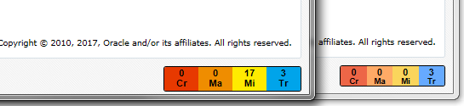

***Figure 4 – Alarm Banner Change***

.

* The second GUI change that will be noticeable to the end user is the Communication Agent 🡪 Configuration 🡪Remote Servers screen. This screen has been modified as shown below. The functionality remains the same only the appearance has been changed. Figure 5 shown below, displays how the ComAgent screen appeared prior to DSR 8.1while Figure 6 displays the updated screen release in DSR 8.1.

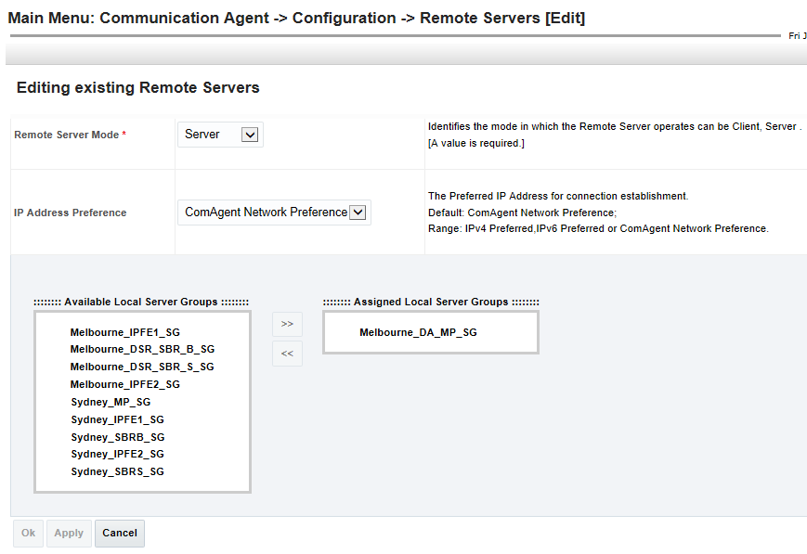

***Figure 5 – Pre-Release 8.1 ComAgent Remote Server Screen***

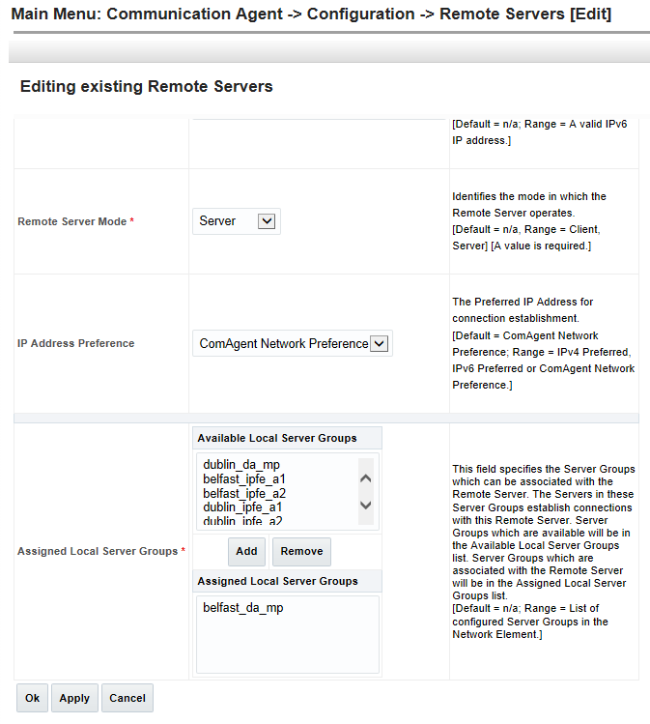

***Figure 6 – Release 8.1 ComAgent Remote Server Screen***

## Automatic Site Upgrade Enhancements for DSR and SDS

* + 1. Description
* Auto Site Upgrade was only partially supported for SDS in release 8.0. Release 8.1 now delivers the same fully automated Site Upgrade functionality for SDS as was delivered in 8.0 for DSR. With Automated Site Upgrade (ASU) an entire DSR/SDS site upgrade (SOAMs and C-level servers) can be initiated with just a few initial selections. Once ASU is initiated, automation will handle the preparation and sequencing of all remaining SOAMs and C-level servers improving speed and reliability. ***Figure 7*** illustrates the screen displayed to the user when Auto Site Upgrade is selected for a SDS Site in Release 8.1.
* Release 8.1 introduces Auto Site Upgrade support for Active/Standby DA-MP configuration.

#### Alarm and Event Changes

* N/A

#### GUI Changes

* The graphic below displays the SDS Site Upgrade Screen along with the server that will be upgraded in each of the four automates cycles.

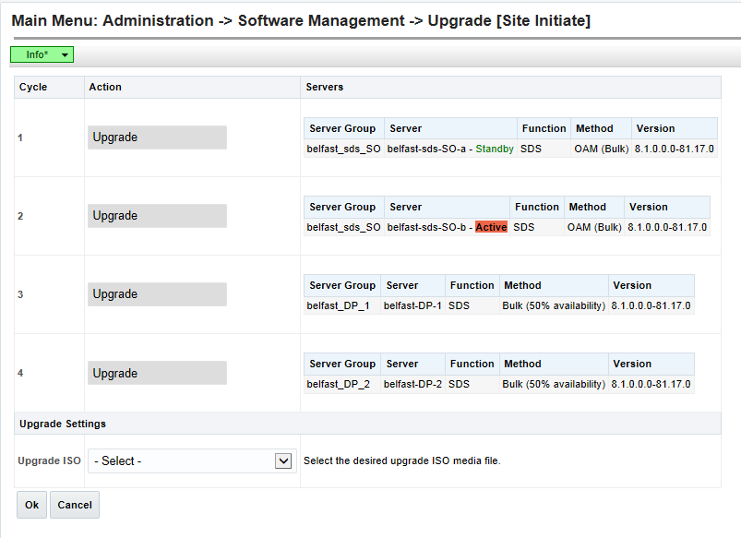

***Figure 7 – SDS Auto Site Upgrade Screen***

## Diameter Answer message back from different connections

* + 1. Description
* This feature allows the DSR to process an Ingress Answer message received from a connection (to an upstream Peer) which is different than the connection used to send the egress Diameter Request for a given Transaction.
* This feature is only applicable for Ingress Answer messages received from an upstream peer. There is no change in routing the Answer message back to the downstream peer, i.e. DSR will use the same connection to send the egress Answer message to the downstream Peer on which the original Diameter request was received.
* DSR shall provide Peer Node level configuration parameter to enable/disable this feature at run-time.
* ***Figure 8*** displays the Peer Nodes screen used to enable/disable this configuration.
* The default post upgrade state shows ‘*answeronAnyConnectionEnabled*’ disabled for all configured peers.

#### Alarm and Event Changes

* N/A

#### GUI Changes

* The graphic below displays the updated Peer Nodes screen with the “Answer On Any Connection” checkbox.

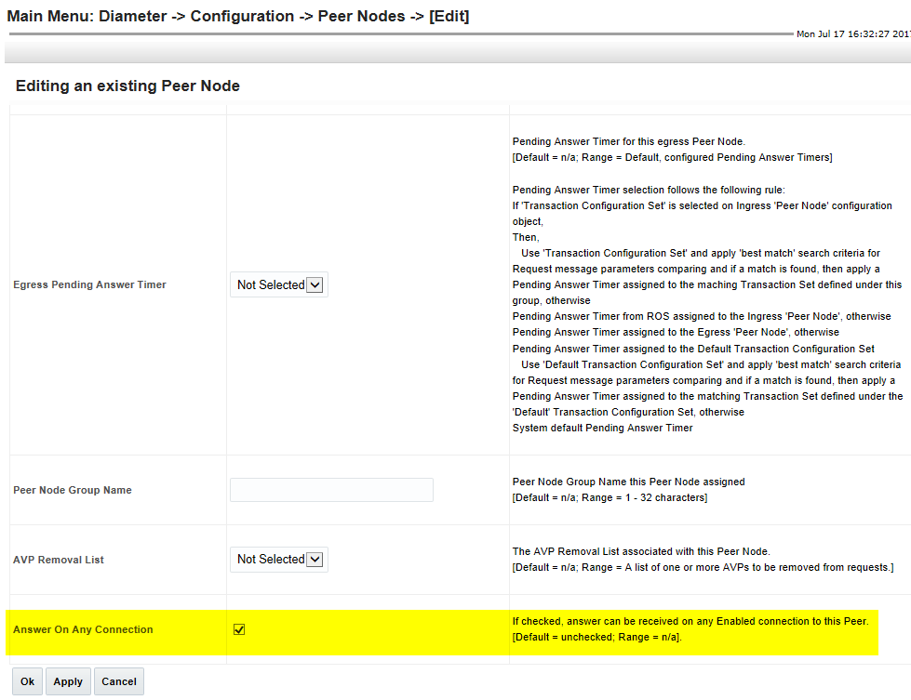

***Figure 8 – Peer Node Answer On Any Connection Configuration***

## Diameter Routing Message Priority (DRMP) and 16 Priorities

* + 1. Description

The DRMP feature introduces:

* Mechanism to allow Diameter endpoints to indicate the relative priority of Diameter transactions using a Diameter AVP (AVP code 301).
* Message priority used in routing, resource allocation and overload abatement decision
* Message priorities are assigned based on Diameter Transactions.
* Answer message can optionally contain a DRMP AVP which assigns priority; otherwise Answer priority is same as Request.
* Priority assigned in DRMP AVP has P0 with highest priority and P15 as lowest.

**Note**: DSR uses the priorities with 0 as lowest and 15 as highest. For DRMP messages, DSR derives the priority value as follows:

DSR message priority = (15 – DRMP AVP Value)

* Specified in [RFC 7944](https://tools.ietf.org/html/rfc7944) - Diameter Routing Message Priority

***NOTE: All SDS systems serving DSR Sites must first be upgraded to 8.1 prior to enabling the DRMP feature on DSR sites.***

#### Alarm and Event Changes

* New alarms 8016, 8017, 8018, 8019 are defined

#### GUI Changes

* + - 1. Set “Answer Priority Mode” and/or enable “16 Priority Admin State” in SOAM GUI:

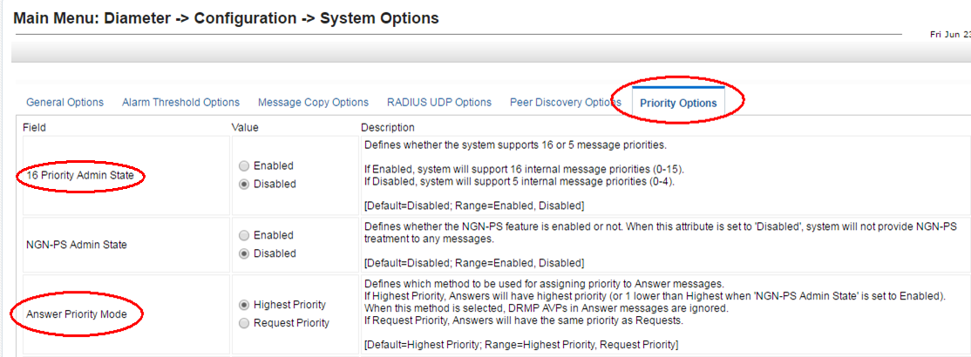

***Figure 9 – Set “Answer Priority Mode” and/or enable “16 Priority Admin State”***

* + - 1. Configure system-wide “Enhanced Overload Control Function” for PCA

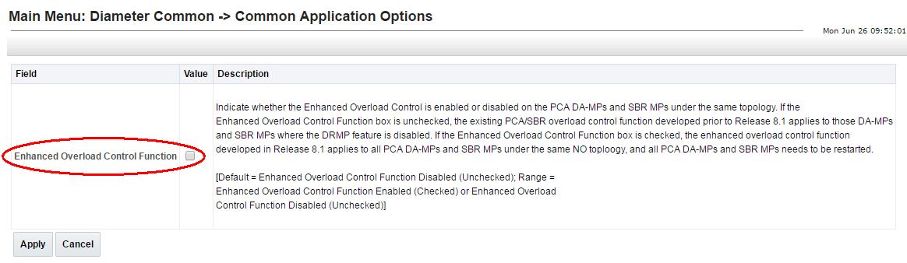

***Figure 10 – Configure system-wide “Enhanced Overload Control Function” for PCA***

* + - 1. Configure System Option “ETG Mode” for Egress Throttle Groups.
* Options are ‘Threshold’ and ‘Limit’.

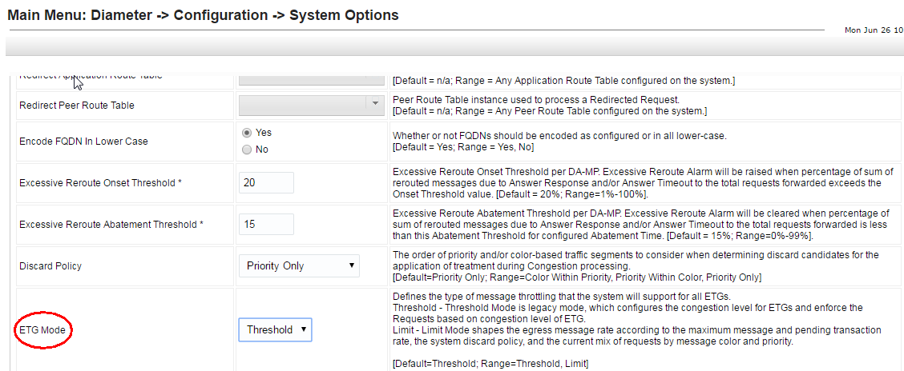

***Figure 11 – PCA Configure System Option “ETG Mode” for Egress Throttle Groups.***

## DSR Route Group Measurements

* + 1. Description

The Route Group Measurements feature adds traffic measurements per Route Group for additional traffic monitoring.

* Support for the following ‘per Route Group’ measurements
  + Number of Request messages send with Priority-0 to Priority-15.
  + Number of Answer messages received with Result-Code 2xxx & non-2xxx.
  + Route Group selected as Primary Route Group within a Route List
  + Route Group was selected for routing a Request message due to Route Group overflow routing
  + Average Upstream transaction response time
  + Route Group was selected for routing a Request message but no egress connection candidates were found
  + Number of Answer time-outs

#### Alarm and Event Changes

* N/A

#### GUI Changes

* + 1. Configuration

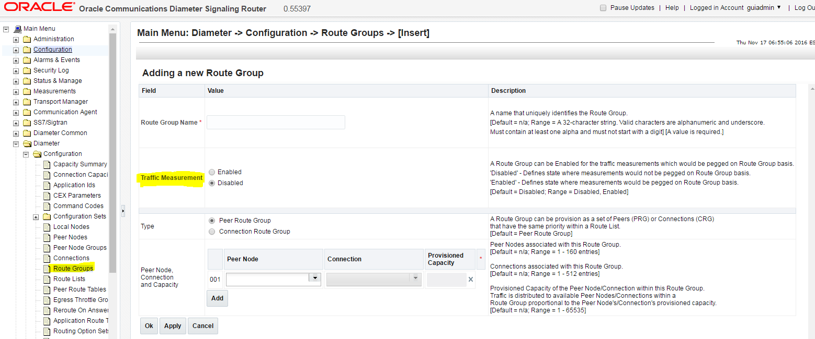

***Figure 12 – Configure DSR Route Group Measurements***

* + 1. Measurements Added

|  |  |  |  |
| --- | --- | --- | --- |
| Number | Name | Interval | Description |
| 14463 | RouteGrpTxReqPri0 | 5min | Number of Request messages sent with Priority-0. |
| 14464 | RouteGrpTxReqPri1 | 5min | Number of Request messages sent with Priority-1. |
| 14465 | RouteGrpTxReqPri2 | 5min | Number of Request messages sent with Priority-2. |
| 14466 | RouteGrpTxReqPri3 | 5min | Number of Request messages sent with Priority-3. |
| 14467 | RouteGrpTxReqPri4 | 5min | Number of Request messages sent with Priority-4. |
| 14468 | RouteGrpTxReqPri5 | 5min | Number of Request messages sent with Priority-5. |
| 14469 | RouteGrpTxReqPri6 | 5min | Number of Request messages sent with Priority-6. |
| 14470 | RouteGrpTxReqPri7 | 5min | Number of Request messages sent with Priority-7. |
| 14471 | RouteGrpTxReqPri8 | 5min | Number of Request messages sent with Priority-8. |
| 14472 | RouteGrpTxReqPri9 | 5min | Number of Request messages sent with Priority-9. |
| 14473 | RouteGrpTxReqPri10 | 5min | Number of Request messages sent with Priority-10. |
| 14474 | RouteGrpTxReqPri11 | 5min | Number of Request messages sent with Priority-11. |
| 14475 | RouteGrpTxReqPri12 | 5min | Number of Request messages sent with Priority-12. |
| 14476 | RouteGrpTxReqPri13 | 5min | Number of Request messages sent with Priority-13. |
| 14477 | RouteGrpTxReqPri14 | 5min | Number of Request messages sent with Priority-14. |
| 14478 | RouteGrpTxReqPri15 | 5min | Number of Request messages sent with Priority-15. |
| 14479 | RouteGrpRxAns2xxx | 5min | Number of Answer messages received with Result-Code 2xxx. |
| 14480 | RouteGrpRxAnsNon2xxx | 5min | Number of Answer messages received with Result-Code non-2xxx. |
| 14481 | RouteGrpSelectedPrimaryWithinRL | 5min | Number of times Route Group was selected as the Primary Route Group within a Route List. |
| 14482 | RouteGrpSelectedNonPrimaryWithinRL | 5min | Number of times Route Group was selected for routing a Request message due to Route Group overflow routing. |
| 14483 | RouteGrpTmResponseTimeUpstream | 5min | Average Upstream transaction response time. |
| 14484 | RouteGrpSelectedNoEgressConnFound | 5min | Number of times Route Group was selected for routing a Request message but no egress connection candidates were found. |
| 14485 | RouteGrpAnswerTimeout | 5min | Number of times that an Answer response was not received from a peer before the maximum allowed time defined by the "Pending Answer Timer" value. |

## Feature machine-to-machine (MMI) Updates

* + 1. Description

The feature adds MMI support for the following features:

* Answer on Any Connection
  + Optional attribute “*answerOnAnyEnabledConnection”* added to the PeerNodes Managed Object
* Route Group Measurement
  + Optional attribute “*isTrafficMeasuringEnabled”* added to the Routegroups Managed Object
* DRMP
  + Application Name added to the ApplicationPriorityOptions Managed Object
  + Application Id added to the ApplicationPriorityOptions Managed Object
  + NGN-PS 3GPP AVP Admin State added to the ApplicationPriorityOptions Managed Object
  + NGN-PS DRMP AVP Admin State added to the ApplicationPriorityOptions Managed Object
  + Request DRMP AVP Admin State added to the ApplicationPriorityOptions Managed Object
  + Answer DRMP AVP Admin State added to the ApplicationPriorityOptions Managed Object
  + CPL1 Minimum Request Priority Allowed added to the ConnCfgSet Managed Object
  + CPL2 Minimum Request Priority Allowed added to the ConnCfgSet Managed Object
  + CPL3 Minimum Request Priority Allowed added to the ConnCfgSet Managed Object
  + Message Priority attribute range increased (0-MAX) in the PeerRouteRule Managed Object
  + Current Egress Transaction Rate (MPS) added to the Etg Managed Object
  + ETG Egress Request Rate deleted from the Etg Managed Object
  + Number of Pending Transactions added to the Etg Managed Object
  + ETL Egress Request Rate deleted from the Etg Managed Object
  + Offered Egress Transaction Rate (MPS) added to the Etg Managed Object
  + Number of ETG Pending Transactions deleted from the Etg Managed Object
  + Target Egress Transaction Rate (MPS) added to the Etg Managed Object
  + Number of ETL Pending Transactions deleted from the Etg Managed Object
  + Percent of Transactions Diverted (%) added to the Etg Managed Object
  + Average Egress Transaction Hold Time (ms) added to the Etg Managed Object
  + Message Priority attribute range increased (0-MAX) in the MsgPriorityCfgSet Managed Object
  + Optional attribute “Convergence Time (msec)” added to the PendTransCfgSet Managed Object
  + Optional attribute “Discard Policy” added to the options Managed Object
  + Optional attribute “ETG Mode” added to the options Managed Object
  + Optional attribute “AVP Code” deleted from the options Managed Object
  + Optional attribute “Vendor ID” deleted from the options Managed Object
  + Optional attribute “16 Priority Admin State” added to the options Managed Object
  + Enum list “Answer Priority Mode” extended in the options Managed Object
  + Enum list “Maximum Normal Request Priority” extended in the options Managed Object
  + Enum list “Maximum Priority-0 Allowed” extended in the options Managed Object
  + Enum list “Maximum Priority-1 Allowed” extended in the options Managed Object
  + Enum list “Maximum Priority-2 Allowed” extended in the options Managed Object

#### Alarm and Event Changes

* + N/A

#### GUI Changes

The MMI API Guide available via 8.1 GUI:

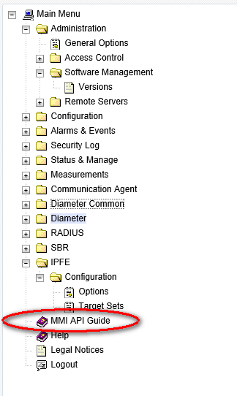

***Figure 13 – MMI API Guide Location on DSR GUI***

## Gen9 V2 Performance Enhancements

#### Description

This feature provides new MP profiles to take advantage of the increase performance if the HP Gen9 v2 blade servers.

DA-MP Per Blade MPS Capacity will be as follows:

* Relay = 120K
* Database = 100K
* Session = 100K

#### Alarm and Event Changes

* N/A

#### GUI Changes

The new Gen9V2 profiles are assigned to the MPs via the SOAM GUI Main Menu: Diameter Common -> MPs -> Profile Assignments screen as shown in ***Figure 14***.

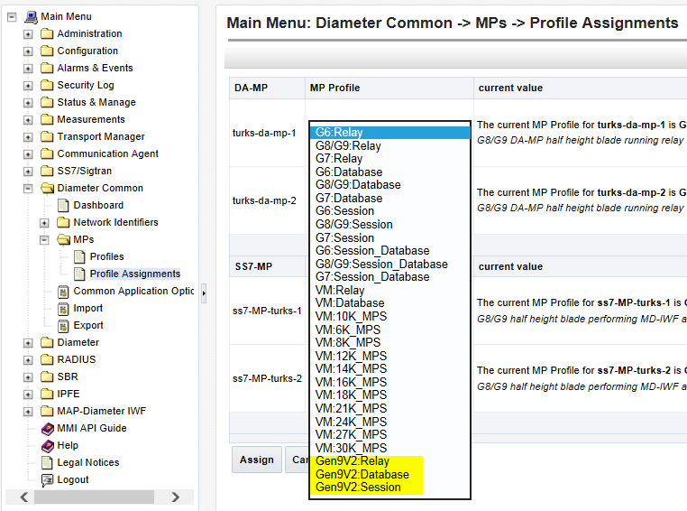

***Figure 14 – Gen9V2 MP Profile Configuration***

#### SDS Add Functionality

#### Description

The feature creates an Insert function for SDS subscriber table SOAP/XML provisioning. The insert function will only add a subscriber to subscriber table if IMSI and MSISDN are not already present in the SDS database. If the subscriber is already present in the SDS database, insert will fail and report the condition which caused the failure.

* A subscriber is a group of related IMSI and/or MSISDN routing entities and an optional Account ID value. All routing entities within a subscriber have the same destination values.
* The <insertSubscriberRequest> request provisions IMSI and MSISDN “routing” data and can also provision “subscriber” data ***if and only if*** IMSI and MSISDN do not already exist in the database.
* The “***Insert Subscriber Request***” section of the Subscriber Database Server Provisioning Interface document (E87981) for additional details including Request and Response messages. This document can be found on the Oracle Communications Documentation Site via the following URL: <http://docs.oracle.com/cd/E86291_01/docs.81/E87981_rev_01.pdf>

#### Alarm and Event Changes

* N/A

#### GUI Changes

* N/A

#### Support for 64 Mediation Template

#### Description

This feature increases the number of Mediation Templates supported by DSR from 15 to 64.

* The maximum number of “Active" Templates has been increased from 15 to 64.
* The maximum number of “Test” Templates shall remain at 10.
* The maximum number of Active Templates that can be associated with all the Trigger Points has been increased from 15 to 64.
* The maximum number of provisioned rules in the system has been increased from 50000 [(15 Active Templates + 10 Test Templates)*2000 rules per template] to 148000 [(64 Active Templates + 10 Test Templates)*2000 rules per template].

#### Alarm and Event Changes

* N/A

#### GUI Changes

* N/A

#### Virtual Signaling Transfer Point (vSTP)

#### Description

This feature introduces Signaling Transfer Point (STP) software that can be deployed in Virtual Machines. This feature will only be offered on KVM/OpenStack in Release 8.1. The vSTP application will share the NOAM and SOAM with DSR 8.1 but will have a dedicated Message Processor (MP) for STP function.

Deployment Model:

* + 2 Network OAM (NOAM) - Active/Standby, integrated with DSR NOAM
  + 2 Sites OAM for each "instance" - Active/Standby, integrated with DSR SOAM
  + 1 STP - Message Processor (STP-MP) per site in this first release
* Support of M3UA (Signaling Gateway) and M2PA (Client server) Sigtran links
* Support of MTP3 Routing
* Support of SCCP Gateway and Screening functions
  + Global Title Translation (Intermediate and Final)
    - Enhanced GTT and Variable Length GTT
    - Intermediate, Flexible, Weighted and Transaction Based GTT Load-Sharing features
* “A Scoped” data - Server, Server Group, Network, Network Element, Network Interfaces, Network Routes, Users, etc. configuration is performed via the DSR NOAM DSR GUI.
* “B Scoped” data STP specific configuration is performed via a REST interface -ie: a Machine to Machine Interface (MMI) very similar to MMI introduced in DSR 8.0.
* STP-MP Performances:
  + Supports up to **1024 SCTP associations** (over 2 network interfaces)
  + Supports up to **10 K MPS**
  + Supports up to 10K Destinations and Routes

#### Alarm and Event Changes

* Several MEAL updates are introduced via the vSTP feature; refer to section ***4.1 DSR/SDS 8.1 MEAL*** Snapshot for additional details.

#### GUI Changes

***Figure 15*** displays the new STP Server Group function added to DSR 8.1 to support the vSTP product. The “A Scoped” configuration is the only configuration entered via the DSR GUI.

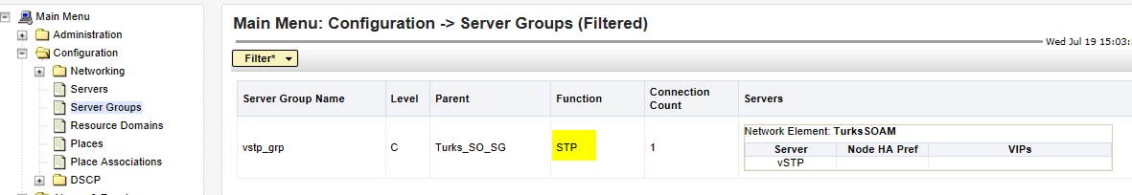

***Figure 15 – vSTP Server Group Screen***

# MEAL INSERTS

This section will summarize the changes to Alarms, Measurements, KPIs and MIBs. In the following inserts pertain to a DSR release 8.1 MEAL Snapshot and deltas to earlier releases 7.0.1, 7.1, 7.1.1, 7.2, 7.3 & 8.0 .

The DSR 8.1 GA Release is dsr-8.1.0.0.0-81.20.0

## DSR/SDS 8.1 MEAL Snapshot

 

## Meal Deltas (8.0)

 

## Meal Deltas (7.3)

 

## Meal Deltas (7.2)

 

## Meal Deltas (7.1.1)

 

## Meal Deltas (7.1)

 

## Meal Deltas (DSR 7.0.1, SDS 5.0.1)

 

# reference list

**DSR 8.1 User Guides for DSR (see customer documentation)**

<http://docs.oracle.com/en/industries/communications/diameter-signaling-router/index.html>

**Release Notices and Licensing Information User Manuals**

*DSR 8.1Release Notice*

*DSR 8.1 Licensing Information User Manual*

**DSR Planning, Installation, Upgrade, and Disaster Recovery**

*DSR 8.1 Feature Guide*

*DSR 8.1 Planning Guide*

*DSR Hardware and Software Installation Procedure*

*DSR Software Installation and Configuration Procedure*

*DSR Software Upgrade Guide*

*DSR Rack Mount Server Installation Guide*

*DSR Rack Mount Server Disaster Recovery Guide*

*DSR Disaster Recovery Guide*

*Policy and Charging DRA Feature Activation Procedure*

*GLA Feature Activation Procedure*

*Mediation Feature Activation Procedure*

*FABR Feature Activation Procedure*

*RBAR Feature Activation Procedure*

*MAP-Diameter Feature Activation Procedure*

*DTLS Feature Activation Procedure*

*IPv6 Migration Guide*

*DSR Network Impact Report Word*

*DSR Security Guide*

**Cloud Installation and Upgrade**

*DSR Cloud Installation Guide*

*DSR Cloud Software Upgrade Guide*

*DSR Cloud Benchmarking Guide*

*DSR Cloud Disaster Recovery Guide*

*SDS Cloud Installation Guide*

*SDS Cloud Disaster Recovery Guide*

**Diameter Signaling Router Core Document Set**

*Operation, Administration, and Maintenance (OAM) Guide*

*Communication Agent User's Guide*

*Hardware Documentation Roadmap Reference*

*Policy and Charging Application User's Guide*

*Diameter User's Guide*

*Mediation User's Guide*

*Range Based Address Resolution (RBAR) User's Guide*

*Full Address Based Resolution (FABR) User's Guide*

*Session Binding Repository (SBR) User's Guide*

*IP Front End (IPFE) User's Guide*

*Alarms and KPIs Reference*

*Measurements Reference*

*Diameter Common User's Guide*

*MAP-Diameter IWF User's Guide*

*RADIUS User's Guide*

*SS7/SIGTRAN User's Guide*

*Transport Manager User's Guide*

*Gateway Location Application (GLA) User's Guide*

*Related Publications Reference PDF*

*DSR VM Placement and CPU Socket Pinning Tool XLSX*

*DSR Compliance Matrix*

**Integrated Diameter Intelligence Hub (IDIH) Document Set**

*IDIH User's Guide*

*IDIH Audit Viewer Administrator's Guide*

*IDIH Alarm Forwarding Administrator's Guide*

*IDIH Operations, Administration and Maintenance Guide*

*IDIH ProTrace User's Guide*

*IDIH System Alarms User's Guide*

*IDIH Log Viewer Administration's Guide*

1. - This represents the minimum release of the HP FUP 2.2.x series to support all content in the Platform 74 release. It is recommended that the latest firmware release always be used in order to address known security issues.
2. - This represents the minimum release of the Oracle firmware series to support all content in the Platform 74 release. It is recommended that the latest firmware release always be used in order to address known security issues.