C2M.CCB v2.6

3.3.6.3 Stop Premise Based Service
For Landlord - Tenant

Creation Date: November 24, 2009
Title, Subject, Last Updated Date, Reference Number, and Version are marked by a Word Bookmark so that they can be easily reproduced in the header and footer of documents. When you change any of these values, be careful not to accidentally delete the bookmark. You can make bookmarks visible by selecting Tools->Options…View and checking the Bookmarks option in the Show region.

To add additional approval lines, press [Tab] from the last cell in the table above.



Copyright © 2017, Oracle. All rights reserved.
This document is provided for information purposes only and the contents hereof are subject to change without notice.
This document is not warranted to be error-free, nor subject to any other warranties or conditions, whether expressed orally or implied
in law, including implied warranties and conditions of merchantability or fitness for a particular purpose. We specifically disclaim any
liability with respect to this document and no contractual obligations are formed either directly or indirectly by this document. This document
may not be reproduced or transmitted in any form or by any means, electronic or mechanical, for any purpose, without our prior written permission. Oracle, JD Edwards, PeopleSoft, and Siebel are registered trademarks of Oracle Corporation and/or its affiliates. Other names may be trademarks of their respective owners.

Contents
Brief Description 4
Business Process Model Page 1 5
Business Process Model Page 2 6
Business Process Model Page 3 7
Business Process Model Page 4 8
Business Process Model Page 5 9
Business Process Model Page 6 10
Business Process Model Page 7 11
Business Process Model Page 8 12
Business Process Model Page 9 13
Detail Business Process Model Description 14
Test Documentation related to the Current Process 33
Document Control 34
Attachments: 35
Control Central Search 35
Dashboard 35
Control Central Premise Tree 35
Account- Credit and Collection History 35
Admin Menu Installation Options Control Central Alerts 35
Pending Start-Stop 36
Service Agreement 36
Landlord Agreement 36

To update the table of contents, put the cursor anywhere in the table and press [F9]. To change the number of levels displayed, select the menu option Insert->Index and Tables, make sure the Table of Contents tab is active, and change the Number of Levels to a new value.

Brief Description
Business Process: 3.3.6.3 C2M.CCB.Stop Premise Based Service For Landlord - Tenant
Process Type: Sub Process
Parent Process: 3.3.2 C2M.CCB.Manage Service Agreement
Sibling Processes: 3.3.2.1 C2M.CCB.Start Premise Based Service, 3.3.2.3 C2M.CCB.Stop Premise Based Service,
3.3.2.2 C2M.CCB.Start Non-Premise Based Service, 3.3.2.4 C2M.CCB.Stop Non-Premise Based Service, 3.3.6.2 C2M.CCB.Start Premise Based Service For Landlord - Tenant, 3.3.3.2 C2M.CCB.Determine Customer Deposit, 3.3.1.1 C2M.CCB.Establish Person and or Account, 3.4.1.1 C2M.CCB.Manage Customer Contacts, 5.3.2.1 C2M.CCB.Manage Field Activities and Field Orders, 3.4.4.1a C2M.CCB.Enroll in Budget, 3.4.4.1b C2M.CCB.Enroll in Non-Billed Budget, 4.3.2.1 C2M.CCB.Manage Collection Process, 5.1.5.1 C2M.CCB.Manage Metered Site

This process describes the Stop process for Premise based service for when a landlord is responsible for the property between tenants, or when the Service is transferring from tenant to tenant.
When a landlord is associated with a property and would like to have service reverted when a tenant moves out, a contract called a Landlord Agreement is established in the system. The Landlord can indicate preferences for each type of service provided at the property. The landlord can choose to have seasonal preferences. It is possible some services may not revert at all depending on the landlord’s preferences.

An Account is established to use for reversion of service and associated with the Landlord Agreement.

Based on configured business rules the system uses the information defined on landlord agreement to create a Service Agreement(s) for the landlord when service for an existing tenant is stopped.

Many organizations need to group and manage multi-unit properties quickly and effectively. The organization can make use of Premise Management functionality to assist with large multi-unit properties. If configured, Premise Management functionality can facilitate grouping of Premises together under a defined single premise called a Parent Premise. It can provide for a single view of properties for a landlord, including status of service. Premise Management functionality provides the ability to change landlord or service status for a group of premises at the same time in one transaction.

Business Process Model Page 1
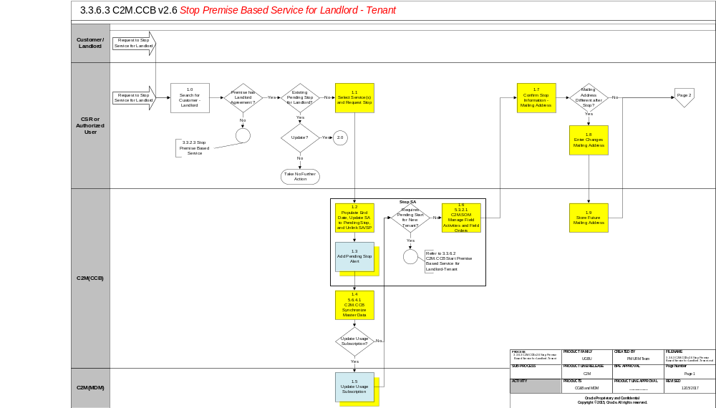

Business Process Model Page 2
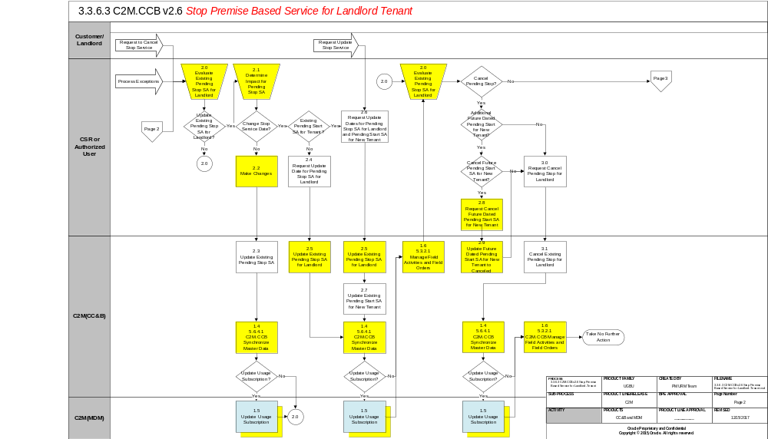

Business Process Model Page 3
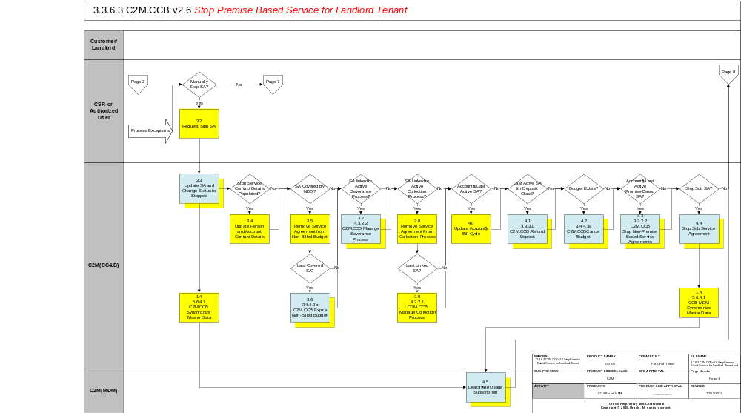

Business Process Model Page 4
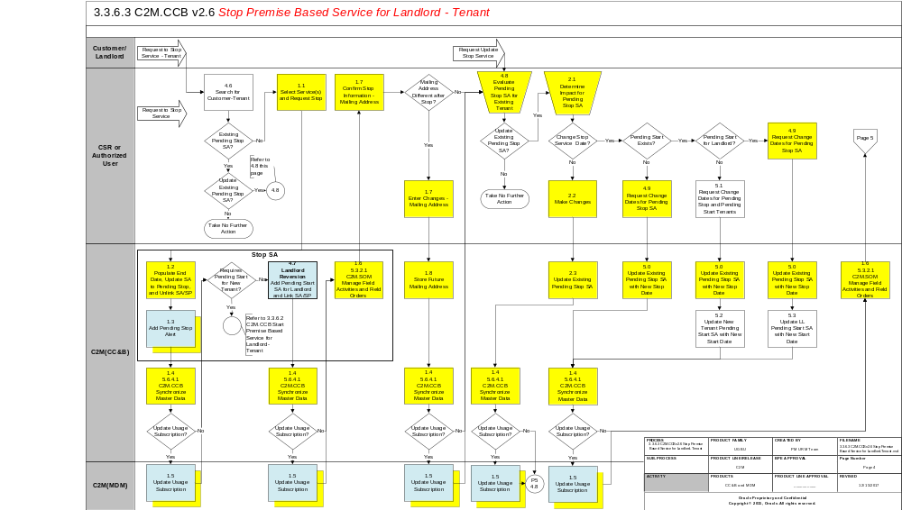

Business Process Model Page 5
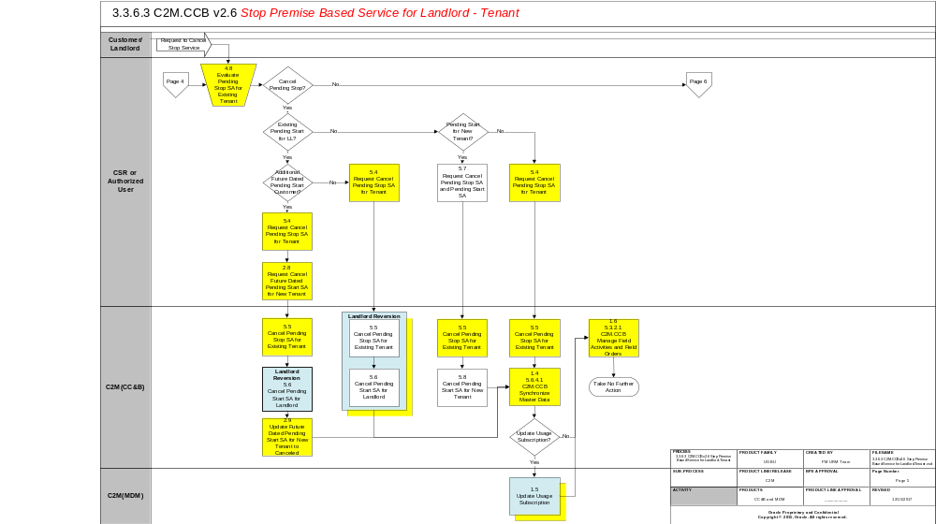

Business Process Model Page 6
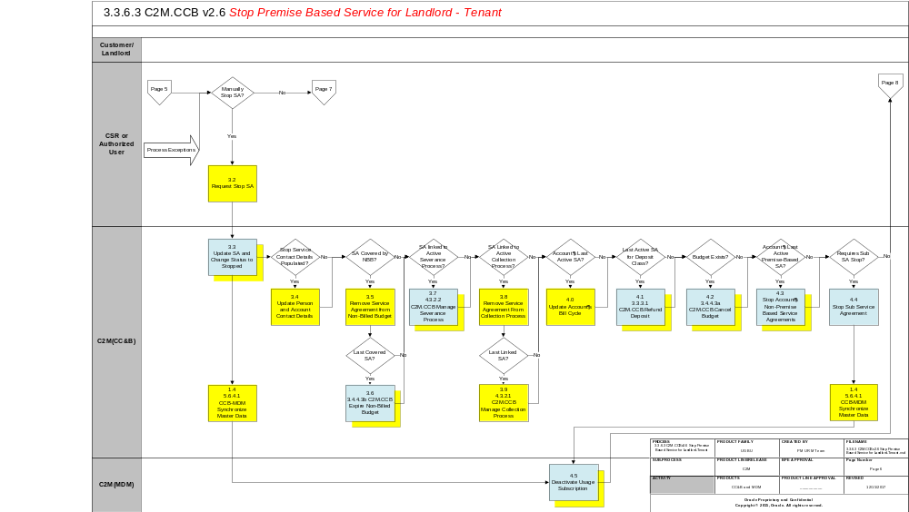

Business Process Model Page 7
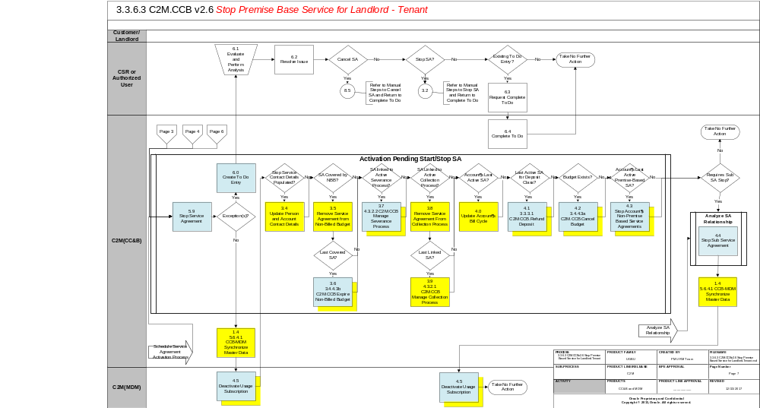

Business Process Model Page 8
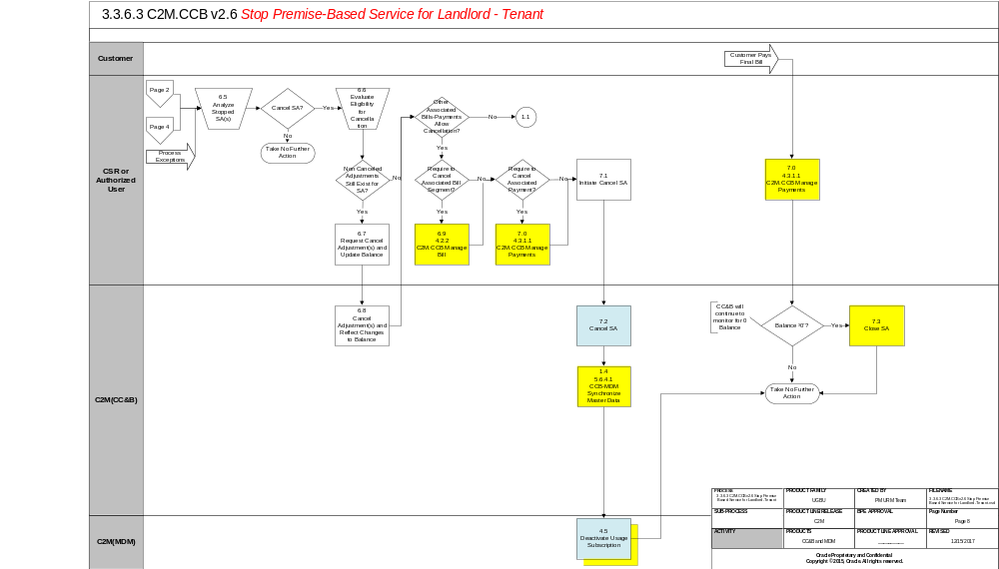

Business Process Model Page 9
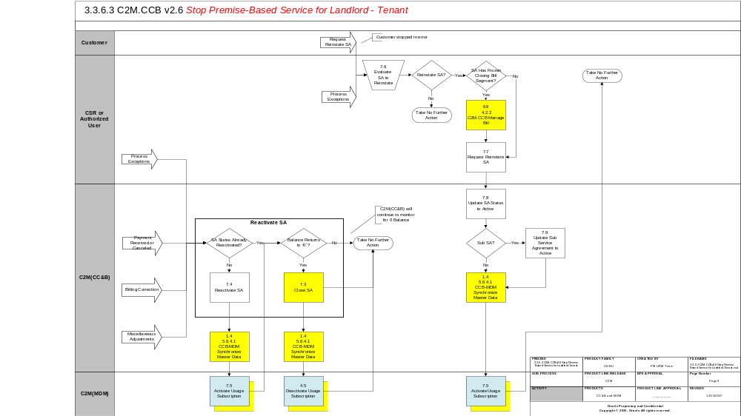

Detail Business Process Model Description
1.0 Search for Customer - Landlord
Actor/Role: CSR or Authorized User
Description:
Upon receipt of request for Stop Service, the Authorized User locates the customer (landlord) in C2M(CCB) using Control Central Search. When a customer is selected, the Authorized User is automatically transferred to Control Central – Account Information refreshed with the selected customer’s data. Dashboard Alerts provide the Authorized User with pertinent information for the customer including Pending Starts. If new service for a new tenant is required, refer to 3.3.6.2 Start Premise Based Service For Landlord - Tenant.

Process Plug-in enabled Y Available Algorithm(s):
C2MPERS-INFO – This person information algorithm display summary information (name, phone number) that appears adjacent to a person ID throughout the system.
C2M-PERNMVAL - Person Name Validation
C1-ACCT-INFO - This algorithm formats the "Account Information" that appears throughout the system.

Configuration required Y Entities to Configure:
Installation Options - Framework

1.1 Select Service(s) and Request Stop
Actor/Role: CSR or Authorized User
Description:
The Authorized User selects Service Agreements to stop.

The Authorized User is presented with the following choices:
- Stop Selected SA’s – To Stop Selected Service Agreements linked to the Account
- Stop a Premise to Stop All Services at the Premise (Address)
- Stop a SA – To Stop a specific SA
- Stop all Active SA’s – To Stop All service agreements linked to the Account

Process Plug-in enabled Y Available Algorithm(s):
C2M-SAT-INFO – This SA Type algorithm formats the “SA Information” that appears throughout the system.
C2MSAI-INFO - This Installation algorithm formats the "SA Information" that appears throughout the system.
C2M-SASPFWCR – Create field activities for pending start and pending stop service agreements if Field Activities do not already exist.

Configuration required Y Entities to Configure:
Installation Options – Framework
SA Type

1.2 Populate End Date, Update SA Status to Pending Stop and Unlink SA/SP Group: Stop SA
Actor/Role: C2M(CCB)
Description:
When service is stopped for a landlord or tenant, the Service Agreement is updated to Pending Stop. The status of the Service Agreement changes to Pending Stop. The SA/SP link is populated with an effective end date (stop) date. A Field Activity may be created if configured. C2M(CCB) links the Field Activity to the SA/SP.

1.3 Add Pending Stop SA Alert Group: Stop SA
Actor/Role: C2M(CCB)
Description:
C2M(CCB) creates a Dashboard Alert for the Pending Stop Service Agreement.

Process Plug-in enabled Y Available Algorithm(s):
C1-STOP-SA– Highlight Stopped SA’s

Configuration required Y Entities to Configure:
Installation Options – Framework

1.4 CCB-MDM Synchronize Master Data
Actor/Role: C2M(CCB)
Description:
Master Data is synchronized for the Pending Start SA for the Landlord.

1.5 Update Usage Subscription
Actor/Role: C2M(MDM)
Description:
The Usage Subscription for the Landlord is updated in C2M.MDM.

D2-USINFO - Usage Subscription Information
D1-DEFTIMZON - Default Time Zone value based on Installation Option
D2-USSPDTVAL - Validate Start and Stop Dates of Usage Subscription's Service Points
D2-USUGDTVAL - Validate Effectivity Period of Usage Subscription's Usage Groups
D2-USFOVAL - Validate the Start and Stop Dates of US Factor Overrides
D2-VALUSTMZN - Validate Usage Subscription Time Zone
D2-VAL-SUBUS - Validate sub usage Subscription
D2-VALUSMC - Validate Measuring Component Class of Direct Channel
Process Plug-in algorithm-in enabled Y Available Algorithm(s):

Configuration required Y Entities to Configure:
Usage Subscription Type
Usage Recipient (Service Provider)

Business Object Y Business Object:
D2-UsageSubscriptionType

1.6 5.3.2.1 C2M.SOM Manage Field Activities and Field Orders Group: Stop SA
Actor/Role: C2M(CCB)
Description:
If fieldwork is required, a Field Activity is created. The Field Activity Type is configured based on specific profiles in conjunction with SOM Fieldwork Orchestration. The SA type SA/SP Fieldwork Creation algorithm determines if a Field Activity is necessary. The background process, Pending SA/SP Monitor, creates Field Activities for Pending Start and Stop Agreements shortly before the start/stop date if Field Activities have not already been created. Algorithms and configuration below are for reference only. Refer to 5.3.2.1 Manage Field Activities and Field Orders for process details and a complete listing of algorithms, background processes, and configuration.
.

Process Plug-in enabled Y Available Algorithm(s):
C2M-SASPFWCR – Create field activities for pending start and pending stop service agreements if Field Activities do not already exist.
C1-FAIN-INFO - This Installation algorithm formats the "FA Information" that appears throughout the system.–
C1-FAAD-INFO - Formats the field activity additional information that appears on the field activity page.
C1-DGRP-DFLT – Default Dispatch Group on a Field Activity.
C2M-FACCHARG – Field Activity Completion – this algorithm applies charges by creating an adjustment

Customizable process N Process Name:
PSASPM - Creates field activities shortly before the start/stop date if field activities have not already been created.
FANRMRCO - The complete field activity using a recent read process looks for pending start / stop field activities for a meter read recently. It prorates the read into an end read and starts read for the start and stop SA’s.
FACOMPL - The field activity completion process completes field activities and field orders using the records in the various field activity staging tables.
SAACT - The service agreement activation process updates the status and SA/SP reads for pending start and pending stop service agreements.

Configuration required Y Entities to Configure:
FA Types
FA Type Profiles
Operations Area
Dispatch Group
Field Service Class
Field Service Control
Batch Control
SA Type

1.7 Confirm Stop Service Information - Mailing Address
Actor/Role: CSR or Authorized User
Description:
There is dialogue with the Customer. Stop information is confirmed including a forwarding mailing address.

1.8 Enter Changes – Mailing Address
Actor/Role: CSR or Authorized User
Description:
After confirming the change, The Authorized User enters required information in C2M(CCB). These changes could be updates for the Account or Person record, i.e. Mailing address. These changes do not impact start or stop dates. The system defaults to mailing premise. The Authorized User can change the default. C2M(CCB) address sources include Person, Premise, and Account. The address information is effective when the Service Agreement is Stopped or Activated.

Configuration required Y Entities to Configure:
Postal Code Default
Installation Options
Bill Route Type
Country

1.9 Store Future Mailing Address
Actor/Role: C2M(CCB)
Description:
The mailing address information is stored until the Service Agreement is transitioned to Stopped status.

1.9 Complete FA Using Recent Read 5.3.2.1 Manage Field Activities and Field Orders
Actor/Role: C2M(CCB)
Description:
If configured, C2M(CCB) can use a recent scheduled read rather than requiring a separate trip to obtain a read in the field. Refer to 5.3.2.1 Manage Field Activities and Field Orders.

2.0 Evaluate Existing Pending Stop SA for Landlord
Actor/Role: CSR or Authorized User
Description:
The Authorized User reviews the pending stop Service Agreement. It may be determined the Service Request needs to be canceled. Request to Stop Service was in error. The customer (landlord) may call and indicate they are not stopping service at this time. A new tenant may cancel a Start Service Request. The landlord needs to continue to assume responsibility for the given Premise. The Authorized User may need to manually stop the Service Agreement to expedite final Billing or to process an anomaly.

2.1 Determine Impact for Pending Stop SA
Actor/Role: CSR or Authorized User
Description:
Before any changes or updates are made for a Pending Stop SA for a tenant or landlord, the Authorized User reviews how the changes impact the existing Pending Stop SA or other related Starts or Stops.

2.2 Make Changes
Actor/Role: CSR or Authorized User
Description:
After confirming the change, The Authorized User enters required information in C2M(CCB). These changes could be updates for the Account or Person record, i.e. Mailing address. These changes do not impact start or stop dates. The system defaults to mailing premise. The Authorized User can change the default. C2M(CCB) address sources include Person, Premise, and Account. The address information is effective when the Service Agreement is Stopped or Activated.

2.3 Update Existing Pending Stop SA
Actor/Role: C2M(CCB)
Description:
The Pending Stop SA for the landlord is updated in C2M(CCB).

2.4 Request Update Date for Pending Stop SA for Landlord
Actor/Role: CSR or Authorized User
Description:
There may be a Pending Stop SA for the landlord without a new customer (tenant) signing for service at the Premise. The Authorized User enters date changes for the Pending Stop SA for the landlord.

2.5 Update Existing Pending Stop SA for Landlord
Actor/Role: C2M(CCB)
Description:
The Pending Stop SA for the landlord is updated in C2M(CCB).

2.6 Request Update Dates for Pending Stop SA for Landlord and Pending Start SA for New Tenant
Actor/Role: CSR or Authorized User
Based on information received and established business rules, The Authorized User changes dates for the Pending Stop SA for the landlord and Pending Start SA for the new tenant.

2.7 Update Existing Pending Start SA for New Tenant
Actor/Role: C2M(CCB)
Description:
The Pending Start SA for the new tenant is updated in C2M(CCB).

2.8 Request Cancel Future Dated Pending Start SA for New Tenant
Actor/Role: CSR or Authorized User
Description:
There is a request to cancel the Pending Stop for the landlord. There is also an existing future dated Pending Start SA for a new tenant that requires cancellation of the Pending Start.

2.9 Update Future Dated Pending Start SA for New Tenant to Canceled
Actor/Role: C2M(CCB)
Description:
The future dated Pending Start SA for the new tenant is canceled in C2M(CCB).

3.0 Request Cancel Pending Stop for Landlord
Actor/Role: CSR or Authorized User
Description:
The Authorized User cancels the Pending Stop for the Landlord. The service(s) were stopped in error or the landlord or the landlord is continuing responsibility for the property at this time.

3.1 Cancel Existing Pending Stop for Landlord
Actor/Role: C2M(CCB)
Description:
The Stop Service Request is canceled in C2M(CCB).

3.2 Request Stop SA
Actor/Role: CSR or Authorized User
Description:
The Authorized User manually stops the Service Agreement in C2M(CCB).

3.3 Update SA and Change Status to Stopped
Actor/Role: C2M(CCB)
Description:
The Service Agreement status is transitioned to stopped in C2M(CCB).
Manual Process: The Authorized User may transition the Service Agreement to Stopped as exception processing.
Automated Process: C2M(CCB) will automatically transition the Service Agreement to Stopped status when all required information is made available.

Process Plug-in enabled Y Available Algorithm(s):
C2M LL REV - This algorithm causes service to be started under a landlord's account at a service point covered by a landlord agreement
NB-SAST - execute additional logic that should be executed when a non-billed budget SA is stopped.
C2M-SAST-RF - This SA Type Stop algorithm refunds a service credit membership fee.
C1-SAIS-ST – This algorithm automatically stops a pending stop service agreement (instead of waiting for the background process that transitions SAs from pending stop to stopped).

Customizable process N Process Name:
SAACT - The service agreement activation process updates the status and SA/SP reads for pending start and pending stop service agreements.

Configuration required Y Entities to Configure:
SA Type

3.4 Update Person and Account Contact Details
Actor/Role: C2M (CCB)
Description:
The Service Agreement’s Account and main customer Person is updated with the bill routing and contact information recorded in the pending stop details.

3.5 Remove Service Agreement from Non-Billed Budget
Actor/Role: C2M (CCB)
Description:
The Non-Billed Budget is updated to remove the Service Agreement as a covered service agreement. Refer to 3.4.4.3b C2M.CCB.Expire Non-Billed Budget.

3.6 3.4.4.3b C2M.CCB Expire Non-Billed Budget
Actor/Role: C2M (CCB)
Description:
Transition the Non-Billed Budget to the Pending Stop state. Note when the last active Service Agreement covered by a Non-Billed Budget is stopped, the Non-Billed Budget will be stopped. Refer to 3.4.4.3b C2M.CCB.Expire Non-Billed Budget.

3.7 4.3.2.2 C2M.CCB Manage Severance Process
Actor/Role: C2M (CCB)
Description:
The Severance Process and its Severance Events are canceled. Refer to 4.3.2.2 C2M.CCB.Manage Severance Process

3.8 Remove Service Agreement From Collection Process
Actor/Role: C2M (CCB)
Description:
The Collection Process is updated to remove the Service Agreement. Refer to 3.4.3.2.1 C2M.CCB.Manage Collection Process.

3.9 4.3.2.1 C2M.CCB Manage Collection Process
Actor/Role: C2M (CCB)
Description:
The Collection Process is cancelled. Note if when the Service Agreement is removed from the Collection Process, the Collection Process is not related to another active Service Agreement, the Collection Process is cancelled. Refer to 4.3.2.1 C2M.CCB.Manage Collection Process.

4.0 Update Account’s Bill Cycle
Actor/Role: C2M (CCB)
Description:
The Service Agreement’s Account is updated in C2M (CCB). The Account’s Bill Cycle is changed so the Account will be billed when billing next executes and allow for final bill creation.

4.1 3.3.3.1 C2M.CCB.Refund Deposit
Actor/Role: C2M (CCB)
Description:
Transition the Deposit Service Agreement to the Pending Stop state. Note this occurs when there are no other active Service Agreements related to the Account for the same Deposit Class. Refer to 3.3.3.1 C2M.CCB.Refund Deposit.

4.2 3.4.4.3a C2M.CCB.Cancel Budget
Actor/Role: C2M (CCB)
Description:
Cancel the budget, refer to 3.4.4.3a C2M.CCB.Cancel Budget.

4.3 3.3.2.2 C2M.CCB Stop Non-Premise Based Service Agreements
Actor/Role: C2M(CCB)
Description:
If the SA is the account’s last active premise-based service, C2M(CCB) proceeds to stop account’s remaining active non-premise based service(s) configured with auto-stop indicator. Refer to 3.3.2.4 Stop Non-Premise Based Service.doc

Customizable process N Process Name:
SAACT - The service agreement activation process updates the status and SA/SP reads for pending start and pending stop service agreements.

Configuration required Y Entities to Configure:
SA Type

4.4 3.3.2.2 Stop Sub Service Agreement
Actor/Role: C2M(CCB)
Description:
If the Sub SA should be stopped, it is transitioned to stop as part of the overall processing. Algorithms below are for reference only as typically apply to other Service Agreement Types.

Process Plug-in enabled Y Available Algorithm(s):
SAST-NB - Algorithms of this type execute additional logic that should be executed when a non-billed budget SA is stopped.
SAST-RF - This SA Type Stop algorithm refunds a service credit membership fee.

Customizable process N Process Name:
ANLYZSAR - Analyze SA Relationship

Configuration required Y Entities to Configure:
SA Type

4.5 Deactivate Usage Subscription
Actor/Role: C2M(MDM)
Description:
Pending Start Usage Subscription for the Landlord is updated to inactive in C2M.MDM.

D2-USINFO - Usage Subscription Information
D1-DEFTIMZON - Default Time Zone value based on Installation Option
D2-USSPDTVAL - Validate Start and Stop Dates of Usage Subscription's Service Points
D2-USUGDTVAL - Validate Effectivity Period of Usage Subscription's Usage Groups
D2-USFOVAL - Validate the Start and Stop Dates of US Factor Overrides
D2-VALUSTMZN - Validate Usage Subscription Time Zone
D2-VAL-SUBUS - Validate sub usage Subscription
D2-VALUSMC - Validate Measuring Component Class of Direct Channel
Process Plug-in algorithm-in enabled Y Available Algorithm(s):

Configuration required Y Entities to Configure:
Usage Subscription Type
Usage Recipient (Service Provider)

Business Object Y Business Object:
D2-UsageSubscriptionType

4.6 Search for Customer - Tenant
Actor/Role: CSR or Authorized User
Description:
Upon receipt of request for Start Service, the Authorized User locates the customer (tenant) in C2M(CCB) using Control Central Search. When a customer is selected, the Authorized User is automatically transferred to Control Central – Account Information refreshed with the selected customer’s data. Dashboard Alerts provide the Authorized User with pertinent information for the customer including Pending Starts. When an existing tenant stops service, a new tenant may also be starting service. Refer to 3.3.6.2 Start Premise Based Service For Landlord - Tenant.

Process Plug-in enabled Y Available Algorithm(s):
C2MPERS-INFO - This Installation algorithm formats the "Person Information" that appears throughout the system.

Configuration required Y Entities to Configure:
Installation Options - Framework

4.7 Add Pending Start SA for Landlord and Link SA/SP Group: Landlord Reversion
Group: Stop SA
Actor/Role: C2M(CCB)
Description:
If configured, service for the Landlord is started automatically. A new Service Agreement will be started and the Service Point Information will be linked to the Service Agreement.

Process Plug-in enabled Y Available Algorithm(s):
C2M LL REV - This algorithm causes service to be started under a landlord's account at a service point covered by a landlord agreement

Configuration required Y Entities to Configure:
SA Type

4.8 Evaluate Pending Stop SA for Existing Tenant
Actor/Role: CSR or Authorized User
Description:
The Authorized User can review the Pending Stop Service Agreement at various times during the stop processing. Updates to mailing address, Account or Person information, or a change in dates is required. Prior to the Service Agreement transitioning to stopped, it is determined the Pending Stop is in error and requires canceling. The Customer (tenant) may call and indicate they are not moving in or taking responsibility for utility charges for the given Premise. They may request to cancel the request to start. The Authorized User may need to manually start the Service Agreement to expedite Billing or process an anomaly.

4.9 Request Change Dates for Pending Stop SA
Actor/Role: CSR or Authorized User
Description:
After review, the Authorized User determines to change the stop date for the existing tenant. A Pending Start SA may exist for the landlord.

5.0 Update Existing Pending Stop SA with New Stop Date
Actor/Role: C2M(CCB)
Description:
The Pending Stop SA is updated with a new date in C2M(CCB).

5.1 Request Change Dates for Pending Stop and Pending Start Tenants
Actor/Role: CSR or Authorized User
Description:
There is a Pending Stop and a Pending Start for existing and new tenants. The Authorized User determines to change the stop dates for the existing tenant. The pending stop dates for the new tenant require change also.

5.2 Update New Tenant Pending Start SA with New Start Date
Actor/Role: C2M(CCB)
Description:
The existing Pending Start SA is updated with the new start date in C2M(CCB).

5.3 Update LL Pending Start SA with New Start Date
Actor/Role: C2M(CCB)
Description:
The Pending Start SA for the landlord is updated in C2M(CCB). The start date matches the stop date for the existing tenant.

5.4 Request Cancel Pending Stop SA for Tenant
Actor/Role: CSR or Authorized User
Description:
There is a Pending Stop for an existing tenant and may be a Pending Start for the Landlord. The Authorized User determines to cancel the Pending Stop SA for the existing Tenant.

5.5 Cancel Pending Stop SA for Existing Tenant Group: Landlord Reversion
Actor/Role: C2M(CCB)
Description:
The Pending Stop SA for the existing tenant is updated to canceled in C2M(CCB).

Process Plug-in enabled Y Available Algorithm(s):
C2M LL REV - This algorithm causes service to be started under a landlord's account at a service point covered by a landlord agreement

Configuration required Y Entities to Configure:
SA Type

5.6 Cancel Pending Start SA for LL Group: Landlord Reversion
Actor/Role: C2M(CCB)
Description:
The Pending Start SA for the landlord is updated to canceled in C2M(CCB).

5.7 Request Cancel Pending Stop SA and Pending Start SA
Actor/Role: CSR or Authorized User
Description:
There is a Pending Stop SA for an existing tenant and a Pending Start SA for a new tenant. This is considered a back-to-back scenario. The Authorized User determines to cancel the Pending Stop and the Pending Start.

5.8 Cancel Pending Start SA for New Tenant
Actor/Role: C2M(CCB)
Description:
The Pending Start SA for the new tenant is canceled in C2M(CCB).

5.9 Stop Service Agreements Group: Service Agreement Activation Process
Actor/Role: C2M(CCB)
Description:
The Service Agreement Activation background process, SAACT, periodically checks and selects Service Agreements with a stop read and stop Date less than or equal to the current date. This background process then attempts to transition the Service Agreement to Stopped status.
Manual Process: The Authorized User may transition the Service Agreement to stopped due to exception processing.
Automated Process: C2M(CCB) will automatically transition the Service Agreement to Active status when all required information is made available.

Customizable process N Process Name:
SAACT - The service agreement activation process updates the status and SA/SP reads for pending start and pending stop service agreements.
TD-SSFTL To Do for Old Pending Start/Stops-catches start/stop requests that have gone unfulfilled.

.

Configuration required Y Entities to Configure:
To Do Types
To Do Roles
SA Type
Batch Control

6.0 Create To Do Entry Group: Service Agreement Activation Process
Actor/Role: C2M(CCB)
Description:
The background process, SAACT, Service Agreement Activation, periodically checks to see if Service Agreements can be activated or stopped. C2M(CCB) creates an exception processing record for each Service Agreement with the Service Agreement’s effective start date less than the current date and with missing or incomplete information. Typically, a To Do Entry is created for the CSR or Authorized User to review. The To Do Entry also allows for tracking and visibility of work efforts. The Service Agreement may also be manually activated. A separate background process creates To Do Entries for Pending Start/Stops that are older than a configured date. To Do Type and To Do Roles must also be configured.

Customizable process N Process Name:
SAACT - The service agreement activation process updates the status and SA/SP reads for pending start and pending stop service agreements.
TD-SSFTL - To Do for Old Pending Start/Stops-catches start/stop requests that have gone unfulfilled.

Configuration required Y Entities to Configure:
To Do Types
To Do Roles
Batch Control

6.1 Evaluate and Perform Analysis
Actor/Role: CSR or Authorized User
Description:
Based on established business rules, the Authorized User investigates viable solutions or workarounds for the missing or incomplete information related to Service Agreement transition. The Authorized User enters this information in C2M(CCB-MDM).

6.2 Resolve Issue
Actor/Role: CSR or Authorized User
Description:
The CSR or Authorized User determines what needs to be done and enters applicable information in C2M(CCB) or MDM.

6.3 Request Complete To Do
Actor/Role: CSR or Authorized User
Description:
If the background process creates a To Do Entry, the Authorized User marks the To Do Entry as complete and requests completion of the To Do Entry once the error is resolved. The Authorized User may add comments or a log entry for future reference.

Configuration required Y Entities to Configure:
To Do Role
To Do Type

6.4 Complete To Do
Actor/Role: C2M(CCB)
Description:
The To Do Entry is updated to Complete status in C2M(CCB).

Configuration required Y Entities to Configure:
To Do Role
To Do Type

6.5 Analyze Stopped SA
Actor/Role: CSR or Authorized User
Description:
The Authorized User reviews the Stopped Service Agreement. Information becomes available that requires further evaluation. The Service Agreement may need to be canceled. The customer may call and indicate they are not moving in to the given Premise. The customer (landlord or tenant) may request to cancel the original request after the Service Agreement is stopped.

6.6 Evaluate Eligibility for Cancellation
Actor/Role: CSR or Authorized User
Description:
At times, a Service Agreement requires cancellation. Typically, this occurs when the Service Agreement was created and then stopped in error. As part of the cancellation process, the Authorized User determines if any associated financial transactions for the Active Service Agreement require cancellation. All financial transactions (bills, payments or adjustments) must be canceled before a Service Agreement can transition to Canceled status.

6.7 Request Cancel Adjustment(s) and Update Balance
Actor/Role: CSR or Authorized User
Description:
The Authorized User cancels applicable adjustment(s) in order to cancel the Service Agreement. The Service Agreement balance is updated accordingly.

Configuration required Y Entities to Configure:
Adjustment Cancel Reason

6.8 Cancel Adjustment(s) and Reflect Changes to Balance
Actor/Role: C2M(CCB)
Description:
The Service Agreement balance is updated in C2M(CCB) to reflect the adjustment cancellation.

Process Plug-in enabled Y Available Algorithm(s):
CMCA-CRDT Adjustment Cancellation - Create To Do Entry

Configuration required Y Entities to Configure:
Adjustment Cancel Reason
Adjustment Type

6.9 4.2.2. C2M.CCB Manage Bill
Actor/Role: CSR or Authorized User
Description:
Refer to 4.2.2.2 C2M.CCB-MDM for Manage Meter Charges or 4.2.3.3 C2M.CCB-MDM Manage Item Charges for cancellation of Bill Segments.

7.0 4.3.1.1 C2M.CCB Manage Payments
Actor/Role: CSR or Authorized User
Description:
Refer to 4.3.1.1 C2M.CCB Manage Payments for cancellation of Payments.

7.1 Initiate Cancel SA
Actor/Role: CSR or Authorized User
Description:
When all financial transactions are canceled, the Authorized User updates the Service Agreement to Canceled.

7.2 Cancel SA
Actor/Role: C2M(CCB)
Description:
The Service Agreement is transitioned to a canceled status. Canceled is a final status. If configured, a To Do entry can be created when a Service Agreement is canceled.

Process Plug-in enabled Y Available Algorithm(s):
C2M-SACA-CRT – SA Cancellation - Create To Do Entry

Configuration required Y Entities to Configure:
To Do Type
To Do Role
SA Type

7.3 Close SA Group: Reactivate SA
Actor/Role: C2M(CCB)
Description:
The Service Agreement is automatically transitioned to Closed Status when the balance is” 0”.

7.4 Reactivate SA Group: Reactivate SA
Actor/Role: C2M(CCB)
Description:
The system moves the Service Agreement to Reactivated status if certain Financial Transactions are created after a Service Agreement is closed. When the financial balance returns to” 0”, the Service Agreement is closed again.

7.5 Activate Usage Subscription
Actor/Role: C2M(CCB)
Description:
When the Service Agreement is reactivated in CCB, the Usage Subscription is activated again in MDM.

7.6 Evaluate SA to Reinstate
Actor/Role: CSR or Authorized User
Description:
The Authorized User reviews and gathers available information to reinstate SA.

7.7 Initiate Reinstate SA
Actor/Role: CSR or Authorized User
Description:
The CSR or Authorized User requests to reinstate the Service Agreement. The Reinstate Action retains the current service’s billing history. A closing bill segment must be canceled prior to the Reinstate action. Note the Reinstate action can be used to reinstate a Closed, Reactivated, or Stopped Service Agreement. Stopped, Reactivated, Closed Sub SAs are returned to Active. Additional updates may be required such as restarting a Deposit SA, Updating Credit and Collection processes, or placing the Account on Budget Billing.

7.8 Update SA Status to Active
Actor/Role: C2M(CCB)
Description:
The Reinstate action in C2M(CCB) changes the status of the Service Agreement to Active. The Reinstate action can be used to reinstate a closed, reactivated, or stopped Service Agreement.

7.9 Update Sub Service Agreement to Active
Actor/Role: C2M (CCB)
Description:
The related Sub Service Agreement is transitioned to the Active state.

Test Documentation related to the Current Process

ID | Document Name | Test Type

Document Control
Change Record
1
Date | Author | Version | Change Reference
11/24/09 | Colleen King | Draft 1a | No Previous Document
10/20/10 | Geir Hedman |  | Update Title and Content page
11/19/10 | Jenny Vagilidad |  | Added Auto-Stop Non-premise based Service feature
2/8/11 | Geir Hedman |  | Update Document and Visio
5/28/2013 | Cynthia Fisher |  | Update to V2.4
6/26/13 | Galina Polonsky |  | Reviewed, Approved
09/11/2017 | Ekta Dua |  | Updated document and Visio to v2.6
10/16/2017 | James Foreman |  | Updated algorithms
12/11/2017 | Colleen King |  | Multiple updates for Visio and Word doc
12/15/2017 | Colleen King |  | Updates for Visio and Word doc
12/20/2017 | Galina Polonsky |  | Reviewed, Approved

Attachments:

Control Central Search


Dashboard


Control Central Premise Tree
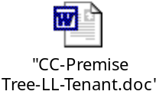

Account- Credit and Collection History


Admin Menu Installation Options Control Central Alerts


Pending Start-Stop


Service Agreement


Landlord Agreement


