Word barcode variants

Outside a Table
Code 39 - default: 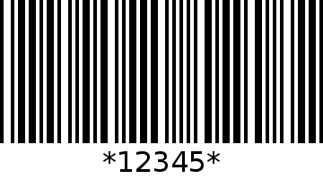
Code 39 - rotated 90 degrees: 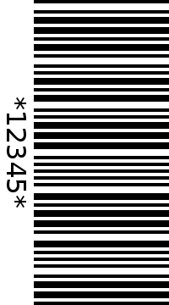
Code 128 - default: 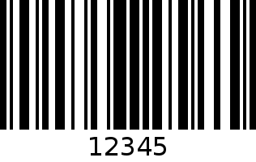
Code 128 - scaled 0.5: 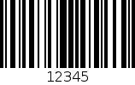
EAN - default: 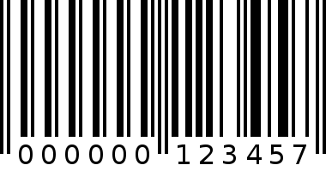
EAN - quiet zone 10/20: 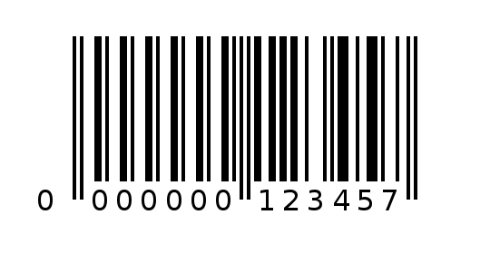
UPC - default: 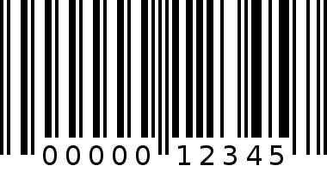
UPC - quiet zone 10/20: 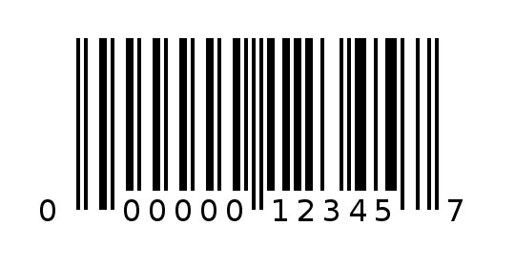
PDF417 - default: 
PDF417 - truncated: 
Data Matrix - default: 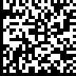
Data Matrix - rectangular: 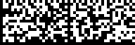
QR - default: 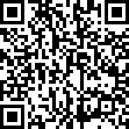
QR - high ECC: 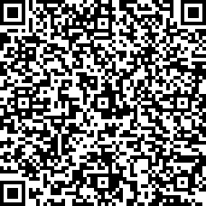

Inside a Table
Code 39 - default:
Code 39 - rotated 90 degrees:
Code 128 - default:
Code 128 – scaled 0.5:
EAN - default:
EAN - quiet zone 10/20:
UPC - default:
UPC - quiet zone 10/20:
PDF417 - default:
PDF417 - truncated:
Data Matrix - default:
Data Matrix - rectangular:
QR - default:
QR - high ECC:

