OBDX CS Mobile Configuration in IDCS

Release:
OBMA - v14.8.1
Oracle Banking Digital Experience CS – OBDX CS – 25.1, 25.1.1.0, 22.2.6

Overview
Release 14.8.1 – Mobile application follows OAuth 2-legged flow
After the IOS and Android workspace setup using mobile technical document is completed, follow this to connect Mobile application with IDCS for authentication flow.
This guide explains how to configure the required properties in your Mobile Workspace application to enable OAuth 2-Legged (Client Credentials) authentication using Oracle IDCS. Follow each section in order.

OAuth 2-Legged Flow: The mobile application authenticates using its own Client ID and Client Secret — no end-user login is involved.

Properties to Set
The following properties must be configured in the mobile application in app.plist in IOS and app.properties in ANDROID

Property | Description
IDCS_URL | Full token endpoint URL
ClientIdClientSecret | Base64 of ClientId:ClientSecret
SiriClientIdClientSecret | Same as ClientIdClientSecret — mandatory, app crashes without it
IDCS_Scope | OAuth scope for the tenancy
Cookie | OAuth scope for the consumer
SERVER_TYPE | Fixed value: OAUTH
KEY_SERVER_URL | Cloud URL — must not end with /

How to Navigate to OAuth Configuration
Several properties below are retrieved from the same screen in Oracle Cloud. Here is the navigation path — follow this once and refer back to it as needed.

- Log in to the Oracle Cloud Infrastructure (OCI) Console.
- Go to Identity & Security → Domains.
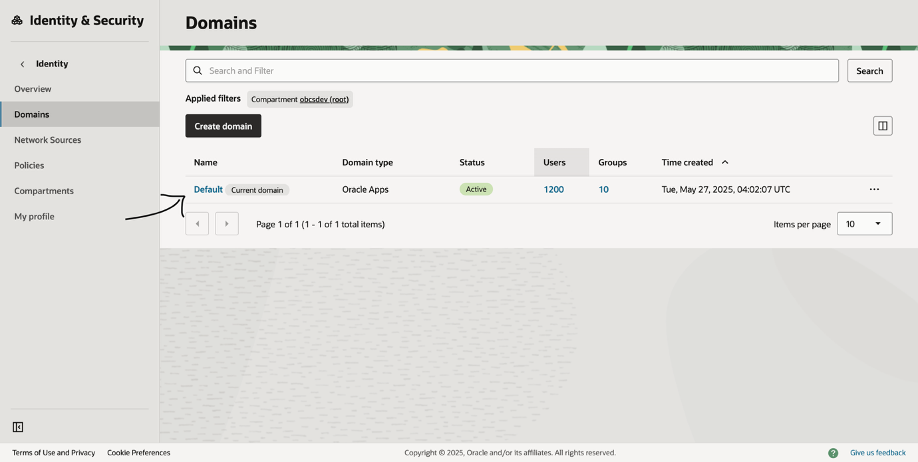

- Select your Identity Domain from the list.
- From the horizontal scroll menu, click Oracle Cloud Services.
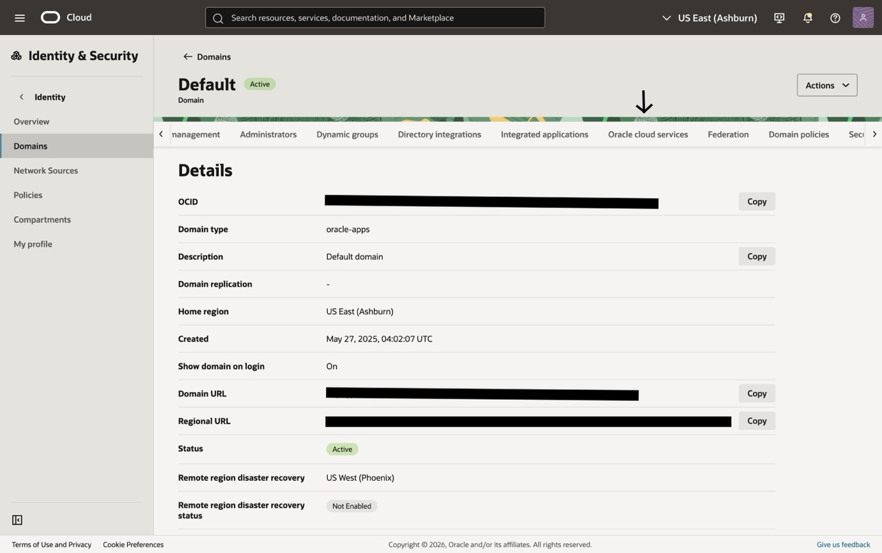

- Find and click your Tenancy Application from the list.
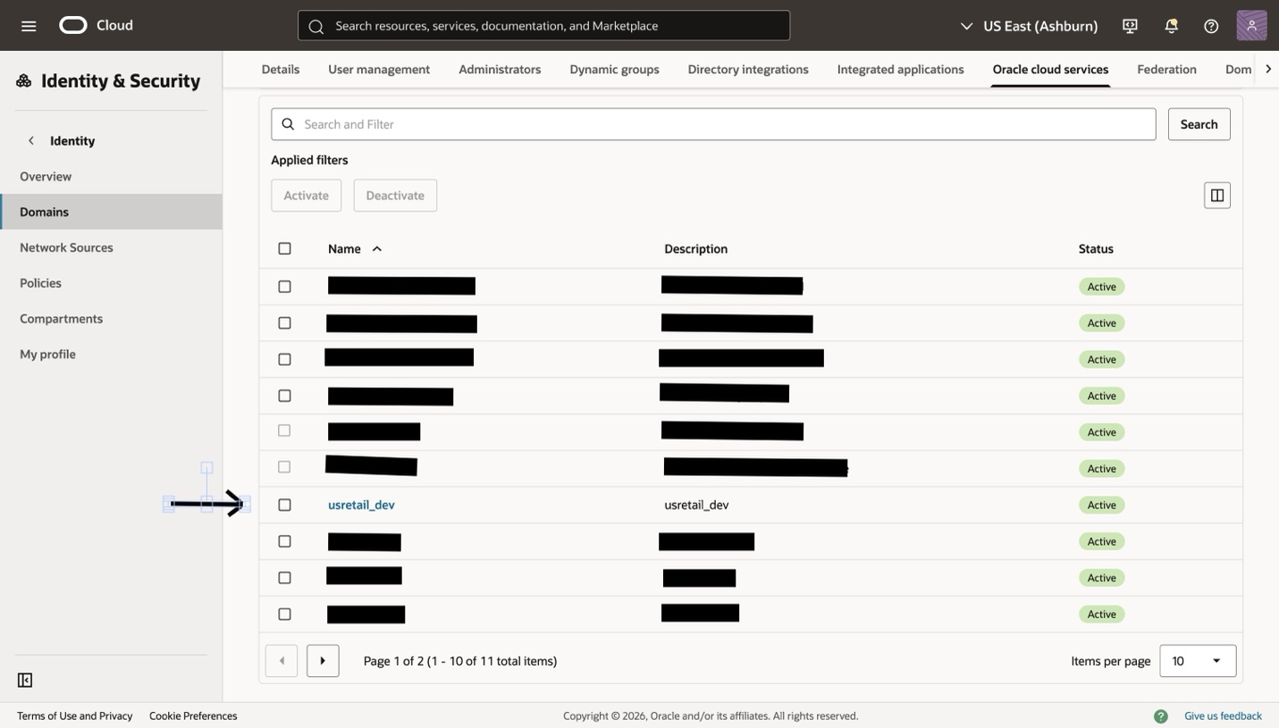

- Click the OAuth Configuration tab.
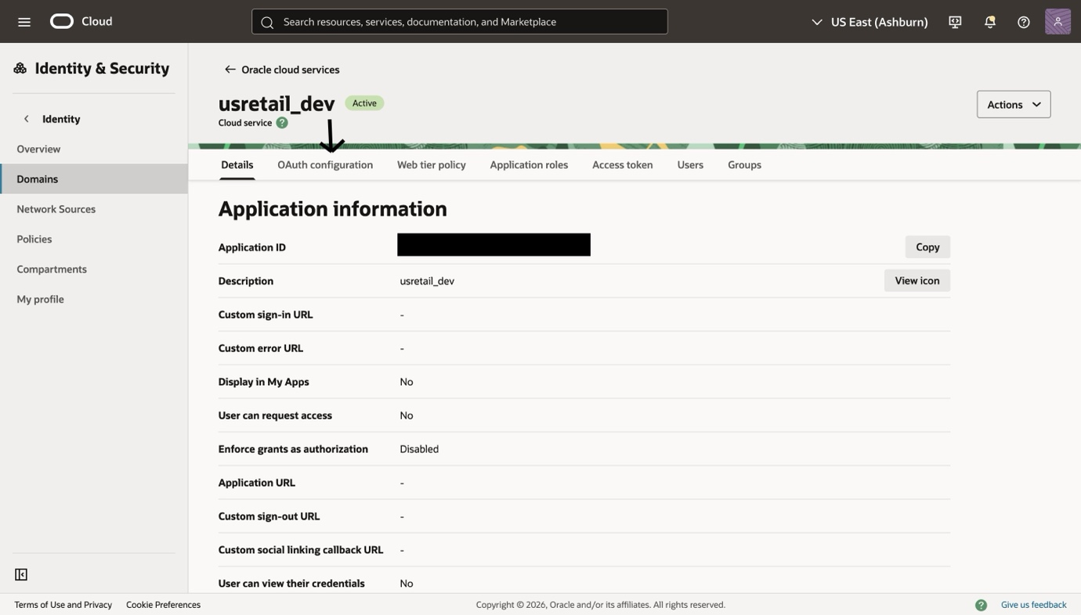
1. IDCS_URL
This is the token endpoint your application calls to get an access token.
How to get it
Your IDCS base URL is shown on the Domain overview page as Domain URL .Take that URL excluding the port and append the token path:

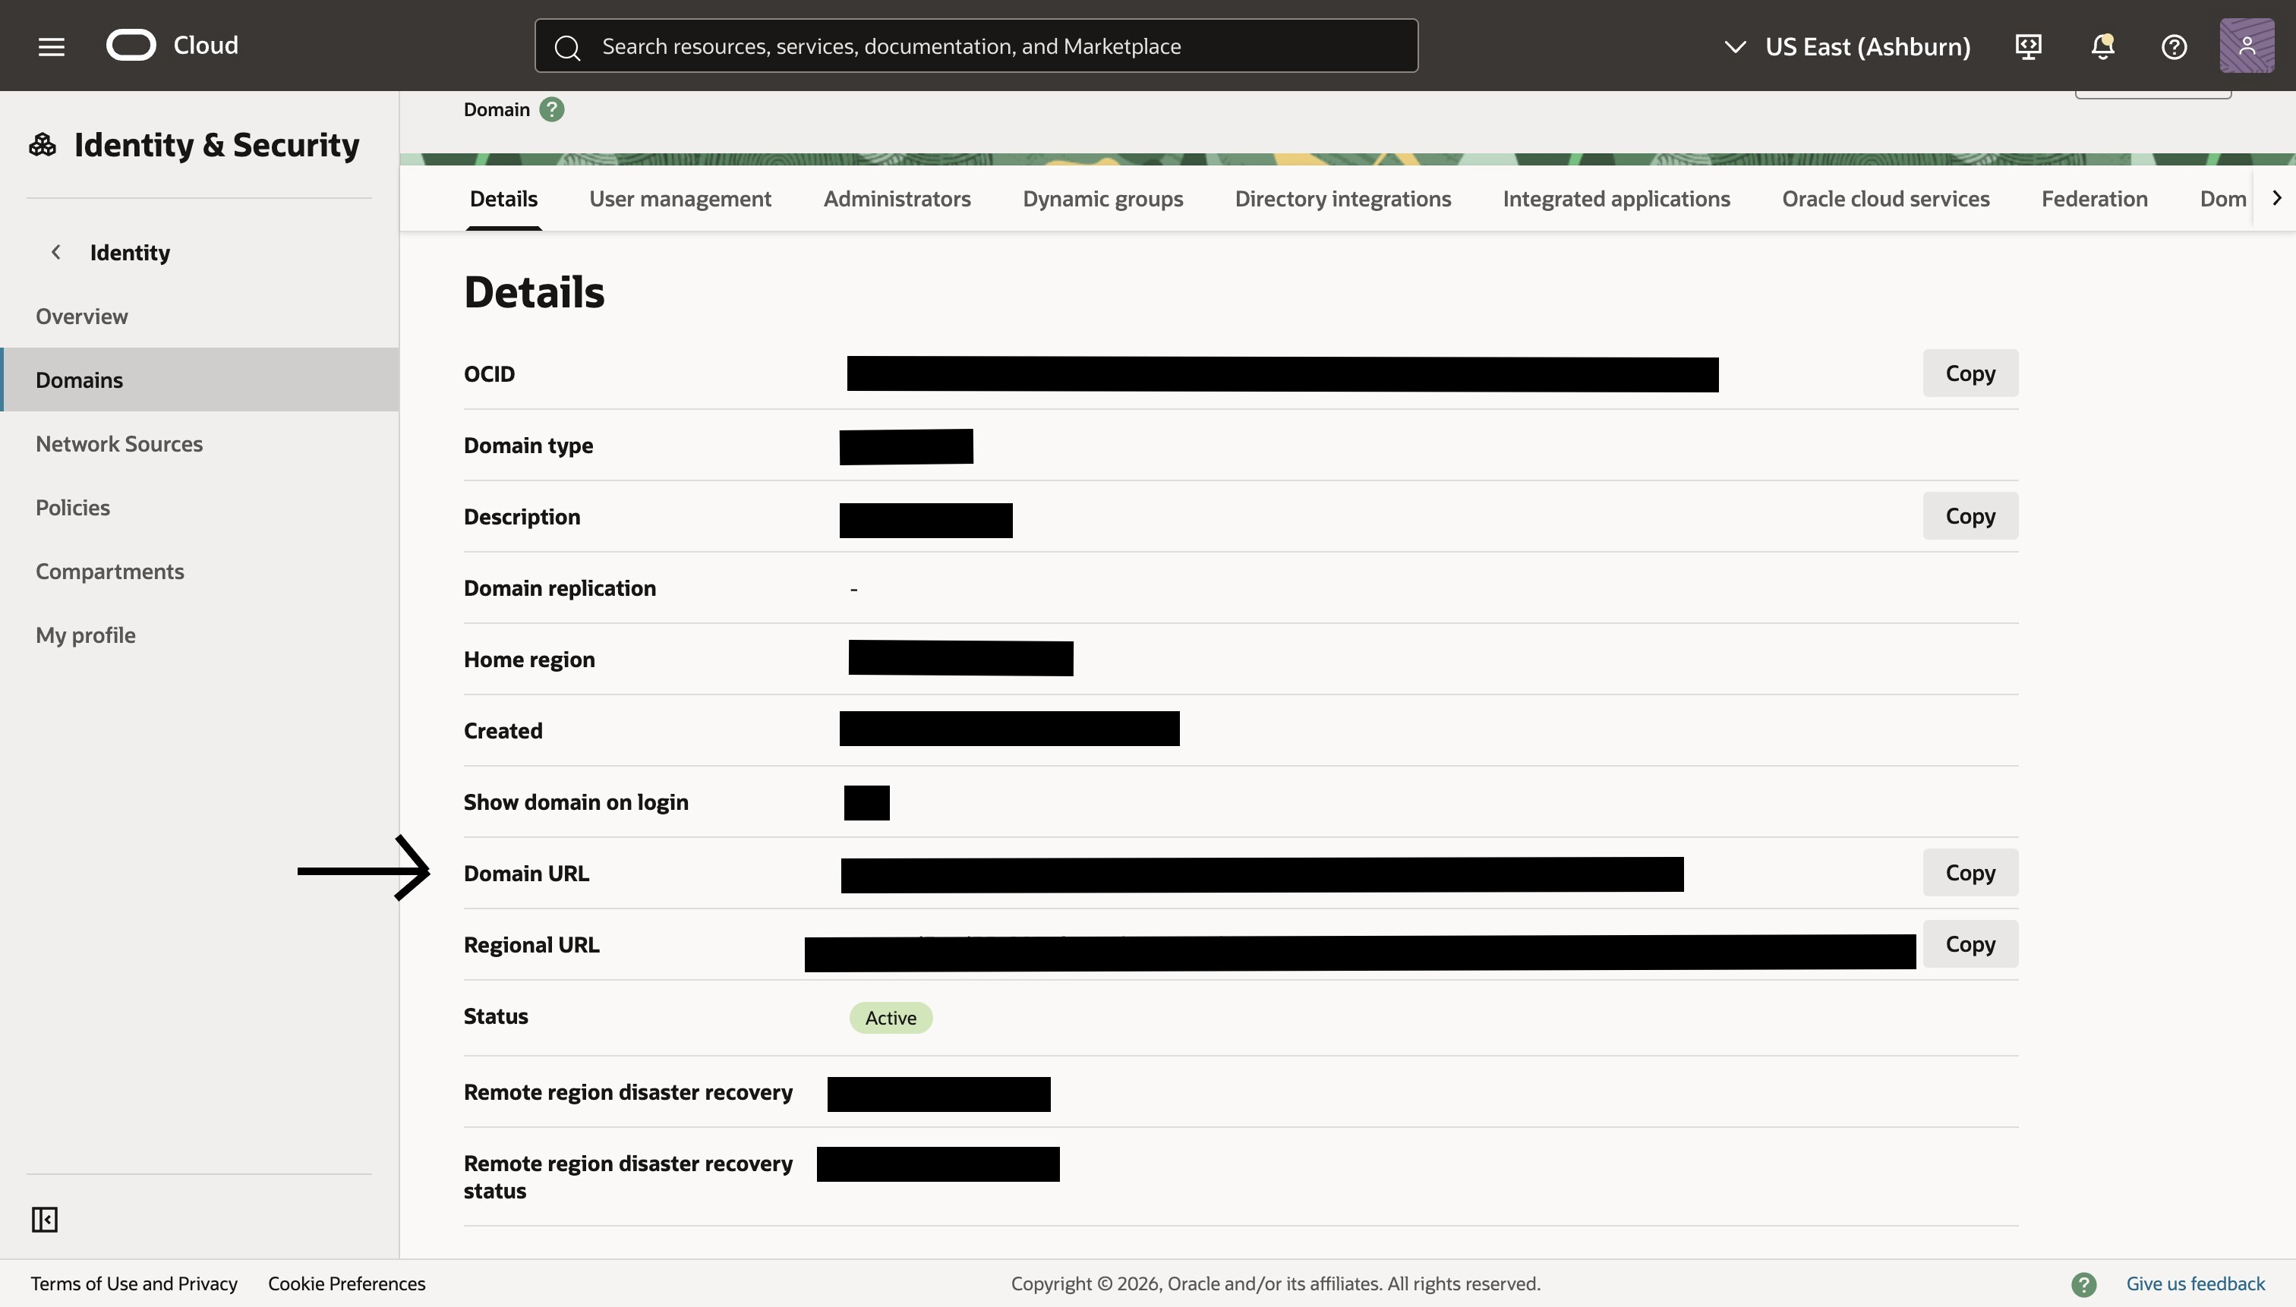
IDCS_URL = <your IDCS base URL>/oauth2/v1/token

Example:
https://idcs-12345.identity.pint.oc9qadev.com/oauth2/v1/token

Set in app
IDCS_URL → <your IDCS base URL>/oauth2/v1/token
2. ClientIdClientSecret
This is a Base64-encoded string of your application's Client ID and Client Secret, used to authenticate the application with IDCS.

How to get it
Follow the navigation steps above to reach the OAuth Configuration tab, then:

- On the OAuth Configuration page, scroll the page then you will see the Client ID.
- Click Show to reveal the Client Secret.
- Copy both values.
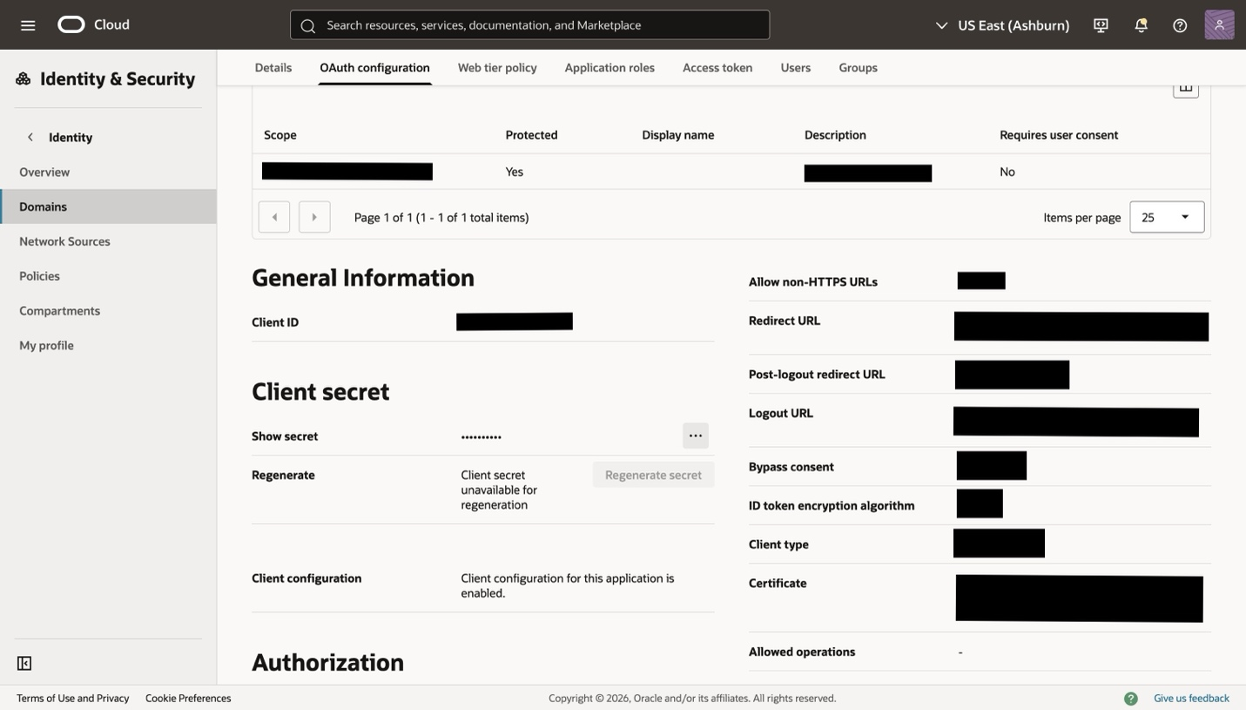

Now combine them with a colon and encode as Base64:

Format: ClientId:ClientSecret

Terminal command:
echo -n 'myClientId123:myClientSecret456' | base64

Example output:
bXlDbGllbnRJZDEyMzpteUNsaWVudFNlY3JldDQ1Ng==

Note: Use the -n flag with echo. Without it, a newline is included in the string and the Base64 output will be incorrect.

Set in app
ClientIdClientSecret → The Base64 string generated above.

3. SiriClientIdClientSecret
This property is required for Siri integration. It must always be set to the same value as ClientIdClientSecret.

Note: This property is mandatory. If it is missing or left blank, the application will crash on launch.

Set in app
SiriClientIdClientSecret → Same value as ClientIdClientSecret.
4. IDCS_Scope
This is the OAuth scope that tells IDCS what resource the application is requesting access to.
How to get it
Follow the navigation steps at the top to reach the OAuth Configuration tab, then:

- Click Edit OAuth Configuration.
- Check if primary audience is set.
- Scroll down to the Scopes section.
- Copy the scope that matches the format below.
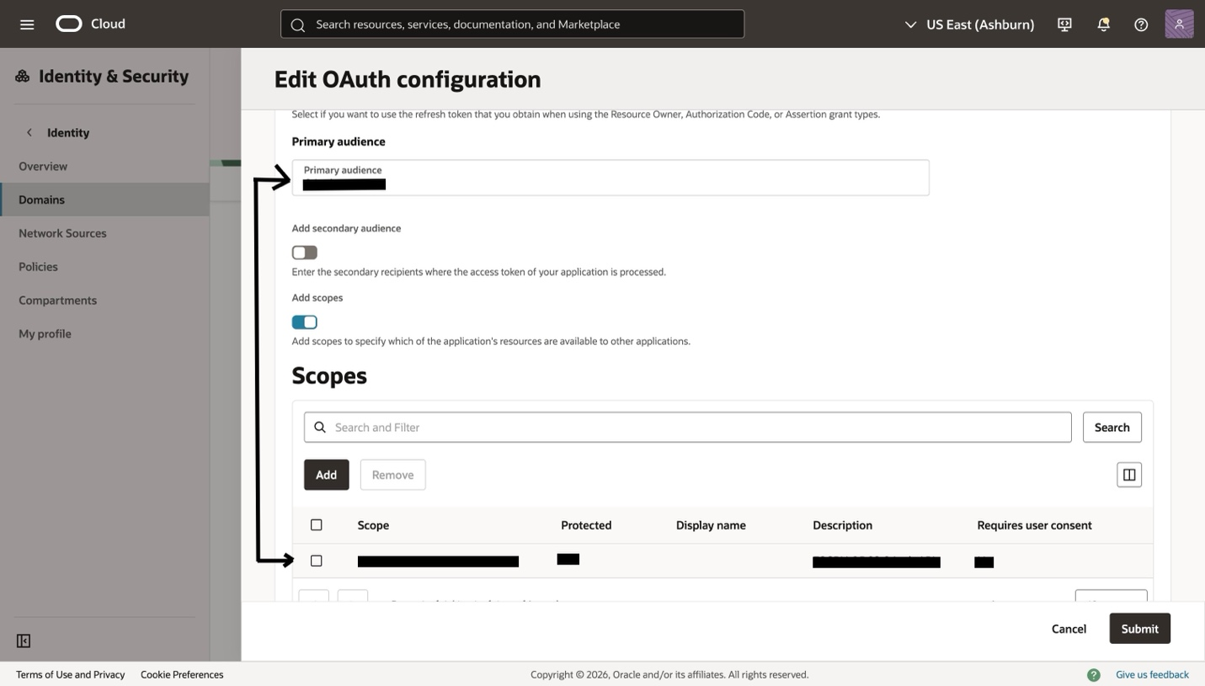
Format: ${Primary Audience}/consumer::<tenancy>

Example:
OAuth_access/consumer::tenancy_Dev_Access

Set in app
IDCS_Scope → The scope value according to above format or what ever applies.

5. Cookie
This can be extracted from the above property (IDCS_Scope)
How to extract it
Look for the scope that contains consumer:: in its string. Copy that value.

Format: OAuth_Access/consumer::<value>

Example:
OAuth_Access/consumer::mycompany.tenancy.oraclecloud.com

Set in app
Cookie → The value or the prefix from the above string (OAuth_Access/consumer:: prefix).

6. SERVER_TYPE
This tells the Mobile Workspace which authentication mode to use. The value is constant.

Set in app
SERVER_TYPE → OAUTH

7. KEY_SERVER_URL
This is the base URL you want your app to point on.

Note: The URL must not end with a forward slash ( / ). Remove it if present — a trailing slash will cause all API calls to fail.

Correct:
https://myapp.example.oraclecloud.com

Incorrect:
https://myapp.example.oraclecloud.com/

Set in app
KEY_SERVER_URL → Your Cloud URL with no trailing slash.

