Oracle Banking Routing Hub/Interconnect Module Setup details

Release:
OBMA/App Shell – 14.8.x
OBDX CS – 25.1, 22.2.6, 25.1.1.0, 25.1.2.0

Summary:
This document has details of the module specific configurations to be made in Oracle Digital Banking Experience CS for host calls to work through Oracle Banking Routing Hub.
This setup is with respect to base entity shipped with Oracle Digital Banking Experience CS setup.

Commonly used acronyms in this document:

Name | Value
OBDX CS | Oracle Banking Digital Experience Cloud Service
OBRH | Oracle Banking Routing Hub / Interconnect
OBMA | Oracle Banking Microservices Architecture

Pre-requisites:

OBRH basic setup is completed in Oracle Digital Banking Experience CS.

Module Specific Configurations as below:

For released version – 25.1.2 and above:

- Login to Oracle Digital Banking Experience CS using SUPERADMIN and search for System Configurations and go to the System Configuration screen as below

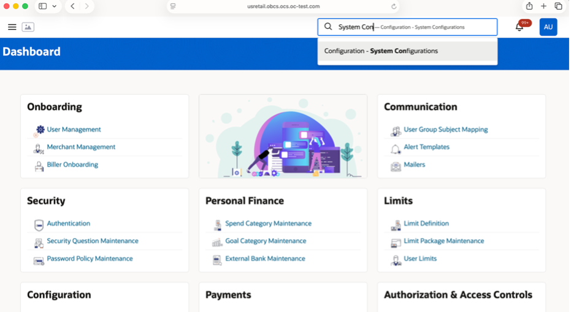

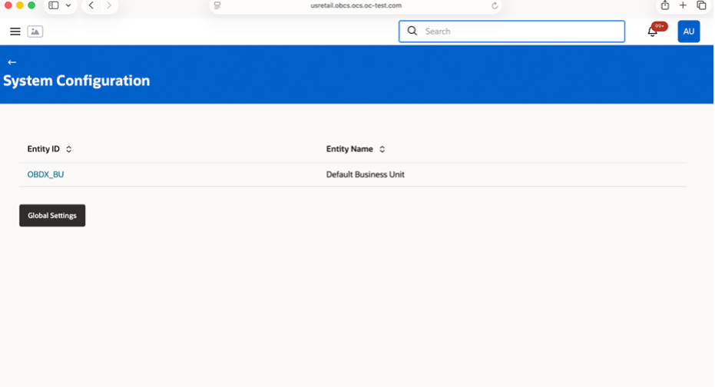

Configuration Screen for an entity will be displayed as below. Admin can navigate to relevant config from the options on the left and edit the configurations on right.

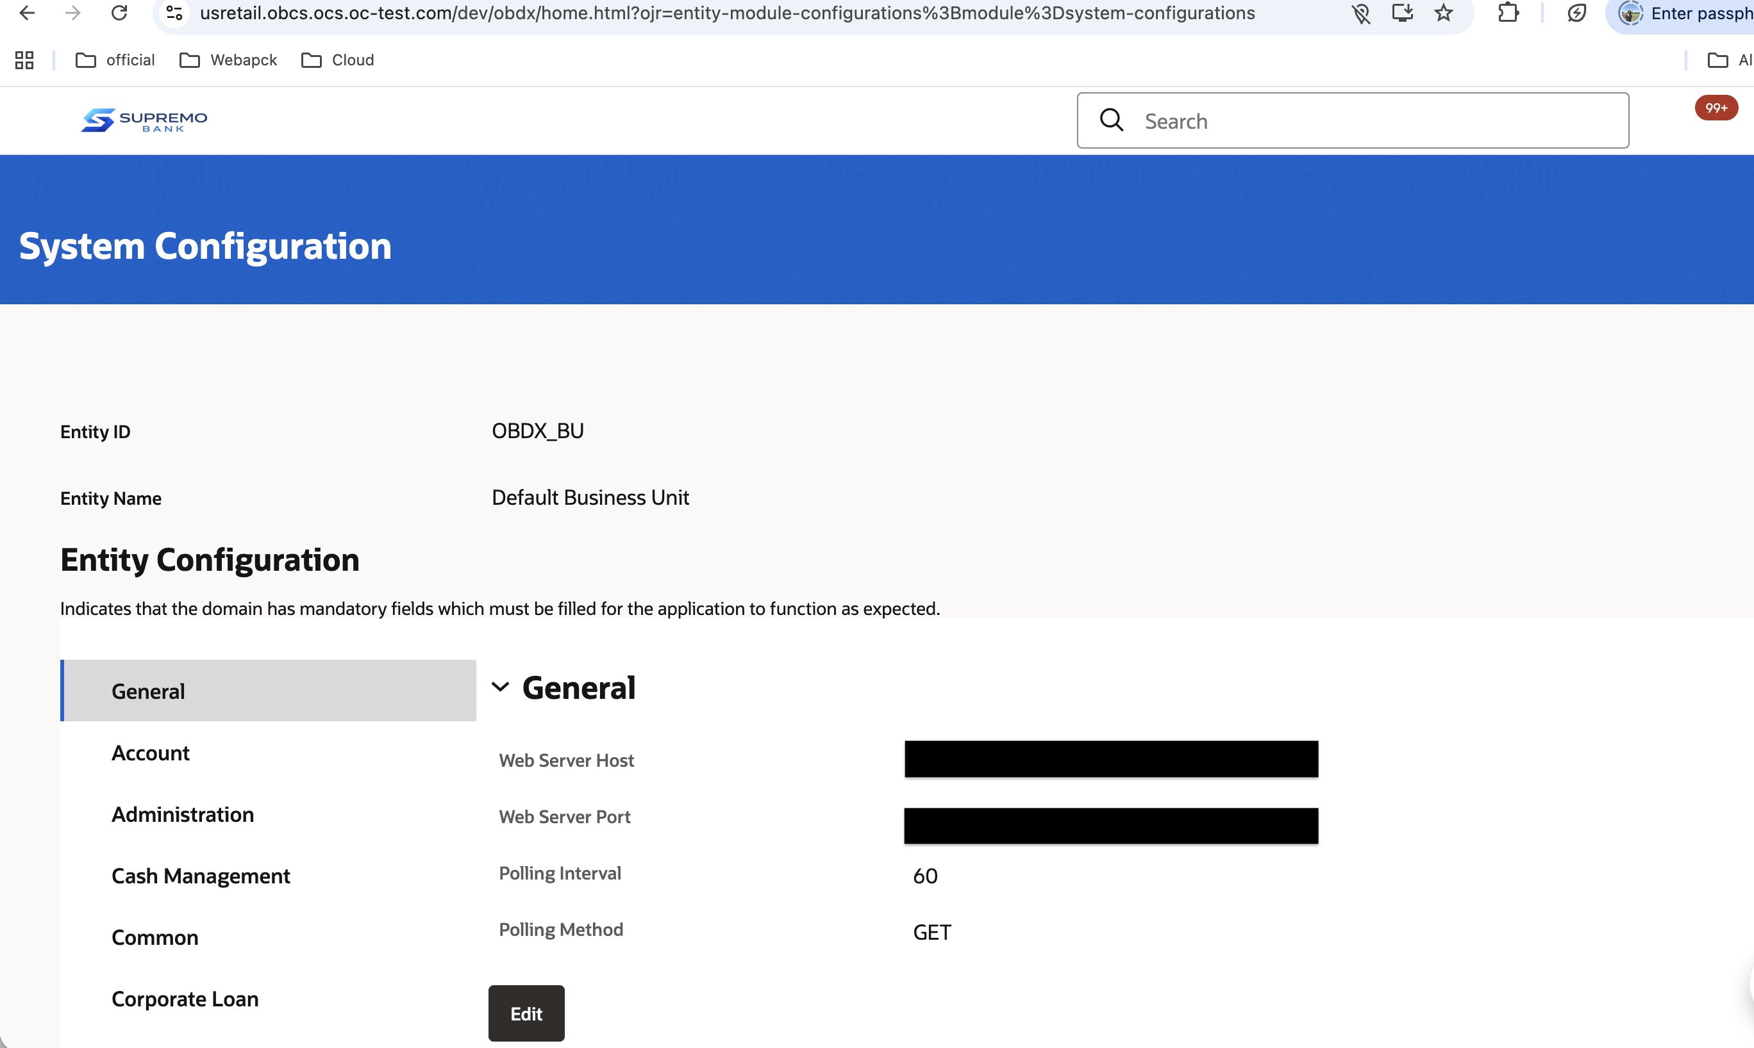

- To enable DDA, Term Deposits, Party & CommonCore, mark below mentioned configs to true under
System Configurations -> Selected Entity -> General Option
Enable common core.
Enable corporate demand deposits accounts.
Enable retail Demand Deposit Account
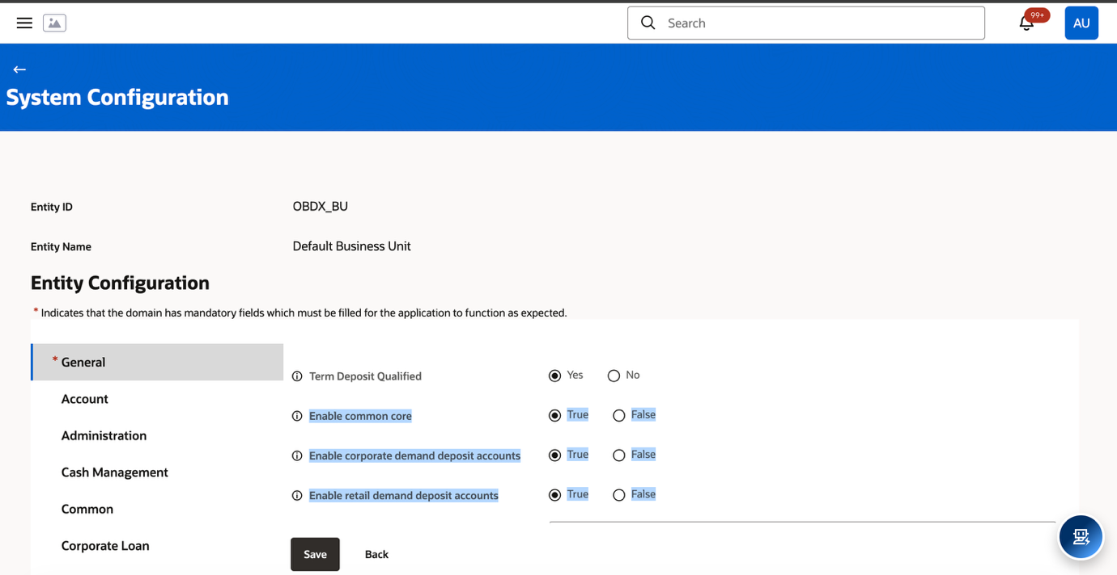

- Check if party calls work from user search screen in OBDX CS. If your party is searched, then OBRH/Interconnect setup is correct. Also, check other calls like accounts, term deposits etc are working.

For released version – 25.1, 25.1.1, 22.2.6.

- Login to Oracle Digital Banking Experience CS using SUPERADMIN and search for System Configurations and go to the System Configuration screen as below.

Configuration Screen for an entity will be displayed as below. Admin can navigate to relevant config from the options on the left and edit the configurations on right.

- To enable DDA & CommonCore, mark below mentioned configs to true under
System Configurations -> Selected Entity -> Account -> Demand Deposit
Enable common core
Enable corporate demand deposits accounts
Enable retail Demand Deposit Account
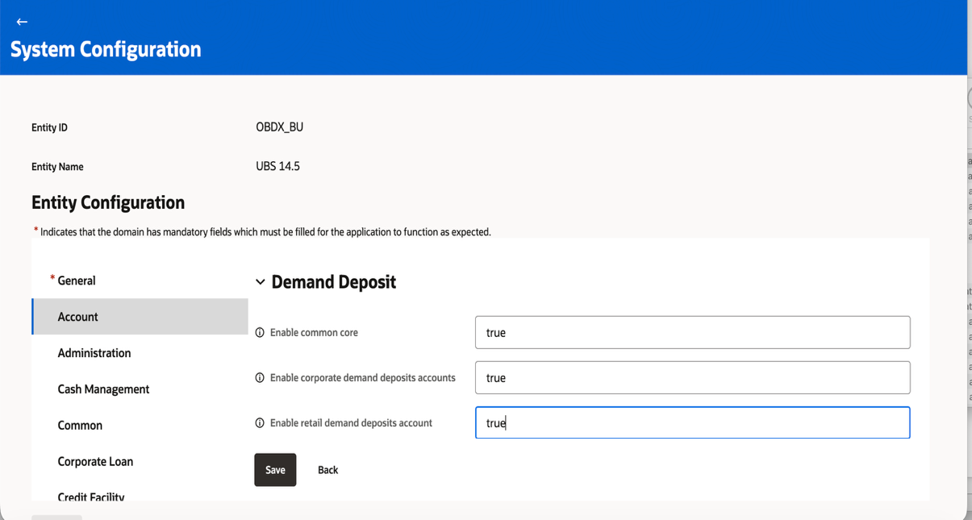
- To enable Term Deposit, mark below mentioned configs to true under
System Configurations -> Selected Entity -> Account -> Term Deposit
Enable common core
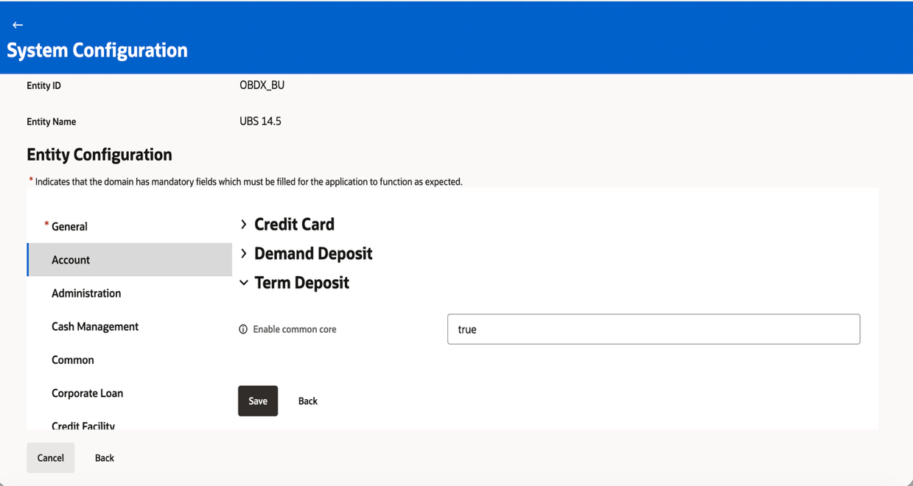
- To enable Party, mark below mentioned configs to true under
System Configurations -> Selected Entity -> Common -> Party

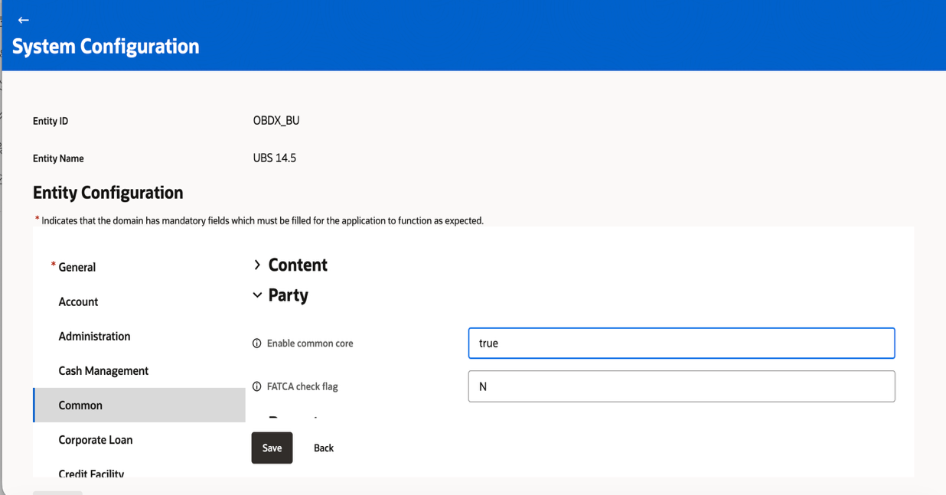

- Check if party calls work from user search screen in OBDX CS. If your party is searched, then OBRH/Interconnect setup is correct. Also, check other calls like accounts, term deposits etc are working.

Note: If OBPY host is not available in a particular setup, mark below flag as false in APP-SHELL
Follow these screenshots,

- Login to app-shell

- From menu search for Service Consumer and click on it

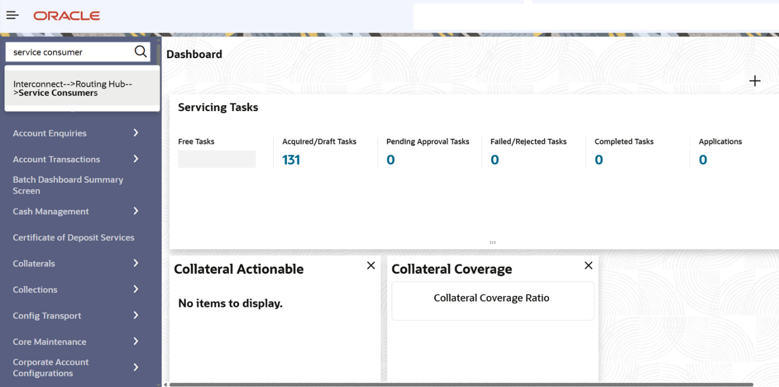

- In List of Service Consumers search for OBDX_TRUNK consumer

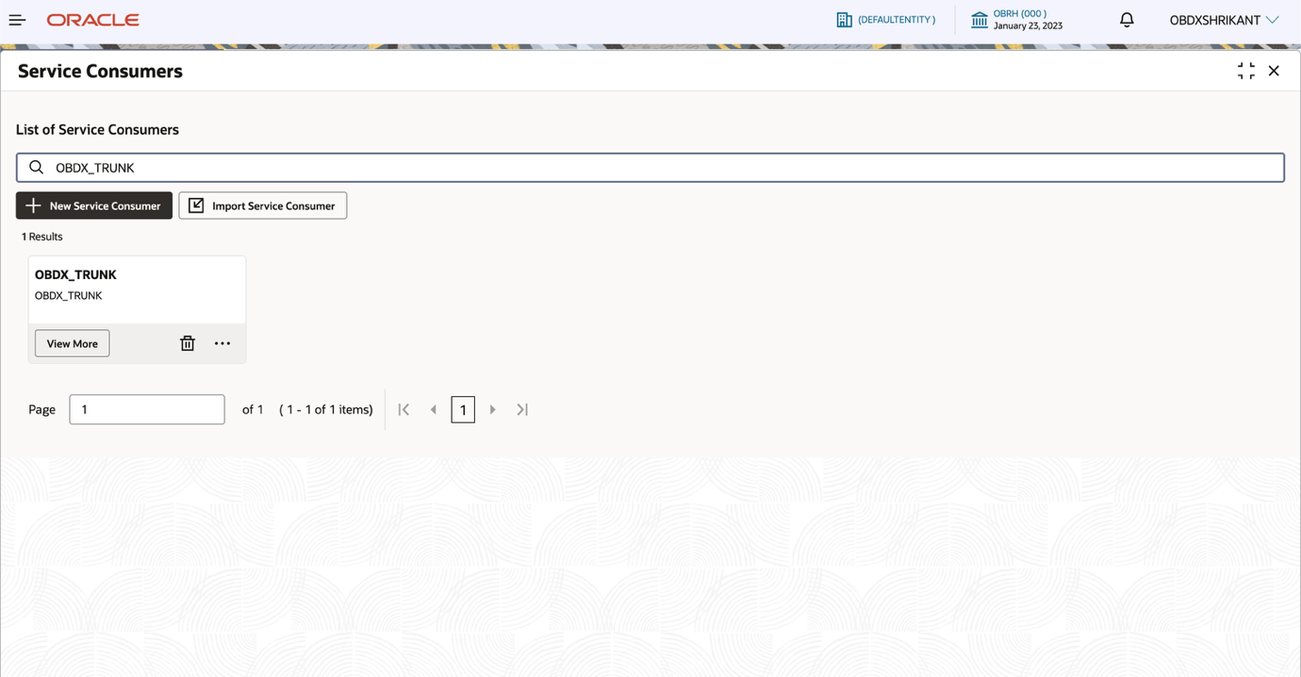

- Go to environment Variables.

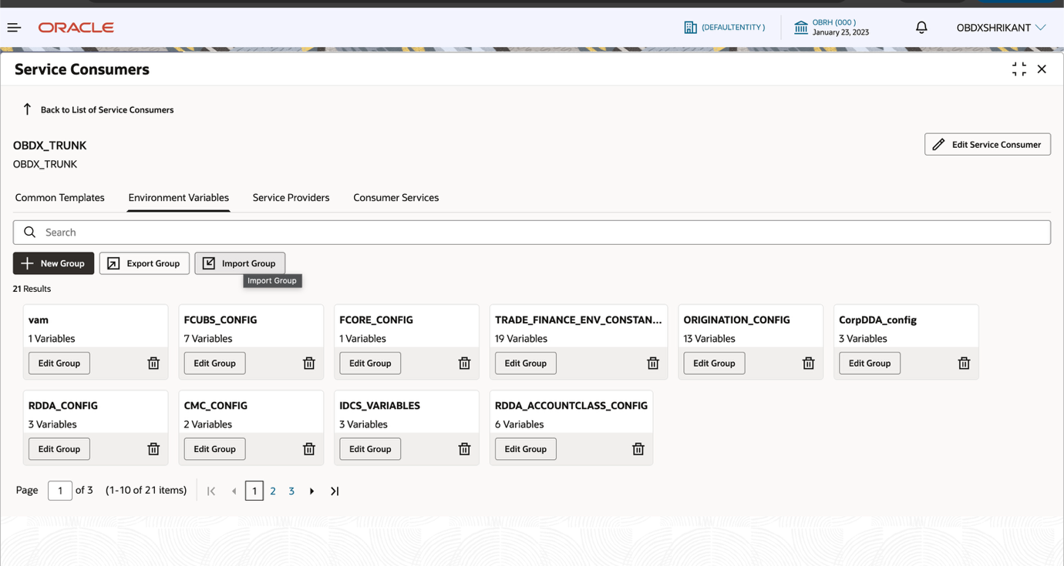

- Search for HOST_SUPPORT_CONFIG

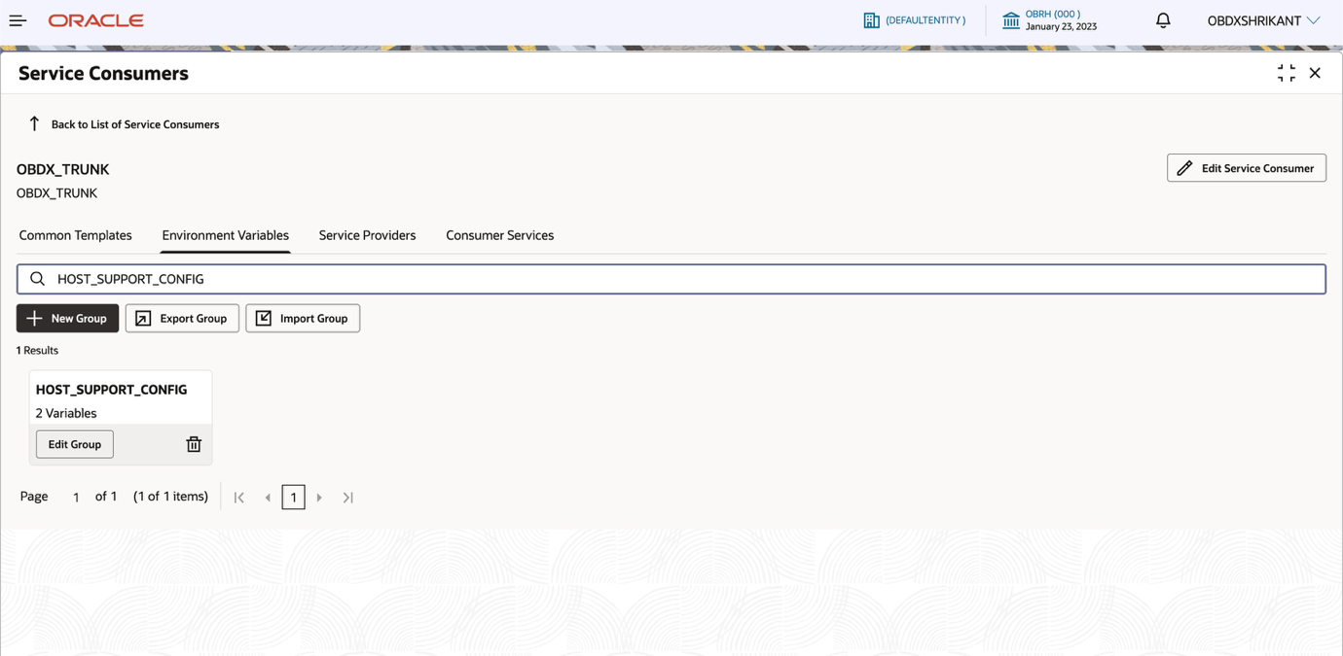

- Click on edit group then change the variable value of OBPY to false and save.

