Refer Technical Integration user manual guide for OBDX-OBO for more detailed information which will get release as part of user manual for end to end integration of OBDX-OBO for Retail Origination.
User Manual: obo-mid-office-and-third-party-setup-and-configuration-guide

- Login to OBRH and search for “Service Consumers”.
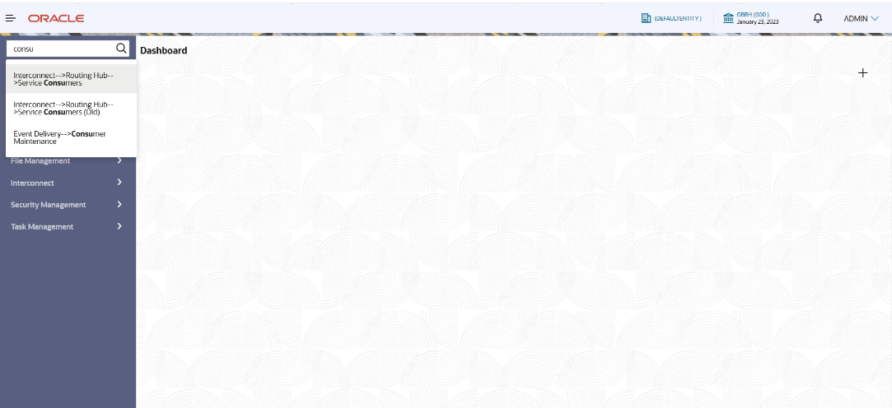

- Search for OBDX_TRUNK service consumer which will be part of each release and all OBDX related OBRH configuration handled in this consumer only.

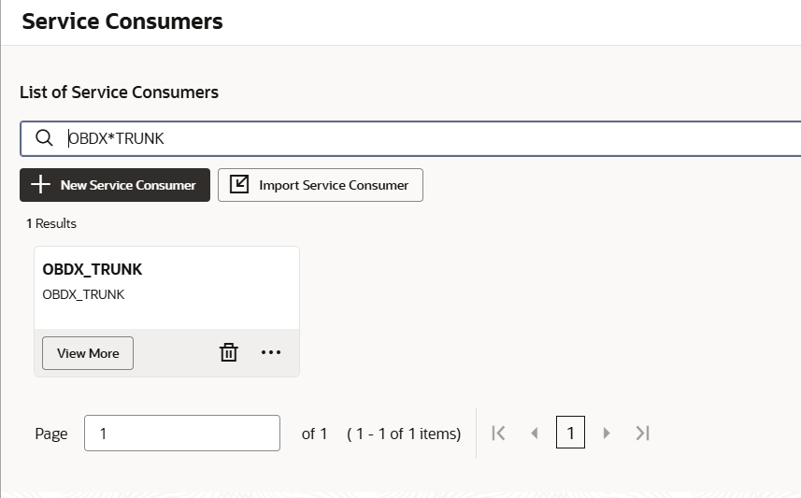

- Go to “Environment Variables” and search for “ORIGINATION_CONFIG” which will have required variables needed to call OBO APIs as part of API Headers.

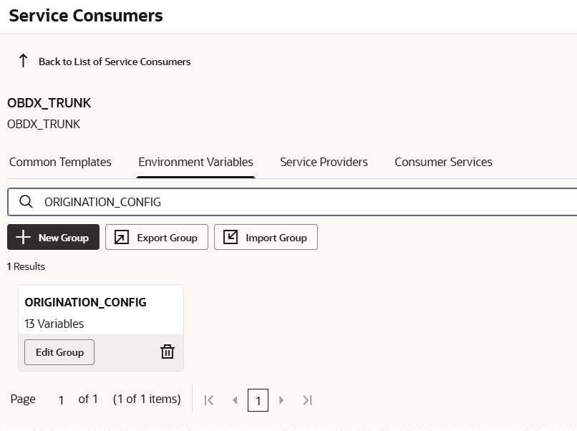

Refer “obo-mid-office-and-third-party-setup-and-configuration-guide” for detailed information.

- Below are the environment variables which need to be updated as per OBO environment to which OBDX is getting integrated.

Variable Name | Variable Value | Remarks
OBO_USER | <OBO_USER> ask OBO team to create API users | To call OBO API, users have to be created in OBO Application and all FACODEs permission should be provided to access the API. In case of CLOUD, user should be present in IDCS also with required permission.
OBO_BRANCH | < OBO_BRANCH> | Host branch as per OBO
OBPY_USER | Same value as <OBO_USER>
OBPY_BRANCH | Same value as <OBO_BRANCH>
CMC_USER | < CMC_USER> as OBO team to create separate user to call CMC APIs | This user should be separate with same permission as OBO_USER as this user is used to handle Content API integration with Token.
CMC_BRANCH | Same value as <OBO_BRANCH>
JUMIO_AUTH | < JUMIO_AUTH> | If client has JUMIO API integration for KYC, then Token will be setup accordingly. On Cloud, JUMIO is not supported.
OBO_VERSION | < OBO_VERSION> | This should be Host release version e.g. 14.8.1 , 14.8.2 as OBO is bring up API versioning. This is important parameter

- For OBRH consumer services / service provider, used in Origination, refer technical guide which has covered all setup information along with list of service providers used by Retail Origination.

- For On-Prem, you need to provide IP and PORT of OBO host application in each Service Provider and for CLOUD, you need to enable EUREKA with HTTP as shown below.
E.g
For On-Prem env, Eureka should be FALSE, Scheme – depending on OBO if HTTPS or HTTP api calls enabled and provide HOST and PORT value of which environment of OBO need to integrate.
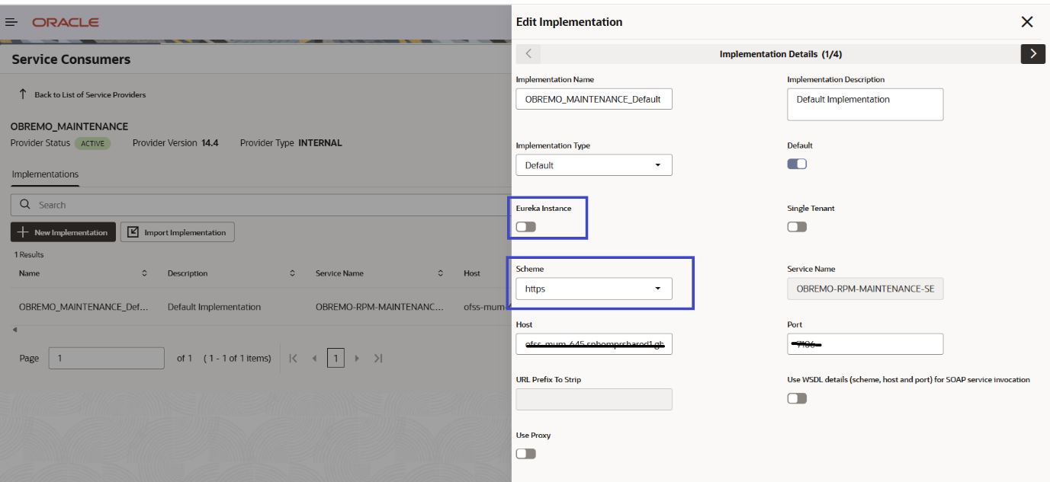

For CLOUD, you need to just enable EUREKA ON (this will be default on when CLOUD env) and scheme should be HTTP. These changes will be handled during deployment on CLOD. In case any issues during OBRH calls, this is pre-requisite.

