Step 1: Login Evidence
After login
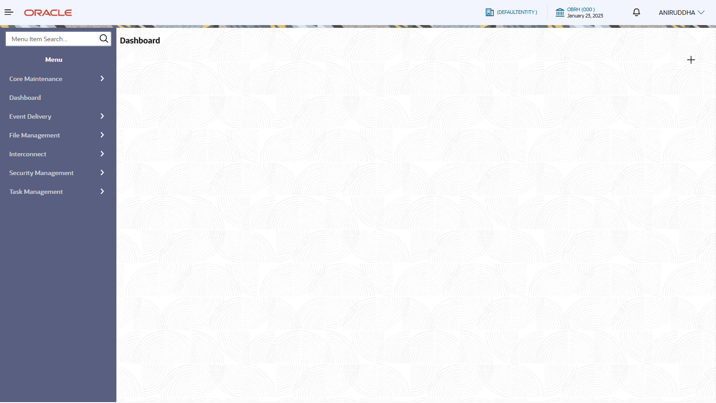

Step 2: OBDX_TRUNK in Service Consumer and Environment Variable
Service Consumers page
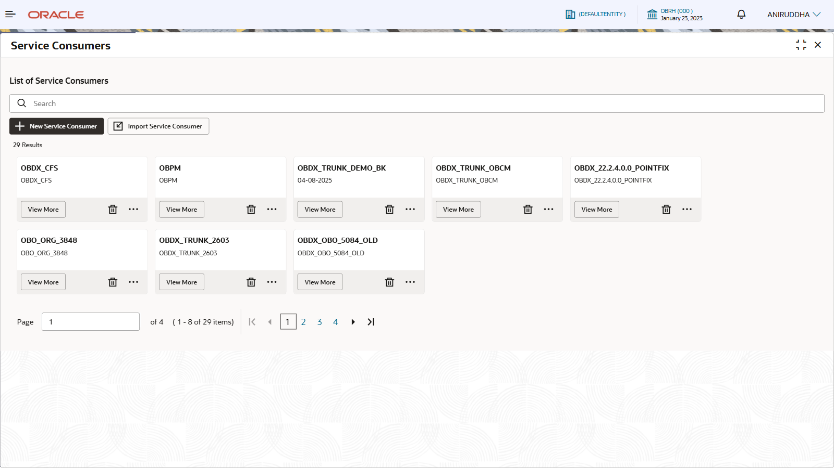
Search result for OBDX_TRUNK
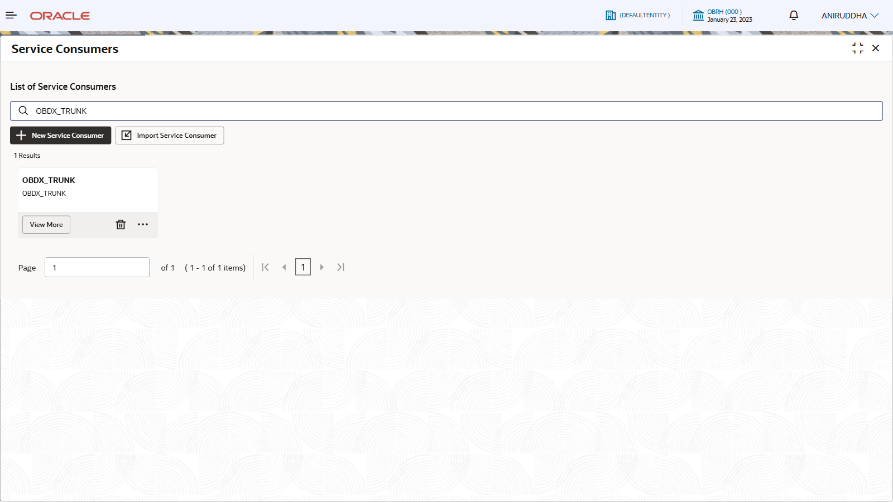
OBDX_TRUNK details open
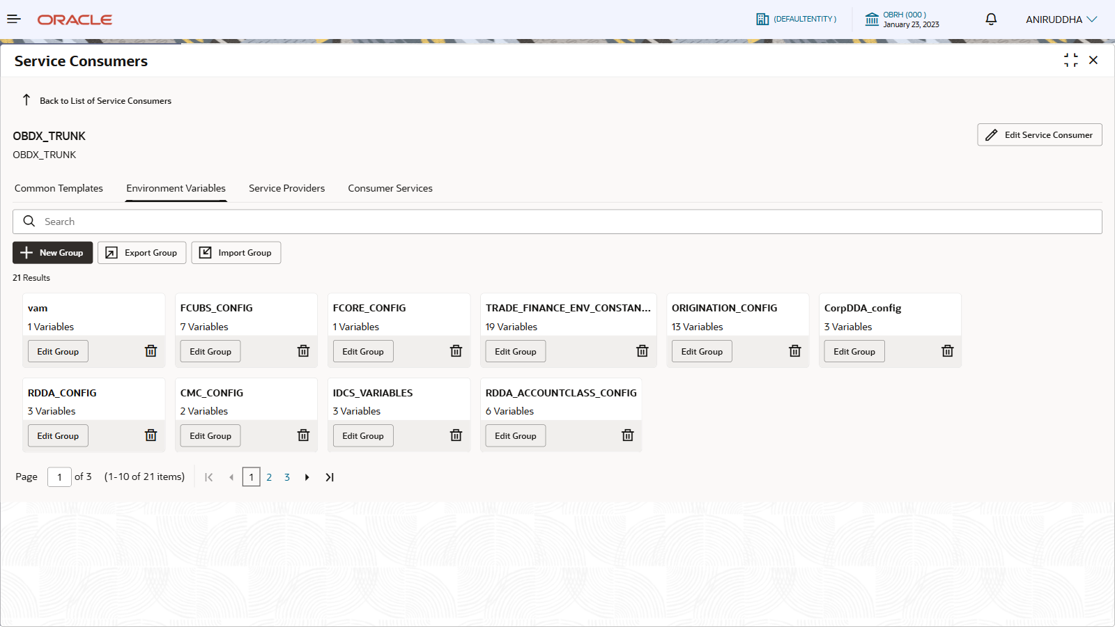
Environment Variable tab open
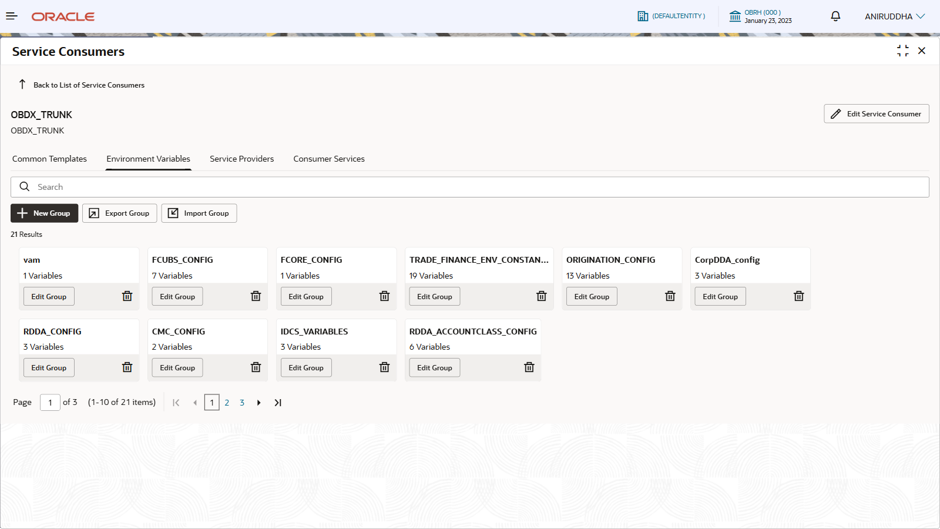

OBTR_FX_CONFIG
Search result for OBTR_FX_CONFIG
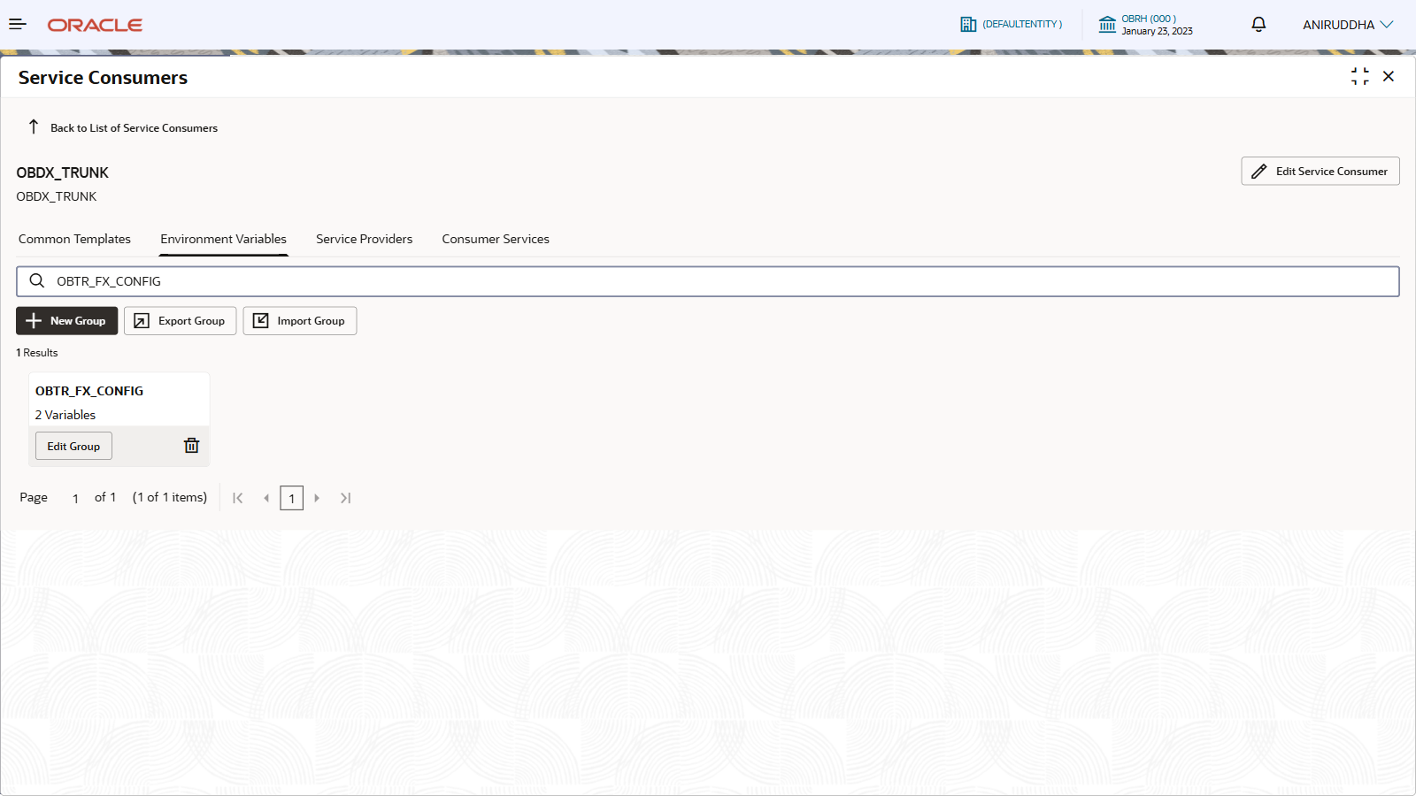
Edit Group window for OBTR_FX_CONFIG
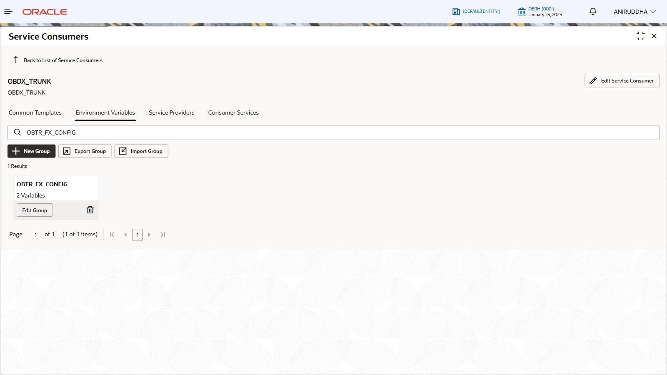
Sample Values :
Name | Description | Sample Value
HOST | OBTR (Oracle Banking Trade & Treasury) FX/Forex service host (endpoint DNS) used to connect to the FX deal/rate engine or related OBTR service. | ofss-mum-682.snbomprshared1.gbucdsint02bom.oraclevcn.com
PORT | TCP port for connecting to the OBTR FX service endpoint. | 7005

OBPM_HEADER_CONFIG
Search result for OBPM_HEADER_CONFIG
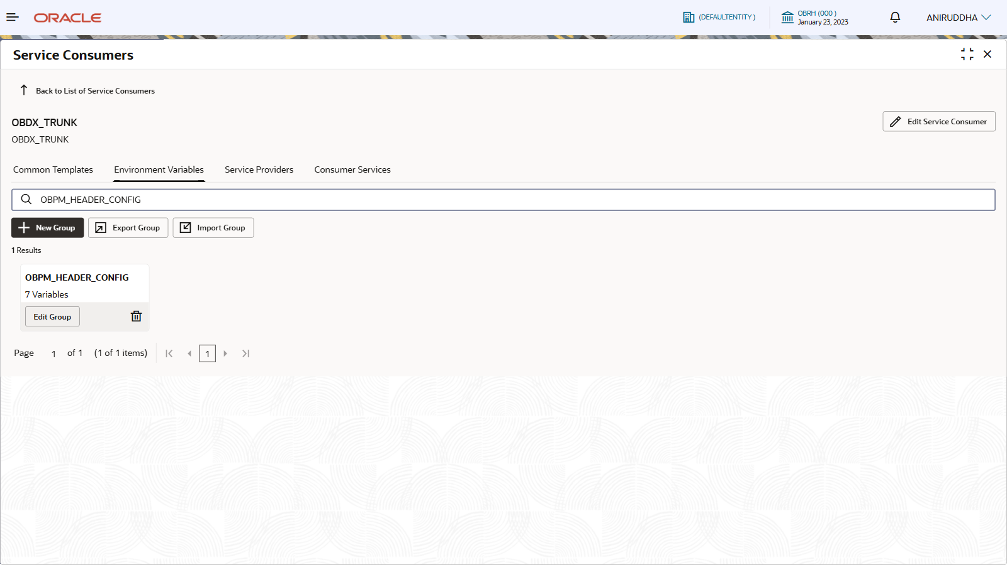
Edit Group window for OBPM_HEADER_CONFIG
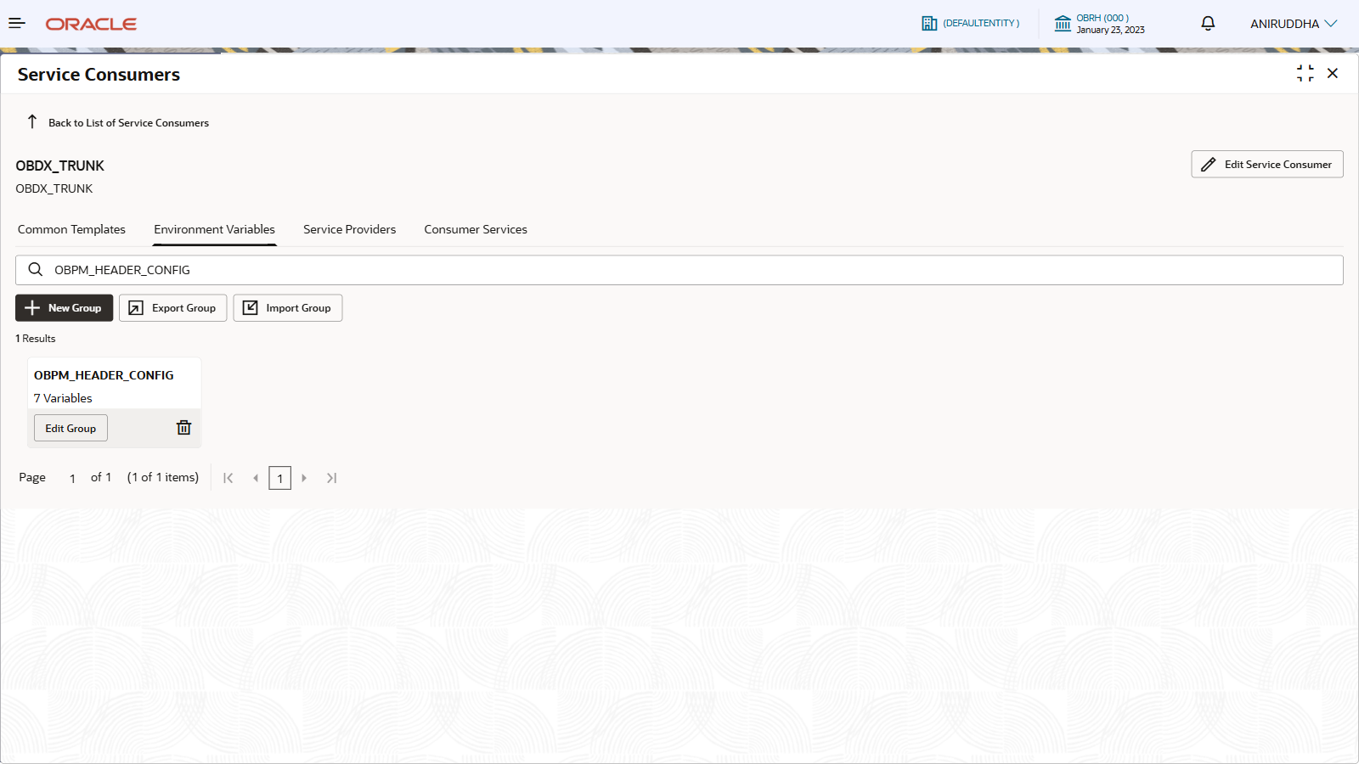
Sample Values :
Name | Description | Sample Value
SOURCE_CODE | Channel/source system code identifying the originating application/channel for the payment request (used for routing/audit/entitlements). | INTBANKING
USER_ID | User identifier sent in OBPM headers for authentication/authorization/audit (service user / system user). | FCATOP
BRANCH_CODE | Branch/office code used for processing context (booking branch, servicing branch, or processing unit depending on configuration). | HEL
HOST_CODE | Logical host/region/processing center code used by OBPM to route requests to the appropriate host integration. | FINLAND
ENTITY_ID | Legal entity/tenant identifier (multi-entity setups) for scoping configuration, processing rules, and data segregation. | ENTITY_ID1
MODULE_ID | Module identifier indicating the functional module handling the request (Payments module). | PM
SOURCE | Source system short code (often same intent as SOURCE_CODE; exact usage depends on implementation). | FCAT

OBPM_HOST_CONFIG
Search result for OBPM_HOST_CONFIG
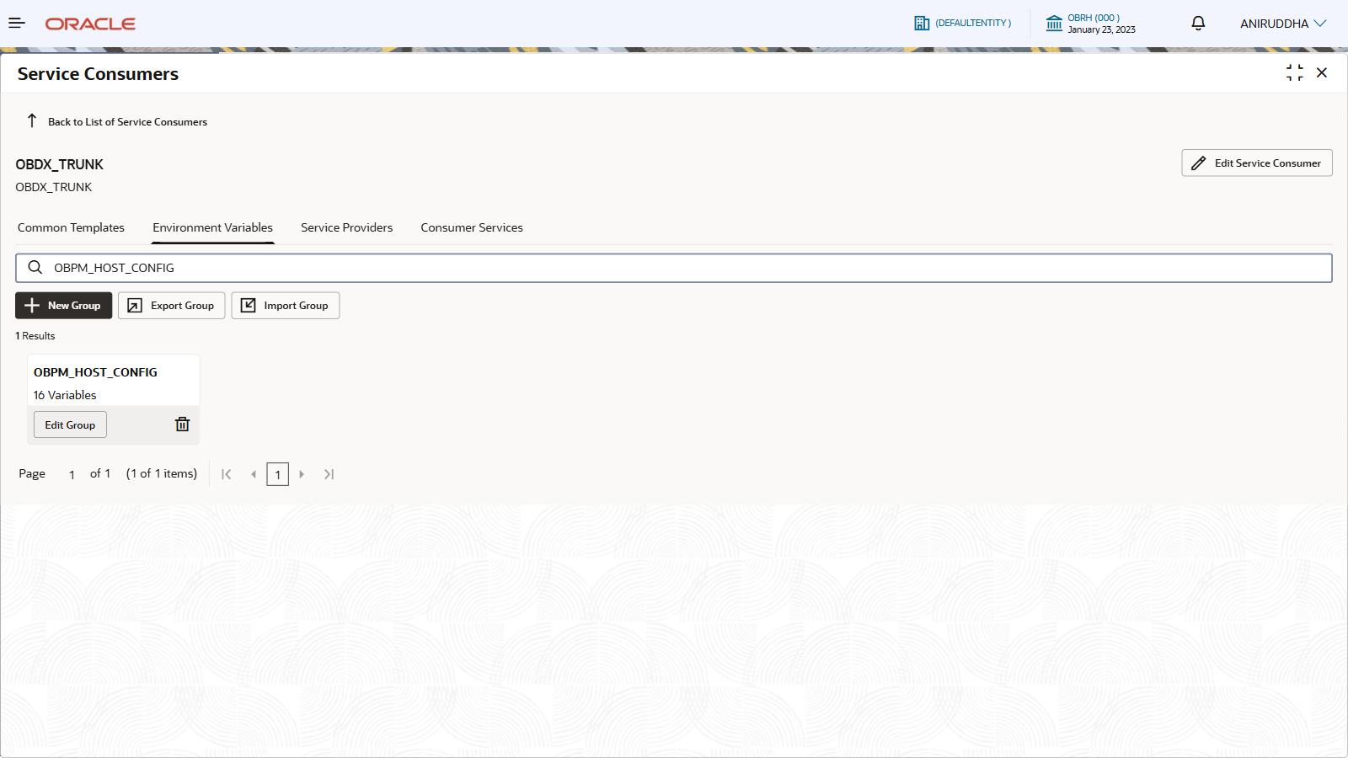
Edit Group window for OBPM_HOST_CONFIG
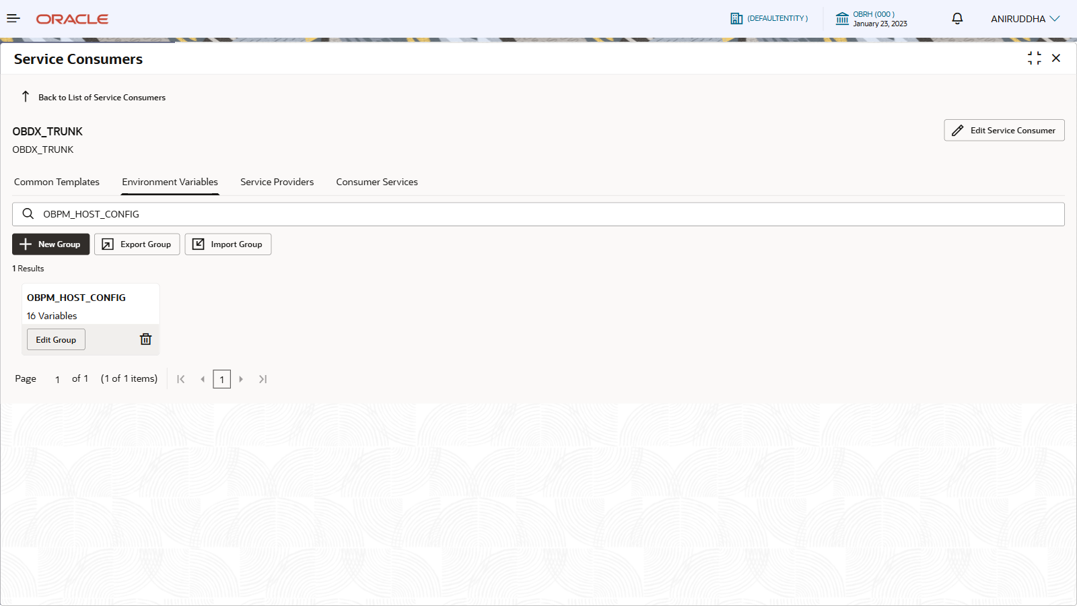
Sample Values :
Name | Description | Sample Value
FOUNDATION_HOST | Host/IP for the OBPM “Foundation”/base services endpoint (common services used by payment processing). | 100.76.144.209
FOUNDATION_PORT | Port for the OBPM Foundation endpoint. | 9999
INDIA_HOST | Host/IP for India payments endpoint (typically used for domestic schemes like NEFT/RTGS/IMPS integrations). | 100.76.144.209
INDIA_PORT | Port for India payments endpoint. | 9999
REST_HOST | Host/IP for OBPM REST API endpoint (HTTP-based service access). | 100.76.144.209
REST_PORT | Port for OBPM REST API endpoint. | 9999
INDIA_IMPS_HOST | Host/IP specifically for IMPS connectivity/processing endpoint (India instant payments). | 100.76.144.209
INDIA_IMPS_PORT | Port for IMPS endpoint. | 9999
CROSSBORDER_HOST | Host/IP for cross-border payments endpoint (e.g., SWIFT/SWIFT gpi or correspondent flows depending on deployment). | 100.76.144.209
CROSSBORDER_PORT | Port for cross-border payments endpoint. | 9999
GENERIC_HOST | Catch-all/default host when a network-specific host is not configured/selected. | 100.76.144.209
GENERIC_PORT | Port for the generic/default endpoint. | 9999
EUROPE_INSTANT_HOST | Host/IP for European instant payments endpoint (often SCT Inst / SEPA Instant rails). | 100.76.144.209
EUROPE_INSTANT_PORT | Port for European instant payments endpoint. | 9999
EUROPE_HOST | Host/IP for Europe payments endpoint (often SEPA Credit Transfer / SEPA Direct Debit rails). | 100.76.144.209
EUROPE_PORT | Port for Europe payments endpoint. | 9999

OBPM_NETWORK_CONFIG
Search result for OBPM_NETWORK_CONFIG
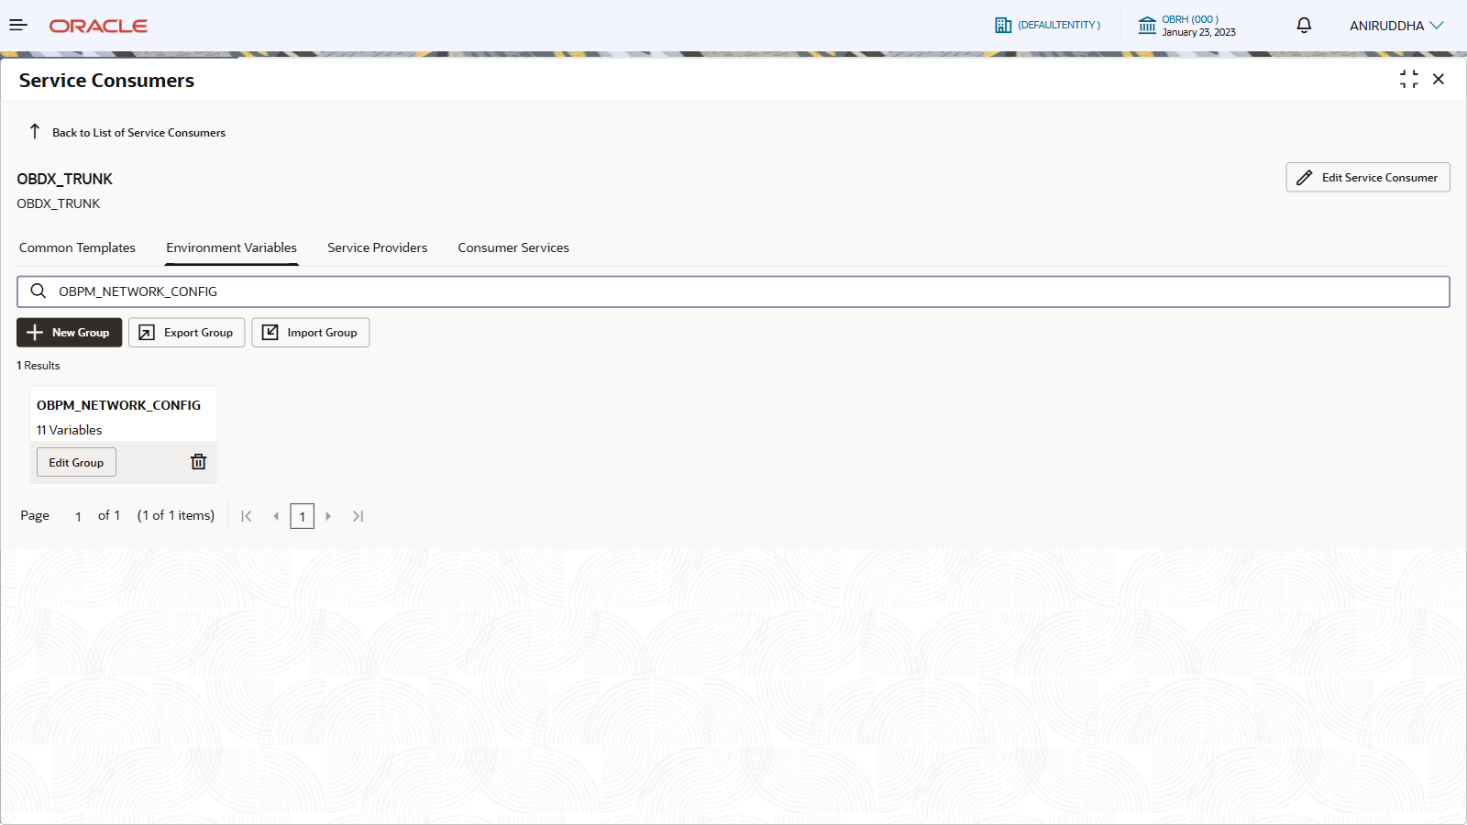
Edit Group window for OBPM_NETWORK_CONFIG
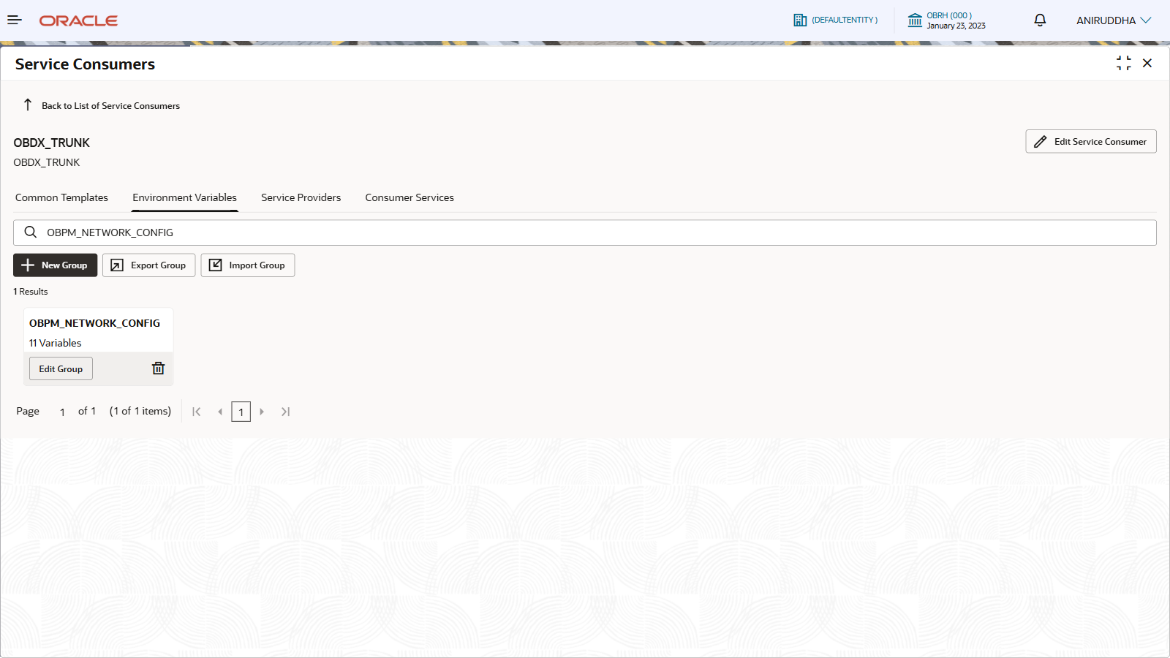
Sample Values :
Name | Description | Sample Value
INTERNAL | Network code for internal/on-us/book transfers (intra-bank). | BOOK
INTERNATIONALSWIFT | Network code for SWIFT FIN / traditional SWIFT cross-border messaging. | SWIFT
SEPACREDIT | Network/clearing identifier for SEPA Credit Transfer (SCT). | STEP2
IMPS | Network code for IMPS (India Immediate Payment Service). | IMPS
NEFT | Network code for NEFT (India batch/near-real-time retail payments). | NEFT
RTGS | Network code for RTGS (India high-value real-time gross settlement). | RTGS
FPOUT | Network code for outgoing instant payments rail (commonly mapped to SCT Inst in Europe). | SCTINST
CLEARING_SYSTEM_ID_CODE | Clearing system identifier code used in payment messages/routing (often a scheme/CSM identifier configured for Europe). | ATBLZ
SEPA_DIRECTDEBIT | Network code for SEPA Direct Debit (SDD). | SDCO
INTERNATIONALSWIFTISO | Network code for SWIFT ISO 20022-based flows (e.g., CBPR+ pacs.* via SWIFT). | SWIFTISO
CHAPS | Network code for UK CHAPS high-value GBP payments. | UKCHAPS

