Step 1: Login
After Login
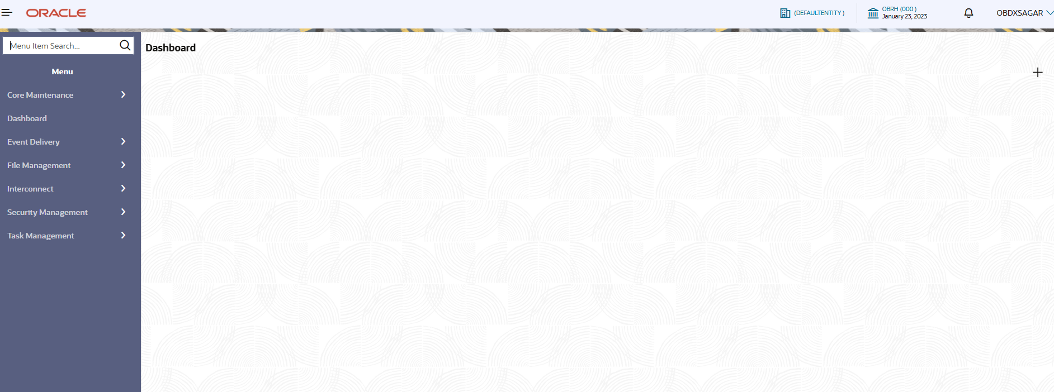

Step 2: OBDX_TRUNK in Service Consumer and Environment Variable
Service Consumers page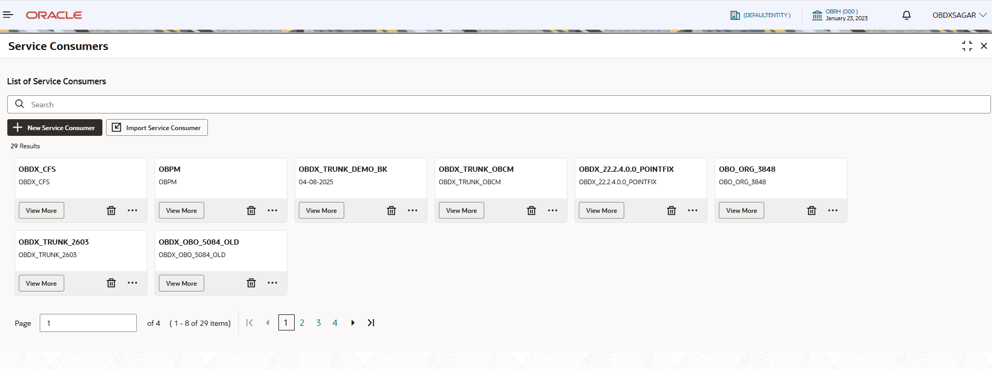

Search result for OBDX_TRUNK
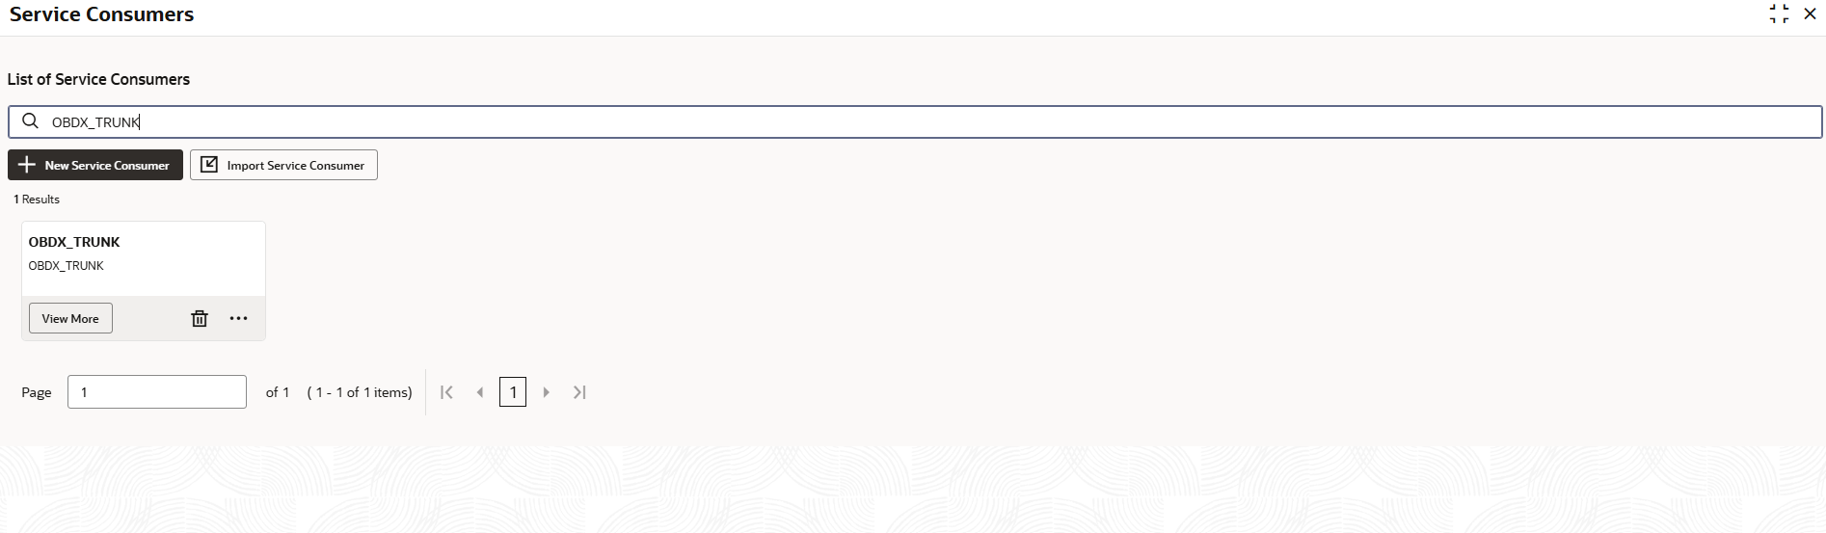
OBDX_TRUNK details open
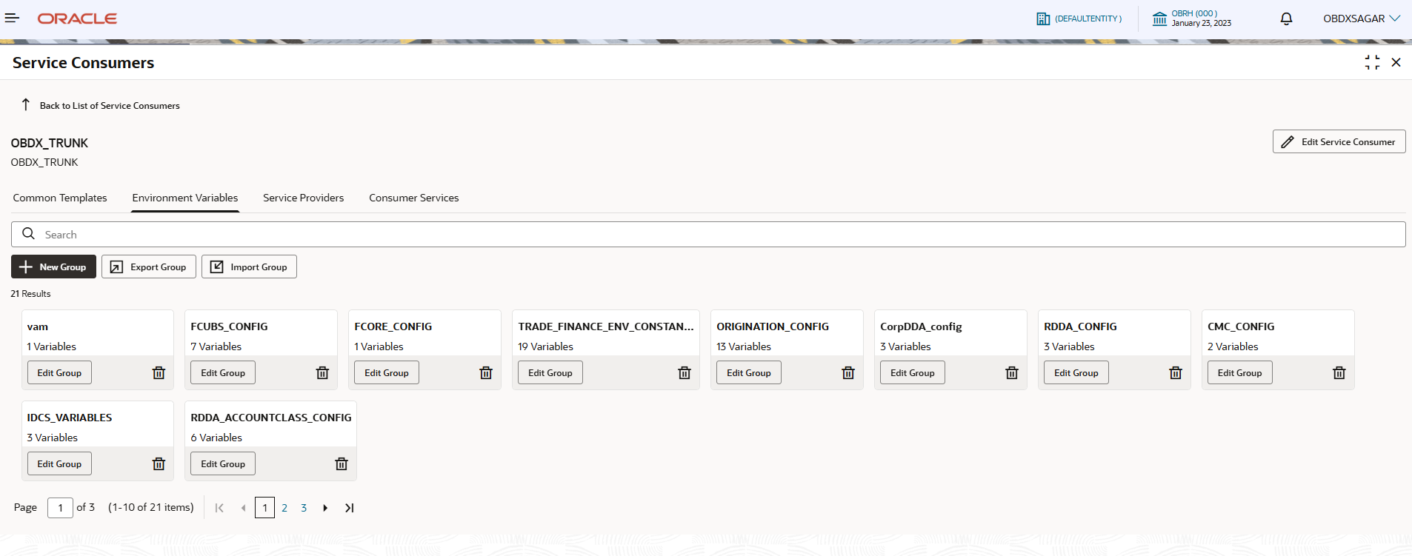
Environment Variable tab open
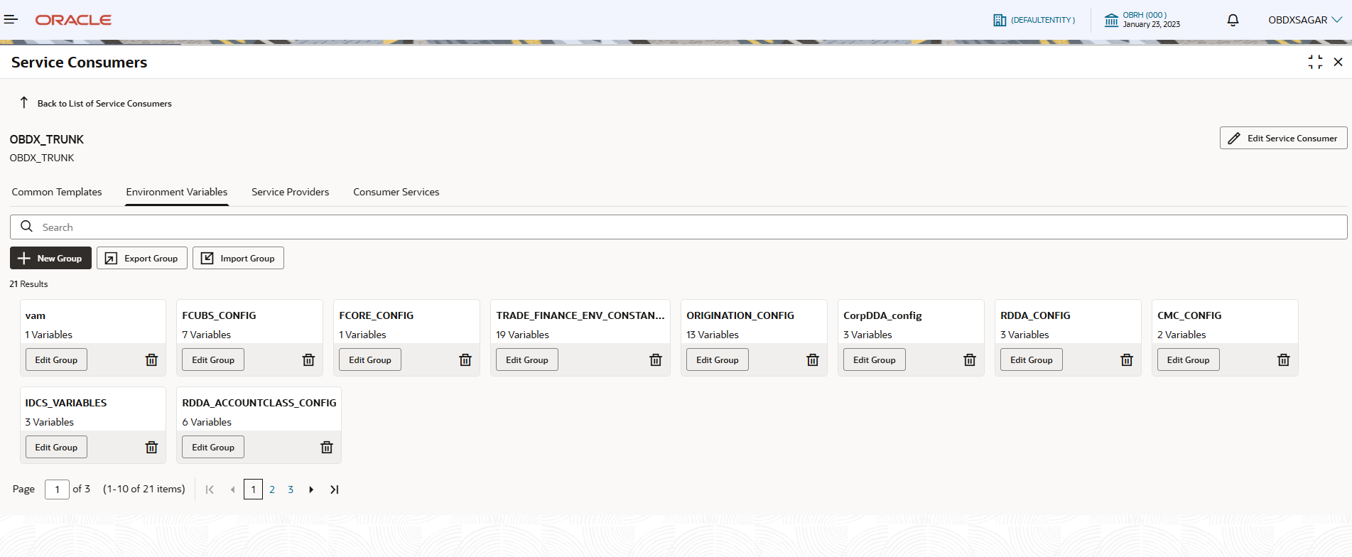

TRADE_FINANCE_ENV_CONSTANTS
Search result for TRADE_FINANCE_ENV_CONSTANTS and click ‘Edit Groups’
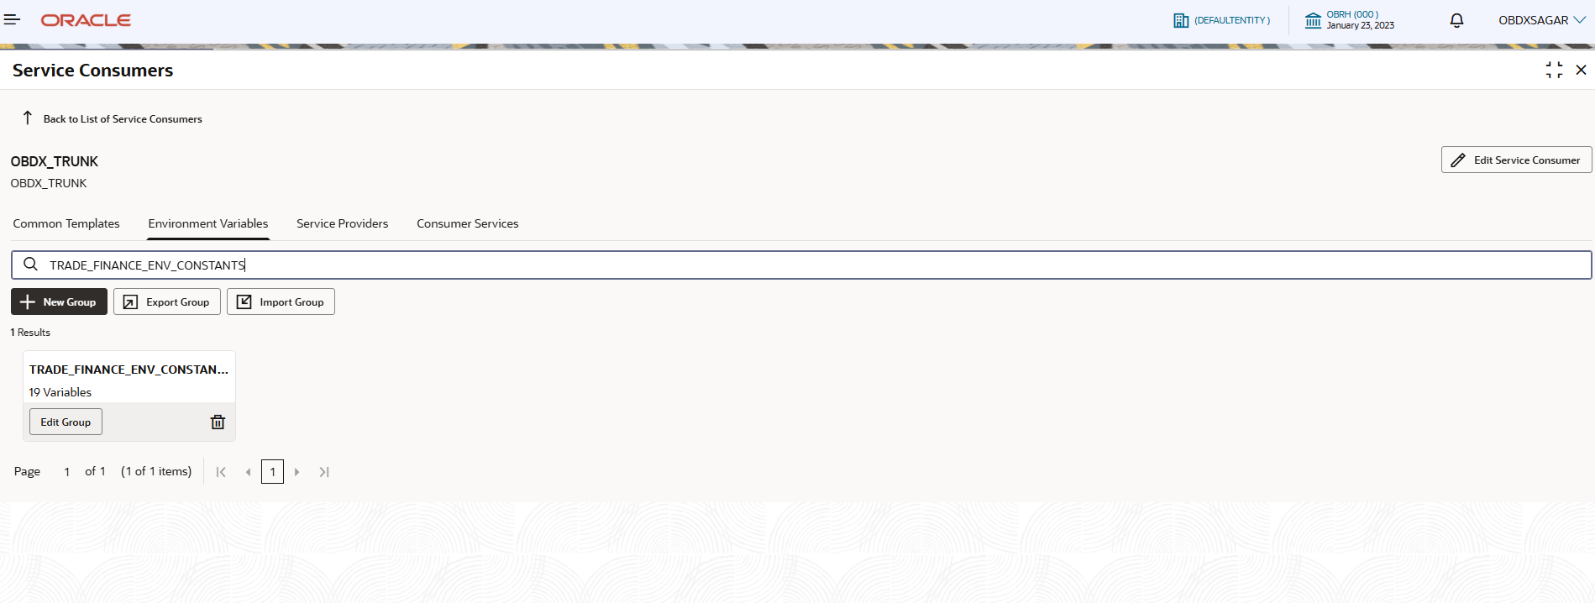
Sample Values
Name | Description | Sample Values
OBTF_ENTITY_ID | Entity ID to be used in request xml header, during OBTF gateway call | ENTITY_ID
OBTFPM_ENTITY_ID | Entity ID to be used in request json, during OBTFPM gateway call | DEFAULTENTITYID
FCUBS_ENTITY_ID | Entity ID to be used in request xml header, during FCUBS gateway call | ENTITY_ID
OBTR_ENTITY_ID | Entity ID to be used in request xml header, during OBTR gateway call | ENTITY_ID
TRADE_FROM_MATURITY_DATE | Default minimum ‘Maturity Date From’ value required in request xml during OBTF gateway call.  Pls note – This value is required for very few cases while fetching contract list. | 2000-10-12
TRADE_TO_MATURITY_DATE | Default maximum ‘Maturity Date To’ value required in request xml during OBTF gateway call.  Pls note – This value is required for very few cases while fetching contract list. | 2040-10-10
BRANCH_CODE_LENGTH | This field indicates maximum length for a branch code. | 3
OBTFPM_USERID | OBTFPM user id | OBTFMPM01
TRADE_BC_SETTLEMENT_COMPONENT | Bill/Collection settlement component | BILL_LIQ_AMTEQ
SUBMISSIONMODE | This field is required while OBTFPM gateway calls | Online
TRADE_BG_INIT_MSG_TYPE | This field is required while OBTFPM gateway calls | GUARANTEE
TRADE_BG_AMEND_MSG_TYPE | This field is required while OBTFPM gateway calls | GUA_AMD_INSTR

