Oracle Banking Routing Hub/Interconnect setup details

Release:
OBMA – 14.8.x
OBDX CS – 25.1, 22.2.6, 25.1.1.0, 25.1.2.0

Summary:
This document has details of the configurations to be made in Oracle Digital Banking Experience CS for host calls to work through Oracle Banking Routing Hub.
This setup is with respect to base entity shipped with Oracle Digital Banking Experience CS setup.
For any other entity in Oracle Digital Banking Experience CS, the same configurations to be followed for that particular entity.

This document is common for all above versions. Specific settings for any specific versions are highlighted in the corresponding configurations steps.

Commonly used acronyms in this document:

Name | Value
OBDX CS | Oracle Banking Digital Experience Cloud Service
OBRH | Oracle Banking Routing Hub / Interconnect
AMS | Application Management Services
OBMA | Oracle Banking Microservices Architecture

Pre-requisites:

From AMS team we need below parameter values. Please contact the team to get these details. These are required for further configurations. Also, please note to re-reverify the values again with them to avoid configurations issues.

- Sub namespace
Eg: cmc-obrh-services.fsgbu-obcbcs--int-1481--foundation:8080
cmc-obrh-services.fsgbu-obcbcs--pre-prod-1481--foundation:8080

For multi -tenant env, the sub-namespace URL for OBDX CS should not include the tenant specific URL.
Eg: ANP1 env sub-namespace will be cmc-obrh-services.fsgbu-obcbcs--anp--foundation:8080 and NOT cmc-obrh-services.fsgbu-obcbcs—anp1--foundation:8080

Below are required for setting up email
- Web Server Host
- Web Server Port
- Email Client Foundation Service
- Email Client Foundation Service Port
- Sender Email Address

Configuration Steps:

- To check if OBRH/Interconnect is configured

  - Open cloud app-shell URL and login with SUPERADMIN user or any other App Shell user which has access OBRH/Interconnect.
  - After login into app-shell with that user and in menu search for Consumers Or you can navigate using
Menu – Interconnect – Routing HUB – Service Consumers

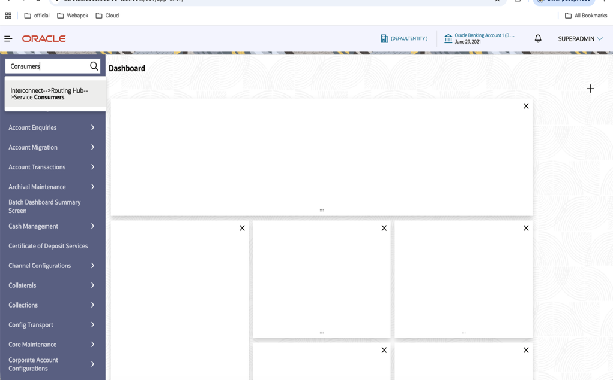

  - Click on the Service Consumers option from the menu and below screen will be loaded

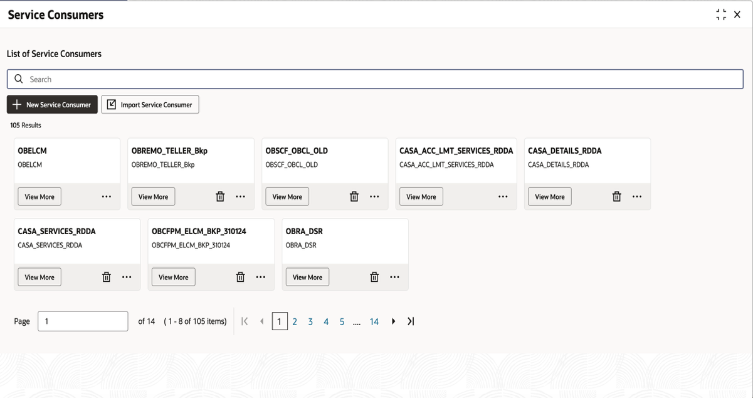

  - Search for OBDX_TRUNK as below. If you see below result, then the OBRH/Interconnect setup is correct and your relevant routing hooks are imported.

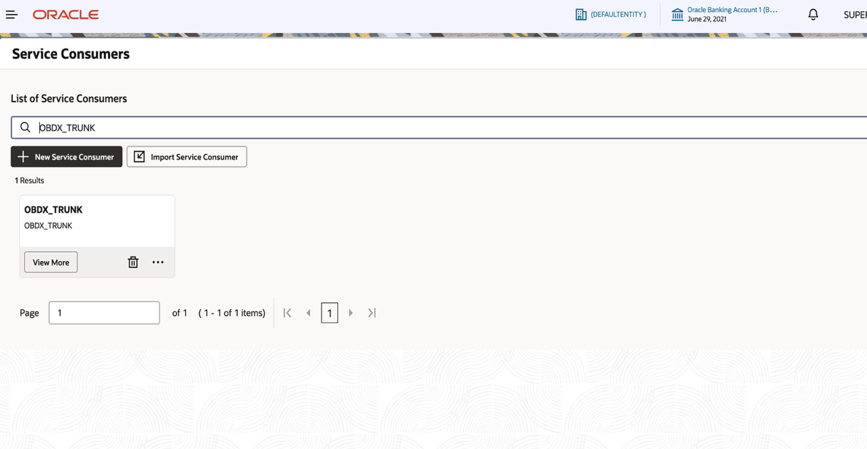

  - If there is no OBDX_TRUNK in the results, then either check if the consumer is imported correct from the installer setup or if the consumer’s name is different. Default shipped is “OBDX_TRUNK”
  - If import is not done, check with the team to import it.
  - If the consumer’s name is kept different, then note down that name.
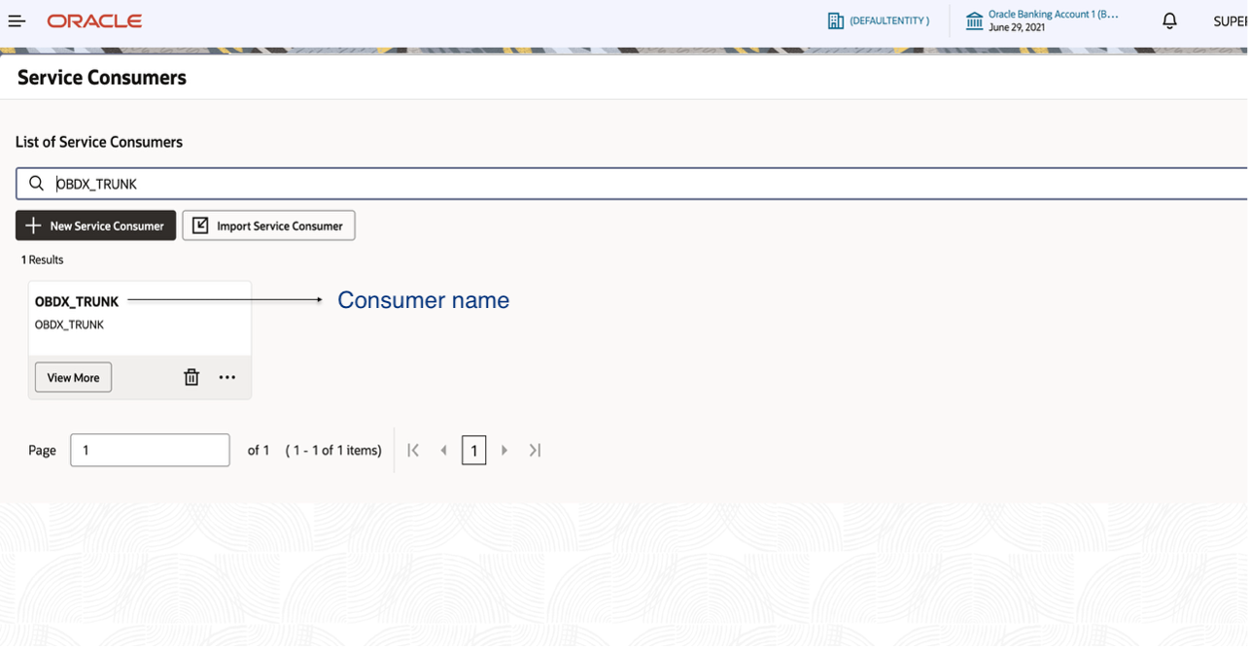

- Proceed with OBRH configurations in OBDX CS for OBRH/Interconnect connection

- We need below values.
Tenantid
Tenantpdb
Tenantsvc
Branchcode
Userid
Entity

These can be obtained from the API request headers. To get above values, follow these steps.

- While you are logged-in in the above app-shell setup, right click on the page and click on Inspect. Developer console will open. Go to Network tab, filter by Fetch/XHR. Search for OBDX_TRUNK consumer on the page and check the API hits in the network tab and get the values from the API call’s Request header

Each of the above key will be seen in the API call’s Request header. Copy the values for each key and keep it handy

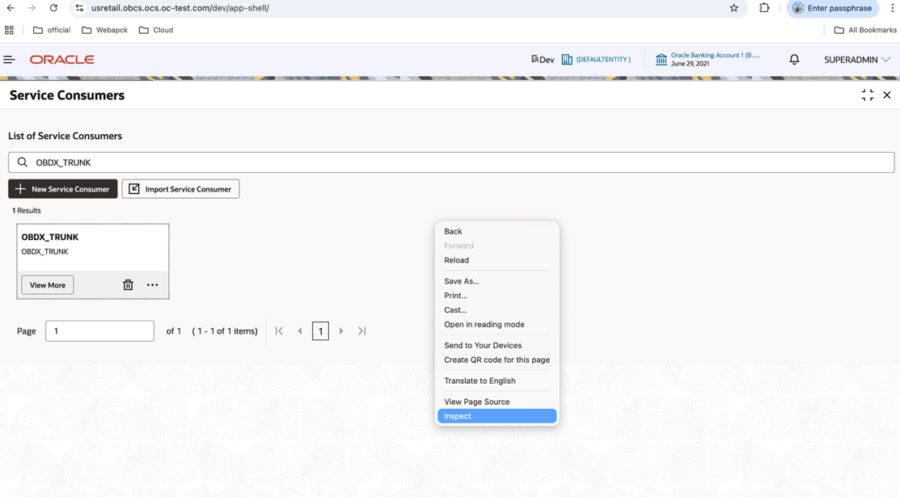

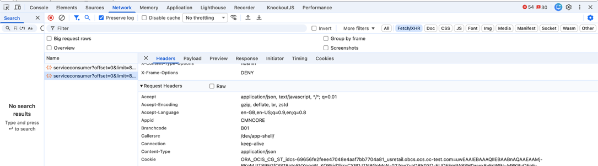

- Now, login to OBDX CS web portal with SUPERADMIN. (Recommended is to open this is new browser or in-Cognito). This logged in user should be the same user with which you had logged-in in the app-shell in step 1
- Once logged-in, search for System Configurations in the search box on the top right section and select the option. You will see System Configuration Screen with available entities listed. Default will be OBDX_BU.

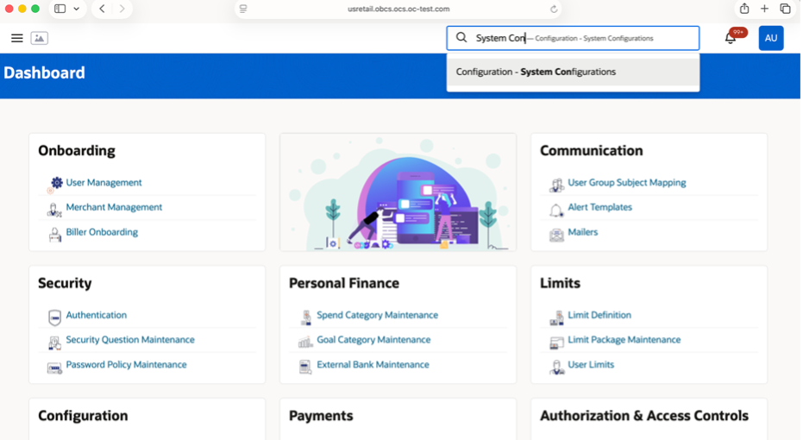

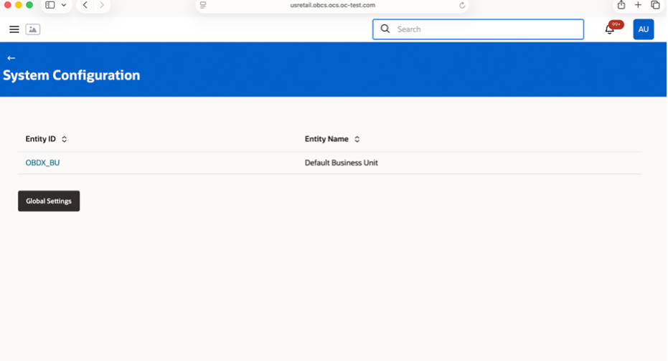

- Click on the other entity for which these configurations are required.
- On selecting OBDX_BU or any other entity, System Configuration Screen will be displayed with section options on left and properties on right like below

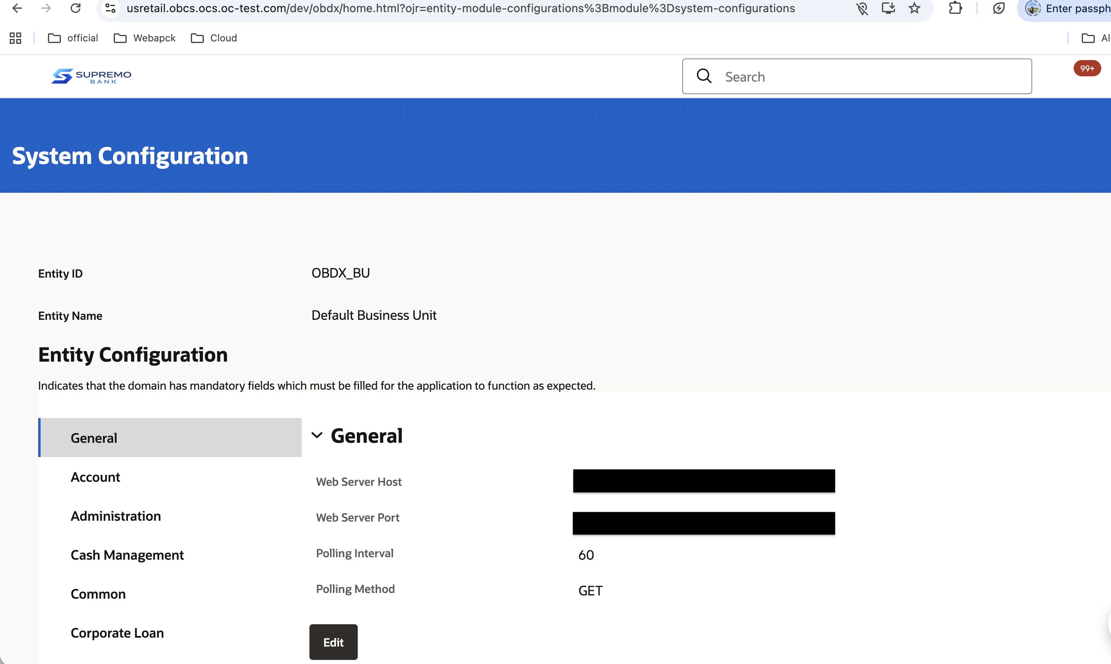

- Update the details noted in step 2.a in below configurations under General option from the left options list
Tenant ID
Tenant Pluggable Database
Tenant Service

Attached below is the SS of the configurations set in base environment. Similar data to be saved for the bank’s environment.

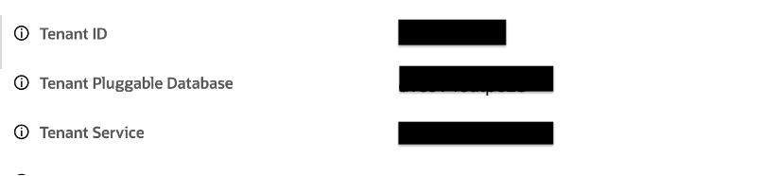

- Update the details in below configurations under General option.
Note: for OBDX CS version before 25.1.2.0.0, these configurations are present under Framework option

OBRH User ID (OBRHAdapterImplConfig.ALL.USER_ID)
OBRH Branch Code (OBRHAdapterImplConfig.ALL.BRANCH_CODE)

Attached below is the SS of the configurations set in base env:

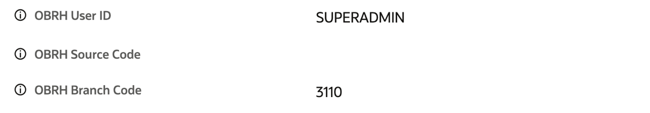

- Update the sub name space details obtained from AMS team in all below configurations under General option
Note: for OBDX CS version before 25.1.2.0.0, these configurations are present under Framework option

OBRH Service Context URL
OBRH Token Generation Context URL
OBRH Mock URL For Service Calls
OBRH Mock URL For Token Generation

Attached below is the screen shot of the configurations set in base env:

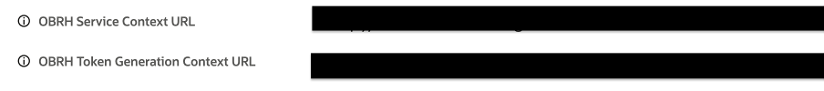
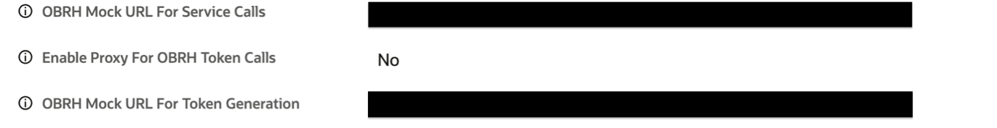

- This completes the basic ORBH setup. Additionally, refer Module specific OBRH setup guide for party, account, payments, trade finance etc.

Oracle Banking Digital Experience Email Setup
- Email Configuration For Cloud should be true in System configurations -> Global Settings -> Event Management
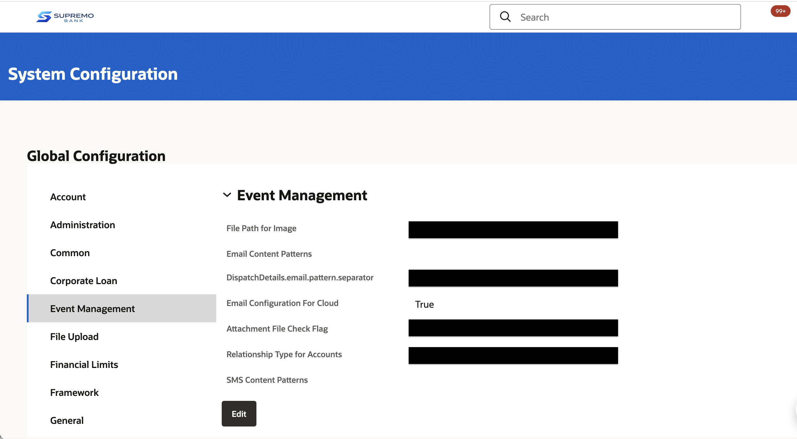

From the details obtained from AMS team for
Server Host
Server Port
Email Client Foundation Service
Email Client Foundation Service Port
Bank’s Sender Email

Below configuration needs to be updated in General Section

