Integration Overview: OBDX & Oracle IDCS (25.1.1.0.0)
This document describes the process flow for onboarding users into OBDX via Oracle Identity Cloud Service (IDCS) and the SCIM application integration with OBDX.

Step-by-Step Guide to Create a SCIM-Client Credentials Application in Oracle IDCS
This document provides instructions for creating a domain in Oracle IDCS, setting up a Confidential Application, and configuring OAuth to generate a Client ID and Client Secret. It also covers the configuration of a GenericSCIM – Client Credentials application for integration with services like Oracle Banking Cloud Services (OBCS).

Part 1: Create a Domain in Oracle IDCS
- Log in to OCI IDCS Tenancy:
  - Access your Oracle Cloud Infrastructure (OCI) tenancy using your credentials.
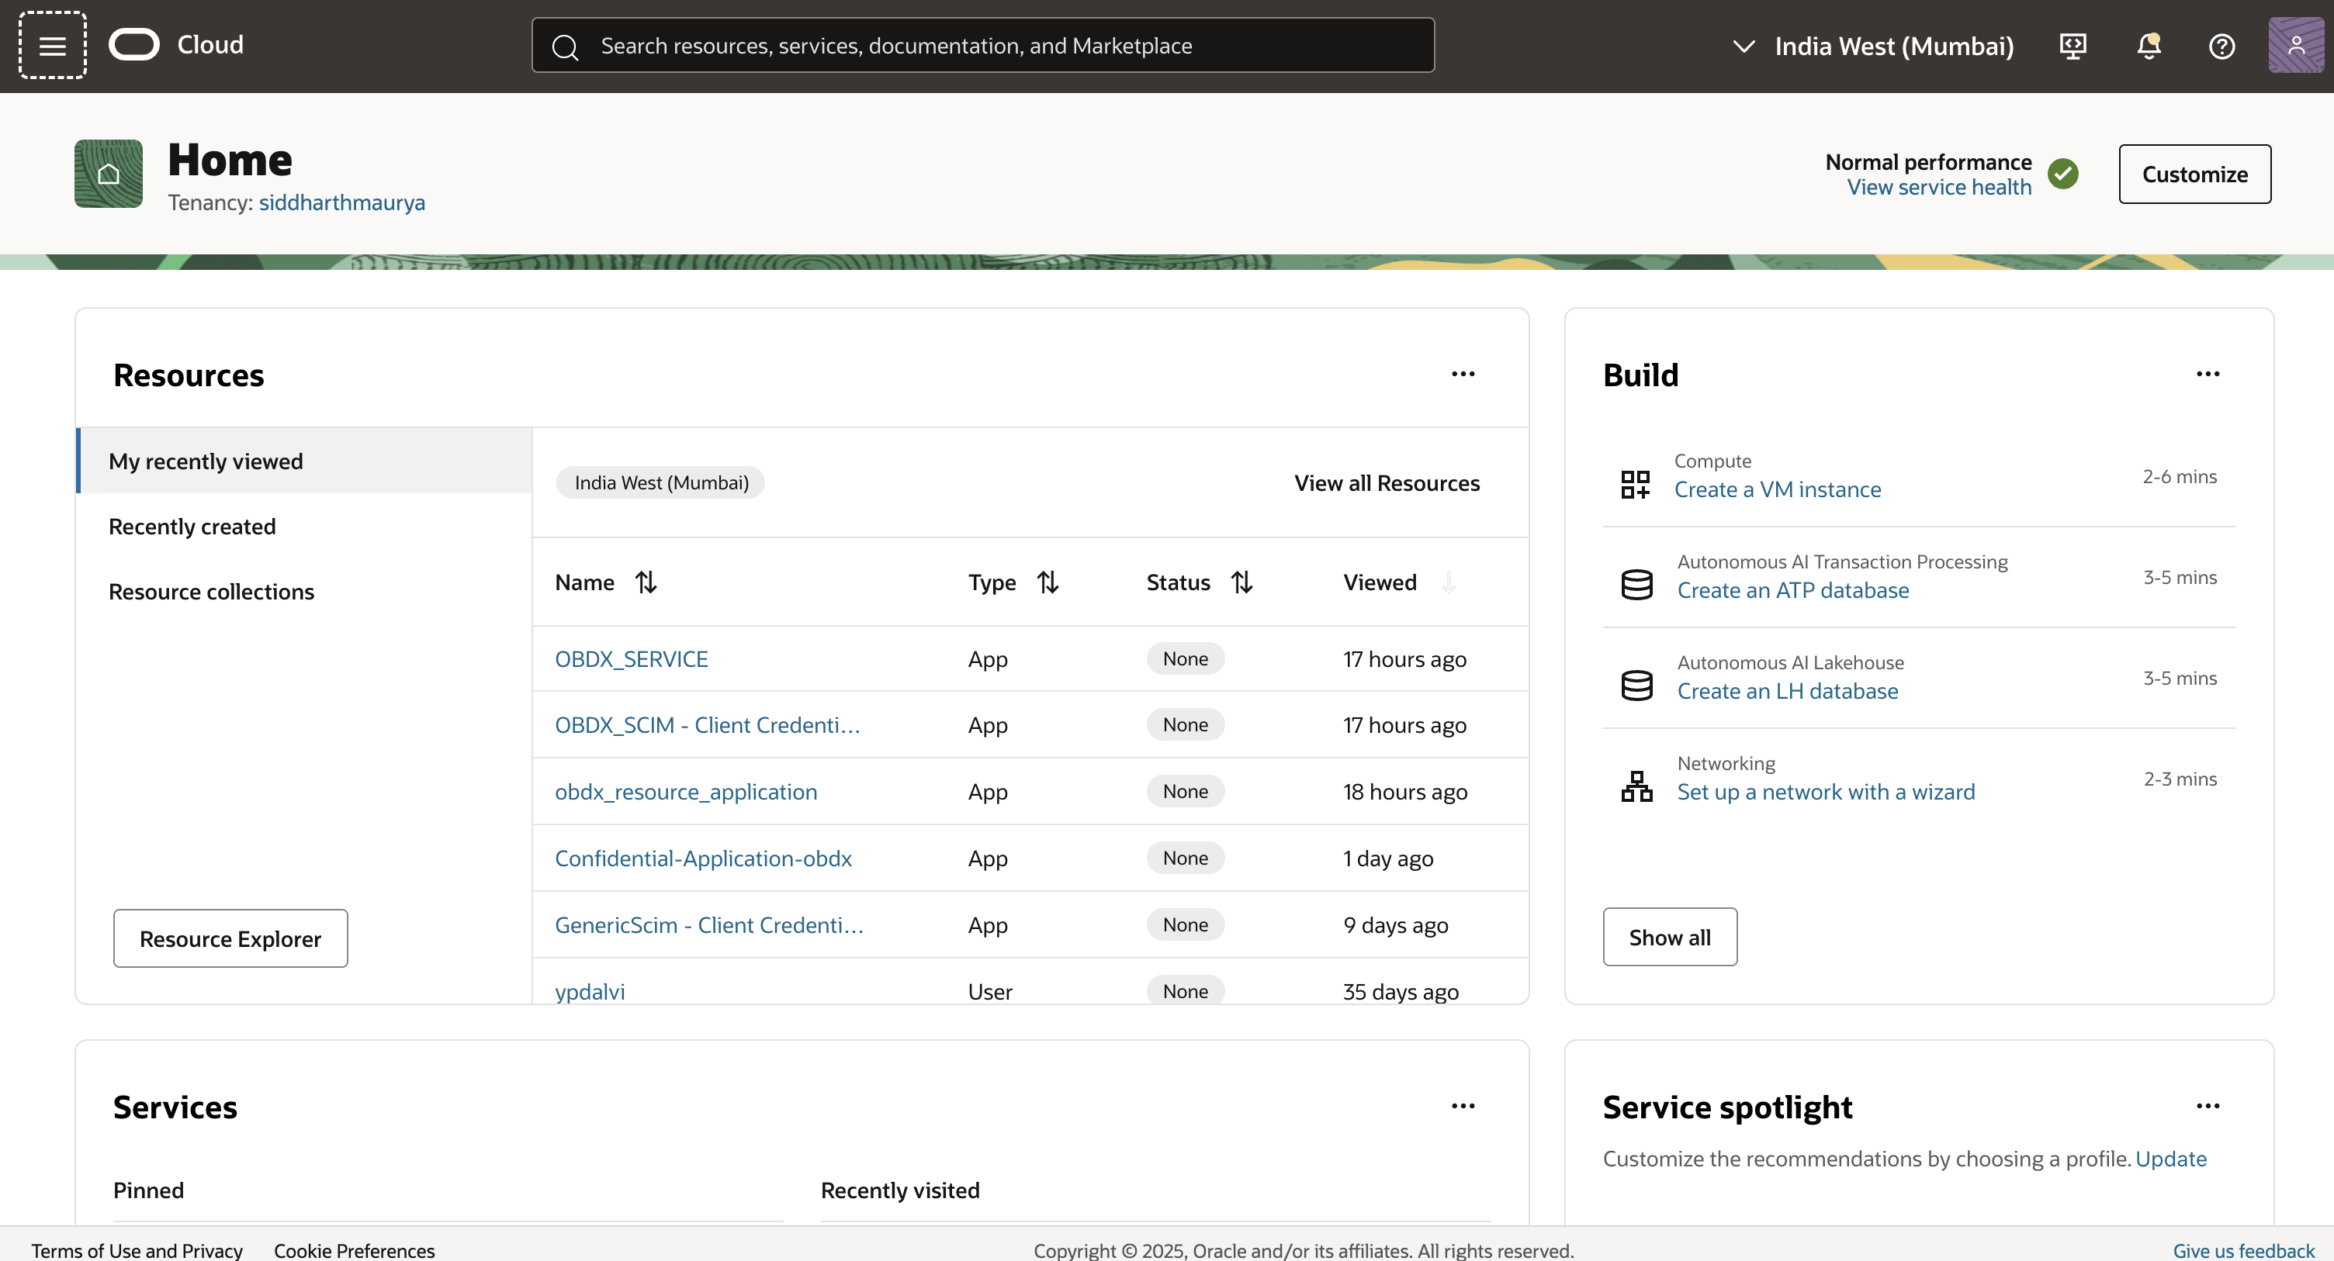
  - From the Sidebar Menu, navigate to Identity & Security > Domains under the Identity section.
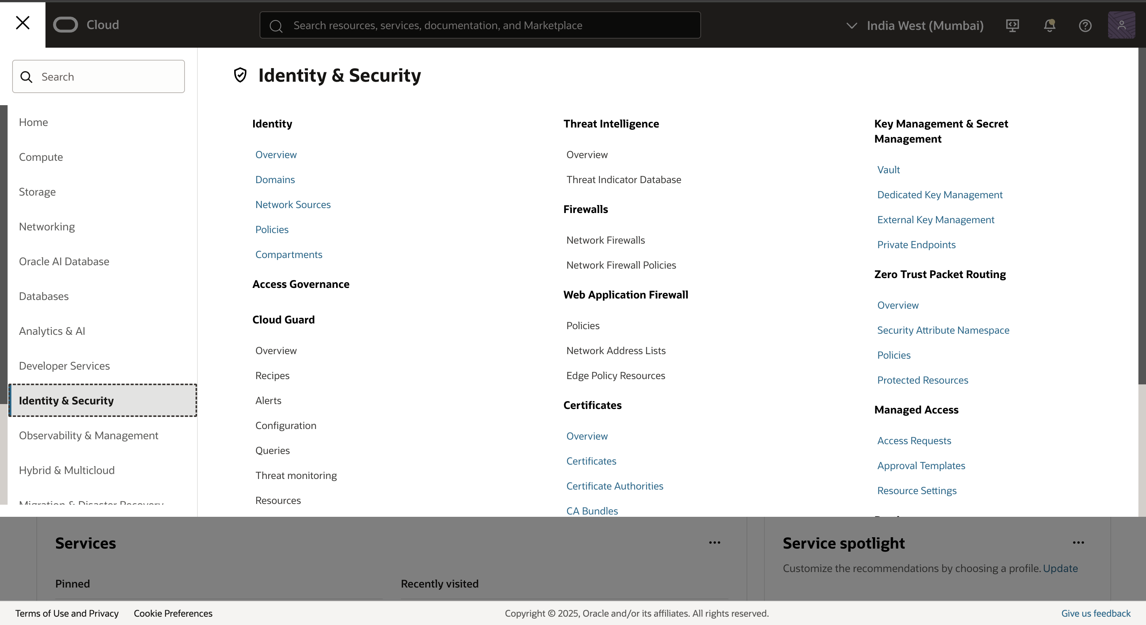
- Create or Select a Domain:
  - If a domain already exists (e.g., Default Domain), select it. If not, click Create Domain and follow the prompts to set up a new identity domain.
  - Note the Domain URL from the Domain Overview page, as it will be used later for OAuth configuration.
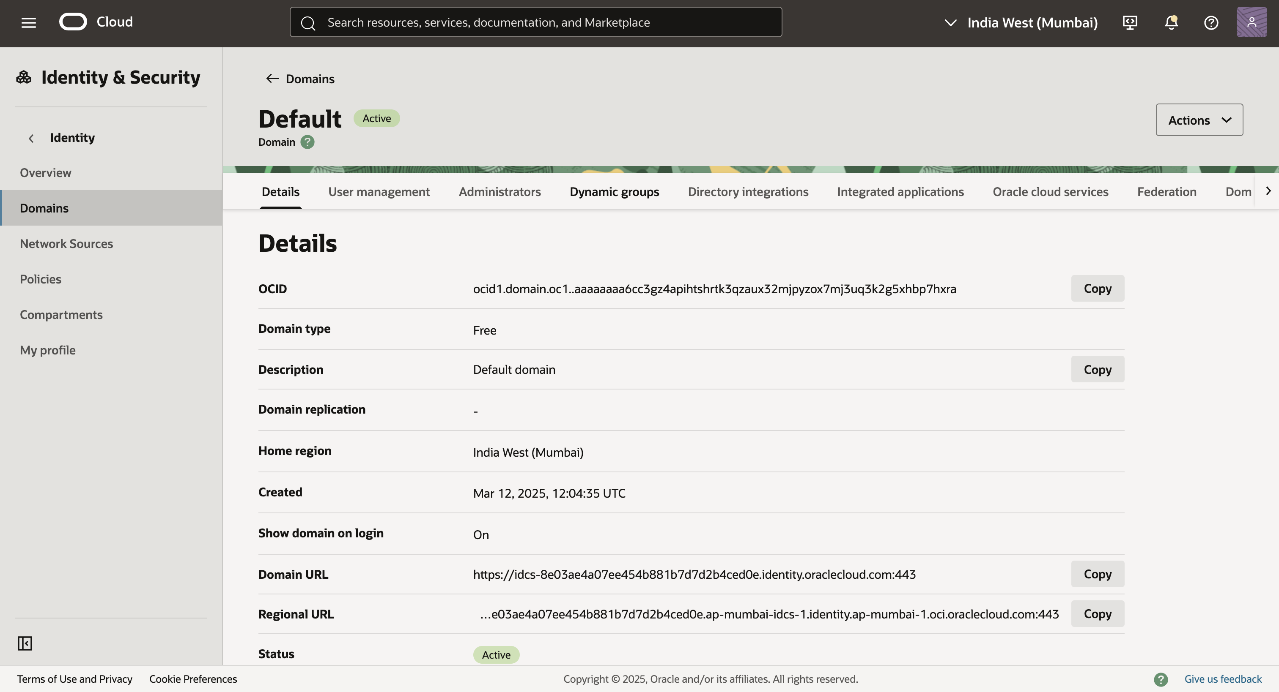

Part 2: Create a Confidential Application and OAuth Configuration
- Access Integrated Applications:
  - Within your selected Identity Domain in IDCS, navigate to Integrated Applications.
  - Click Add Application to start the process of adding a new application.
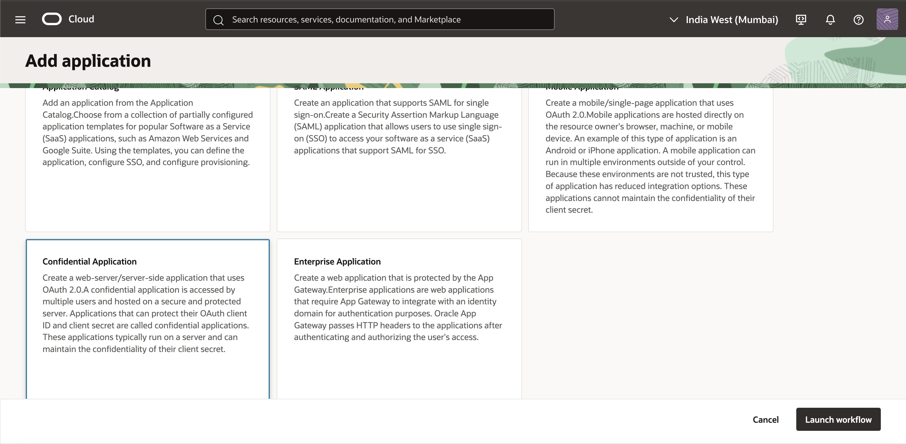
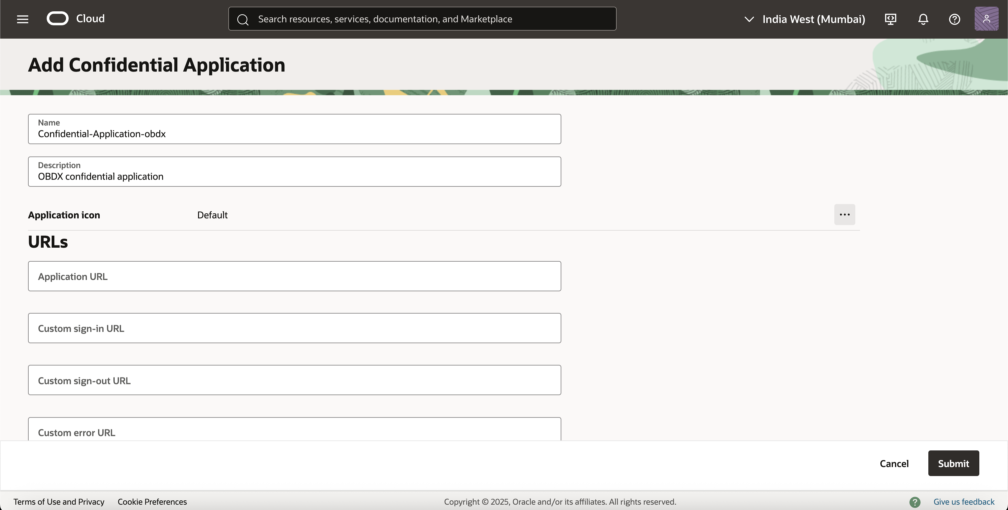
Add OAuth Configuration for Client Credentials:
- Select Confidential application and edit the details according to your application only Name and Description are mandatory for SCIM application setup, If needed.
- Navigate to OAuth Configuration and edit and configure it as Client Credentials.
- In the Client Configuration section, enable Client Credentials as the allowed grant type.
- Add the scope from the Confidential app that is mentioned in the steps outlined in Getting Started with Oracle Banking Cloud Services(https://docs.oracle.com/cd/G43625_01/PDF/User_Guide/getting-started-oracle-banking-cloud-service.pdf).
- Click Save Changes.
- After saving, navigate to the Client Details section to view or regenerate the Client ID and Client Secret. Securely store these credentials as they will be used for authentication (e.g., generating Bearer Tokens).
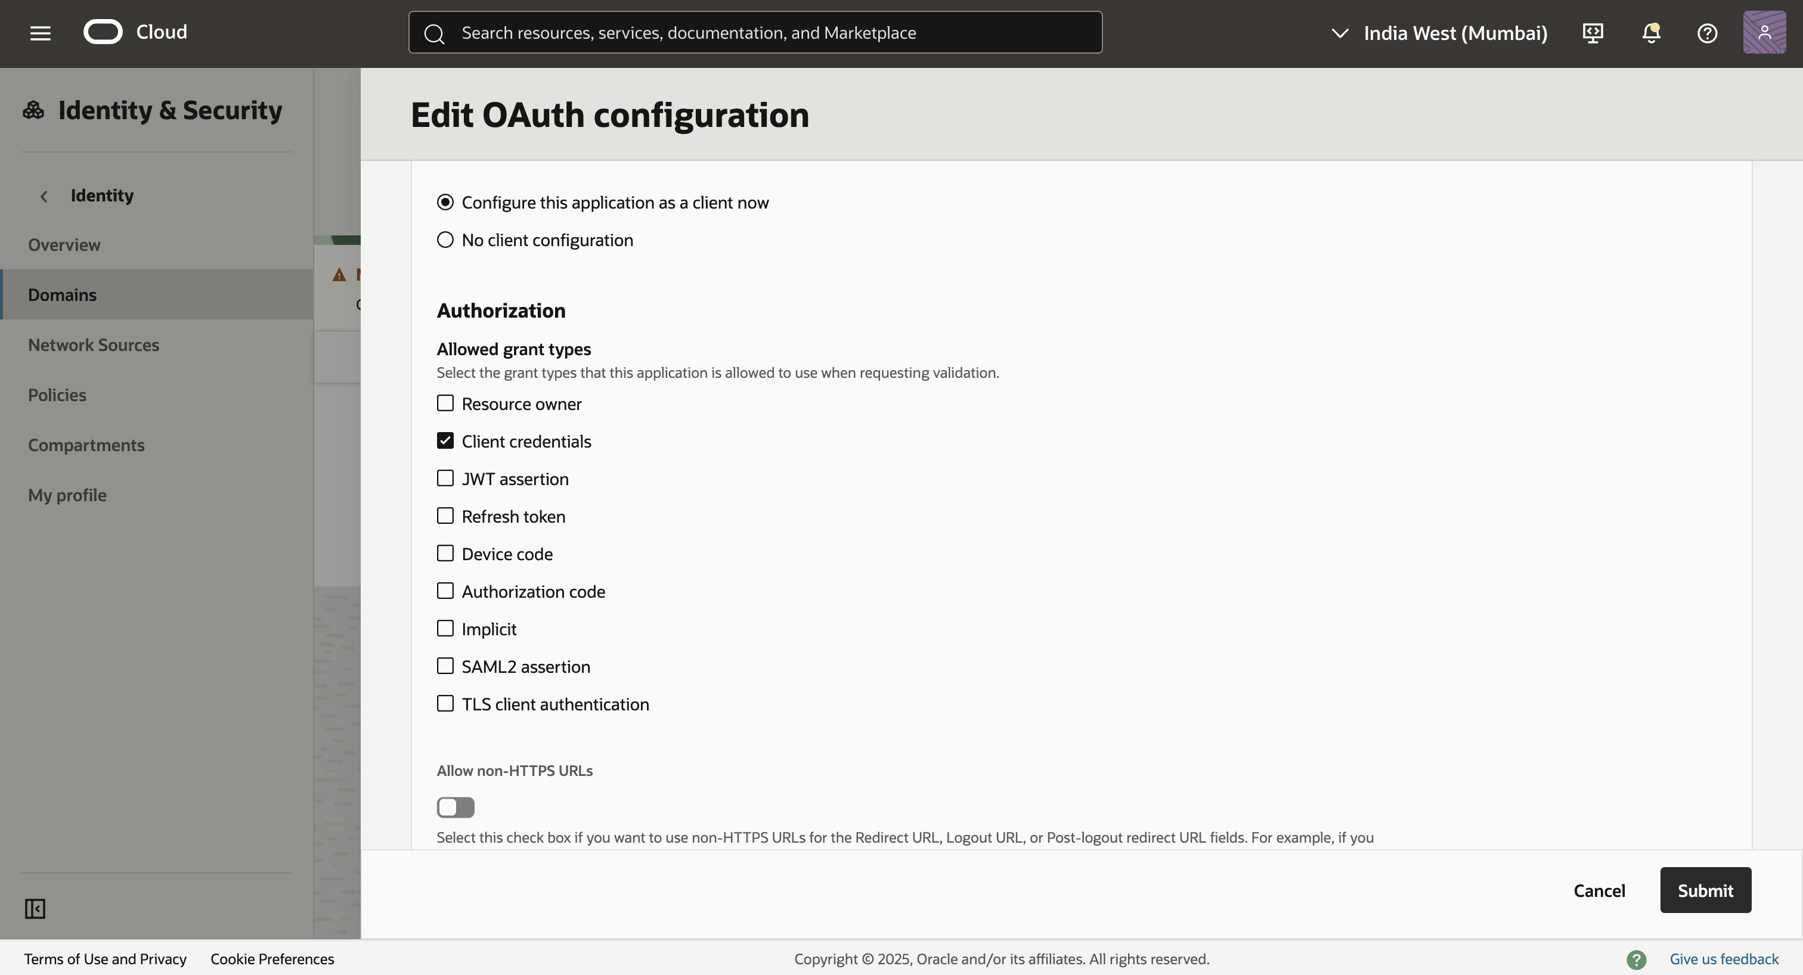
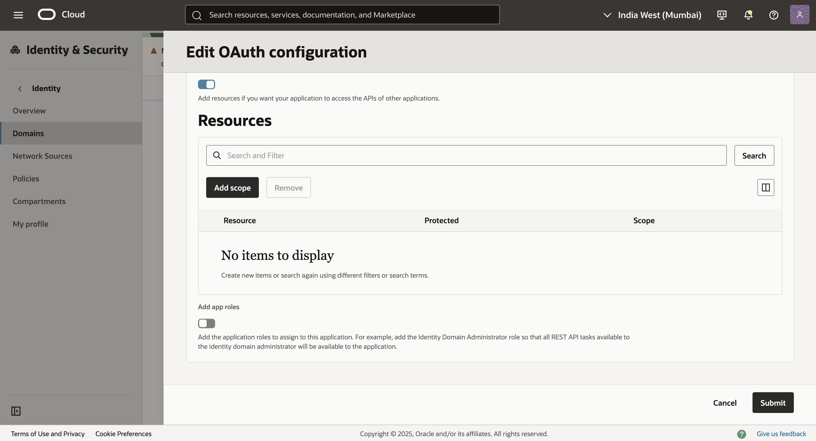
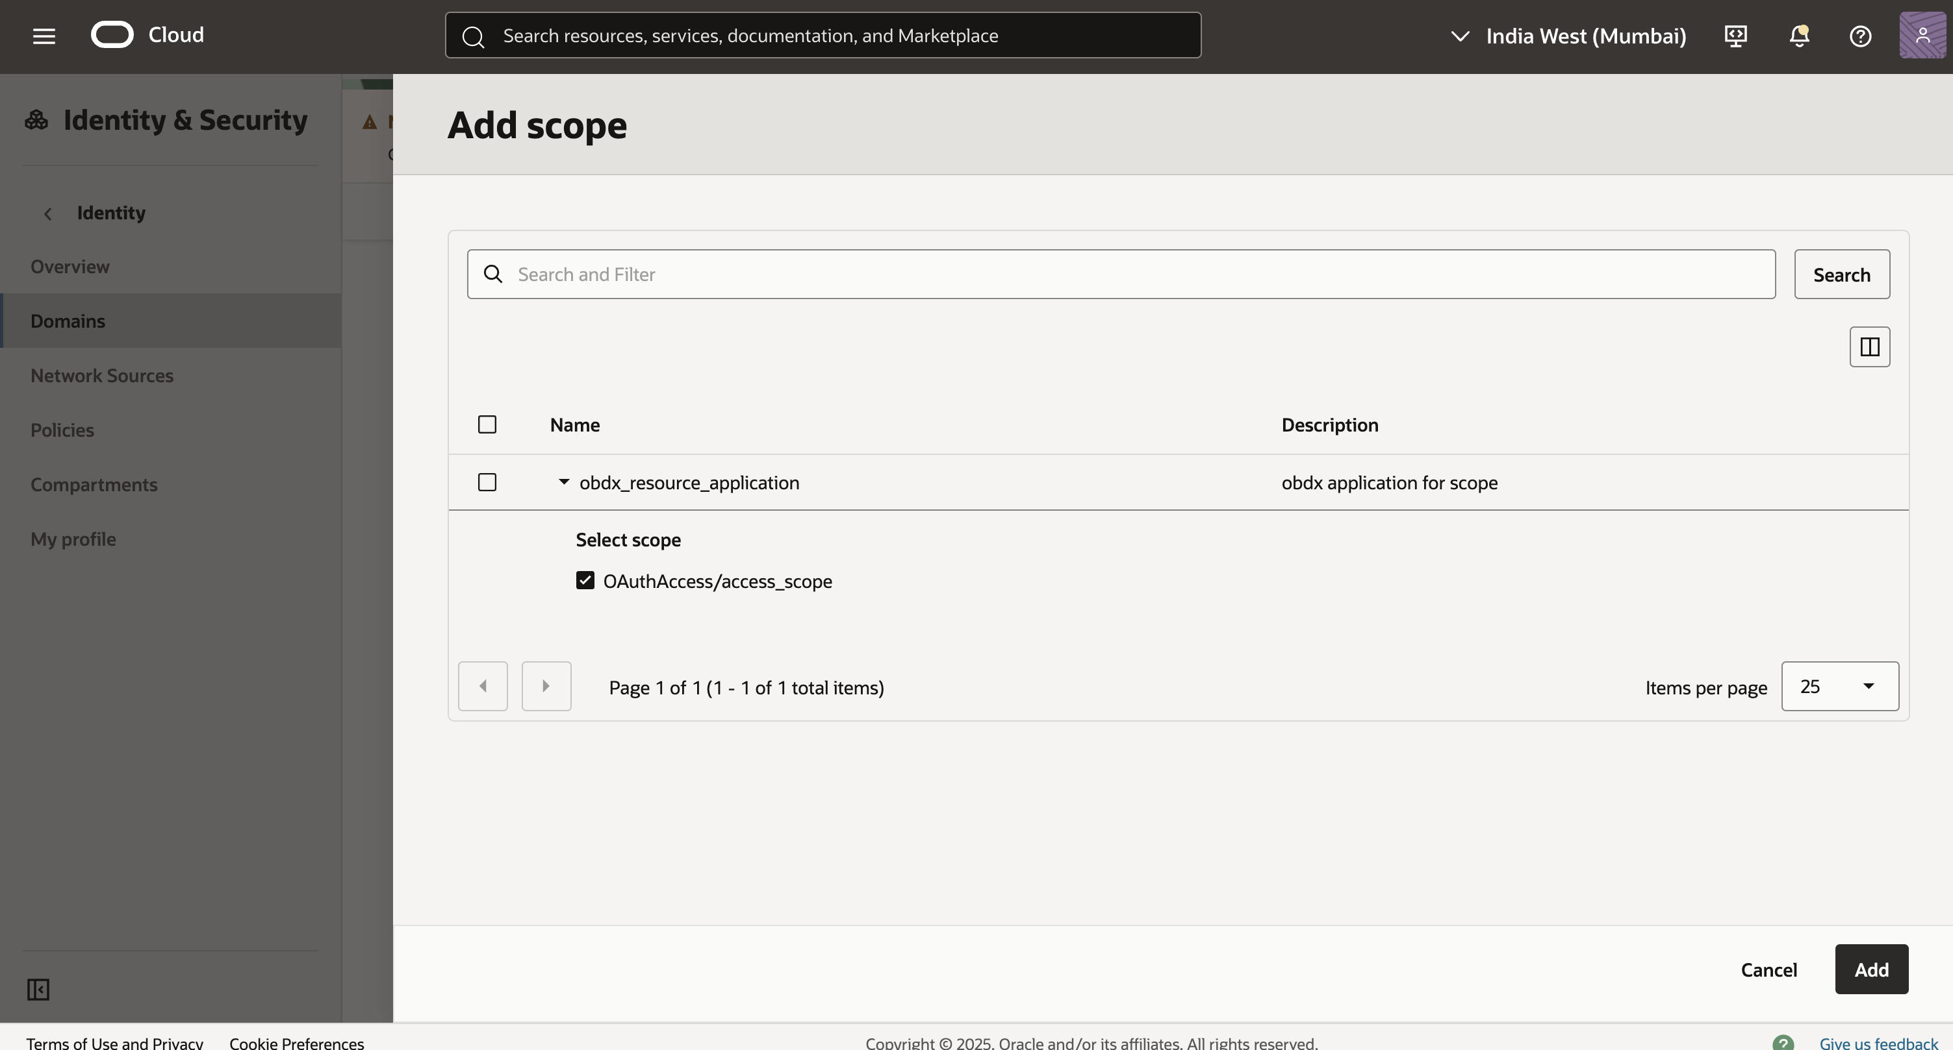

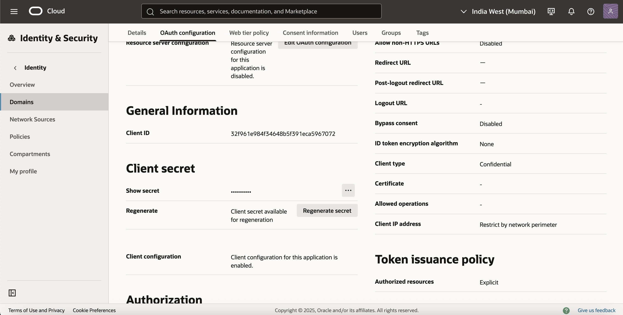
OBDX-SIDE configuration
Part 3 - Add client-id to touch point in OBDX application.
- Navigate to the Touch Point Maintenance Screen.
- Click on the API Access touch point.
- Add the client-id configured in the confidential application (Ensure that the touch point status is enabled).
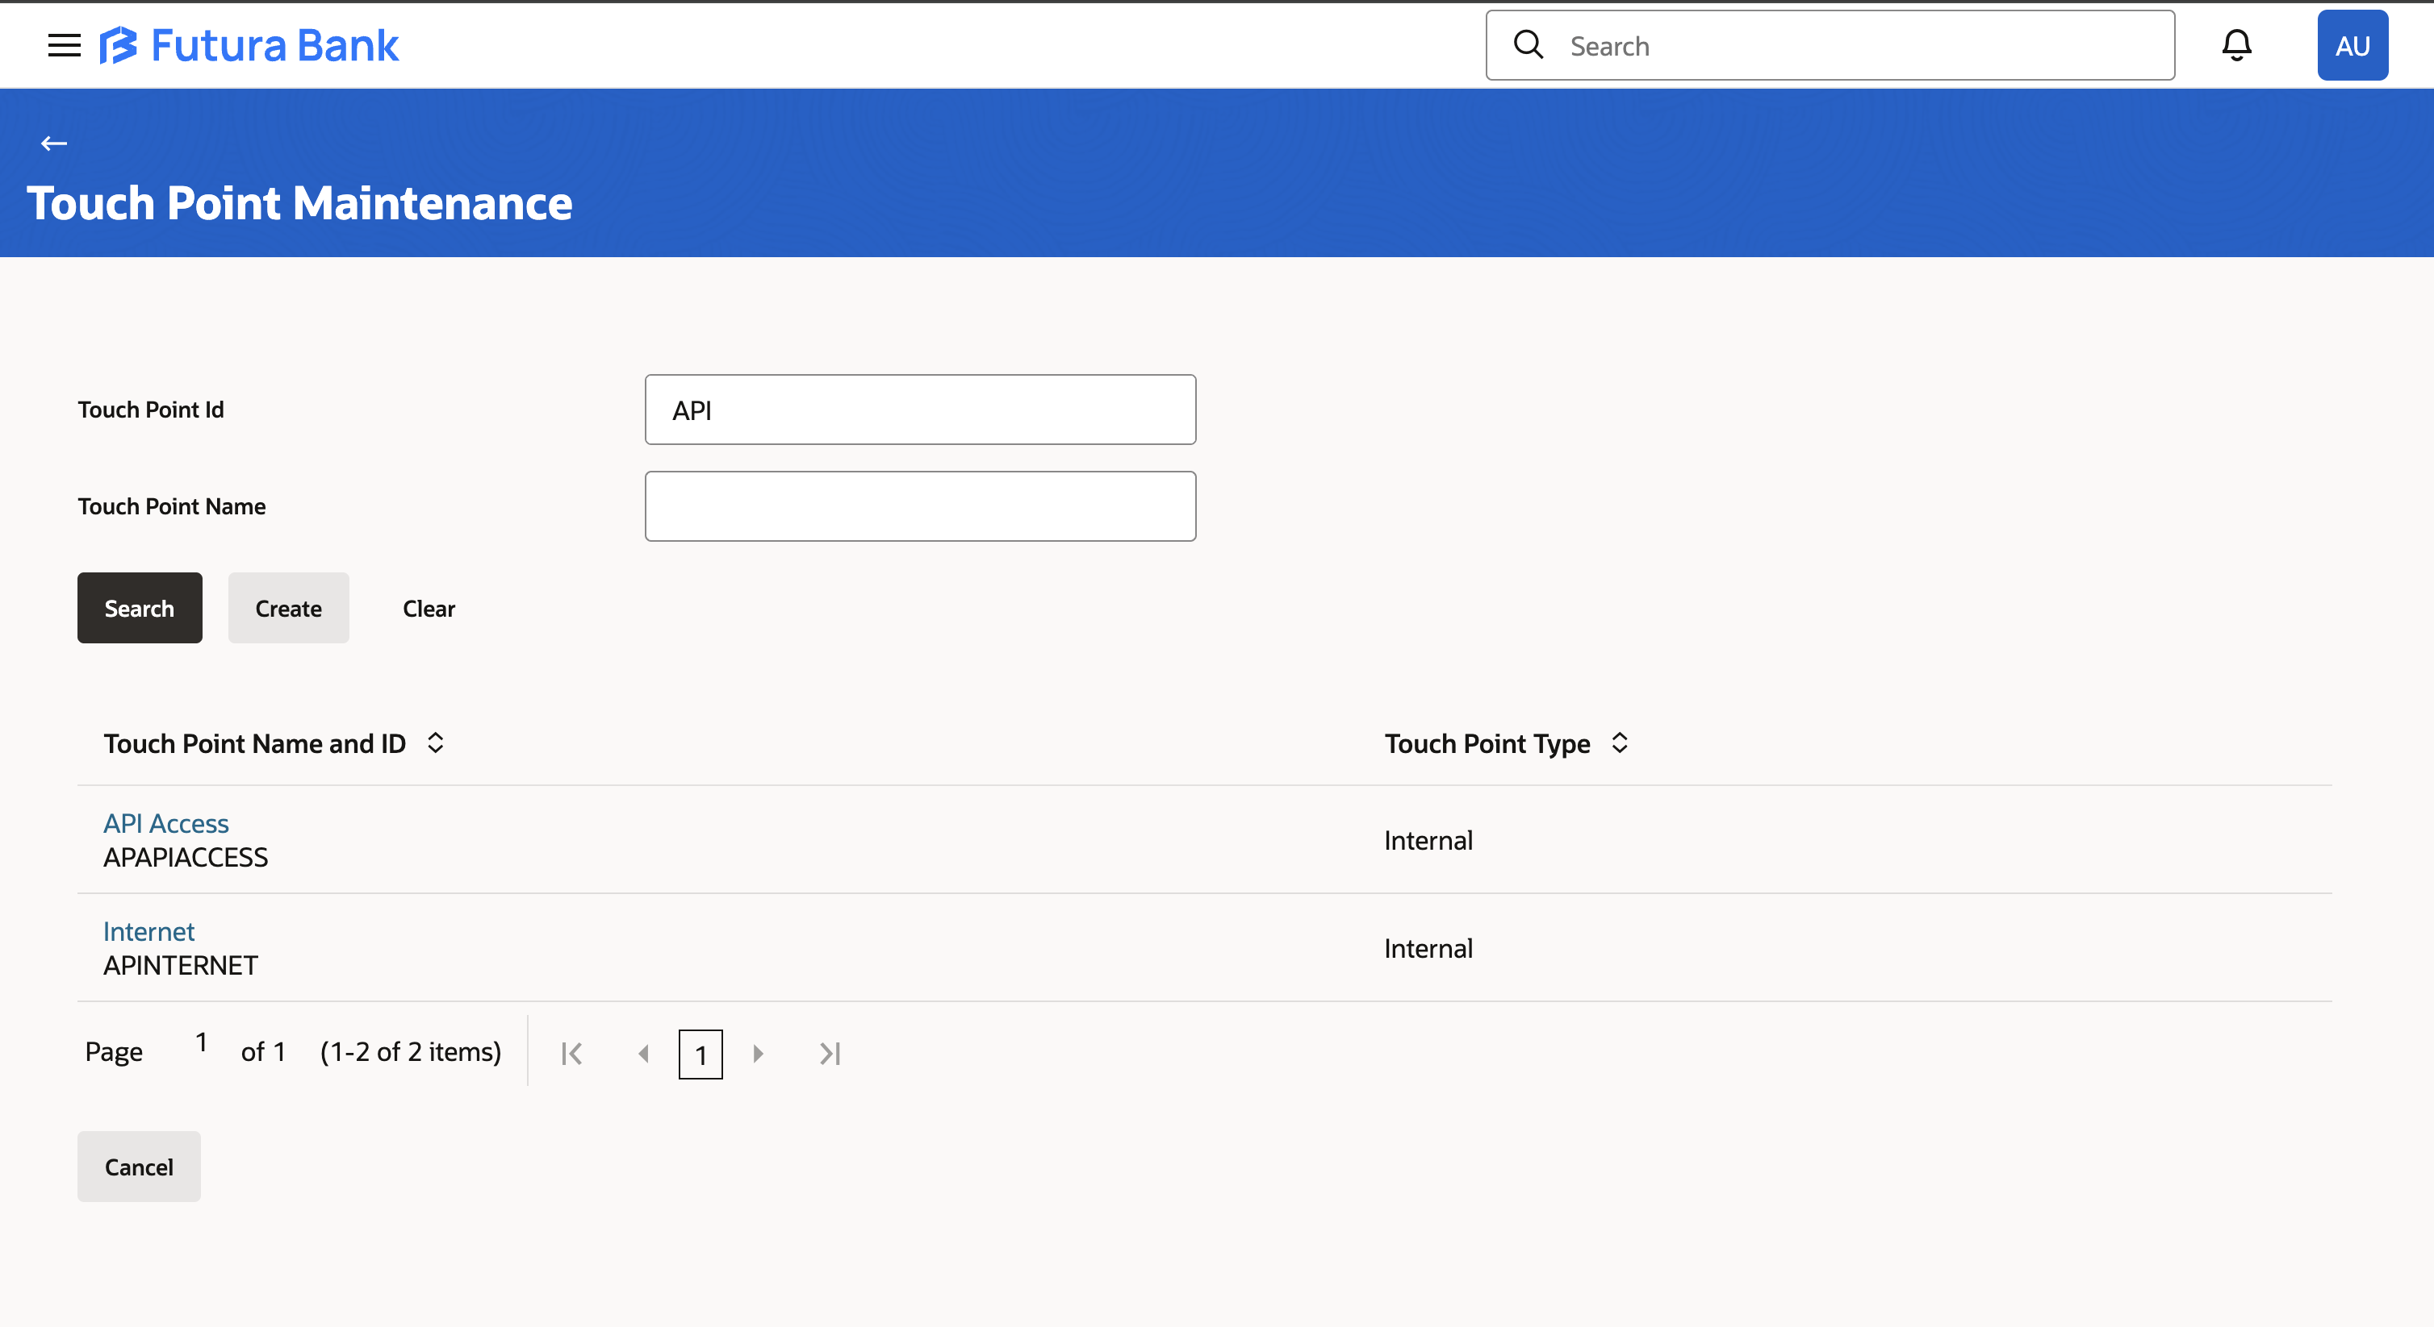
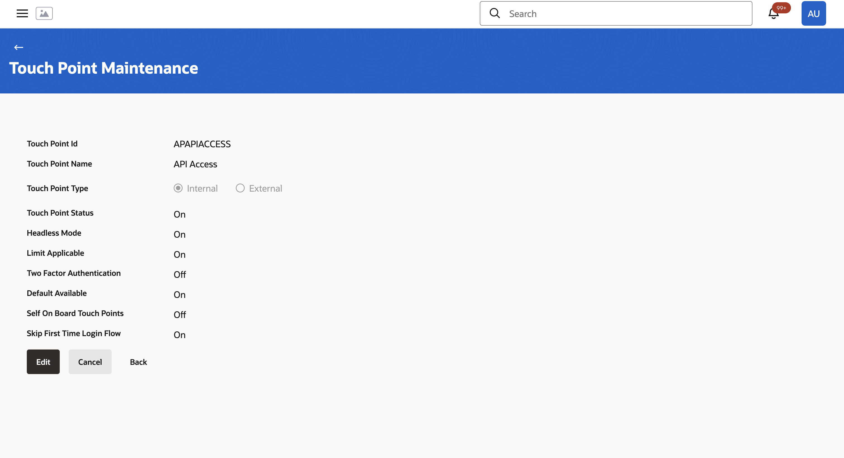
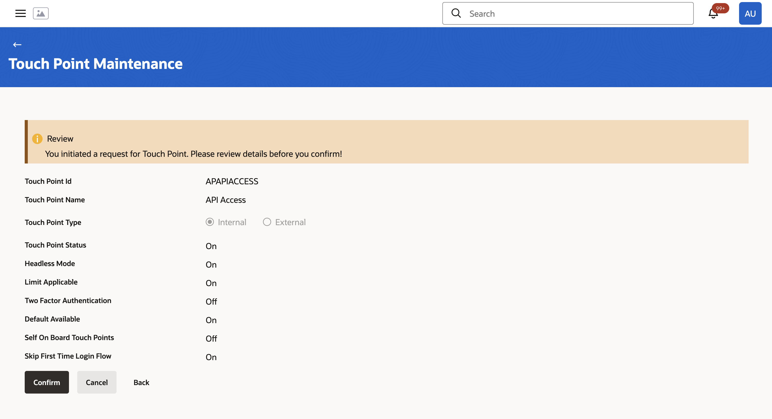

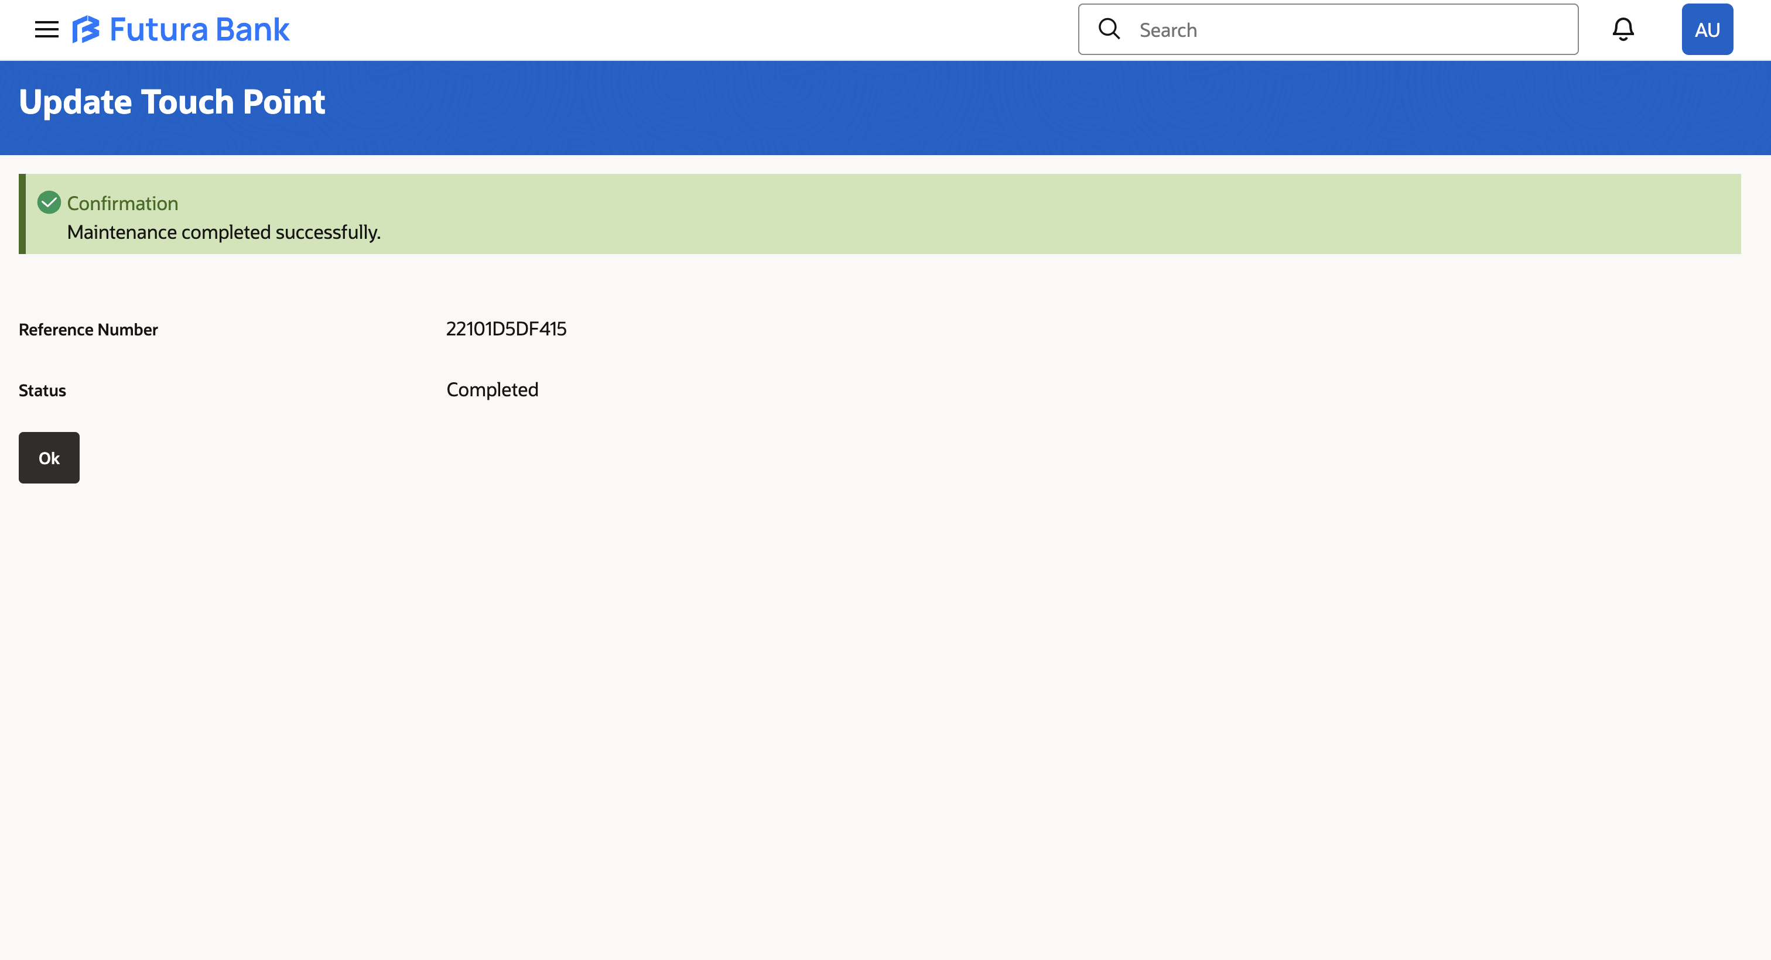

Part 4: Configure GenericSCIM – Client Credentials Application
- Launch App Catalog:
  - From the Integrated Applications page in IDCS, click Add Application.
  - Click Launch App Catalog and search for GenericSCIM.
  - Select GenericSCIM – Client Credentials from the results and click Next.
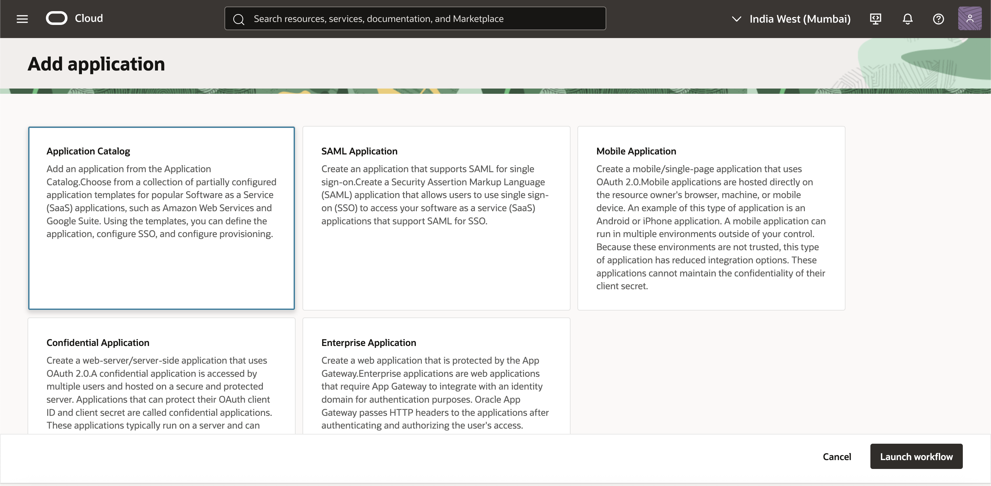
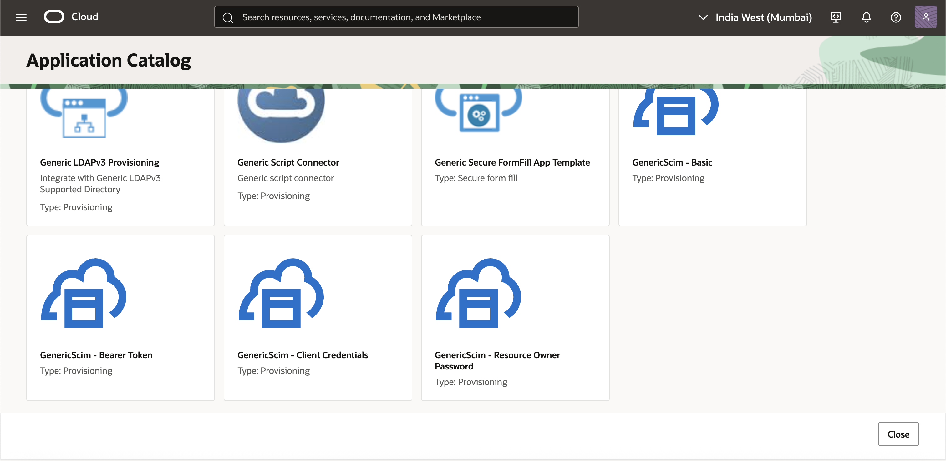
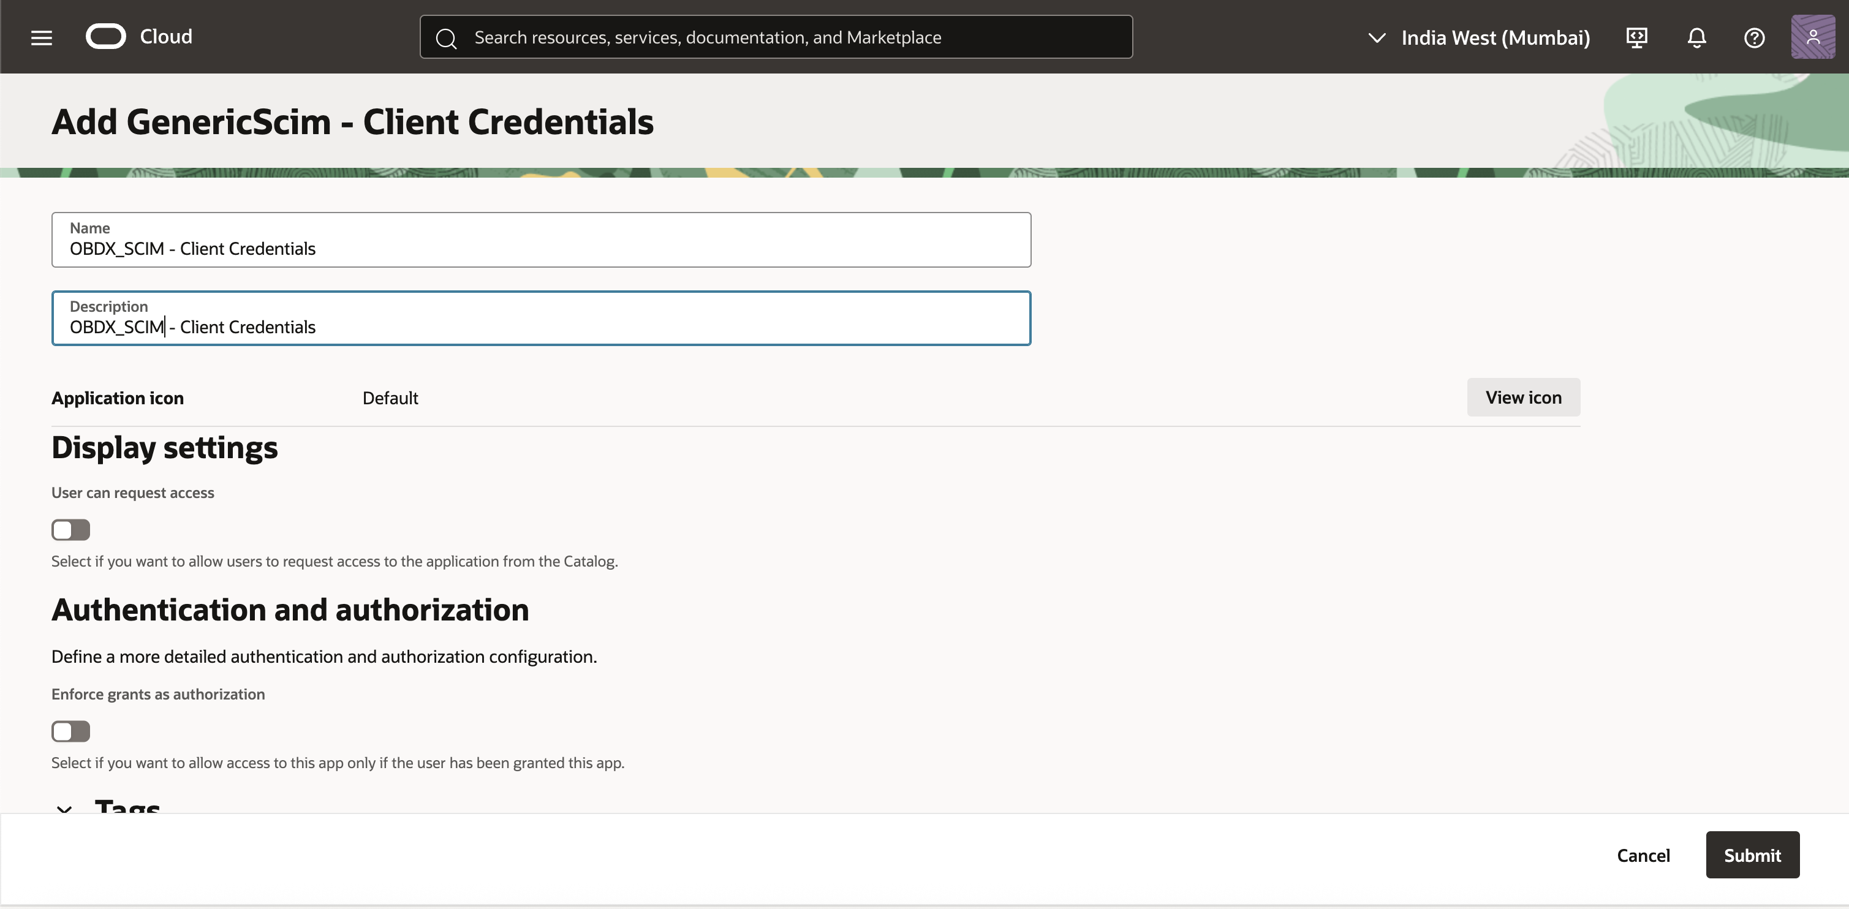
- Enable Provisioning:
  - On the application setup page, click Enable Provisioning to activate SCIM provisioning capabilities.
- Configure Application Details:
  - Fill in the required fields for the SCIM application as follows:
    - Host Name: Enter the hostname for the target application (e.g., HostName).
    - Base URI: Specify the base URI for the SCIM endpoint, prefixed with the environment (e.g., /non-prod/digx-sms/v1/). In the target OBDX application, the SCIM endpoint path would begin with "/Users" as per SCIM standards.
    - Client ID: Enter the Client ID used for generating the Bearer Token.
    - Client Secret: Enter the corresponding Client Secret.
    - Scope: Define the access scope used for the Bearer Token(Add the scope previously generated).
    - Authentication Server URL: Combine the Domain URL (from Domain Overview) with /oauth2/v1/token (e.g., https://idcs-example.identity.oraclecloud.com/oauth2/v1/token).
  - Review the fields to ensure accuracy.
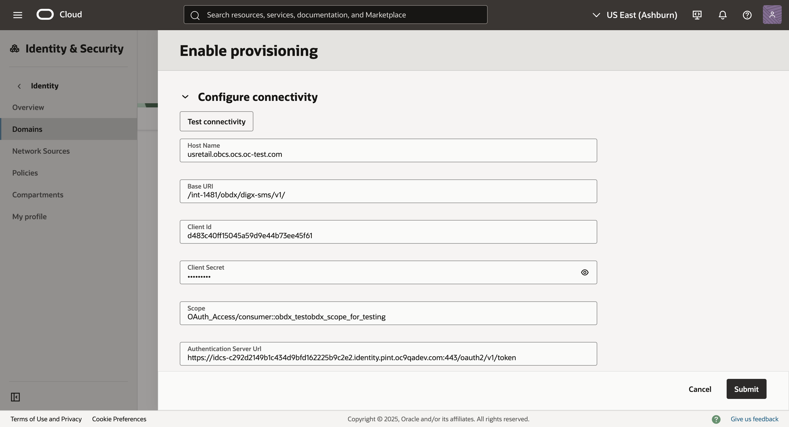
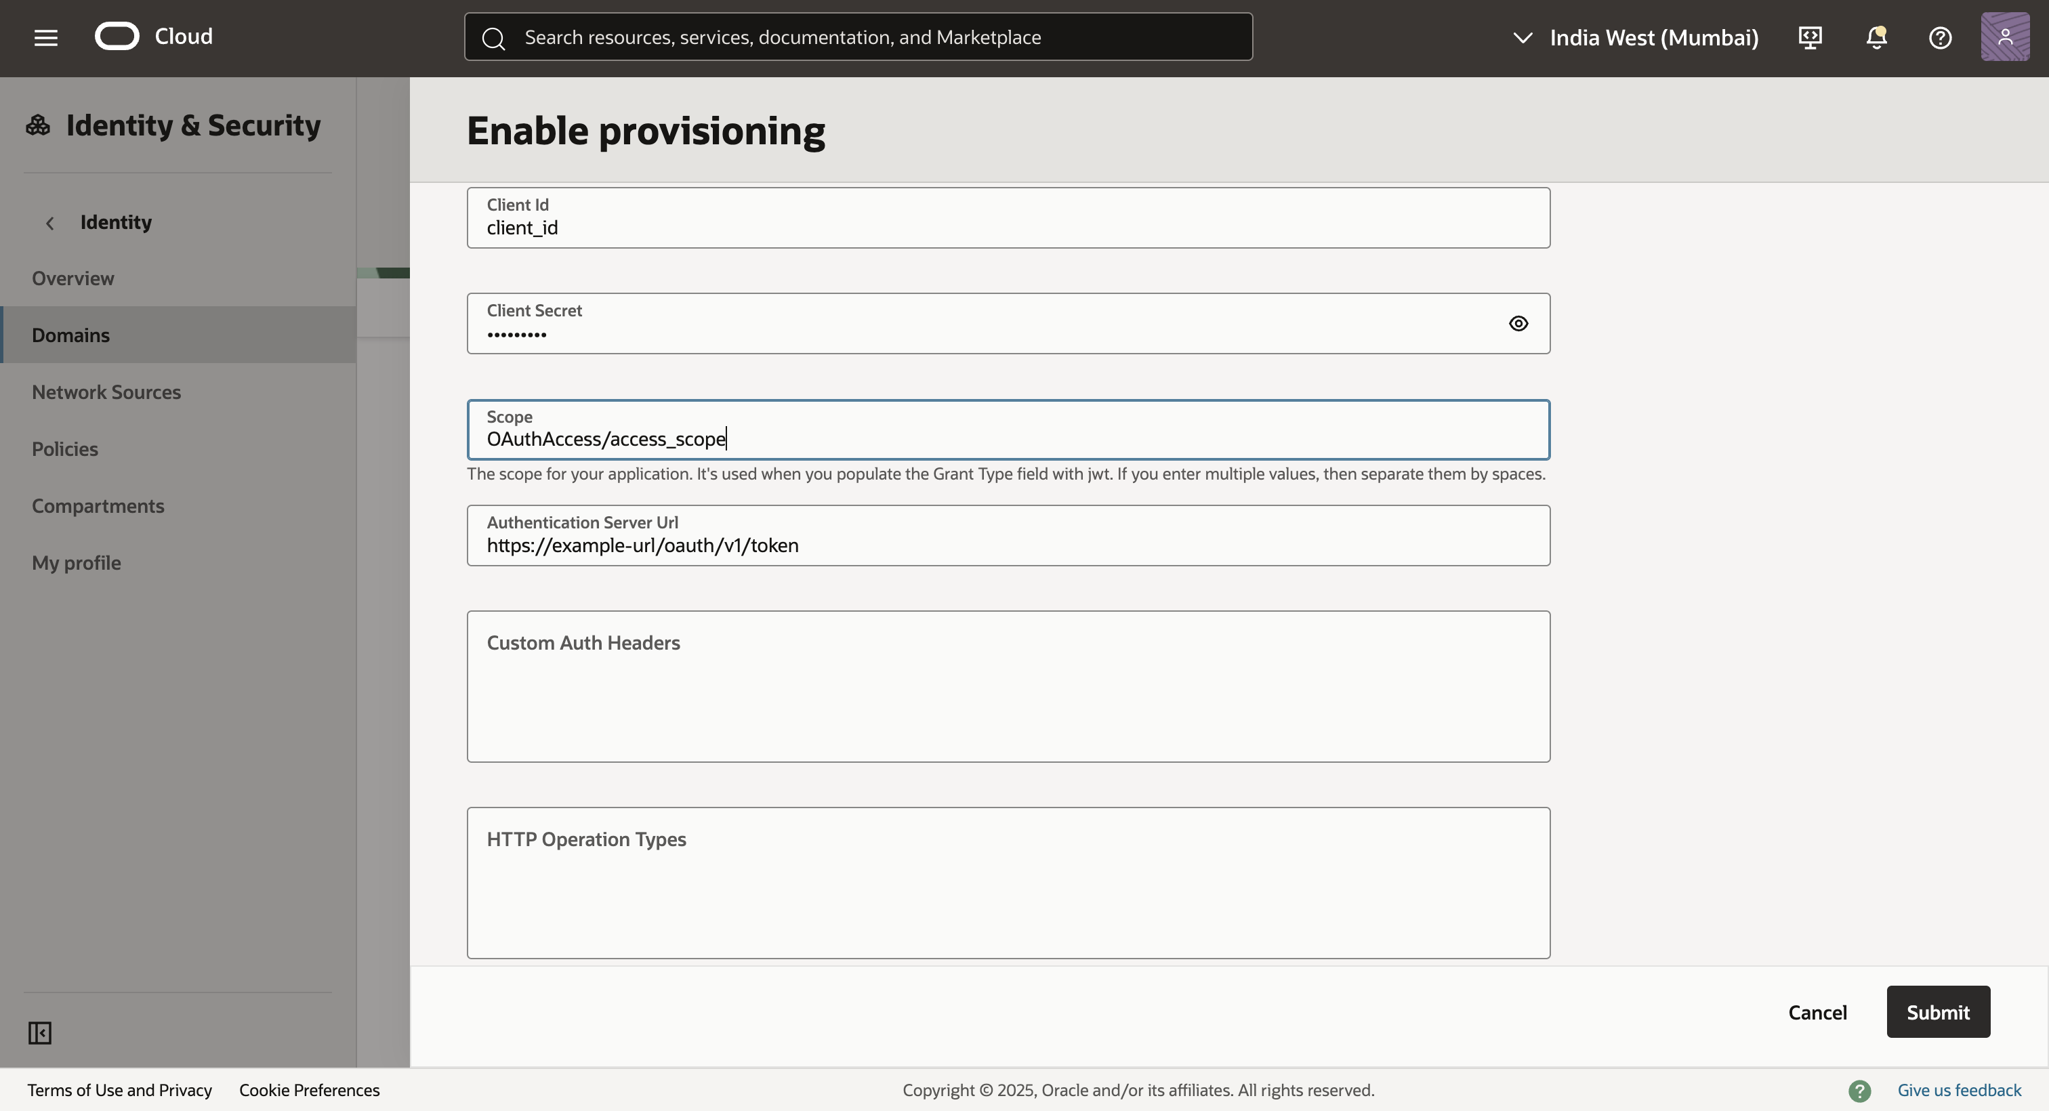
- Test Connection:
  - Scroll to the bottom of the configuration page and click Test Connection to verify connectivity and correctness of the entered details.
- Set Provisioning Operations:
  - In the Select Provisioning Operations screen, configure the operations Create, Update, Delete.
  - Toggle Enable Synchronization and configure the synchronization settings as needed Ensure that External ID is selected as the identifier.
  - Click Save Changes. (Screenshot)
- Activate the Application:
  - Once all configurations are complete, click Activate to enable the application for use. (screenshot)
This will configure your app and will be able to manually assign a user to the application in order to automatically assign a user to a scim application follow the configuration.
Part 5. Configure auto assignment by user groups.
- Navigate to the domains tab and click on the domain in which the application is configured.
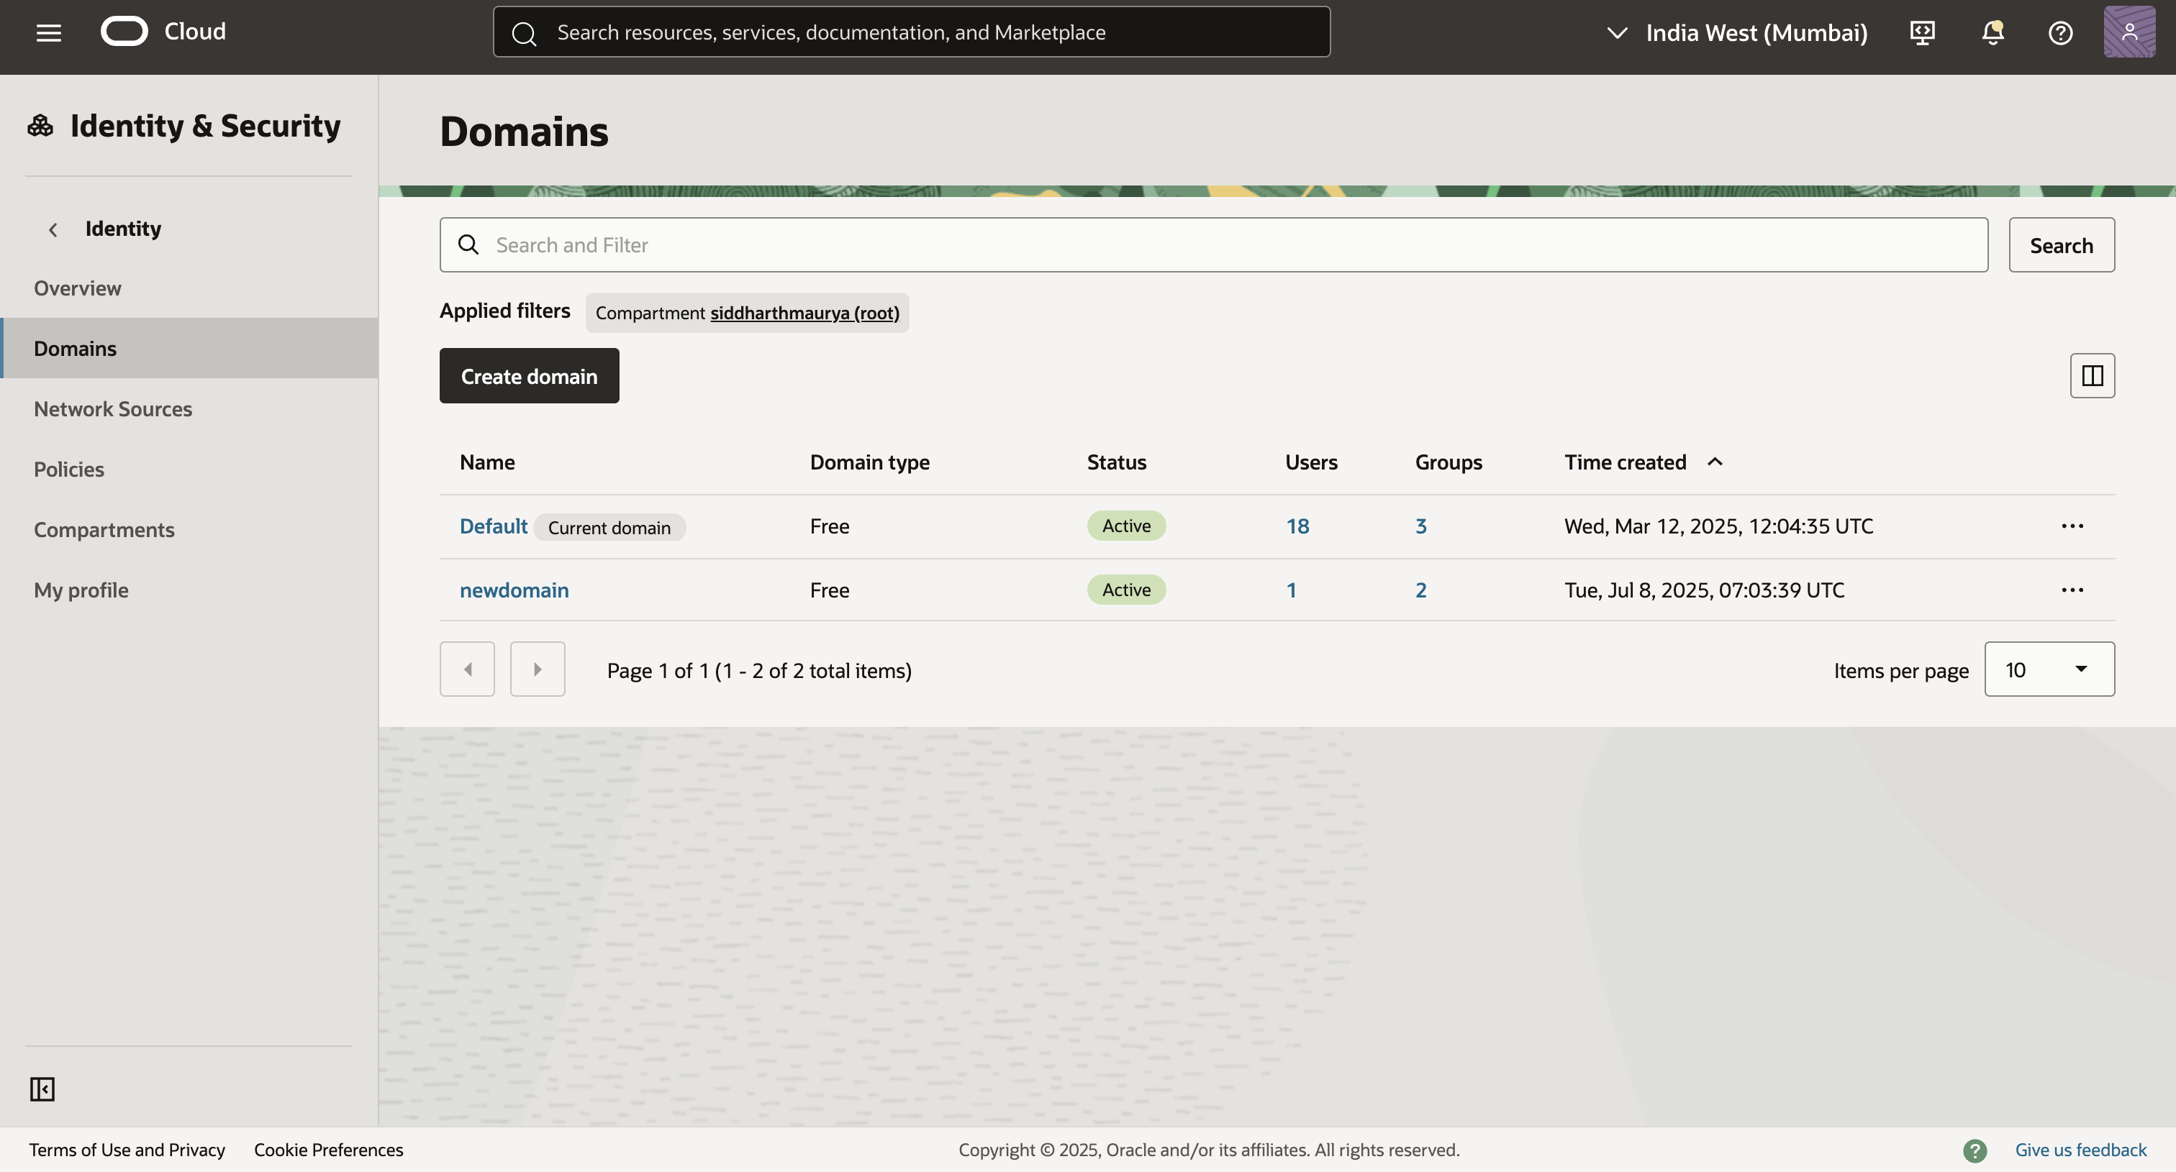
- Navigate to the user management tab, scroll down to the groups section, and click on create group.
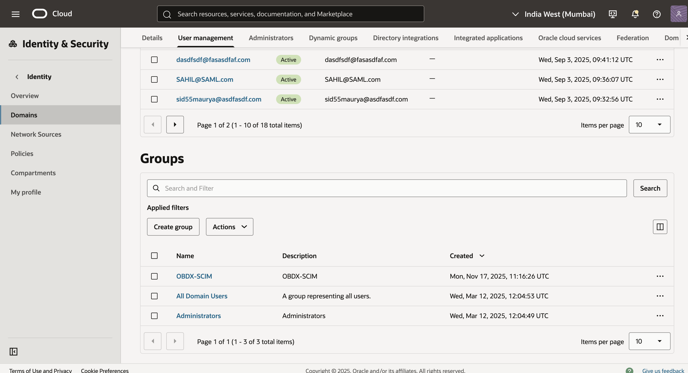
- Add the appropriate name and description and click on create.
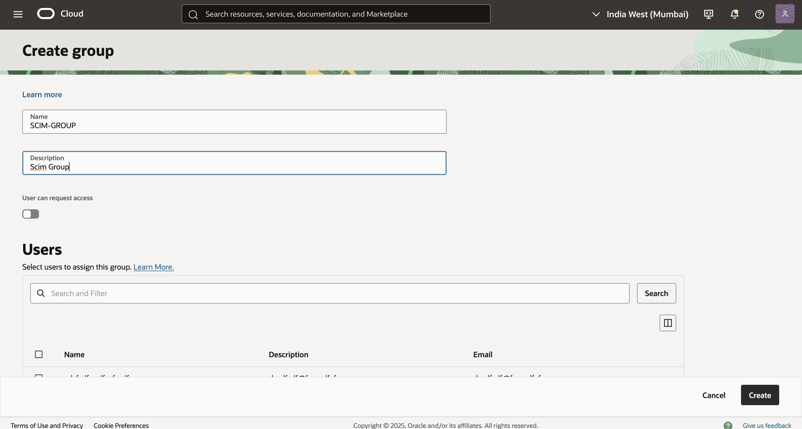
- Navigate to the integrated applications tab of the group description and click on Assign applications.
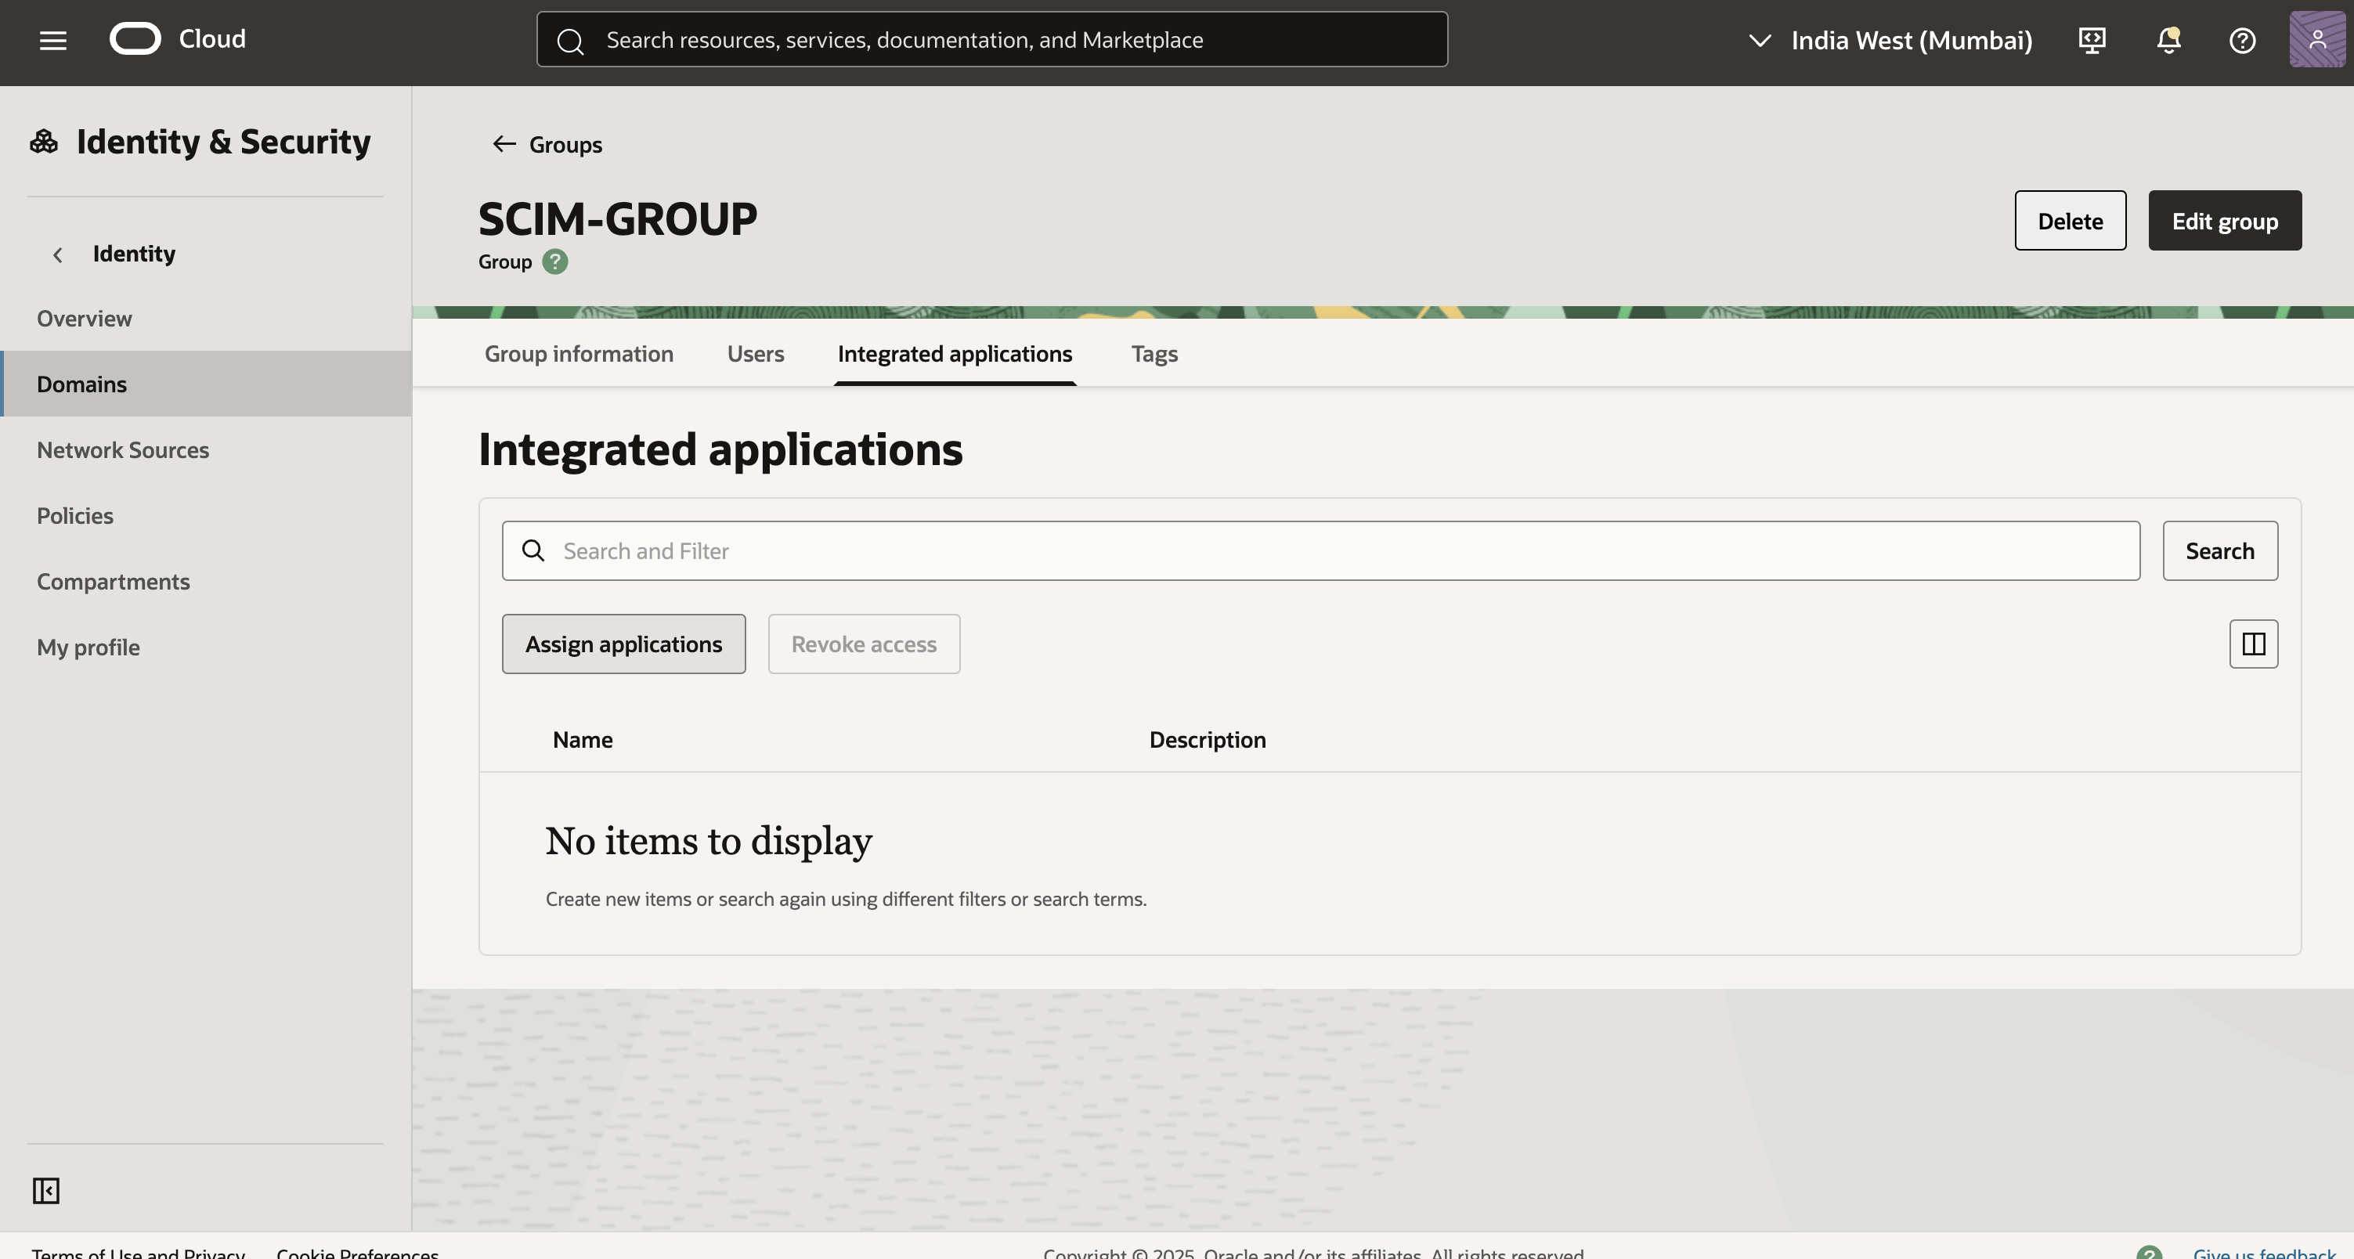
- Click on the appropriate integrated application and choose fill form and assign.
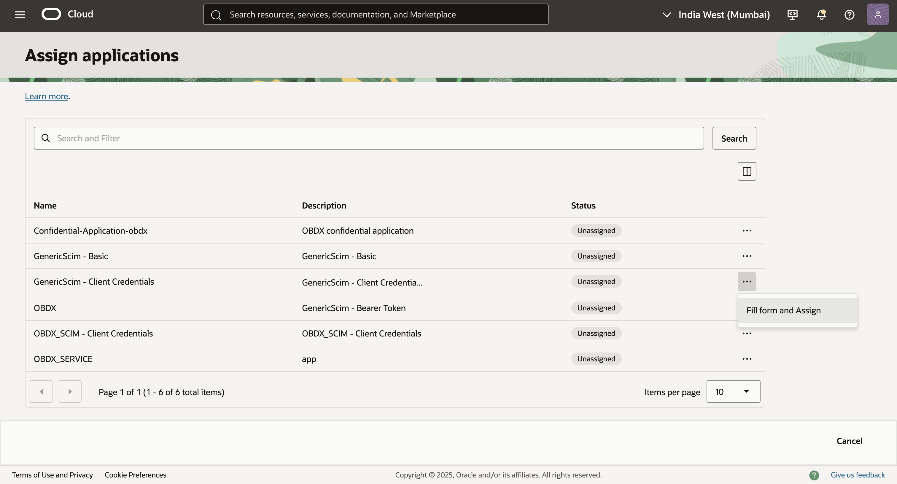
- Click on assign application to assign the group to the application.

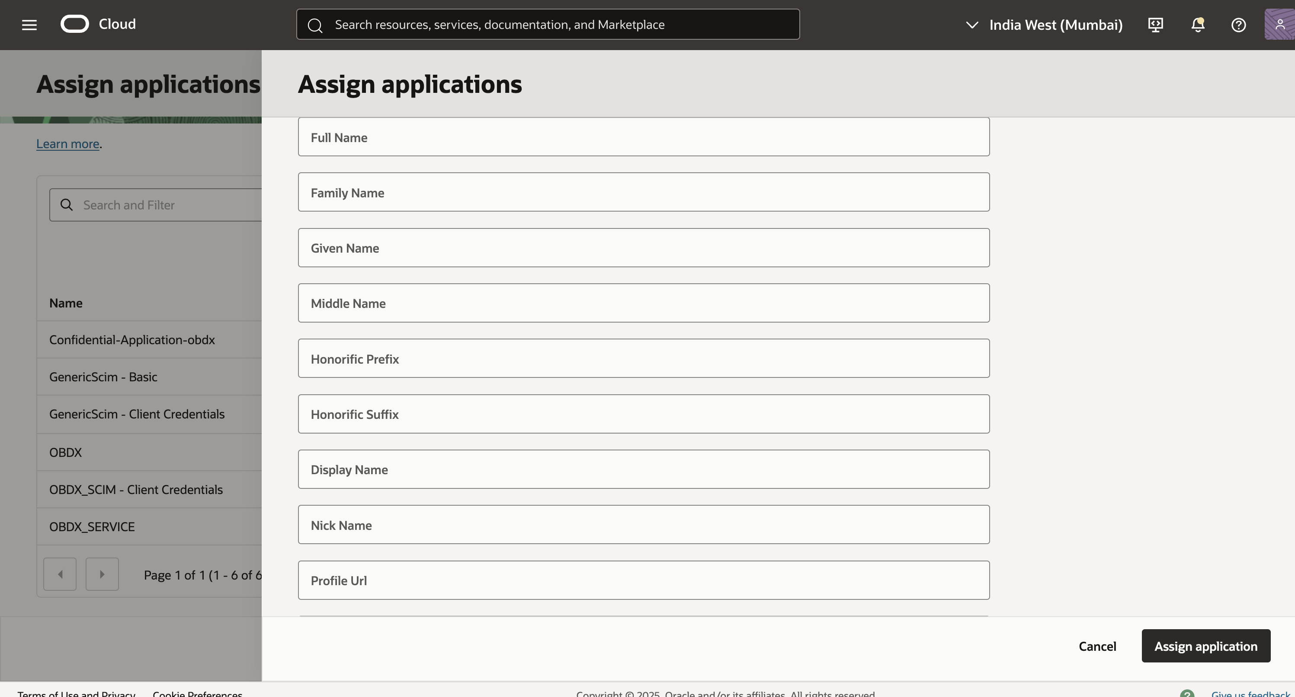
- Subsequently, when you create a user through API or through IDCS screen, assign the group to the user, and the user will be auto provisioned to the application.
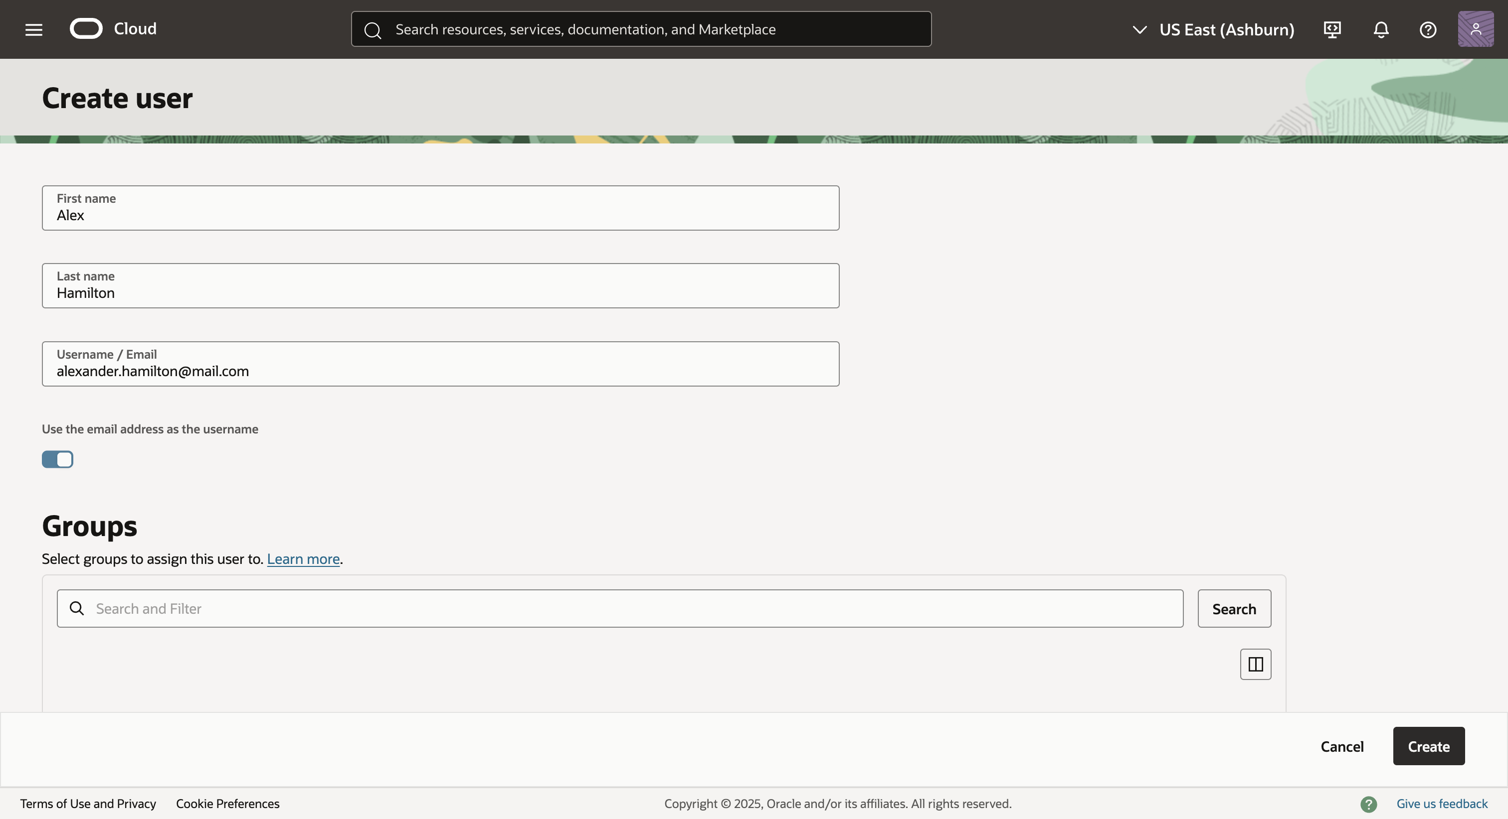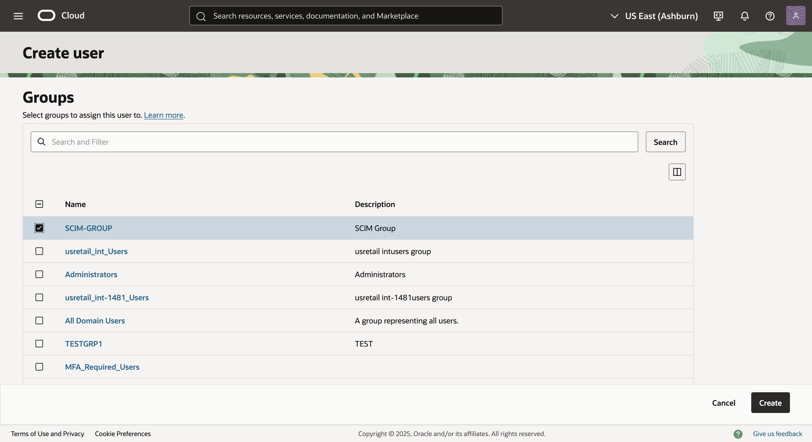
Refer to IDCS user create documentation to view how to assign the group.
https://docs.oracle.com/en/cloud/paas/identity-cloud/idcsa/op-admin-v1-users-post.html

