Email And SMS Setup

Release:
OBMA – 14.8.2
OBDX CS - 25.1.2.0

Summary:
This document has details of the email and SMS configurations to be made in Oracle Digital Banking Experience CS.
This setup is with respect to base entity shipped with Oracle Digital Banking Experience CS setup.
For any other entity in Oracle Digital Banking Experience CS, the same configurations to be followed for that particular entity.

Commonly used acronyms in this document:

Name | Value
OBDX CS | Oracle Banking Digital Experience Cloud Service
OBRH | Oracle Banking Routing Hub / Interconnect
AMS | Application Management Services
OBMA | Oracle Banking Microservices Architecture

- EMAIL SETUP:

There are two types of configurations supported for Email
- Using SMTP server
- Email service through Interconnect

- Using SMTP server to trigger emails:

Configuration Steps:

- Go to System configurations -> Global Settings -> Event Management and set ‘Email Configuration for OBRH should be set to false

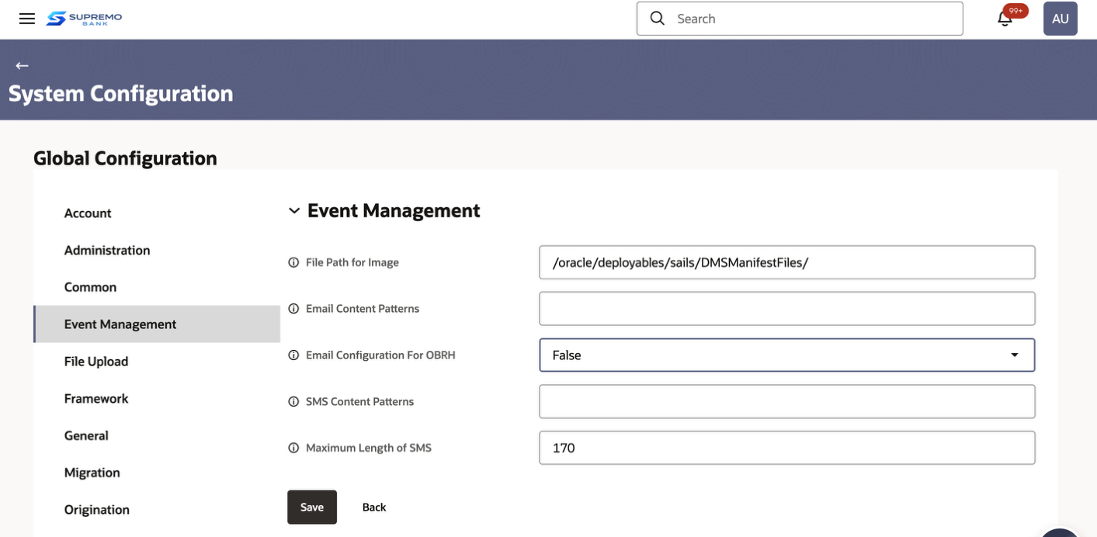

- Provide the proxy settings in System Configurations -> Entity -> Event Management -> Email Proxy Settings

Email Proxy setting format is :
HTTP,<proxy URL>,<port>,<userId>

AMS team to mount this proxy details on the setup

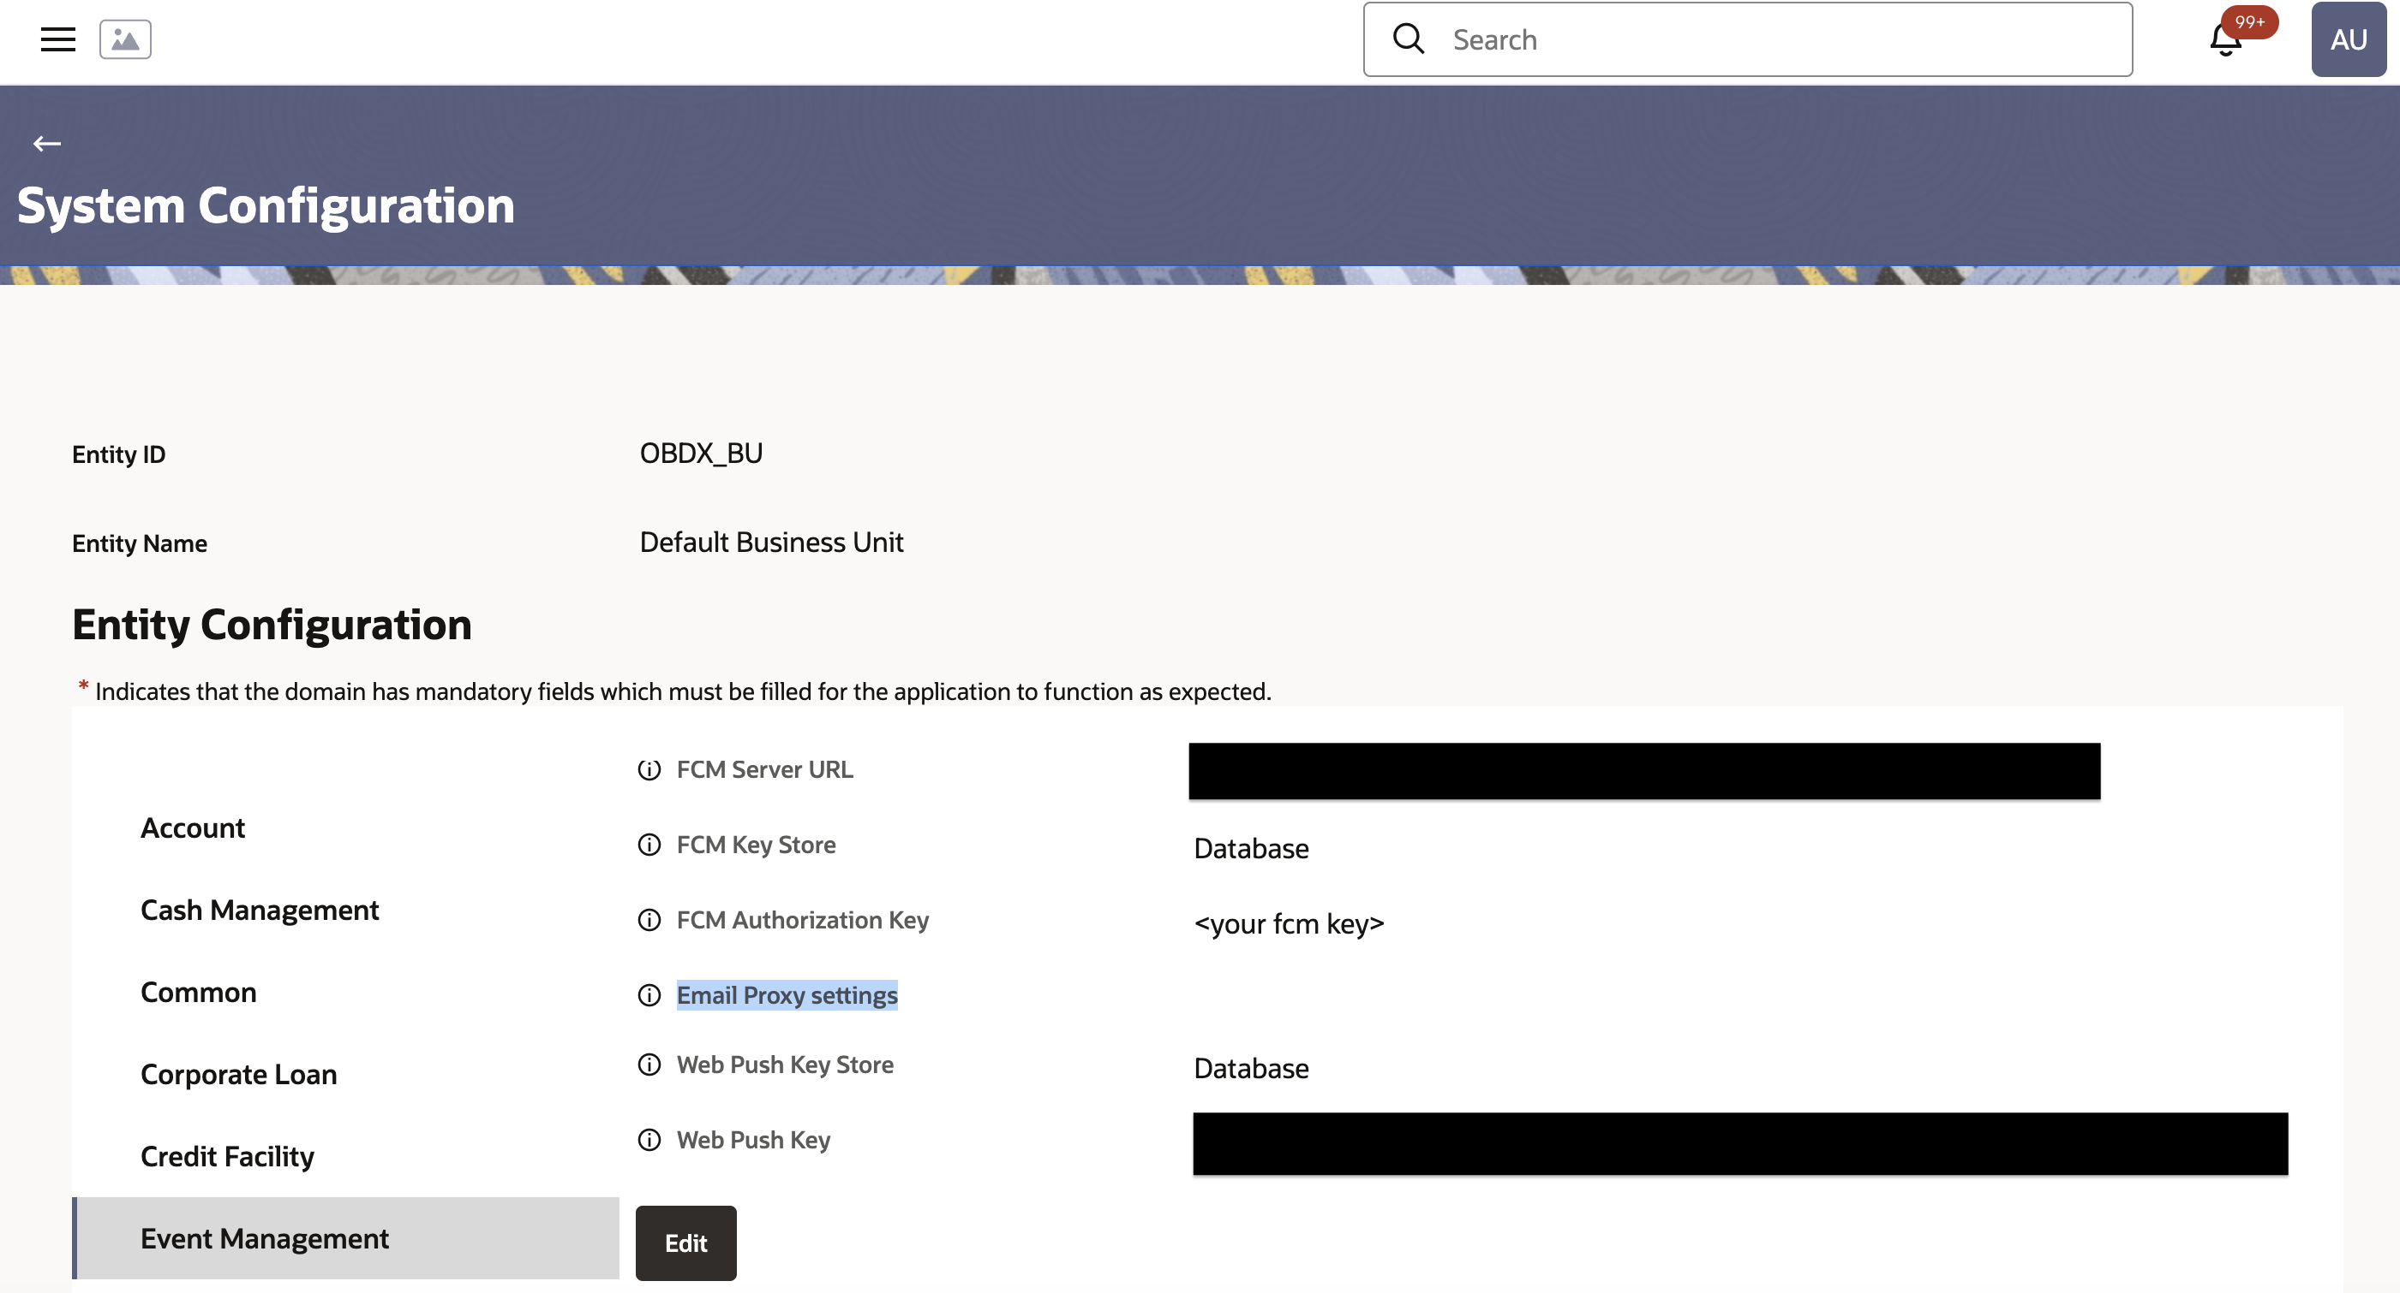

- Check with AMS team for any URL whitelisting and to allow port
for bank’s cluster for their tenancy

- Email Service through Interconnect

Pre-requisites:
Below are required for setting up email
- Web Server Host
- Web Server Port
- Email Client Foundation Service
- Email Client Foundation Service Port
- Sender Email Address

Configuration Steps:

- Go to System configurations -> Global Settings -> Event Management. ‘Email Configuration for Cloud’ should be set to true

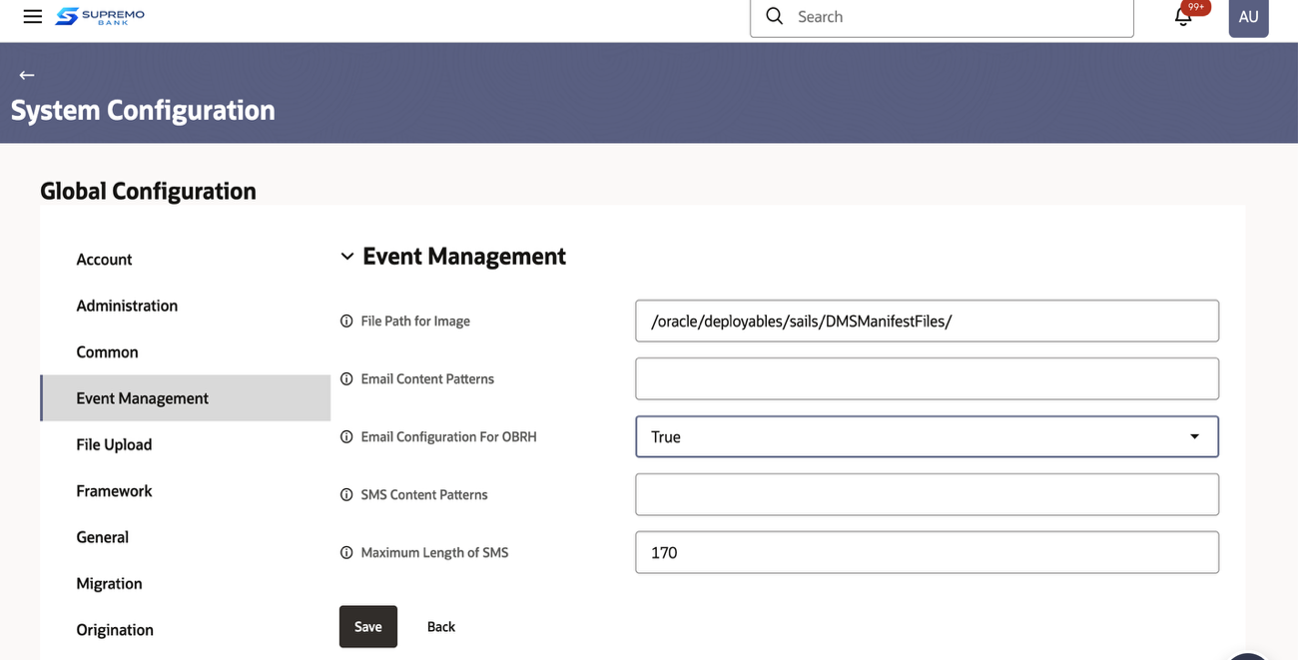

- Go to System configurations -> Entity -> General

From the details obtained from AMS team for
Web Server Host
Web Server Port

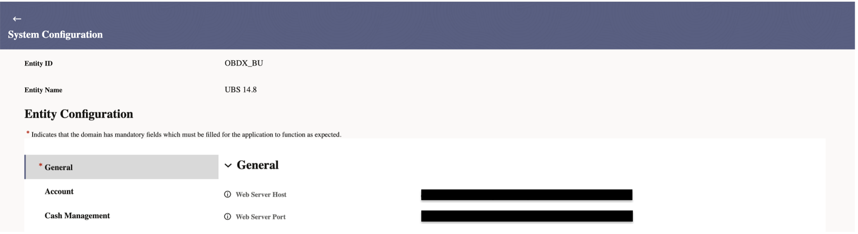

- Go to System configurations -> Entity -> General, set below values

SMTP Server IP Address - (set Email Client OBCS Foundation Service Address / External Email Service Address)
SMTP Server Port - (set Email Client OBCS Foundation Service Port/ External Email Service Port)

Bank’s Sender Email Address (set Bank’s Sender Email Address)

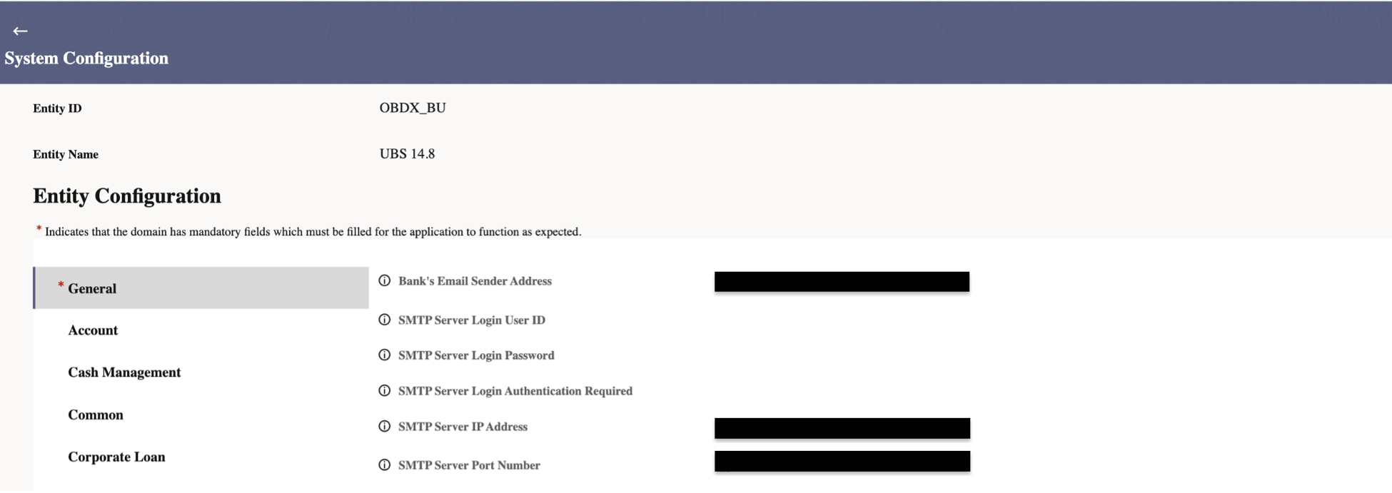

- Default email server is the OBCS foundation email service. However, if bank wants to configure external email service, bank needs to update certain configurations in Interconnect.
    - Login to app-shell user (non-entity admin). Go to Interconnect -> Routing Hub->Service Consumers
    - Search for OBDX_TRUNK. And click “View More”
    - Go to Service Providers and search for “EXTERNAL_DISPATCHER_PROVIDER”. Click on “View More” and edit EMAIL route.

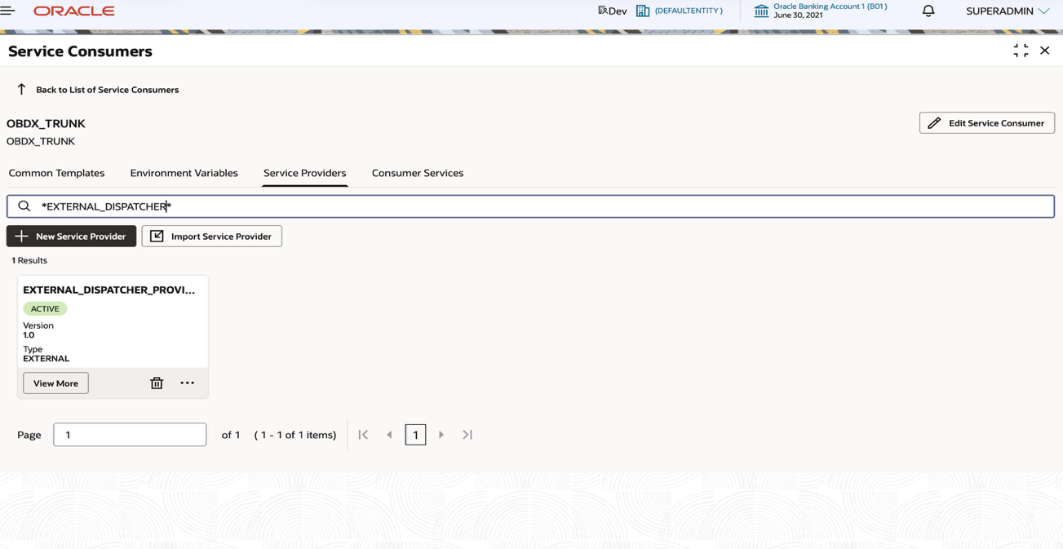

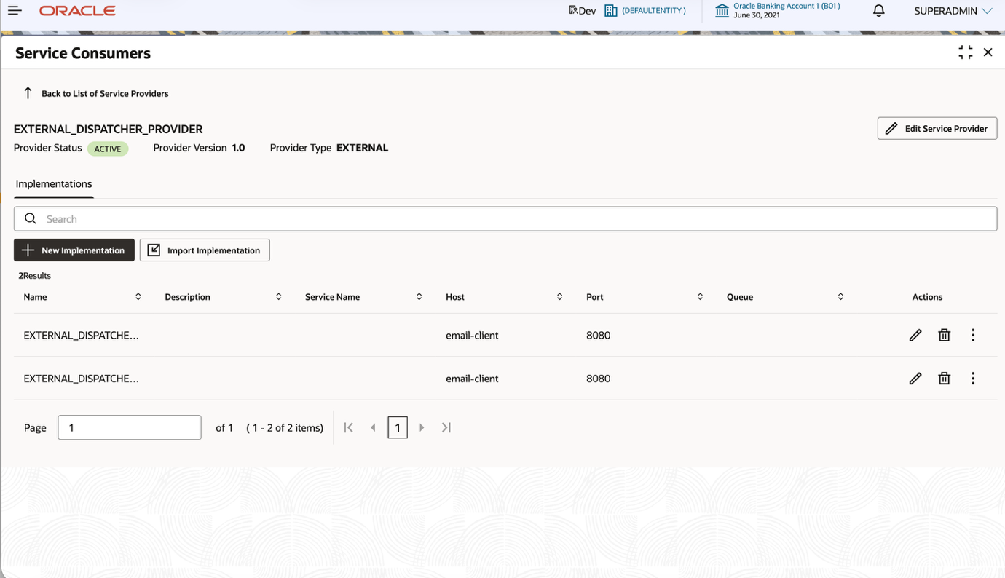

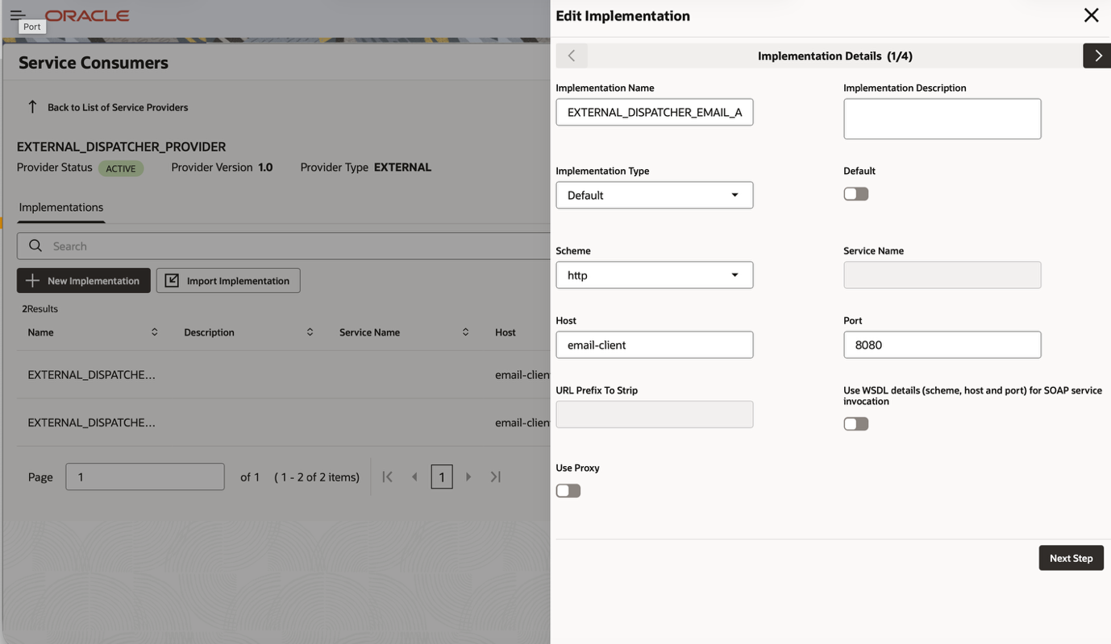

    - Enable Proxy to connect the Apis outside cloud environment

    - Configure the host and port any authentication and additional headers if any.

- SMS Setup

SMS will always route through interconnect. The configuration steps are as well

Configuration Steps:

- Login to app-shell user (non-entity admin). Go to Interconnect -> Routing Hub->Service Consumers
- Search for OBDX_TRUNK. And click “View More”
- Go to Service Providers and search for “EXTERNAL_DISPATCHER_PROVIDER”. Click on “View More” and edit SMS Route.

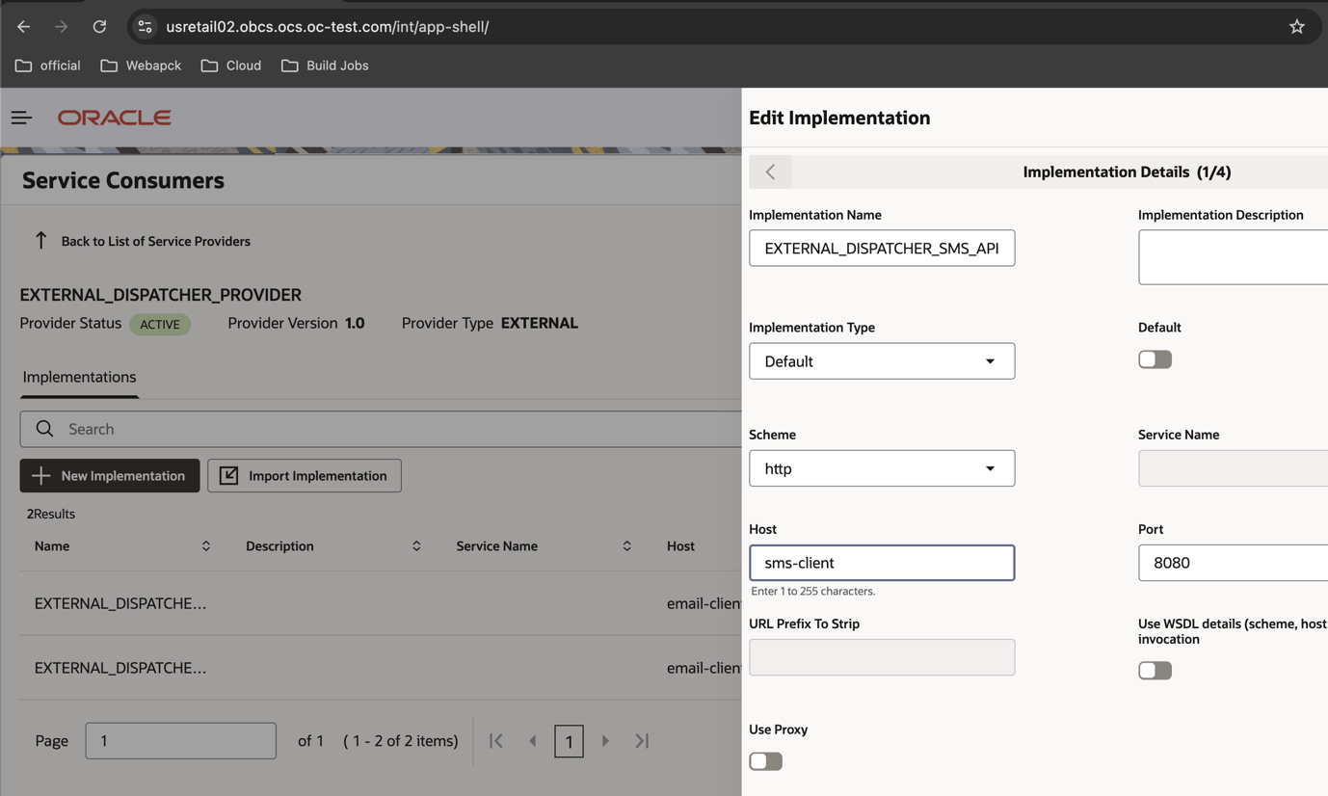

- Enable Proxy to connect the Apis outside cloud environment
- Configure the host and port any authentication and additional headers if any.

