JWKs Configuration:

OBMA - v14.8.2
Oracle Banking Digital Experience CS - OBDX CS – v25.1.2.0

Summary:
This document has details of the configurations for configuring the JWKs key for validating the authorization calls from Authorization server. This is mandatory step.

JWKS is set of JSON Web key Set which contains public keys for verifying JWT signature issue by the authorization server. This is used in OAuth2 or OIDC standards to allow clients to verify tokens without managing keys manually.

Impacted Areas (Areas this JWKs validation is required):

- OBDCS mobile application
- Cloud API Testing through Postman which has X-Token_type is IDCS

Pre-requisites:
IDCS admin console URL and credentials to be taken from AMS team for the bank’s tenancy

Configurations Steps:
- Sign in to Oracle IDCS Admin Console
- Open Oracle IDCS administration URL
- Log in with your administrator credentials
- Navigate to Domains section
- Default Domain will be displayed
- Click on the Default
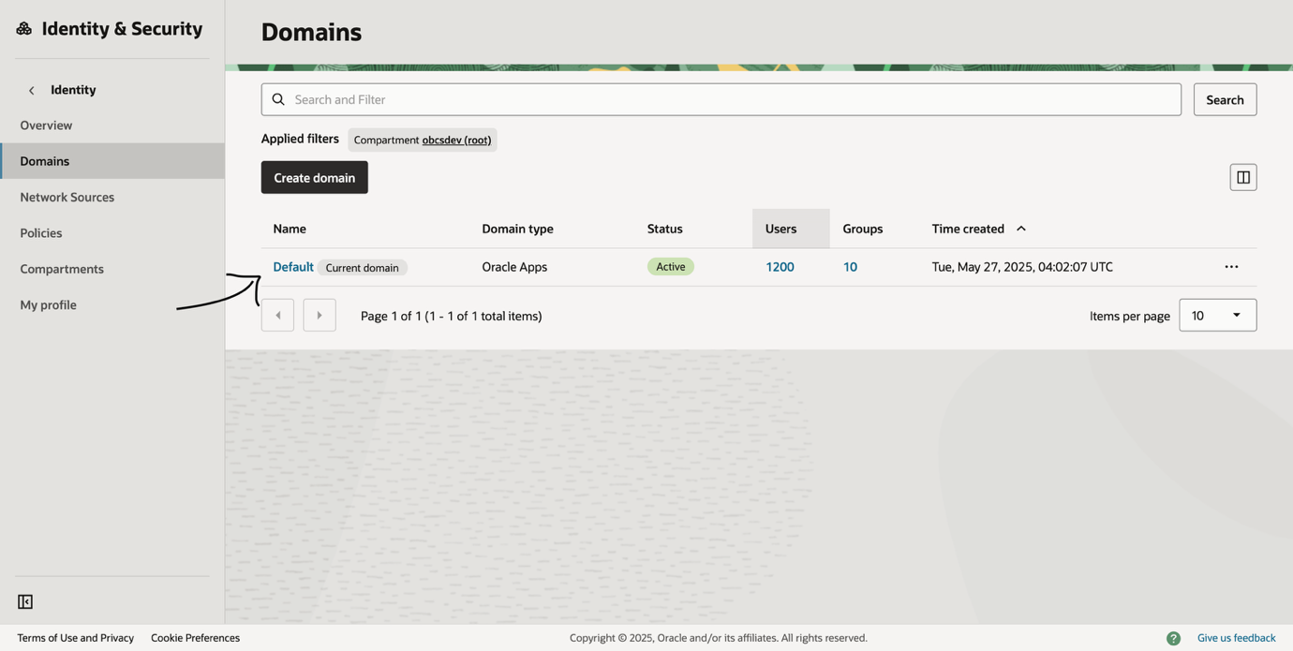

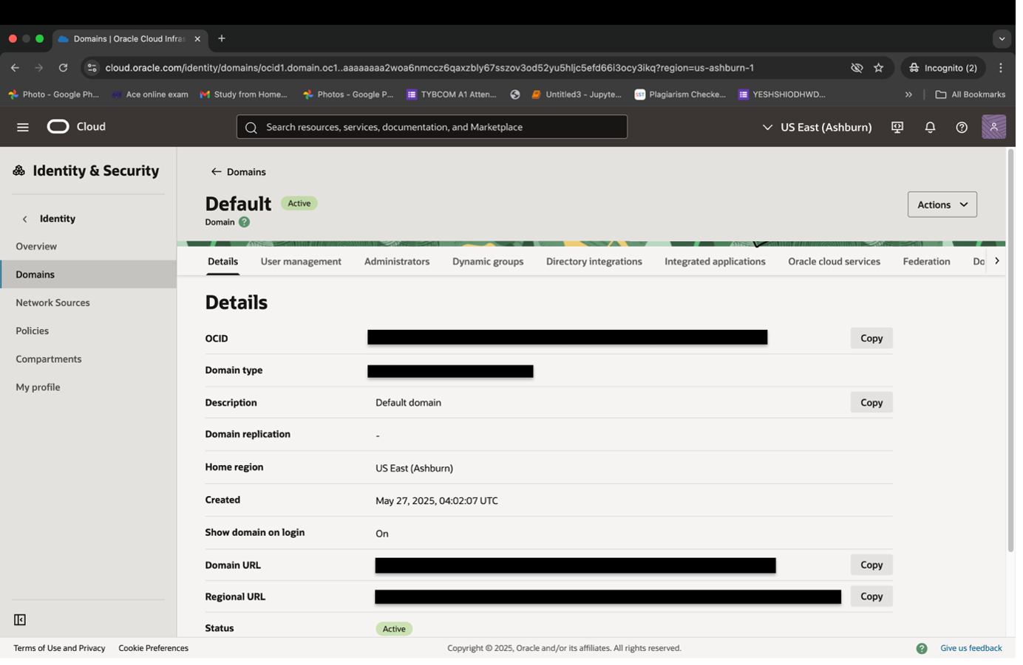

c. Copy the Domain URL and logout
d. Login to OBDCS application and login with SUPERADMIN and go to System Configurations
e. Select Entity and go to General -> Edit
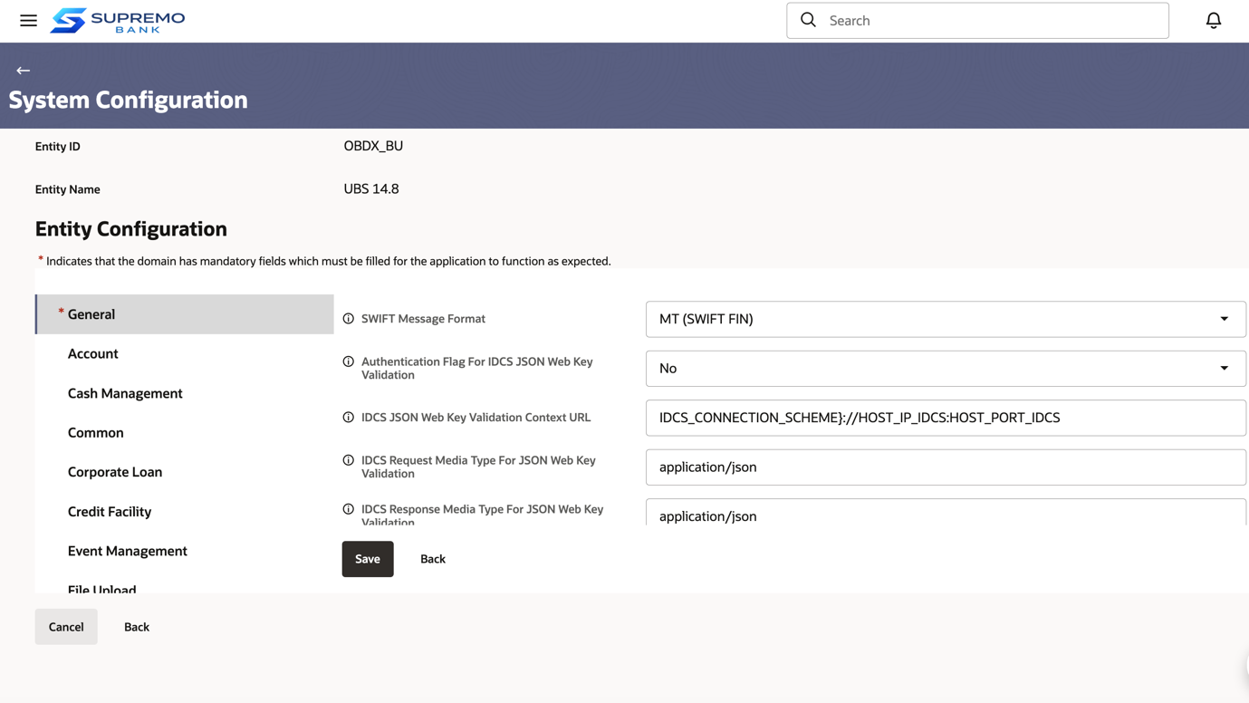
f. Replace the domain URL copied from IDCS in IDCS JSON Web Key Validation Context URL
g. Click Save and Confirm

