Oracle IDCS — MFA Policy Setup Guide
Overview
This guide explains how to configure a Multi-Factor Authentication (MFA) policy in Oracle IDCS that triggers 2FA for users belonging to a specific group. When a user in the assigned group logs in, they will be prompted to verify their identity using a second factor.
Assigning a MFA policy to a group can be optional setup if bank needs 2fa for IDCS login flow. If these steps are skipped, 2fa will not be enabled for login IDCS flow. If later MFA policy is applied, the user will be prompted to perform 2fa on login.

How it works:
- Create group in IDCS (mandatory)
- Configure that group in OBDX CS application configuration to map the user to the group when creating a user through SCIM. (mandatory)
- Configure MFA factors (optional)
- Create an MFA policy, configure the allowed second-factor methods, and assign the policy to a group. Any user in that group will be required to complete 2FA on login. (optional)

- Prerequisites
Before you begin, make sure you have:

- Administrator access to the Oracle Cloud Infrastructure (OCI) Console.
- An existing Identity Domain (or IDCS instance) already set up.
- A group already created in IDCS that contains the users who should be prompted for MFA.
- If SCIM is enabled, refer to SCIM integration guide to check how user are flowed into the SCIM group and overall working of SCIM. MFA policy can be applied to same SCIM group as OBDX CS users will be created in that group.

Note: If the group does not exist yet, create it first under your Identity Domain → Groups before proceeding.

- Group Creation in IDCS:
The existing SCIM configuration must already be completed before performing the steps below. Do not replace the existing SCIM group configuration. The groups mentioned on this page are additional groups.

Prerequisites
The IDCS domain has already been created.
The Confidential Application and GenericSCIM application have already been configured.
The existing SCIM group configuration has already been completed as per the main integration guide.
The user performing these steps has access to create groups in IDCS and maintain system configuration values in OBDX.

Create Additional Groups in IDCS
Create three additional groups in the same IDCS domain that is used for the OBDX integration.
Administrator | Administrator user group | IDCS Group OCID / Group ID
Corporate User | Corporate user group | IDCS Group OCID / Group ID
Retail User | Retail user group | IDCS Group OCID / Group ID

Steps to Create Each Group
- Access your Oracle Cloud Infrastructure tenancy using your credentials.
- From the sidebar menu, navigate to Identity & Security > Domains.
- Select the domain that is used for the OBDX and IDCS integration.
- Navigate to User Management > Groups.
- Click Create Group.
- Enter a suitable name and description for the group.
- Example group names: (These groups are based on user type to control the 2fa policy to be applied to the respective user type)
  - OBDX Administrator Users
  - OBDX Corporate Users
  - OBDX Retail Users
- Click Create.
- Open the created group and note the Group OCID or Group ID shown in IDCS.
- Repeat the same steps until all three groups have been created.
- Record the IDCS Group OCID / Group ID carefully. This value must be maintained in OBDX. Do not use the group display name in place of the Group OCID / Group ID.

- OBDX Side Configuration
- After the three groups are created in IDCS, maintain the corresponding group details in OBDX system configuration.
- Login to OBDX with a user having access to maintain system configurations.
- Navigate to System Configurations > Global Settings > Security Management System.
- Search for and maintain the following configuration values:
IDCS Administrator Group ID | IDCS Group OCID / Group ID of the Administrator user group
IDCS Corporate Group ID | IDCS Group OCID / Group ID of the Corporate user group
IDCS Retail Group ID | IDCS Group OCID / Group ID of the Retail user group

- Open each configuration key for editing.
- Enter the corresponding IDCS Group OCID / Group ID as the configuration value.
- Save the configuration.
- Ensure that the configuration status is enabled, wherever applicable.
- Repeat the same steps for all three configuration keys.
- If any one of the required group configuration values is missing/wrong in OBDX, user creation for the corresponding user type may not proceed successfully.

- Configure Allowed Authentication Factors
Oracle IDCS supports several second-factor methods. You configure which ones are allowed on the MFA settings page.

Navigate to MFA Settings
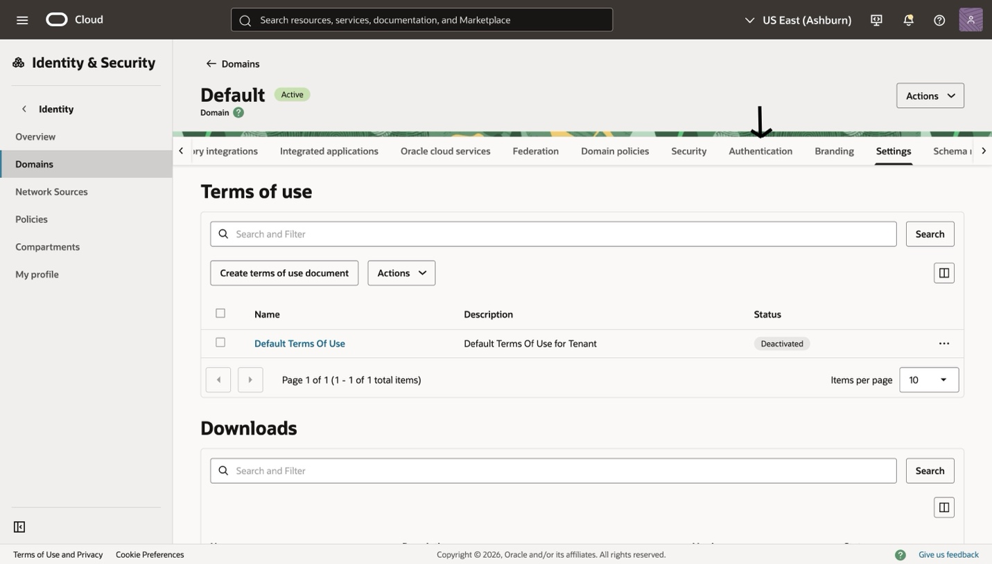
- From the horizontal menu, click Authentication

Available Factors
Enable or disable each factor as required for your organisation. The table below describes each option:

Factor | Description
OTP via SMS | A one-time passcode is sent to the user's registered mobile number.
OTP via Email | A one-time passcode is sent to the user's registered email address.

How to Enable a Factor
- On the Authentication page click Enable or Disable Factors
- Toggle ON each factor you want to allow.
- Click Save changes after making your selections.

Note: Enabling a factor here makes it available for users to enrol — it does not force users to use it. The Sign-On Policy (Step 3) controls when 2FA is enforced.

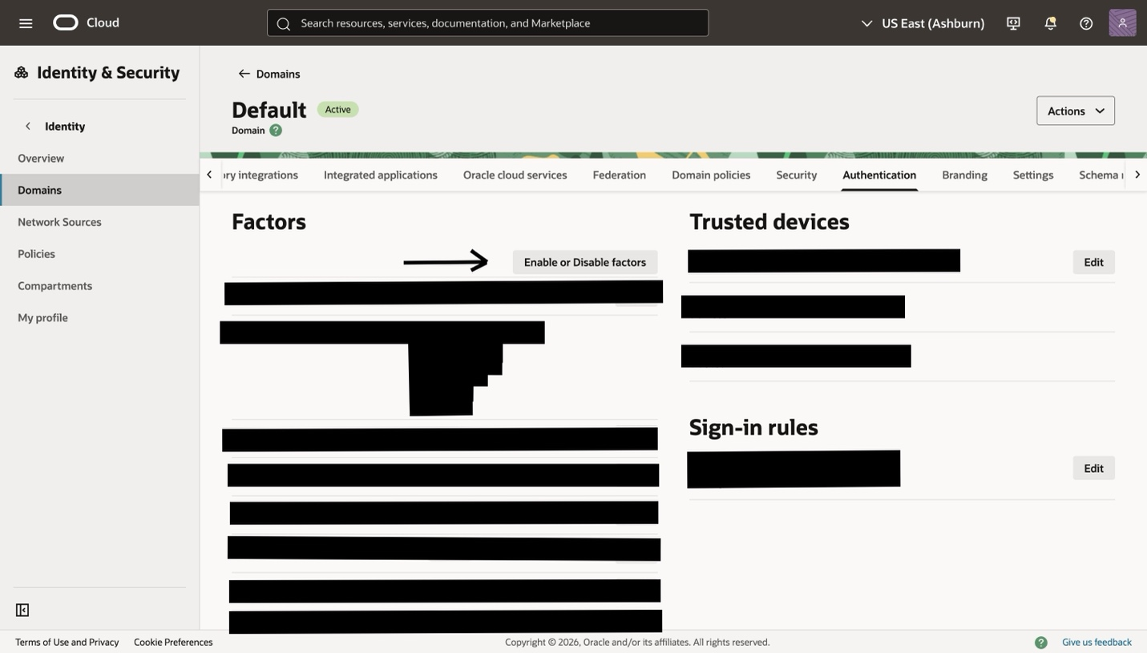
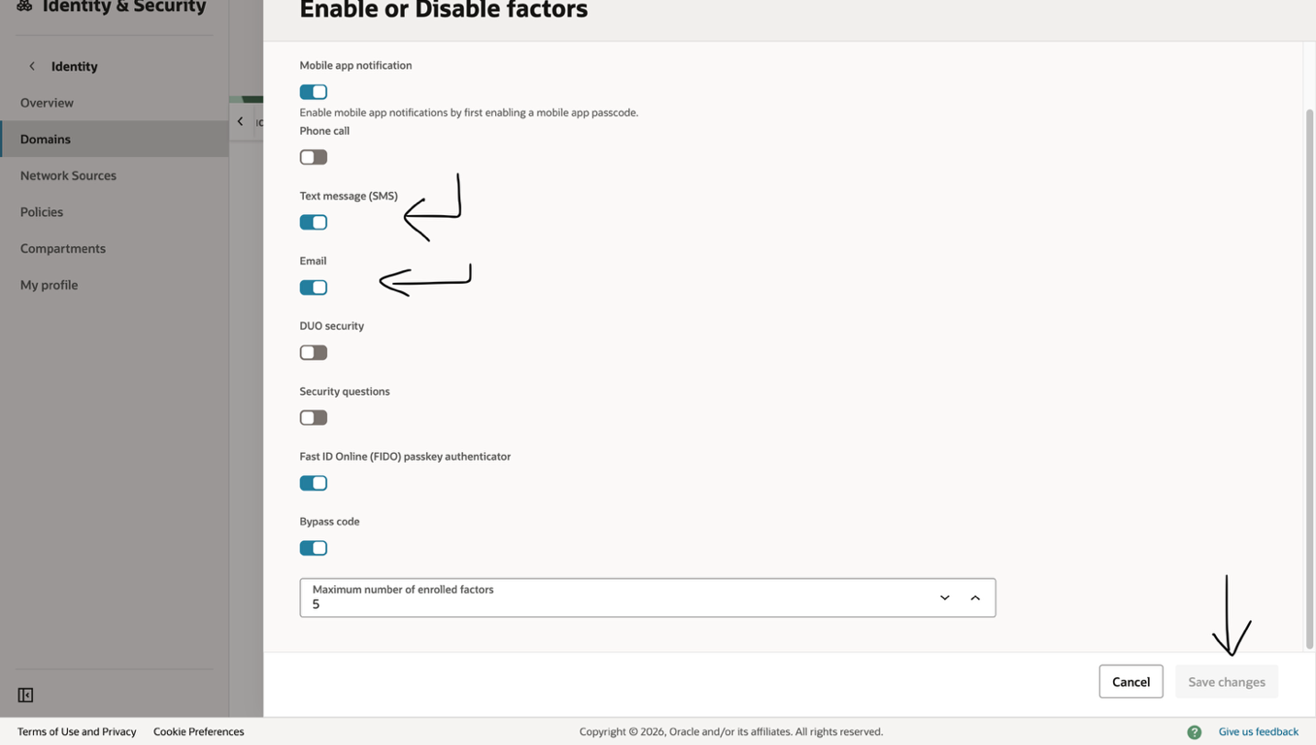

- Create the MFA Sign-On Policy

All MFA configuration in Oracle IDCS is done through the Sign-On Policies section. Use the path below to get there — this is referenced throughout the guide.

- Log in to the OCI Console.
- Go to Identity & Security → Domains.
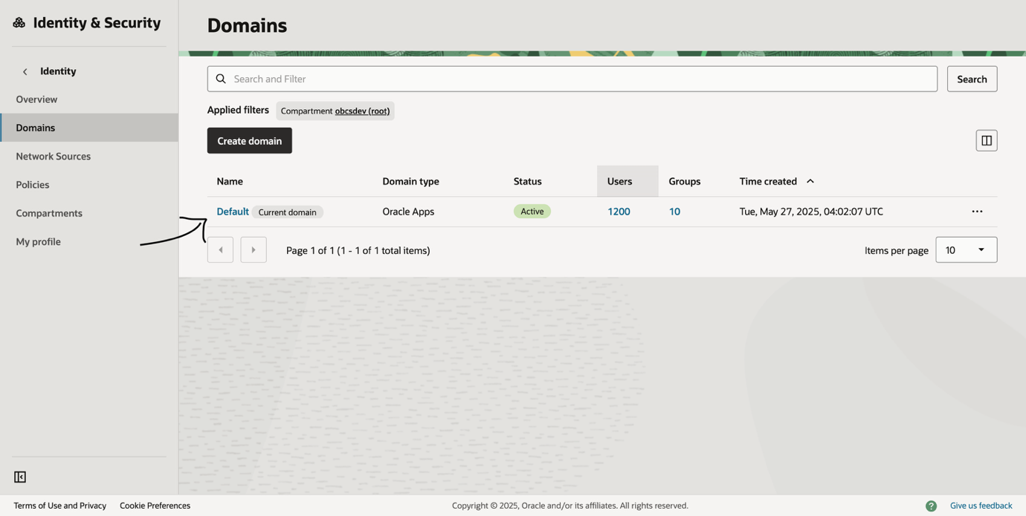
- Select your Identity Domain.
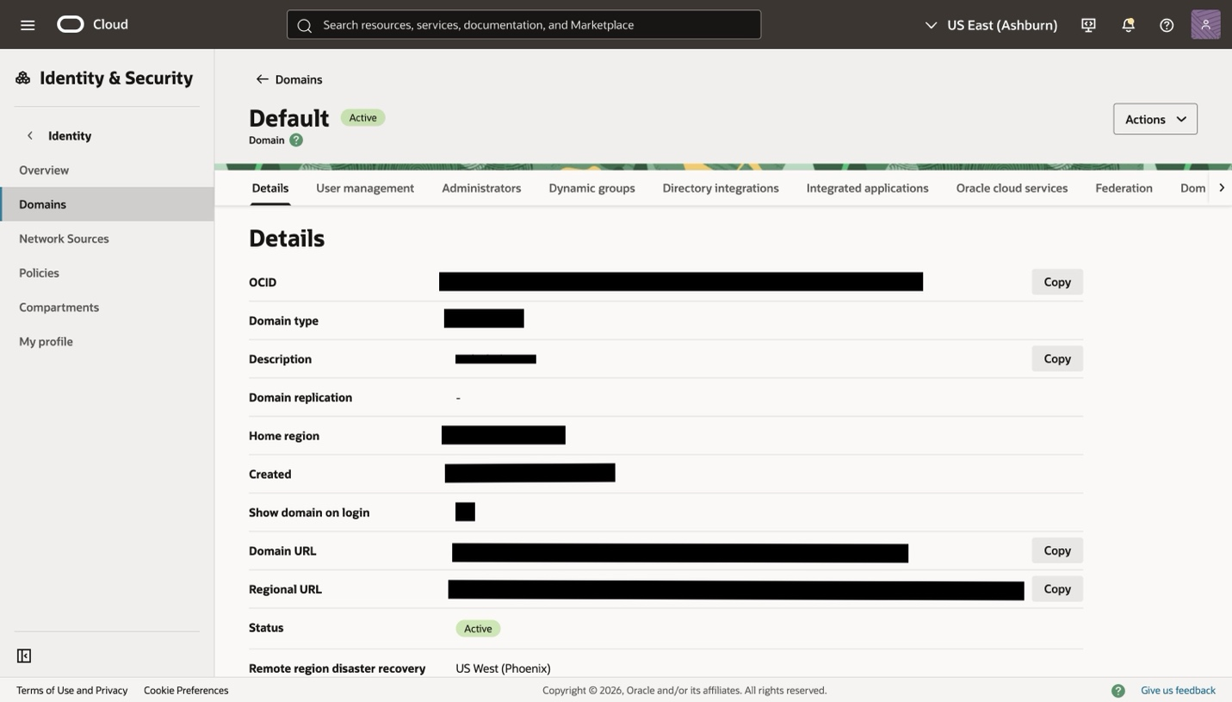

- From the horizontal menu, click Domain policies.
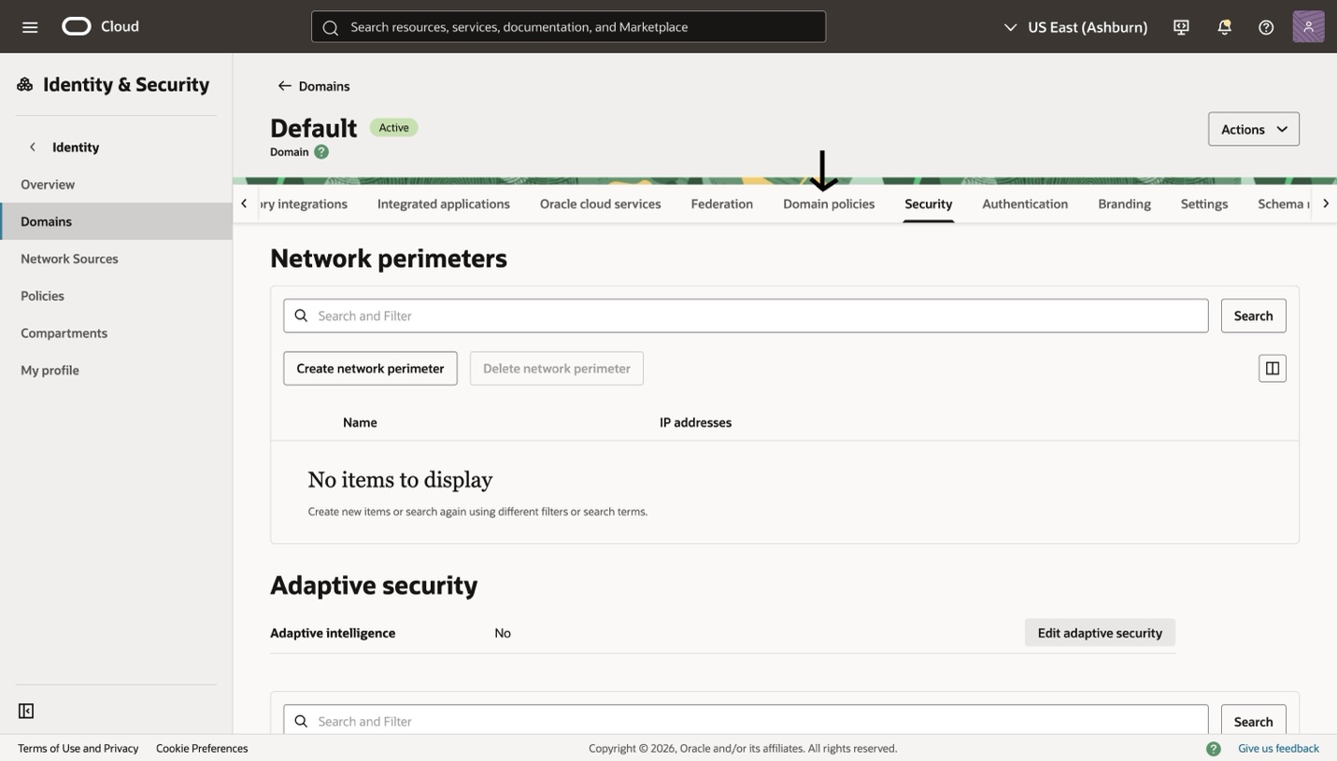
- Under Domain Policies, click Create sign-on policy.
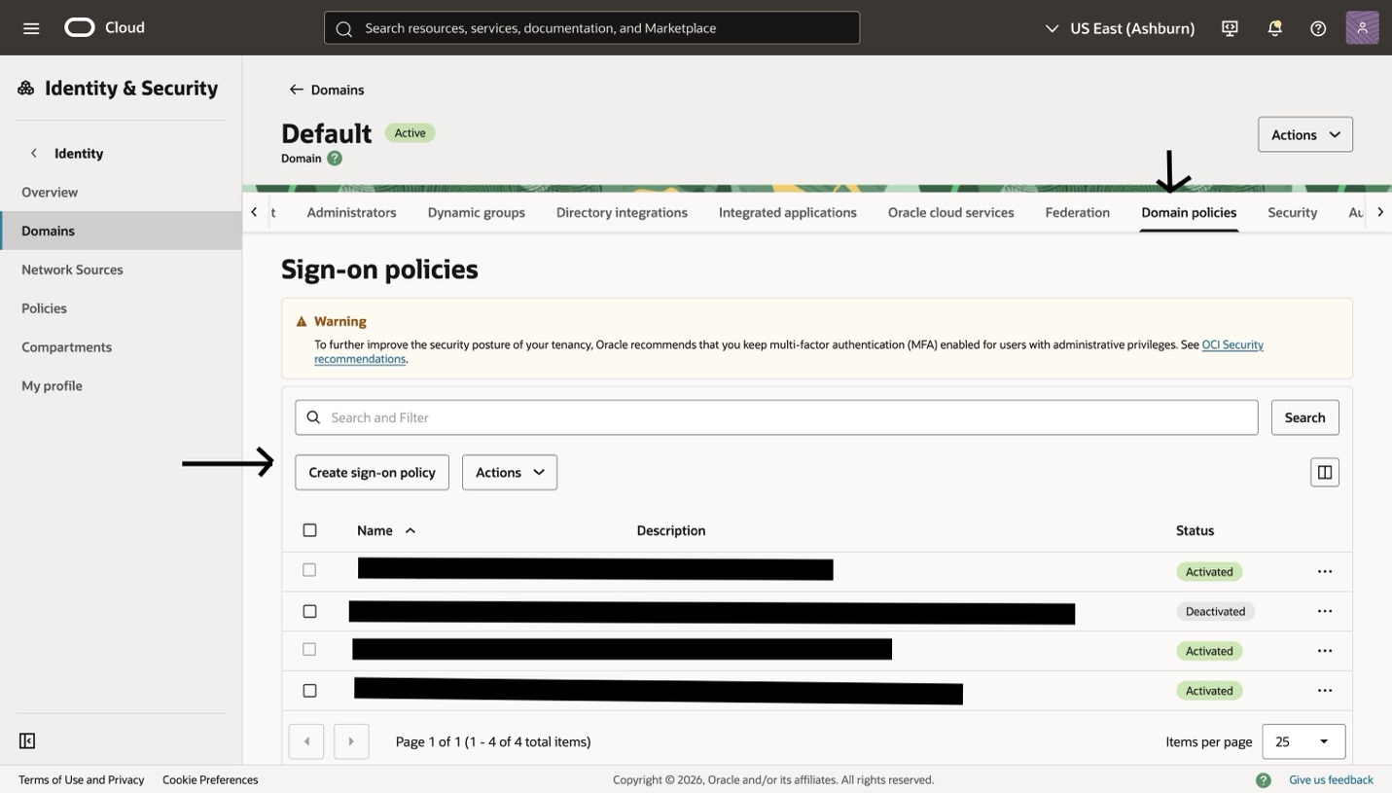

A Sign-On Policy defines the conditions under which MFA is required. You will create one policy and assign it to your target group.

Create the Policy
- Enter a Policy name (e.g. MFA-Group-Policy).
- Enter an optional Description (e.g. Enforces 2FA for users in the MFA-Users group).
- Click Create sign-on Policy.
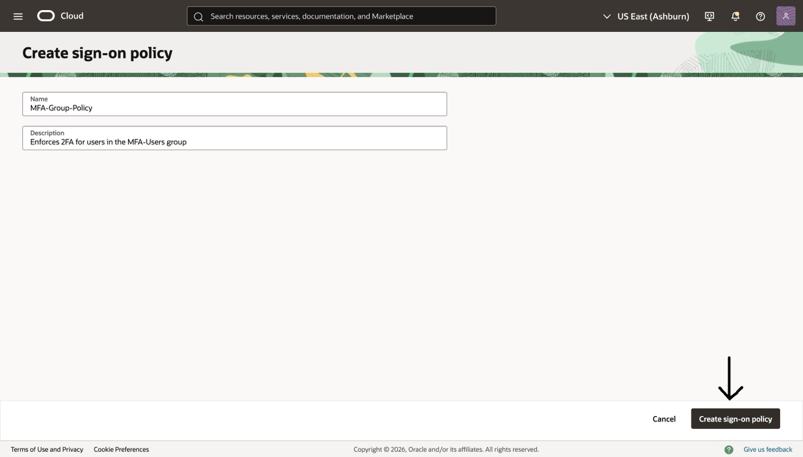

Add a Sign-On Rule
Rules within the policy define exactly who is affected and what action to take.

- After the Sign-On Policy is created, edit that policy and On the Sign-On Rules tab click Add Sign-On Rule.
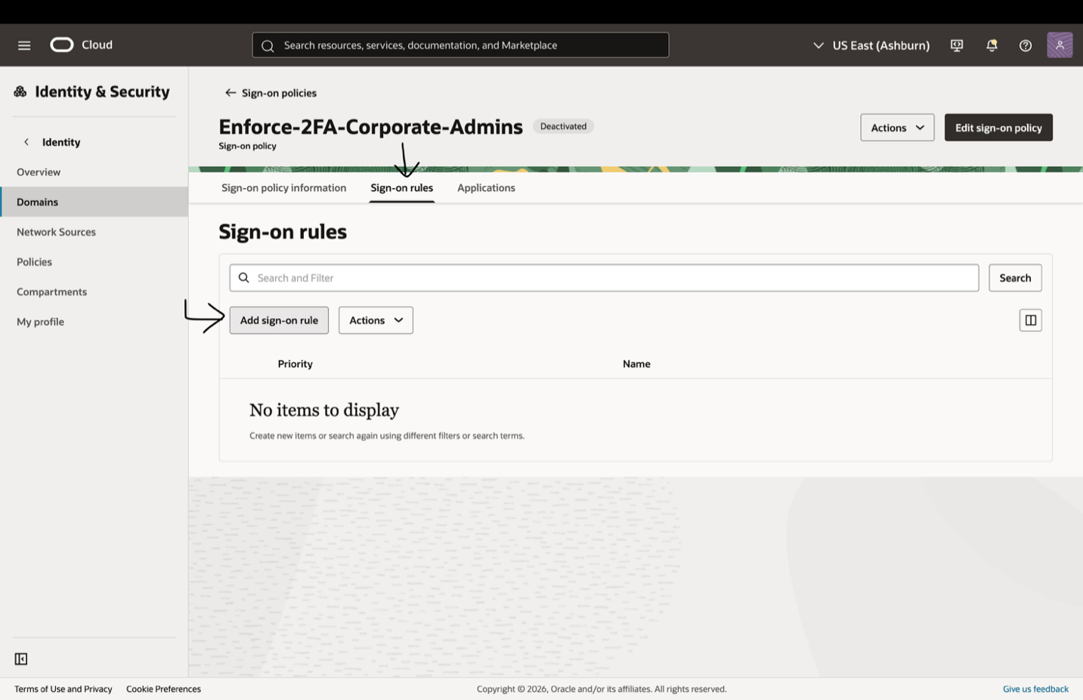
- Enter a Rule name (e.g. Require-MFA-For-Group).
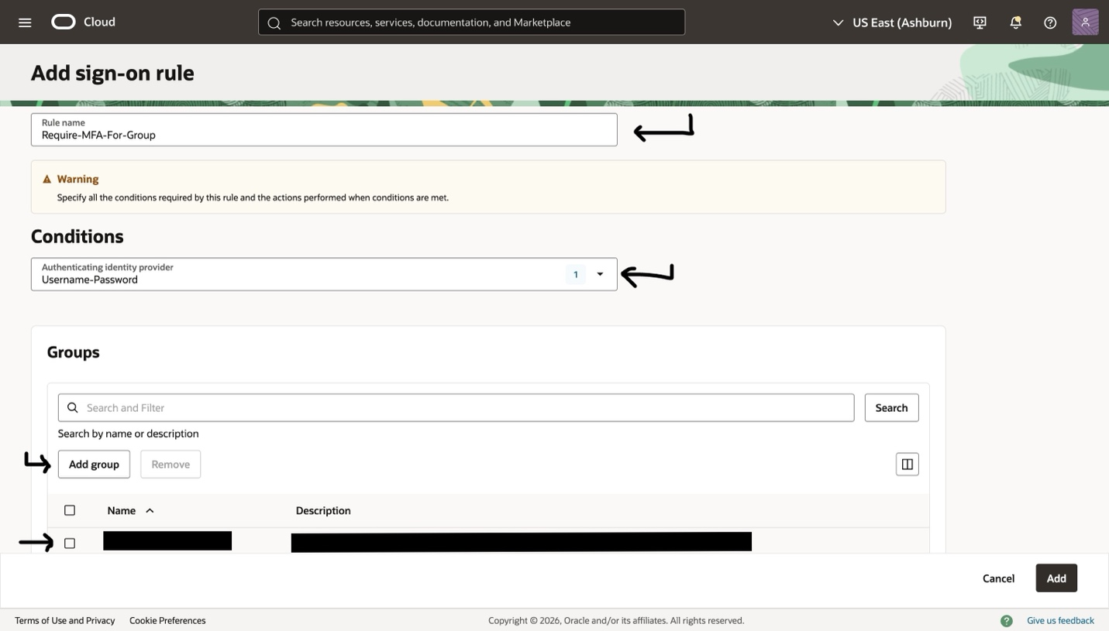
- Under Conditions, select: Username-Password
- Click Add groups and search for your target group. Select it.
- Under Actions, set Access to Allow.
- Prompt for reauthentication :Toggle On.
- Prompt for an additional factor: Toggle On.
- Specified Factors Only : Choose this field if you want to trigger only specified factors or else choose Any Factor
- Set Enrollment to Required — this forces users to enrol a factor if they have not done so already.
- Click Add.
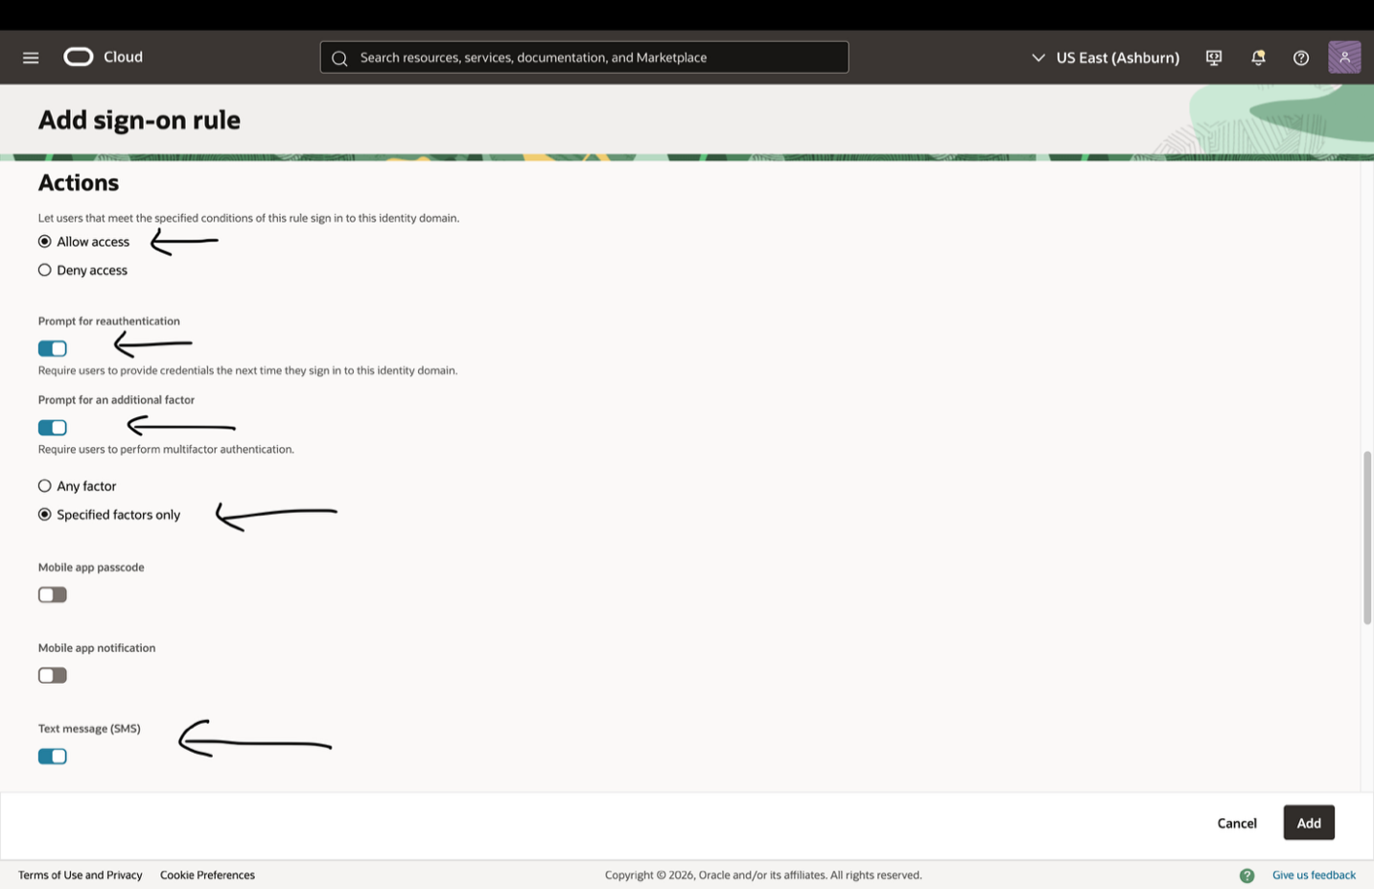
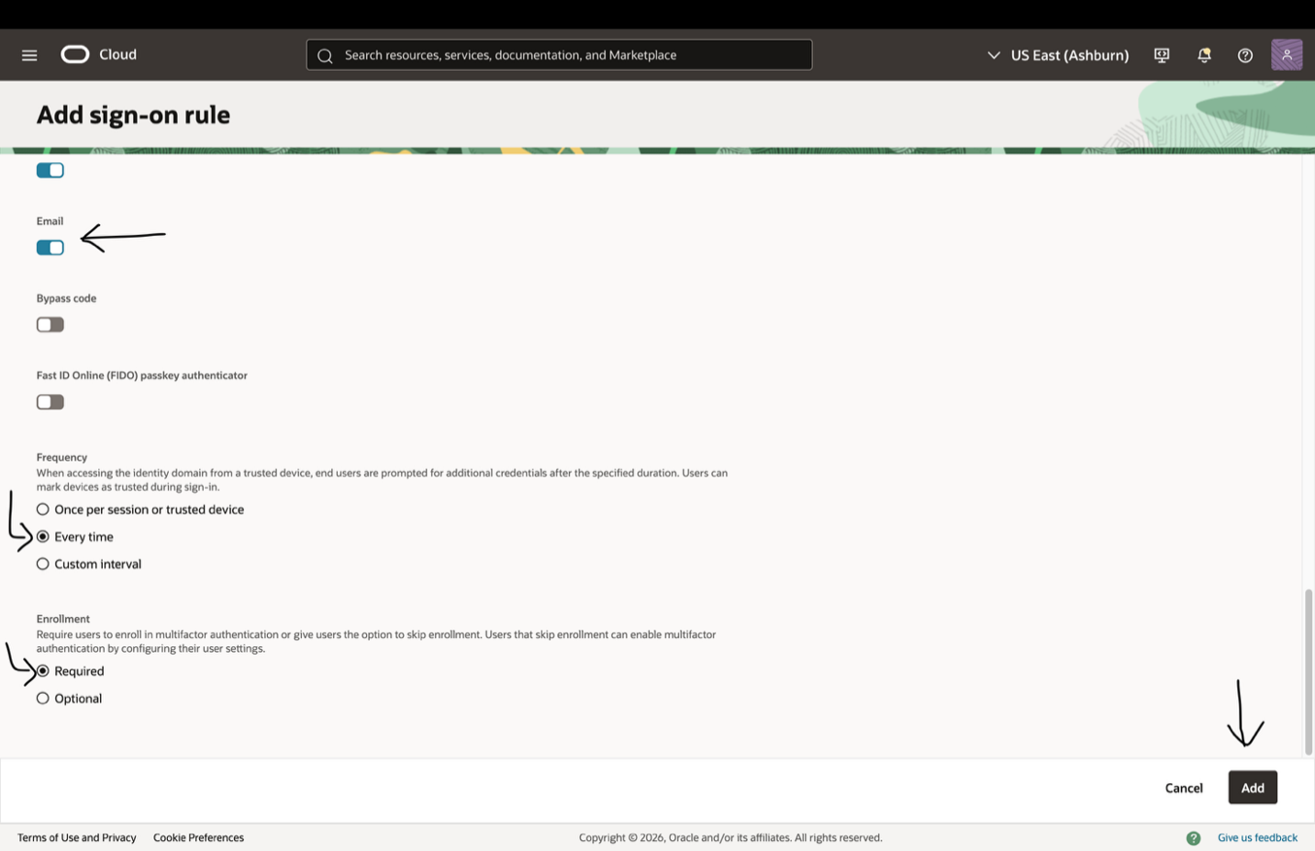
- A new rule will be created with priority assigned as 1.
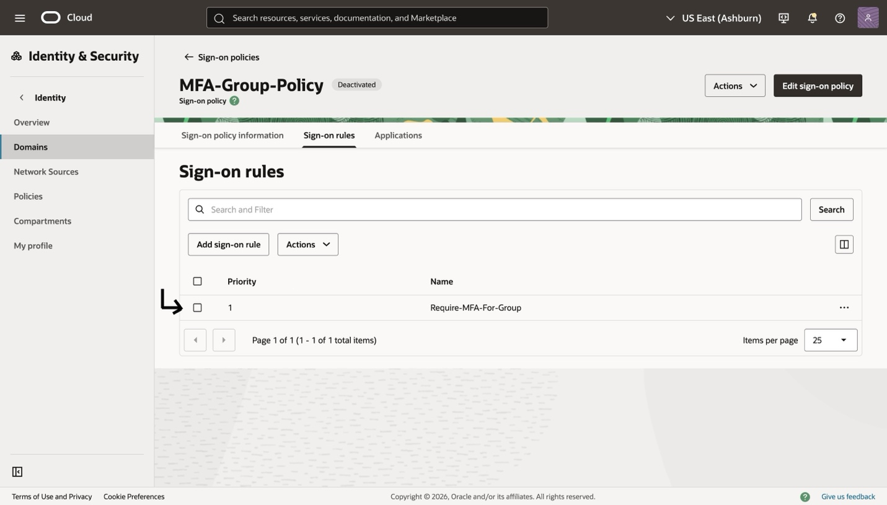

Finalise the Policy
- The policy is created but not yet active — proceed to next step to assign it to an application.

- Assign the Policy to Your Application
A Sign-On Policy takes effect only when it is assigned to an application. This step links the policy you created to the application your group users will log in to.

- In the policy detail view, click the Applications tab.
- Click Add app.
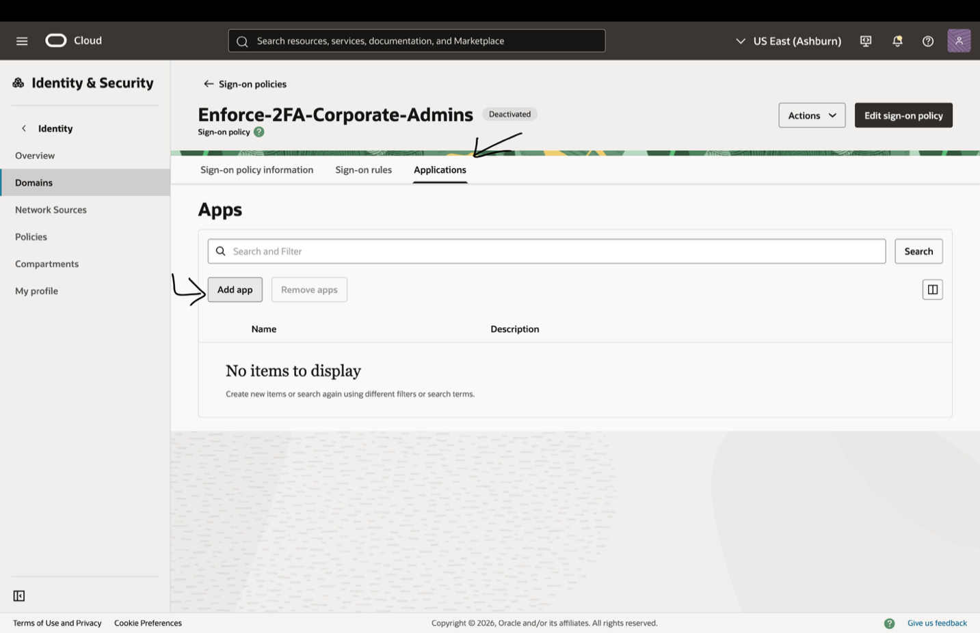
- Select the applications that policy access.
- Click Add App to confirm.
- Once Applications is assigned now policy is ready to use only step left is to activate the policy from top right Actions > Activate Policy
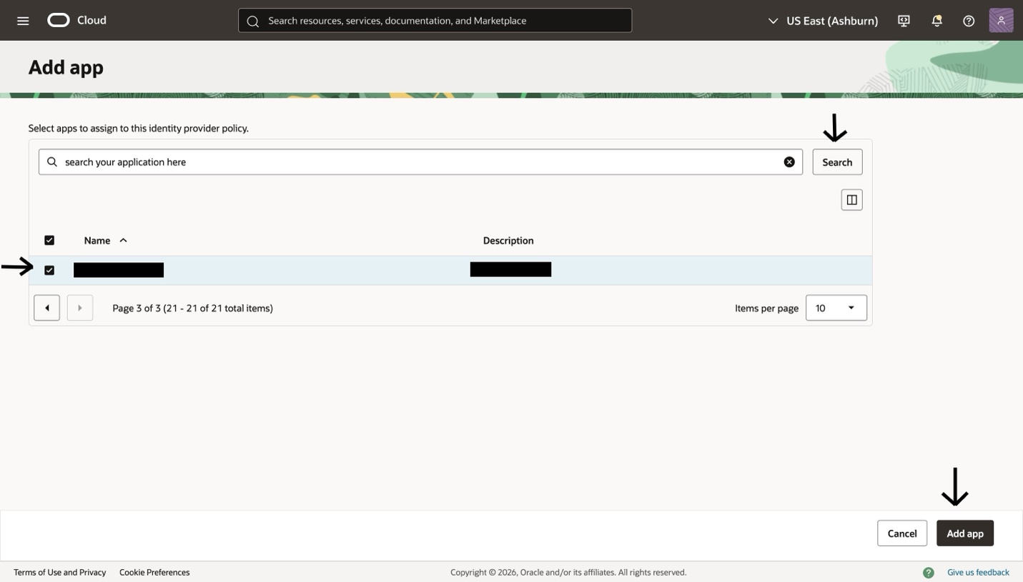

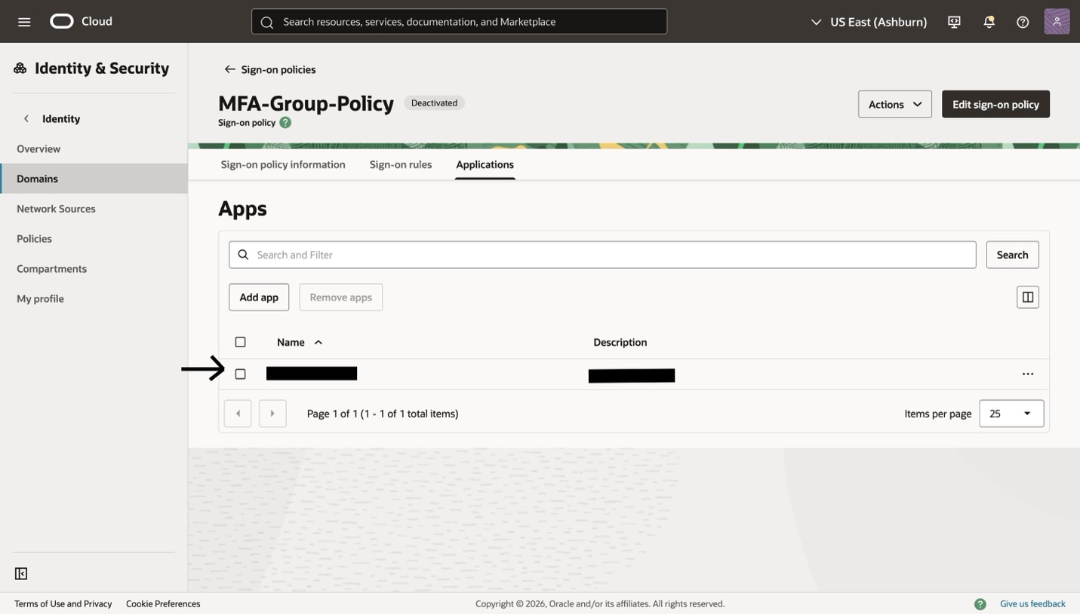

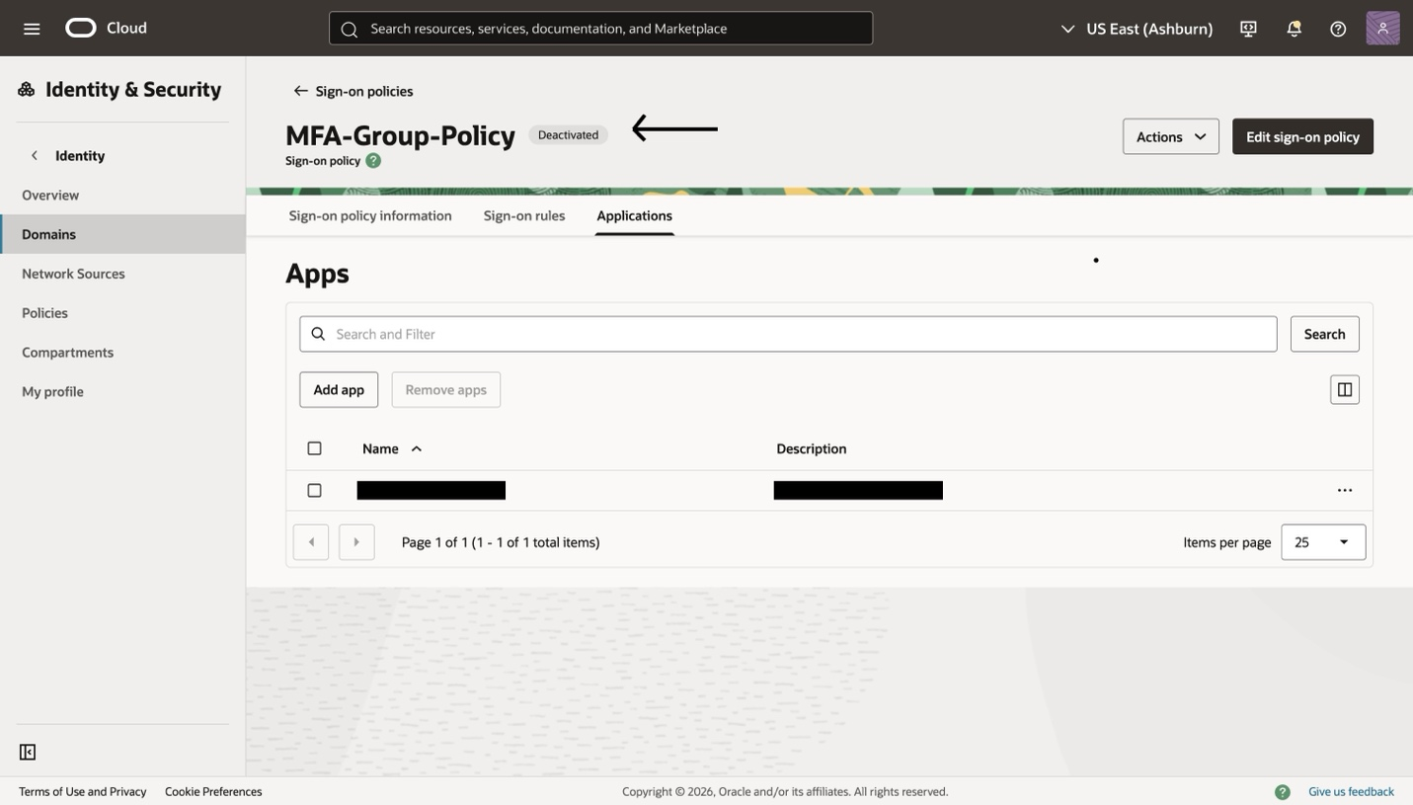

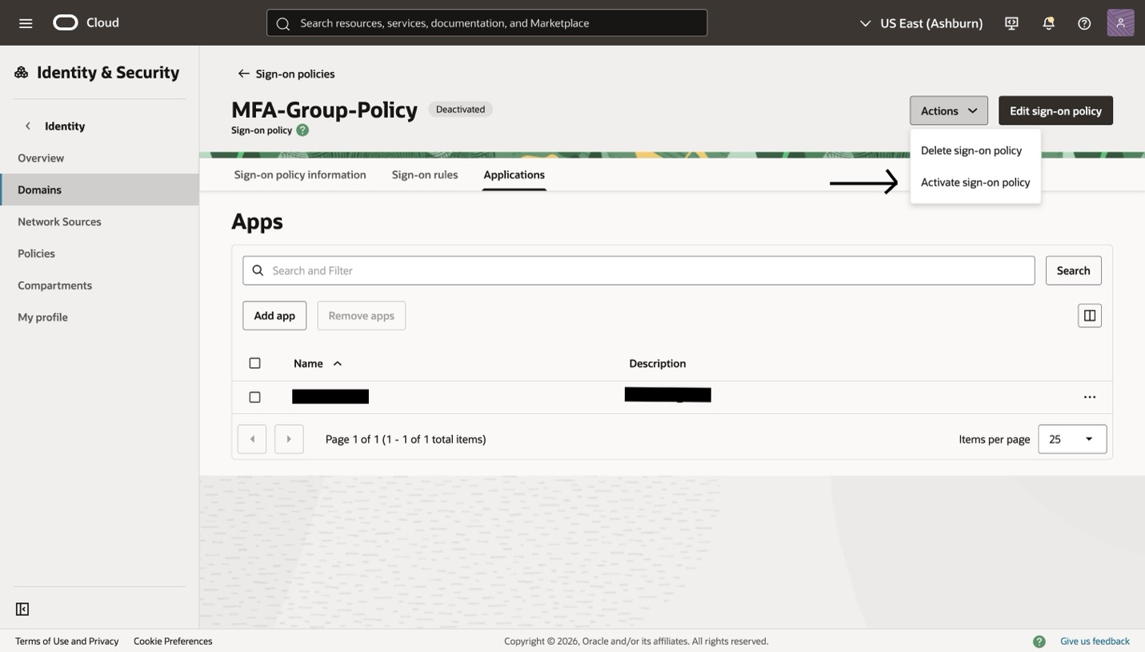

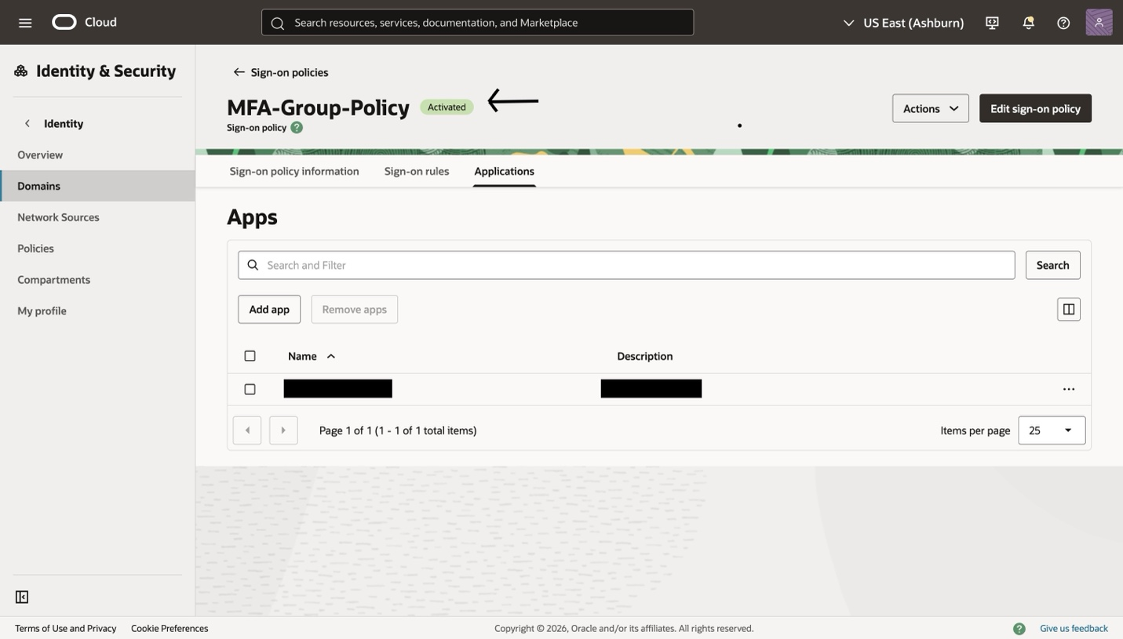

In order to avoid sign on policy access denied a fallback Default policy rule needs to be created in case no condition is satisfied it will fall back to this rule and trigger the mentioned configuration.

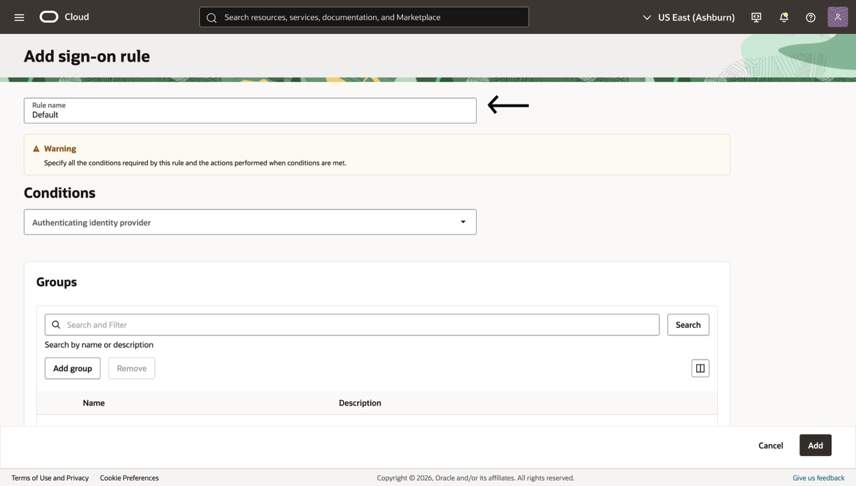

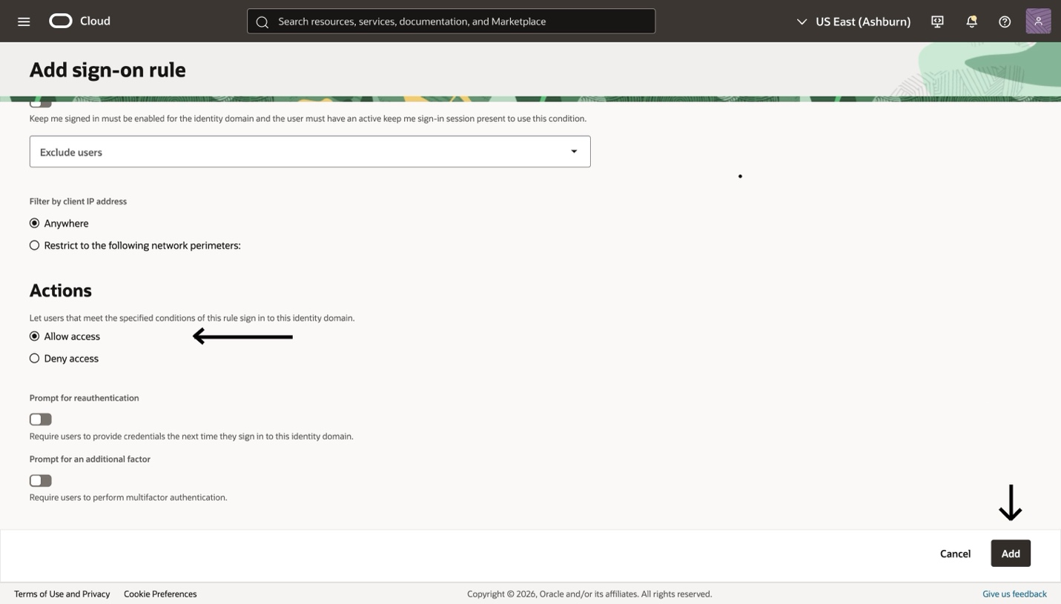

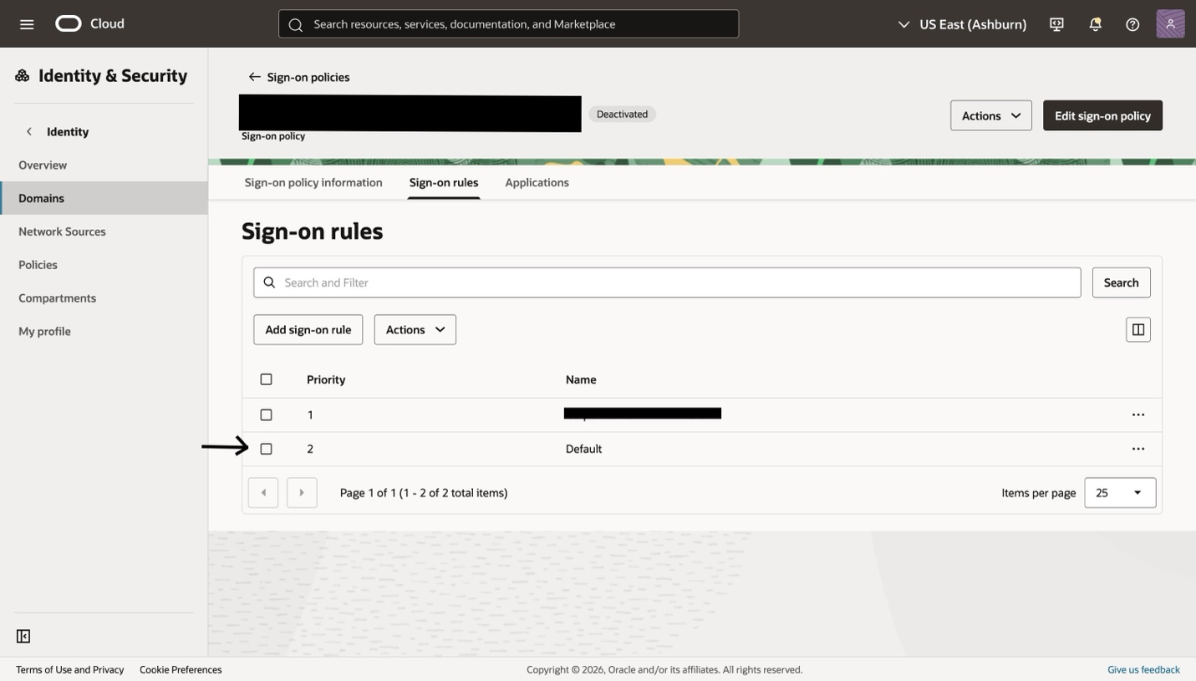

Make sure the priority is set lower than all the required rules to be evaluated first for MFA Factors.

