Mobile Application Configurations
Release:
OBMA - v14.8.2
Oracle Banking Digital Experience CS - OBDX CS – v25.1.2.0
Summary:
This document has details of the configurations for onboarding Oracle Banking Digital Experience CS mobile application on IDCS.
Pre-requisites:
IDCS admin console URL and credentials to be taken from AMS team for the bank’s tenancy
Mobile IOS and Android workspace
- Mobile Application Onboarding in IDCS
Configurations Steps:
- Sign in to Oracle IDCS Admin Console
- Open Oracle IDCS administration URL.
- Log in with your administrator credentials.
- Navigate to Domains section
- Default Domain will be displayed
- Click on the Default. From the navigation menu, click Integrated applications.
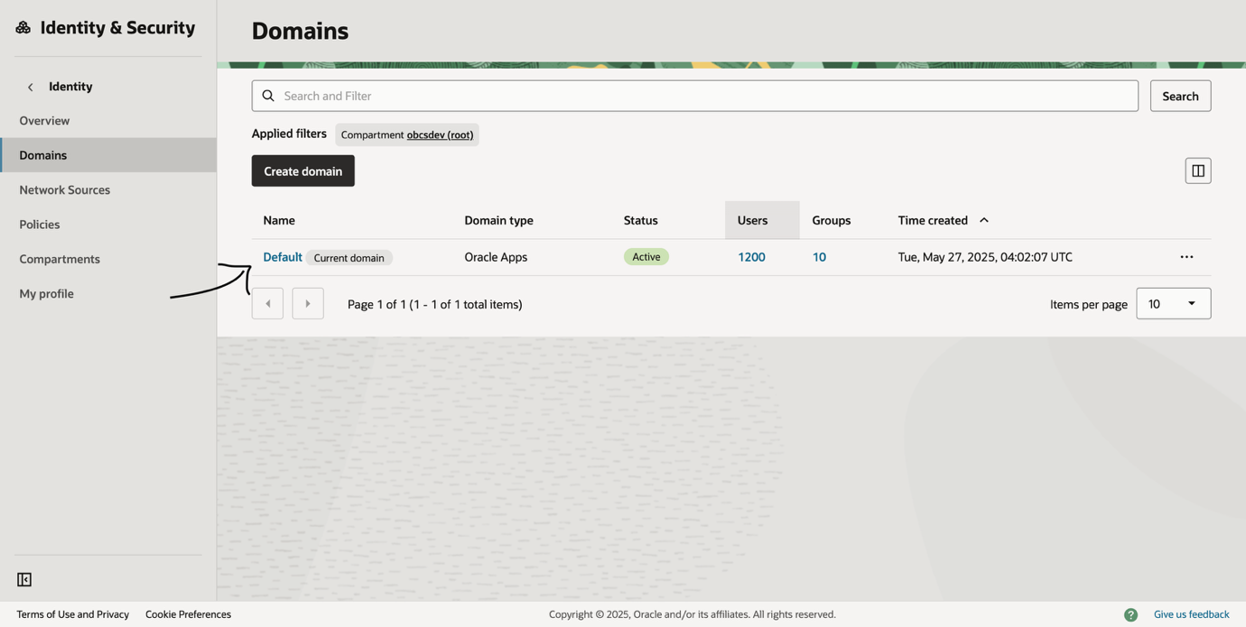
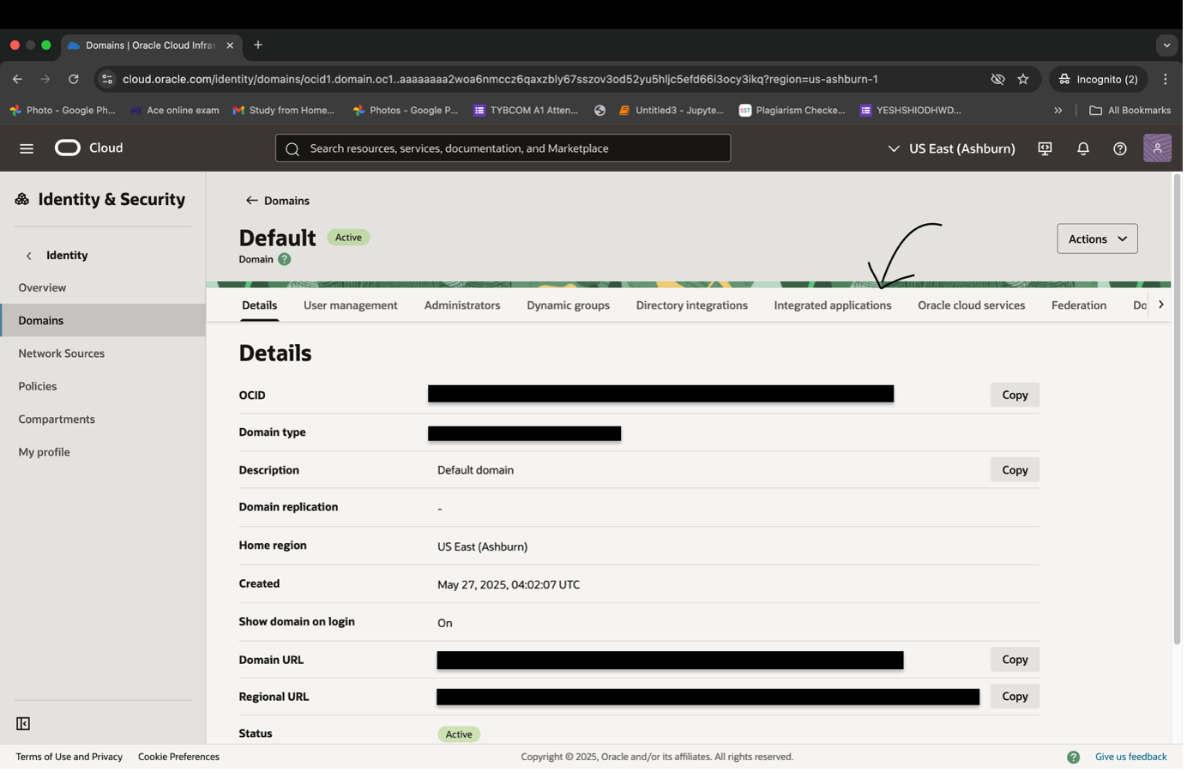

- Register a New Integrated Application
- Click Add Application.
- Choose Mobile Application and click Next.
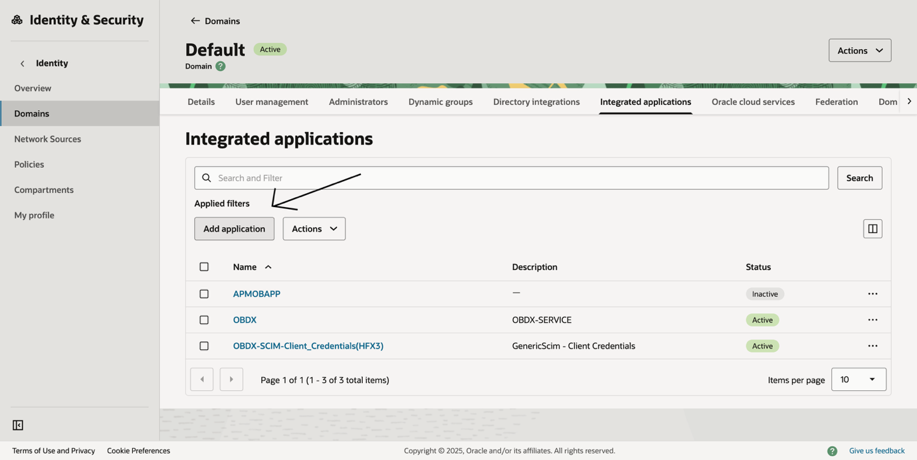
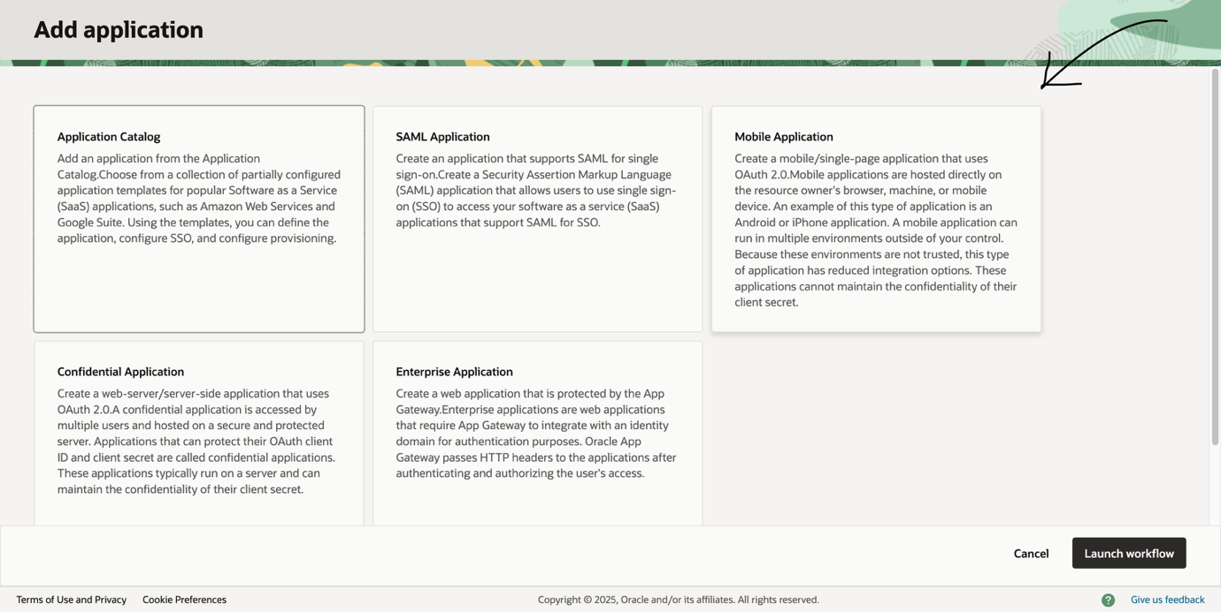

- Basic Information
- Enter the Name (e.g., “My Mobile App”). This name will be displayed on the mobile application’s IDCS login page when user enters username and password.
- Optionally fill out other fields like description or Application icon.
- Click Submit.
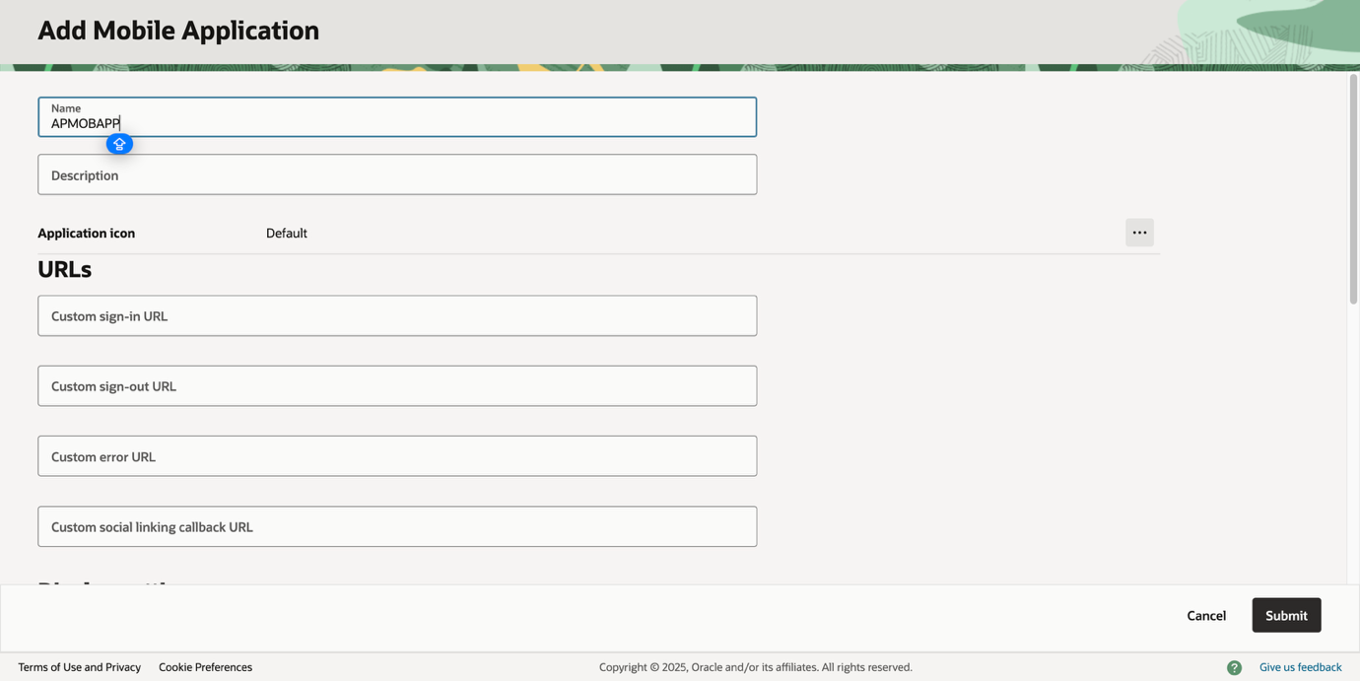

- Once clicked on submit integrated application will be created. This will be by default in deactivated state with no ‘OAUTH configurations’ but a ‘ClientID’ will be generated.

- OAUTH configurations
- Navigate to OAuth configuration and click on ‘Edit OAuth configuration’
- Under Allowed Grant Types, ensure Authorization Code is selected, refresh token and Implicit is selected
- Select Allow non-HTTPS URLs
- In Redirect URIs, enter the URI to handle redirection after IDCS authentication is complete.
Set this value to ‘<uniqueName://oauthredirect’
‘uniqueName’ can be appName, packageName or any unique name as per bank’s specification). Do not use same as mentioned below in the example
Eg: zigbank://oauthredirect
This value should match the value set in IOS workspace –> app.plist - > REDIRECT_URI in step 8.

You can add the same value in Android workspace -> app.properties -> REDIRECT_URI

If you want two separate redirect URL, then you can add another Redirect URL in IDCS and set corresponding in IOS and Android workspace respectively. Recommended is to keep it same across both channels.

NOTE: keep this value handy as we need this to be set in the application workspace as well. Refer: Mobile Technical Doc for workspace configurations

- Add same values in Post-Logout Redirect URL as per the configurations done for REDIRECT_URI
- Click Next
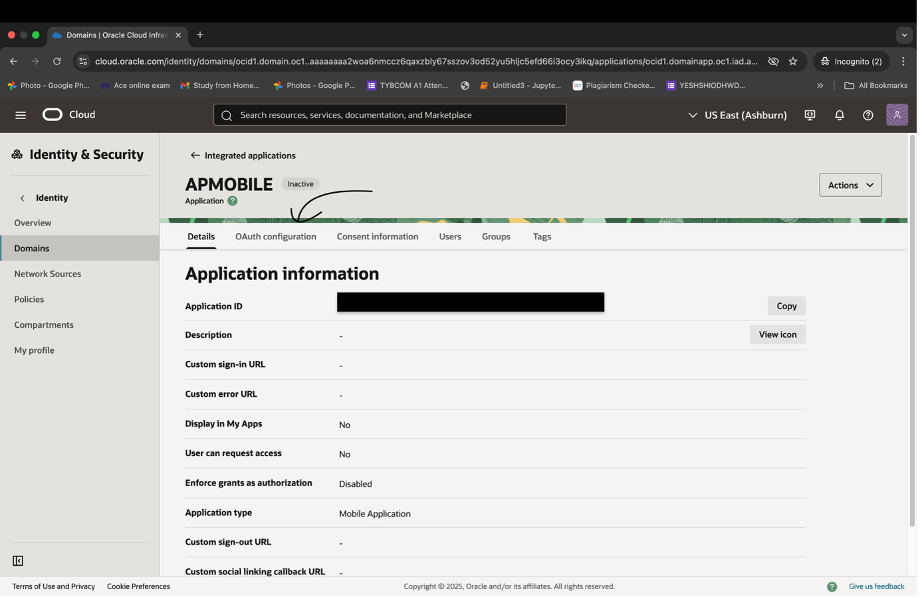
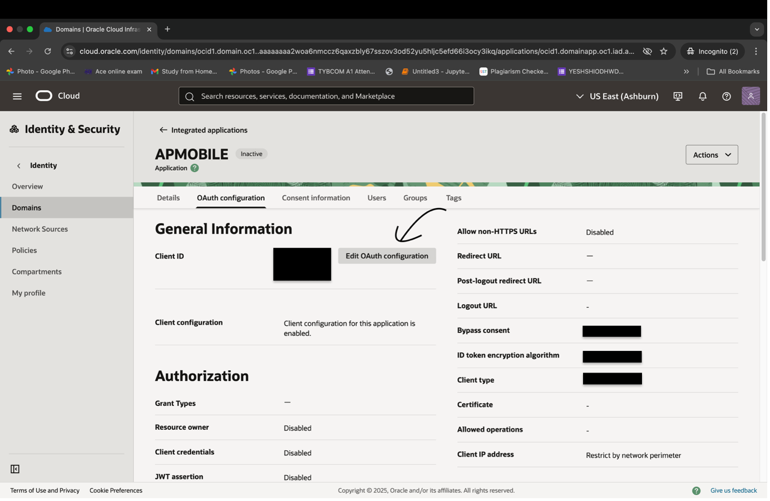
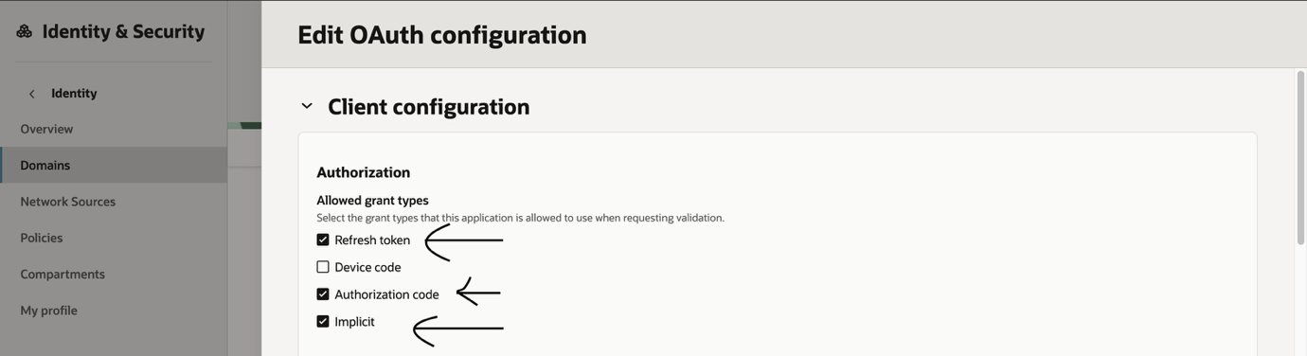
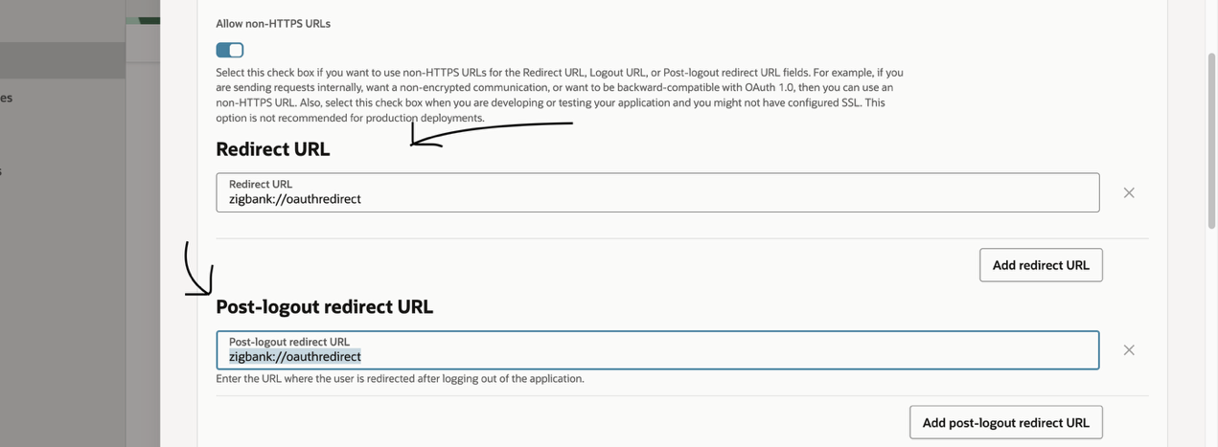

- Review and Finish
- Review your application settings.
- Click on Submit.
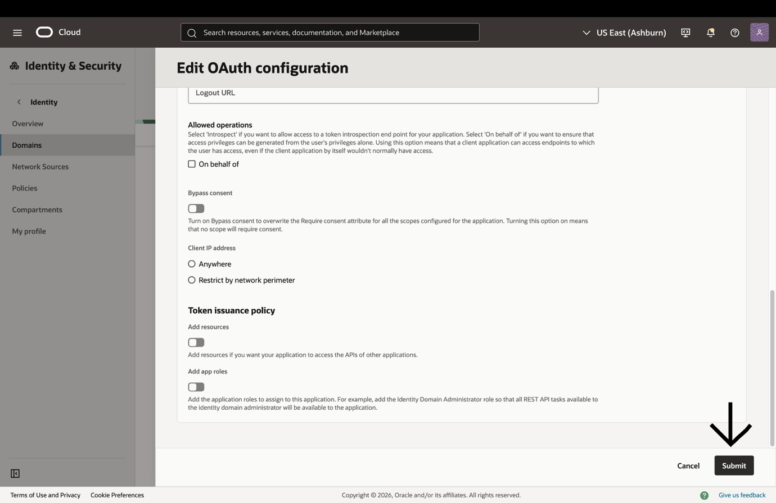

- Activate the integrated mobile application
The application should be in active state. If Inactive, go to actions and Activate
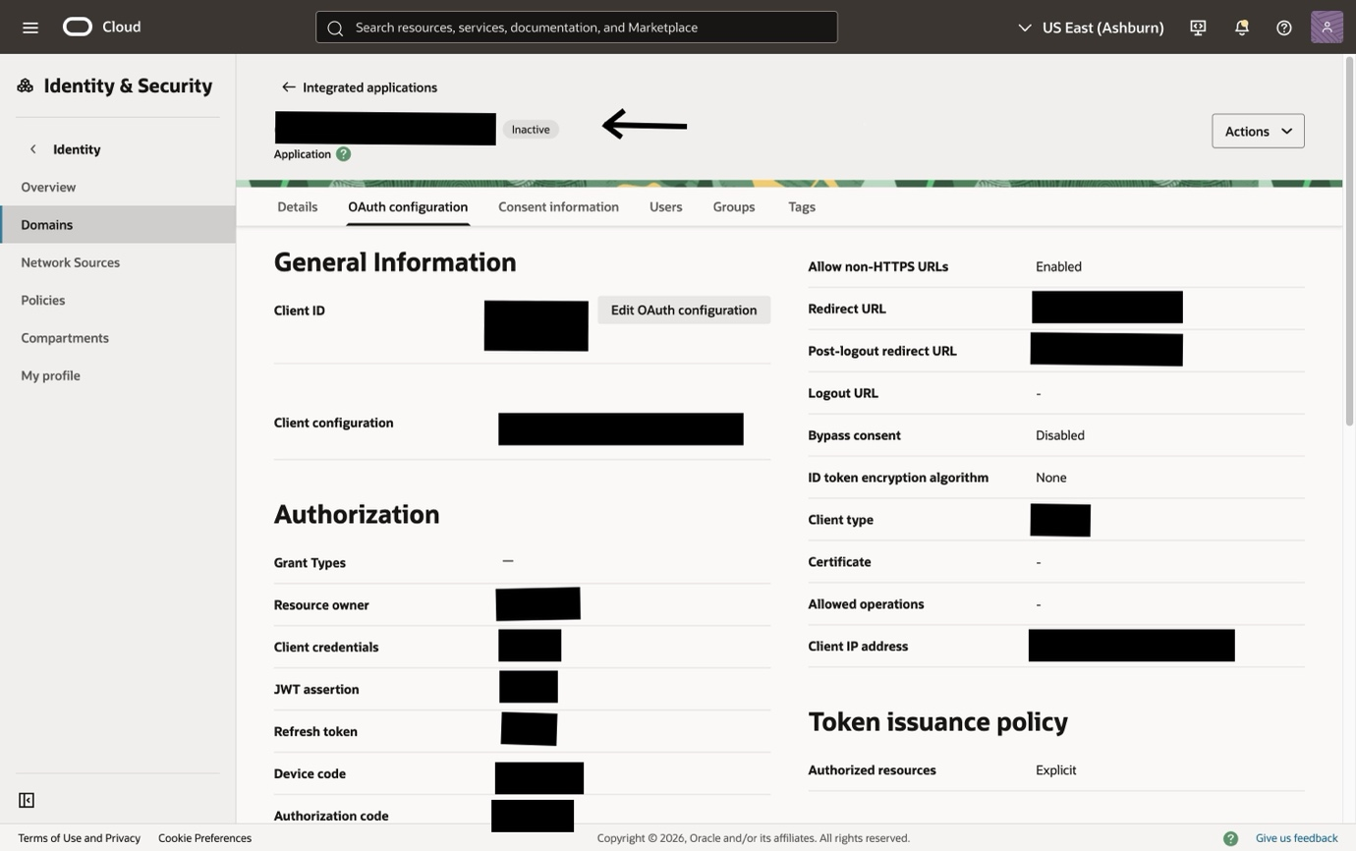
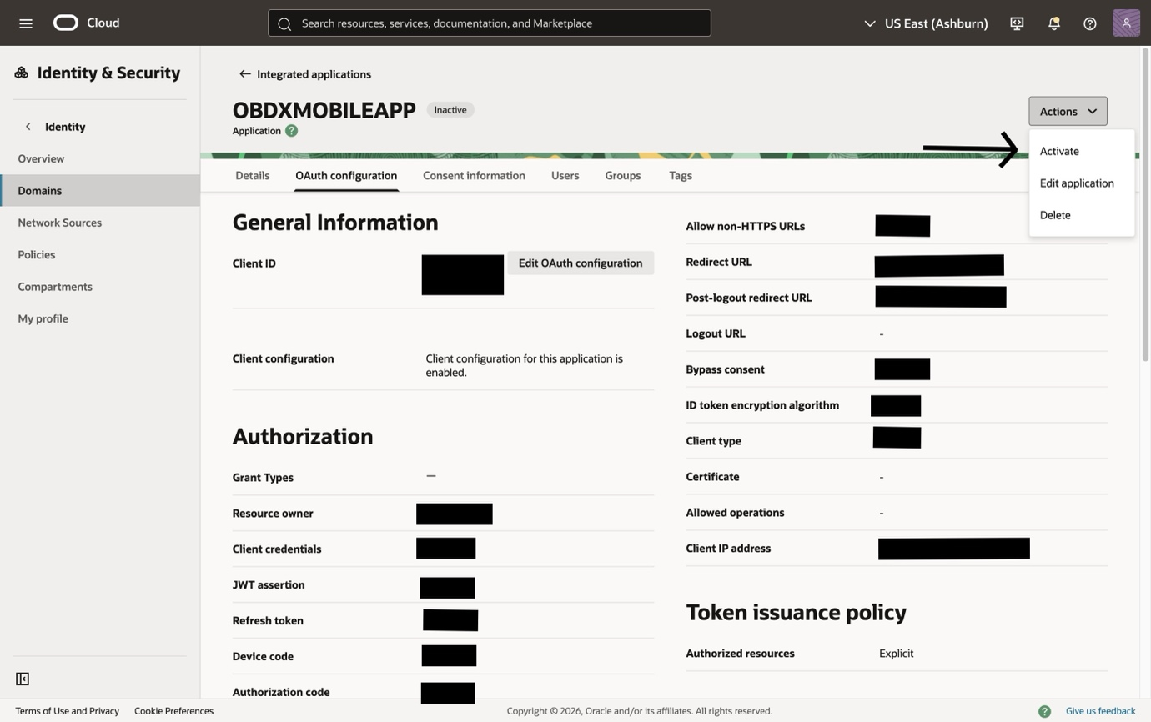

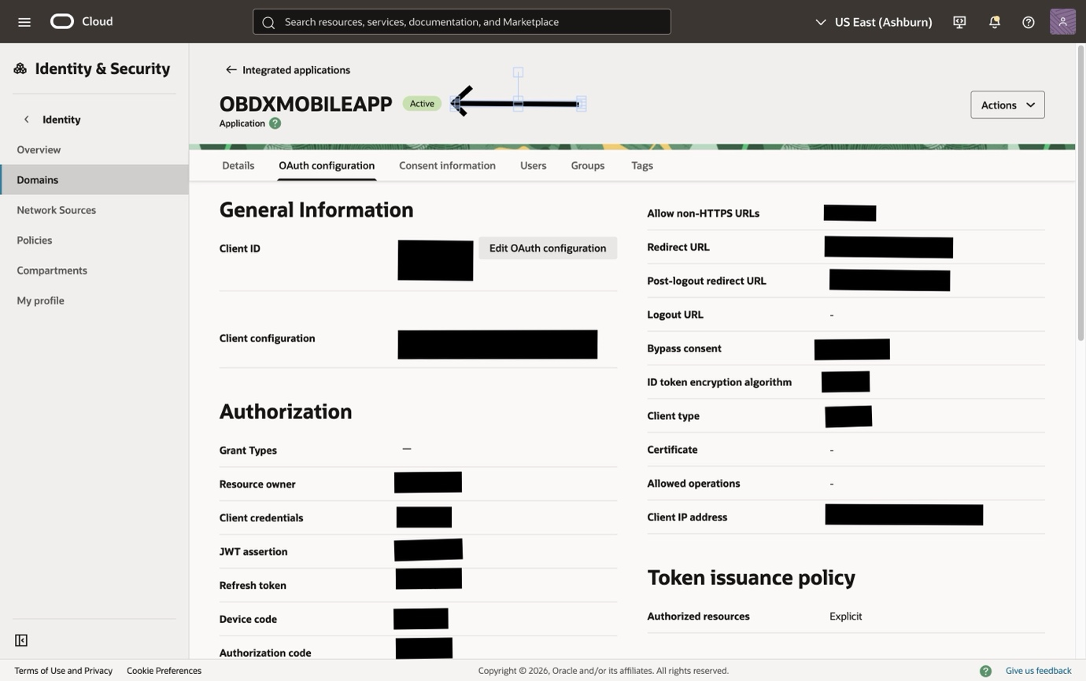

- Client ID configuration in Oracle Banking Digital Experience
- After successful creation, note down the Client ID from the General Information Screen. This is required for mobile workspace setup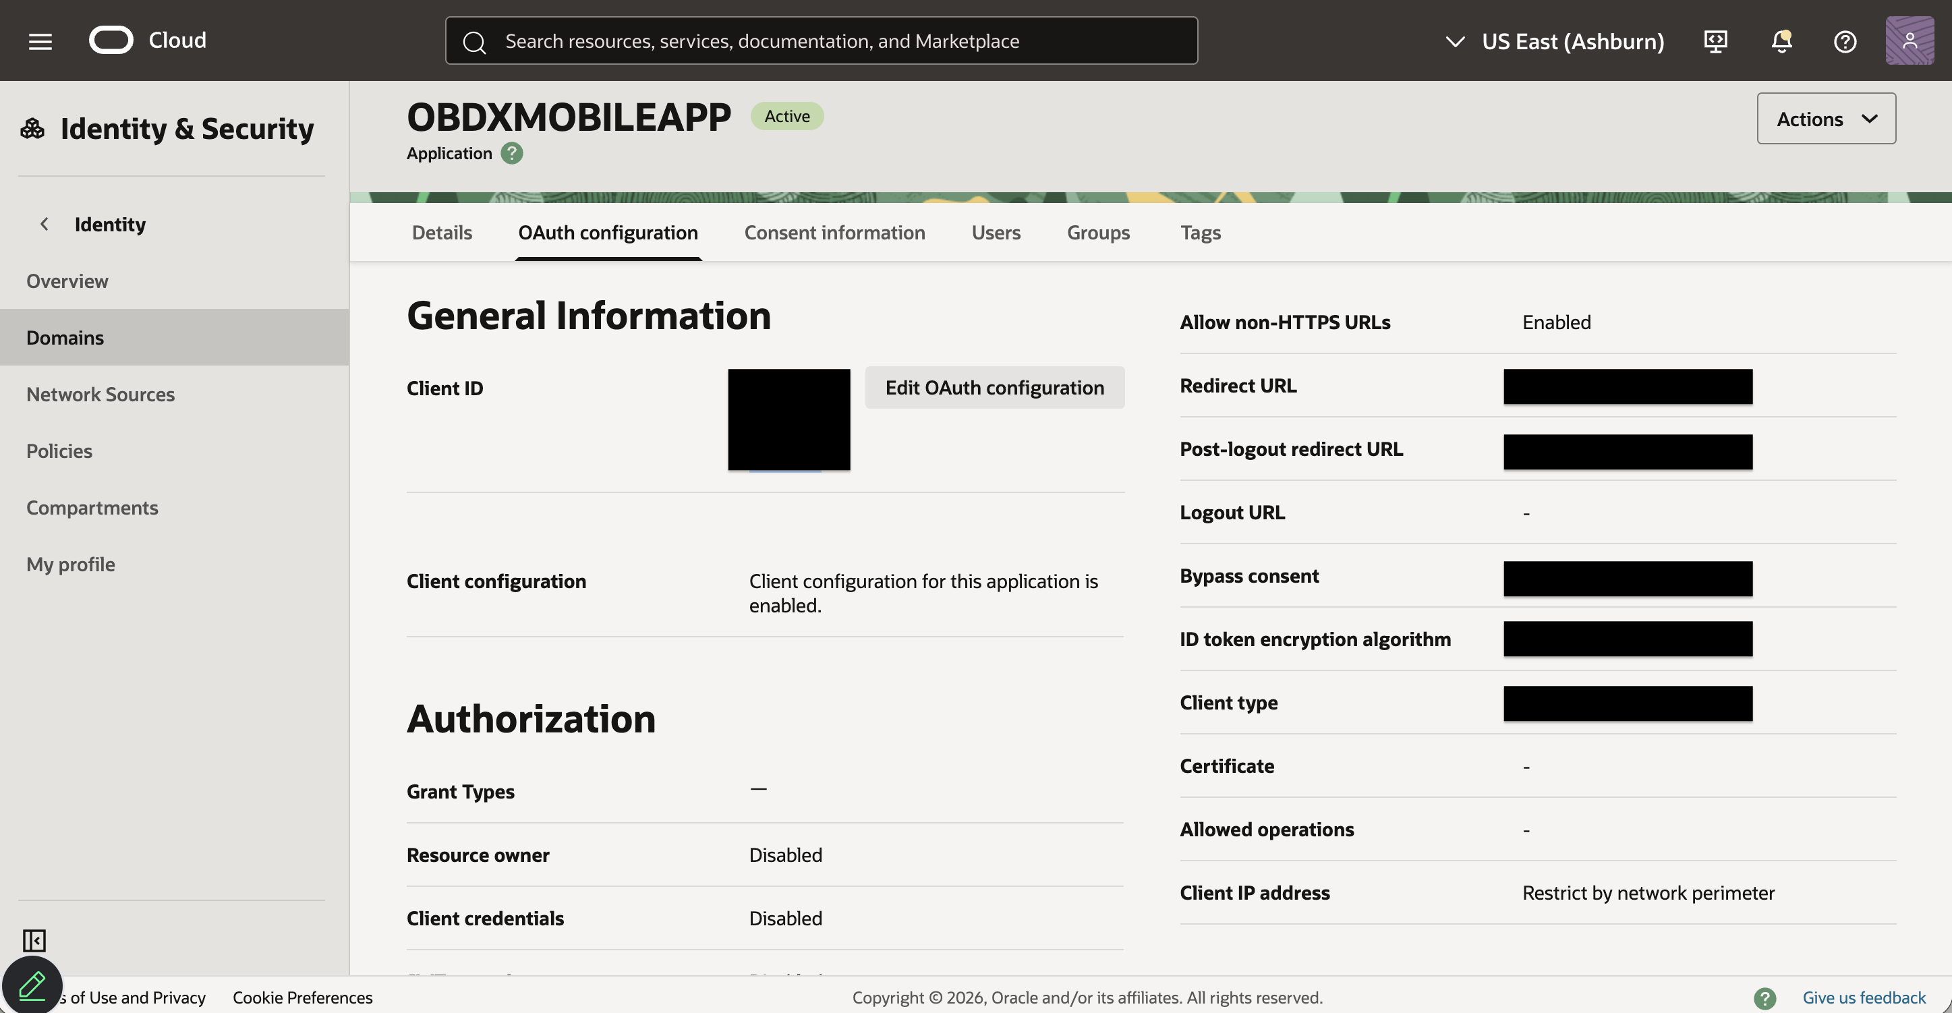

- Copy this Client ID and Login using ‘Superadmin’ and navigate to Touchpoint Maintenance > search the touchpoint ‘APMOBAPP > Edit > Add the copied Client ID and click save.
- Quick Snapshot onboarding in IDCS
- To enable Mobile Quick Snapshot, follow the same onboarding steps under "Mobile Application Onboarding in IDCS" and create a separate integrated Mobile Application for Quick Snapshot.
- Activate the Quick Snapshot integrated application and note the generated Client ID from General Information.
- Copy this Client ID and Login using ‘Superadmin’ and navigate to Touchpoint Maintenance > search the touchpoint ‘APSNAPSHOT > Edit > Add the copied Client ID and click save.

- Refer Mobile Application Technical Guide for mobile side configurations
Below data to be kept handy
- KEY_SERVER_URL: ${KEY_SERVER_URL}
- APP_CLIENT_ID: ${Client ID} - (generated in IDCS above)
- SNAPSHOT_CLIENT_ID: ${Quick Snapshot Client ID} - (generated from Quick Snapshot integrated application in IDCS)
- IDCS_URL: ${IDSC_URL}/oauth2/v1/token
- WEB_URL: ${WEB_URL}
- REDIRECT_URI: ${REDIRECT_URI} - (as mentioned above)
- KEY_OAUTH_PROVIDER_URL: ${KEY_OAUTH_PROVIDER_URL}

- KEY_SERVER_URL this is URL is the OBDX CS application URL where OBDX CS application is hosted. Note: There should be no trailing ‘/’ at the end of the URL.
Example:
https://<bankTenancy URL>/dev/obdx
- IDCS_URL, WEB_URL and KEY_OAUTH_PROVIDER_URL – these values bank can get it from Admin Console -> Domains ->Details -> Domain URL.
Copy this value without port from admin console and replace the variables.
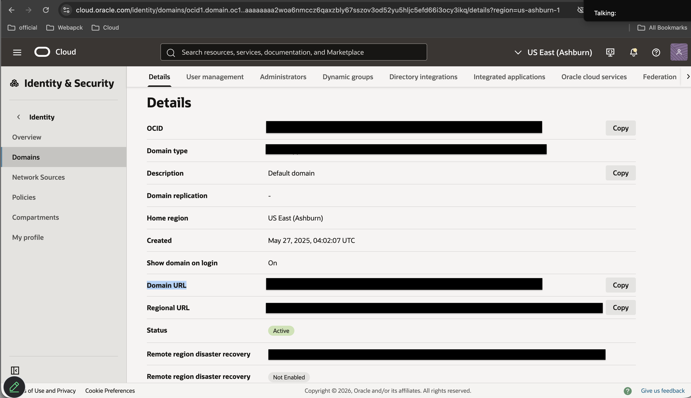

- Test the setup
- Deploy your application to a mobile device/emulator/Simulator
- Trigger the login process.
- Confirm you are redirected to the Oracle IDCS login page and successfully navigate to dashboard after login. This will ensure that mobile application’s configuration in IDCS is correct.

