Integration Configuration Guide - OBDX and Oracle IDCS (25.1.2)
- SCIM Configuration
  - Domain Creation in IDCS
  - Creating a Confidential Application and OAuth Configuration
  - OBDX Side Configuration
  - Configuring GenericSCIM - Client Credentials Application
  - Configure Auto-Assignment by User Groups
- IDCS Originated Flow
  - Configuring for IDCS Originated Flow
- OBDX Originated Flow
  - OBRH Configuration
  - OBDX Side Configuration

SCIM Configuration

Domain Creation in IDCS

    - Access your Oracle Cloud Infrastructure (OCI) tenancy using your credentials.
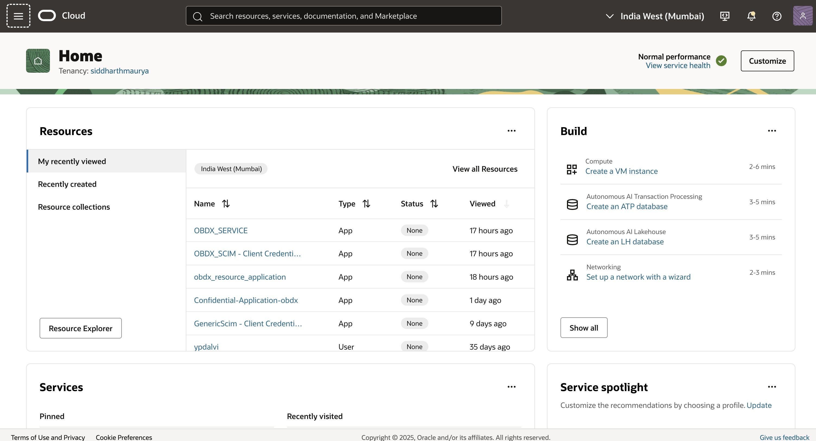

    - From the Sidebar Menu, navigate to Identity & Security > Domains under the Identity section.

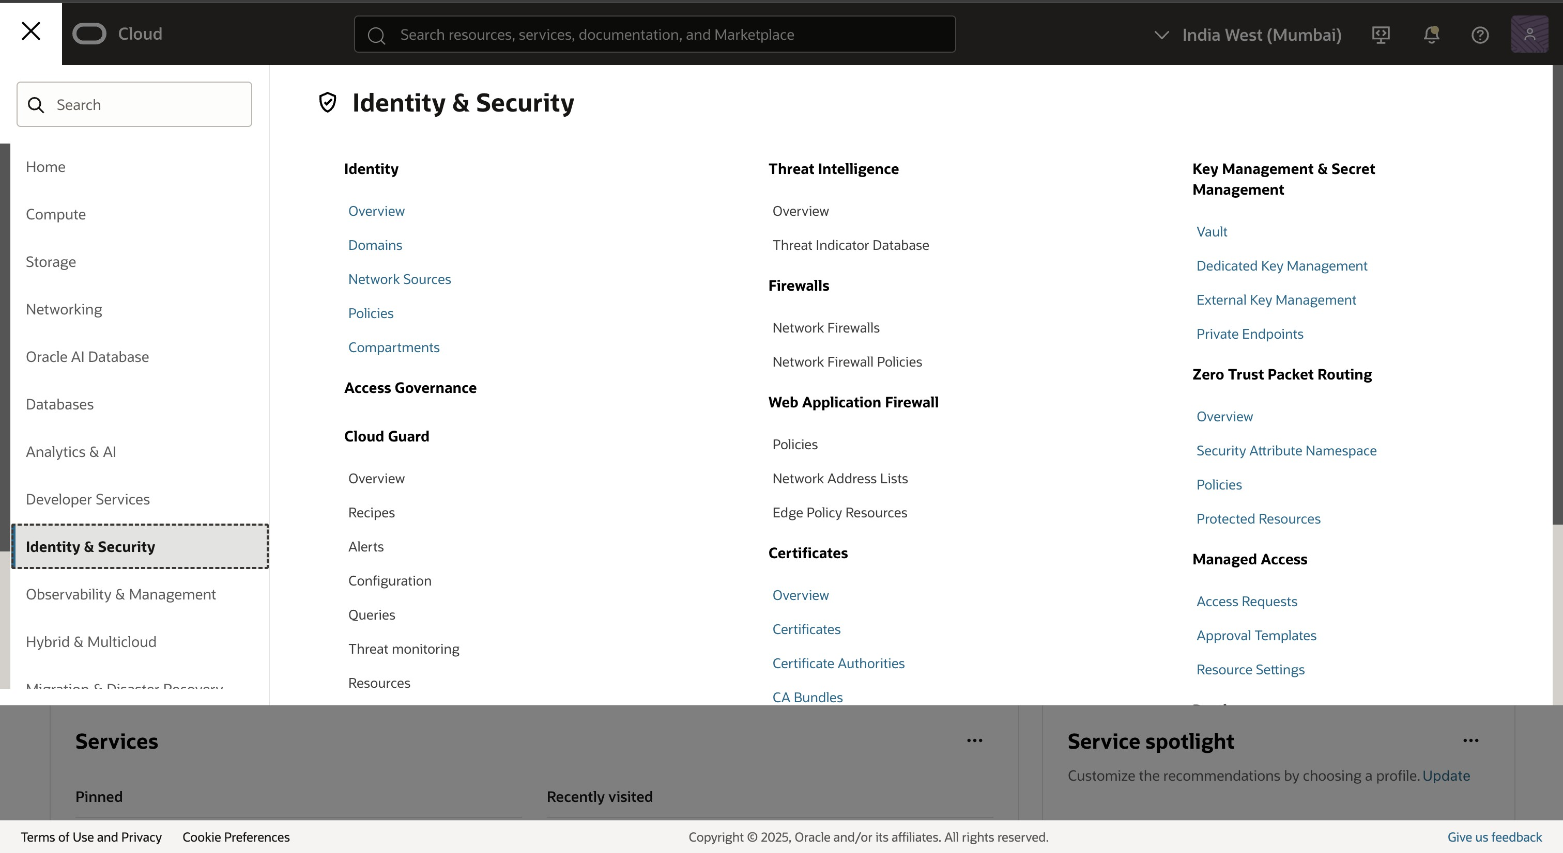

    - If a domain already exists (e.g., Default Domain), select it. If not, click Create Domain and follow the prompts to set up a new identity domain. Note the Domain URL from the Domain Overview page, as it will be used later for OAuth configuration.
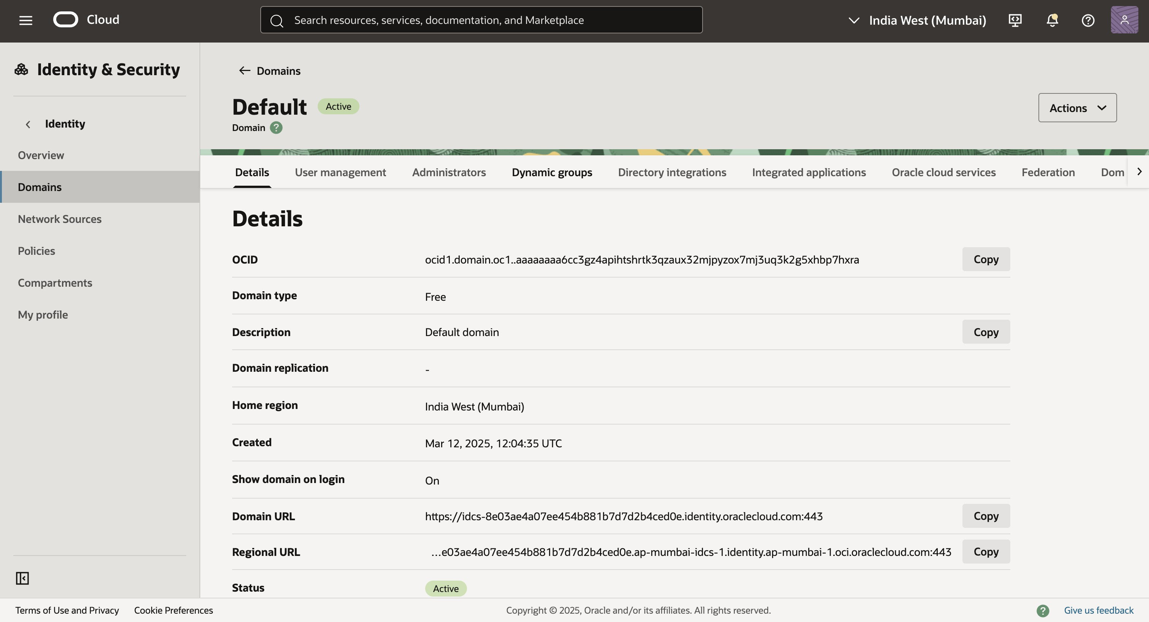

Creating a Confidential Application and OAuth Configuration

    - Login and get to the Integrated Applications section
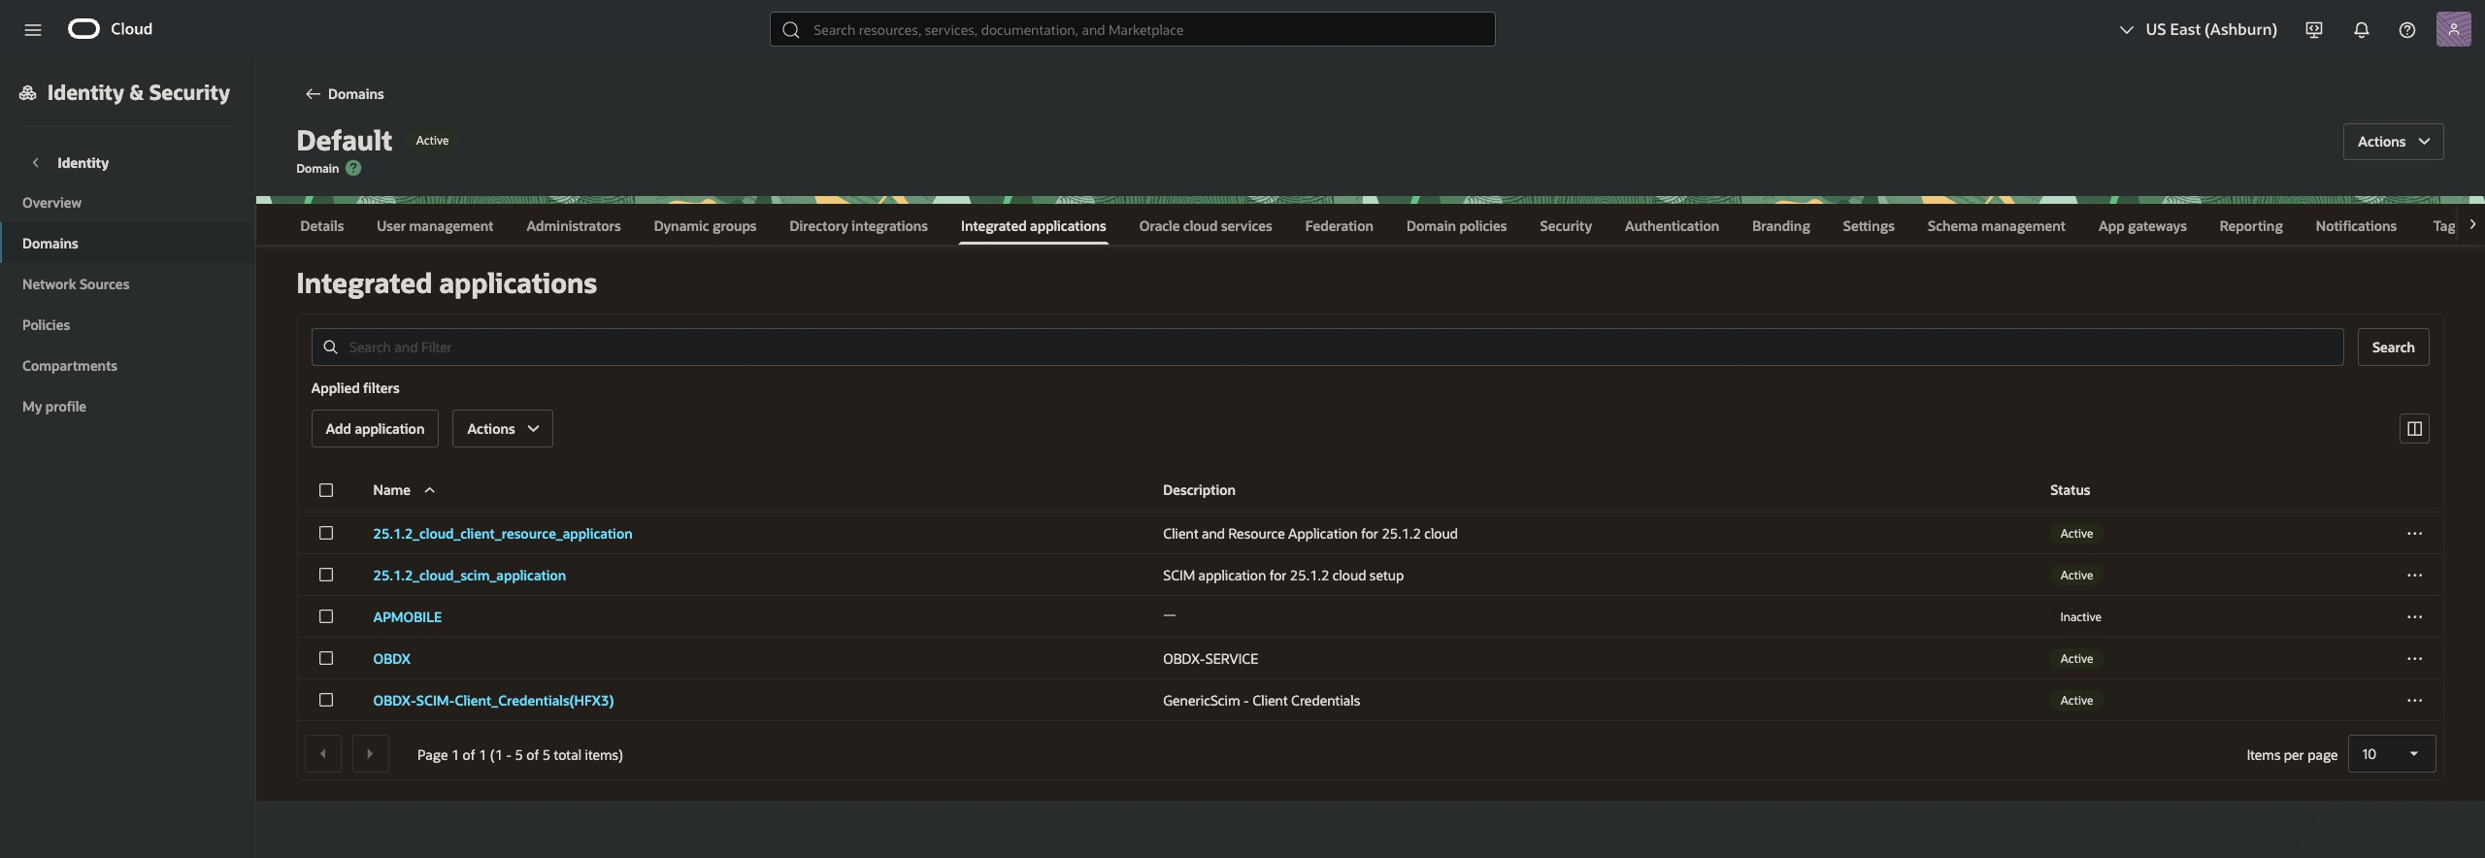

    - Add a new application

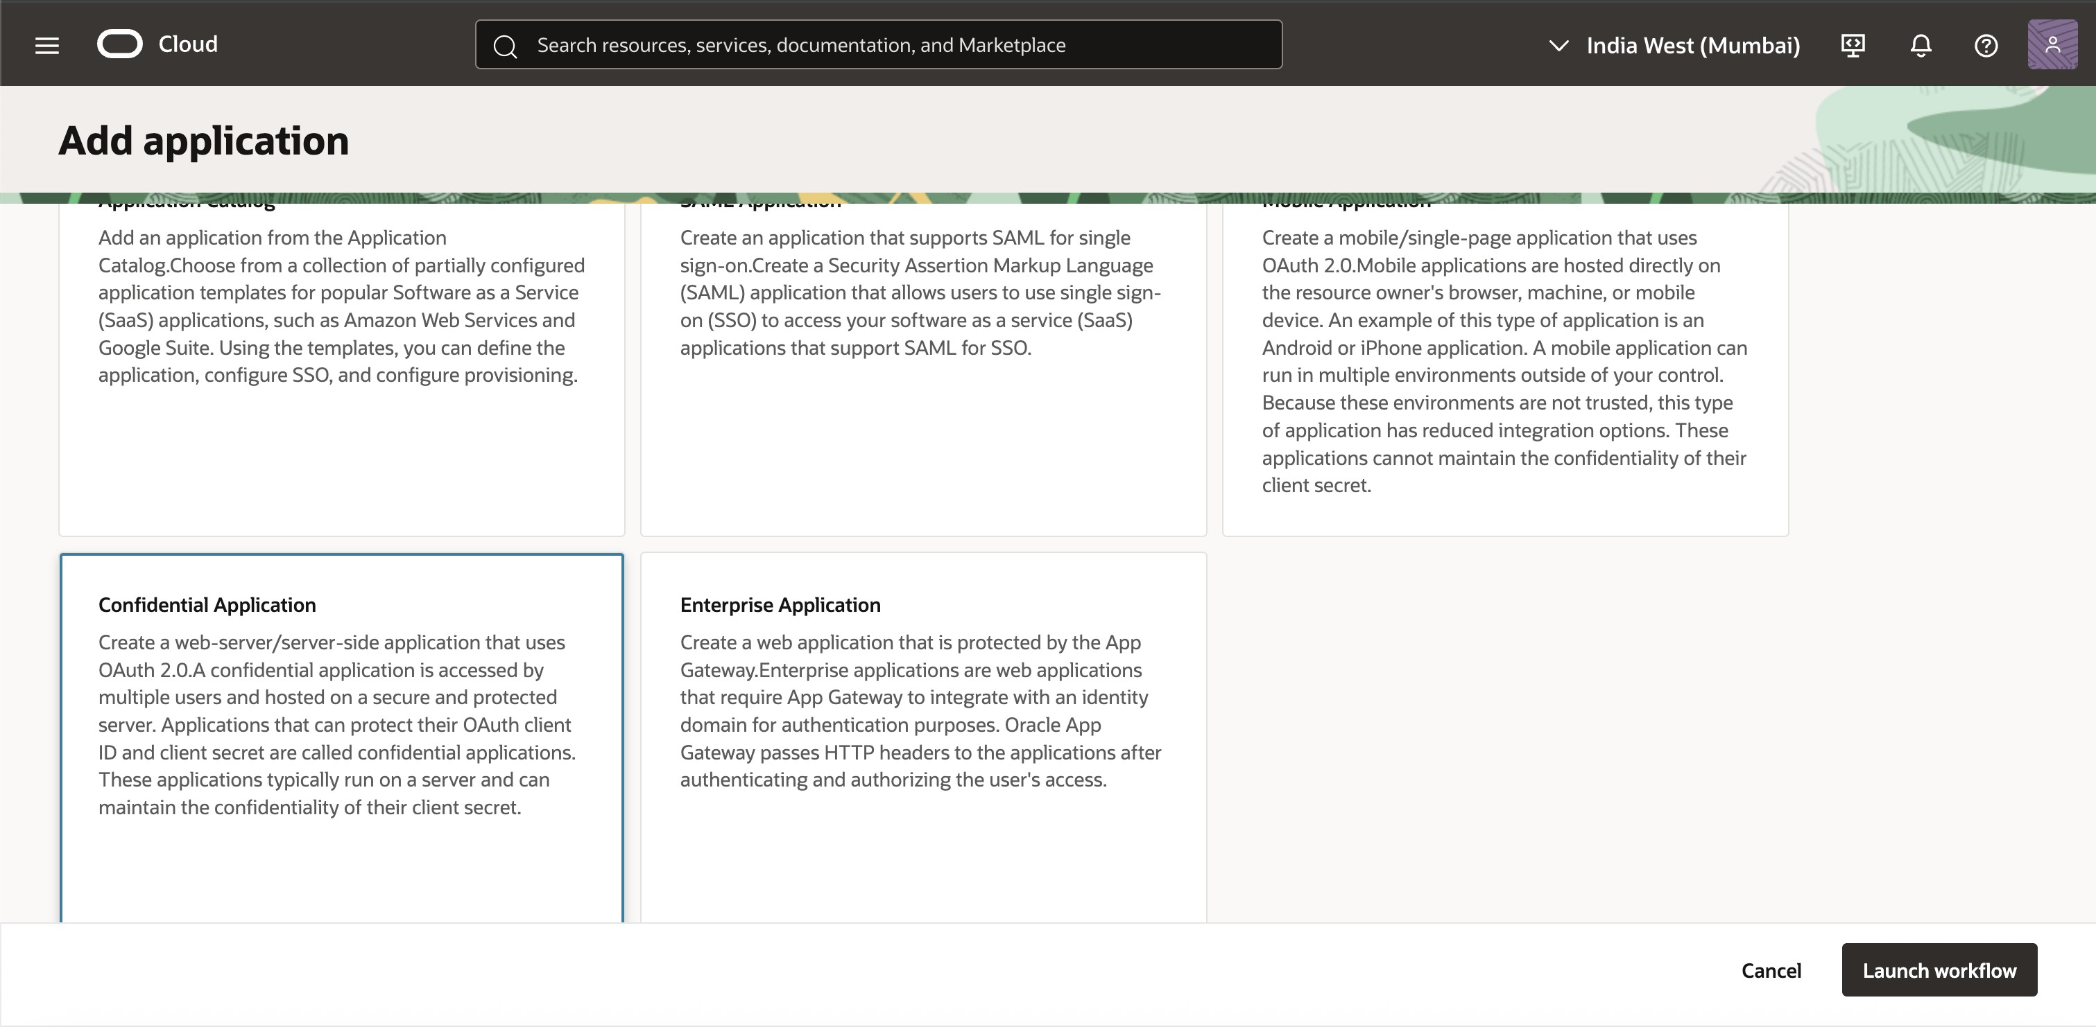

    - Select "Confidential Application" and Launch Workflow

    - Select Confidential application and edit the details according to your application only Name and Description are mandatory for SCIM application setup, If needed.
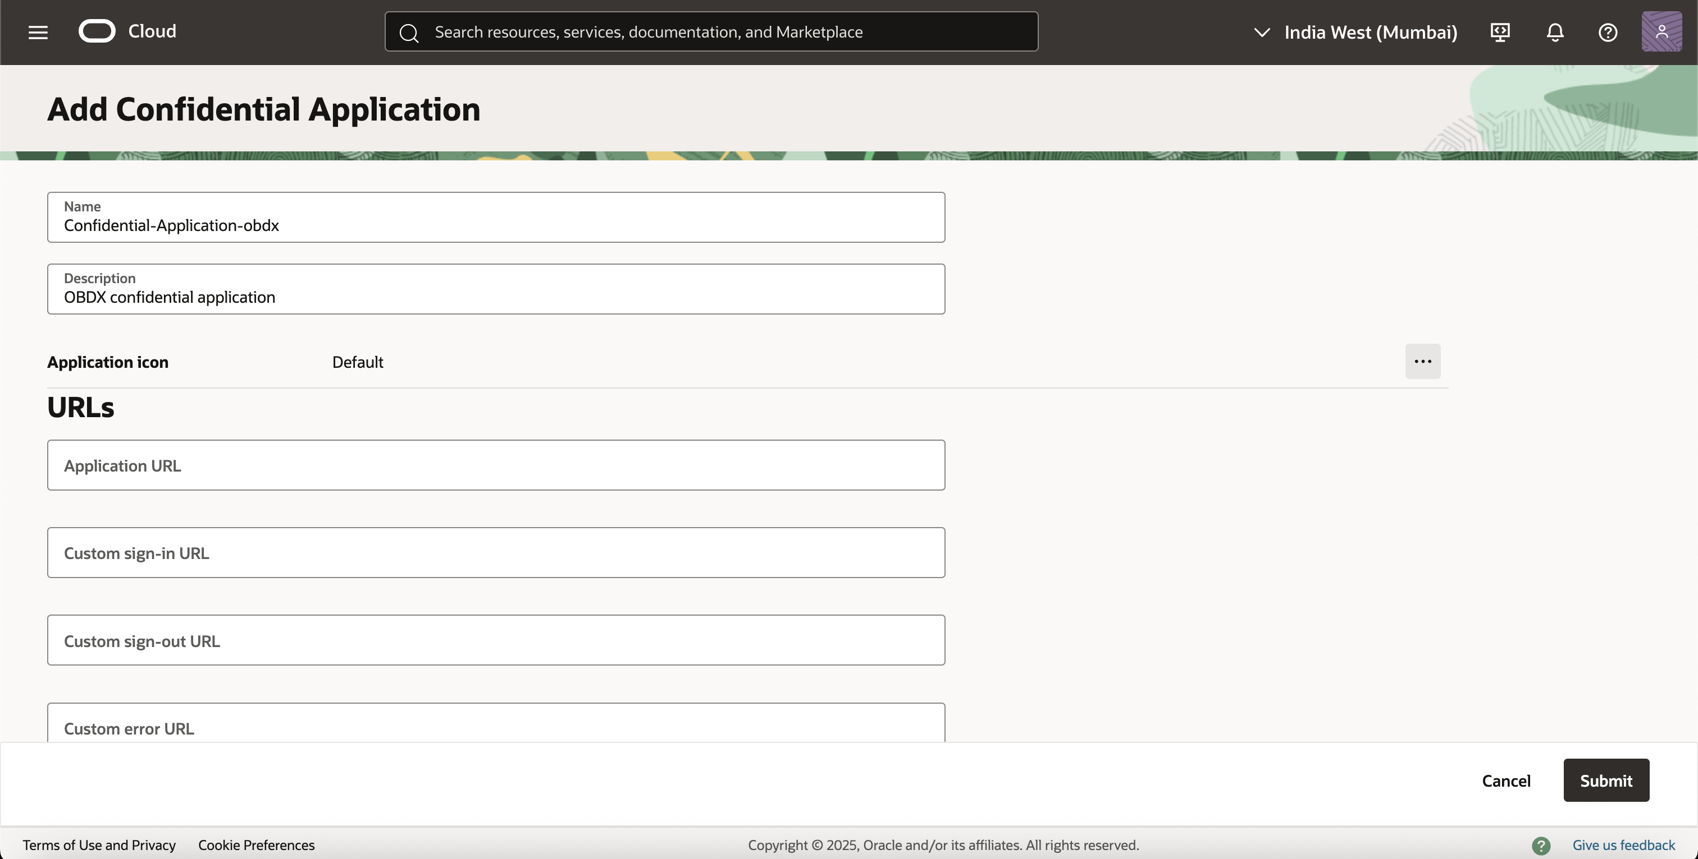

    - Application will be created and you will be brought to it's OAuth Configuration settings. This is where we setup Client server configuration.
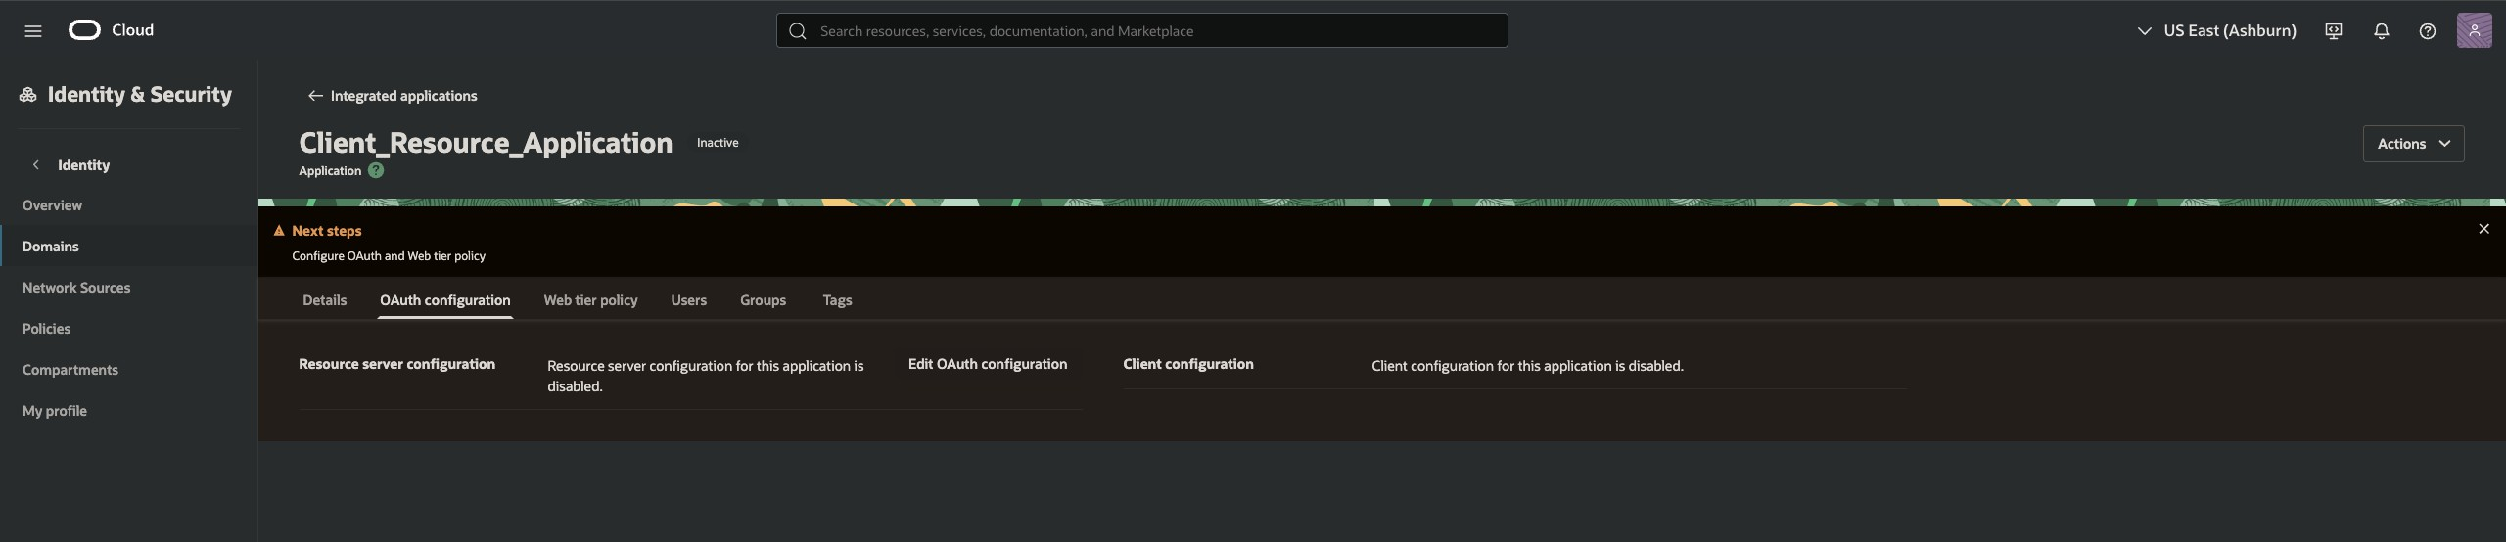

Configuration can be done by clicking on the "Edit OAuth Configuration" button.

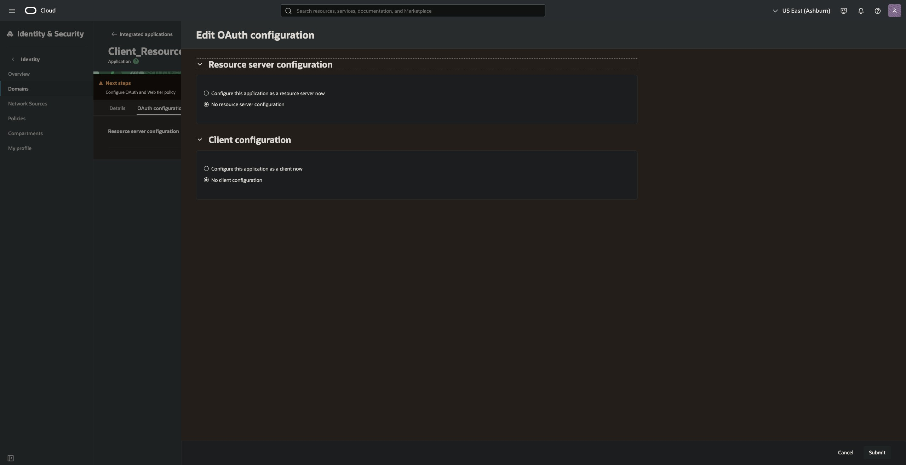
    - Add OAuth Configuration for Client Credentials

      - Navigate to OAuth Configuration and edit and configure it as Client Credentials.

      - In the Client Configuration section, enable Client Credentials as the allowed grant type.
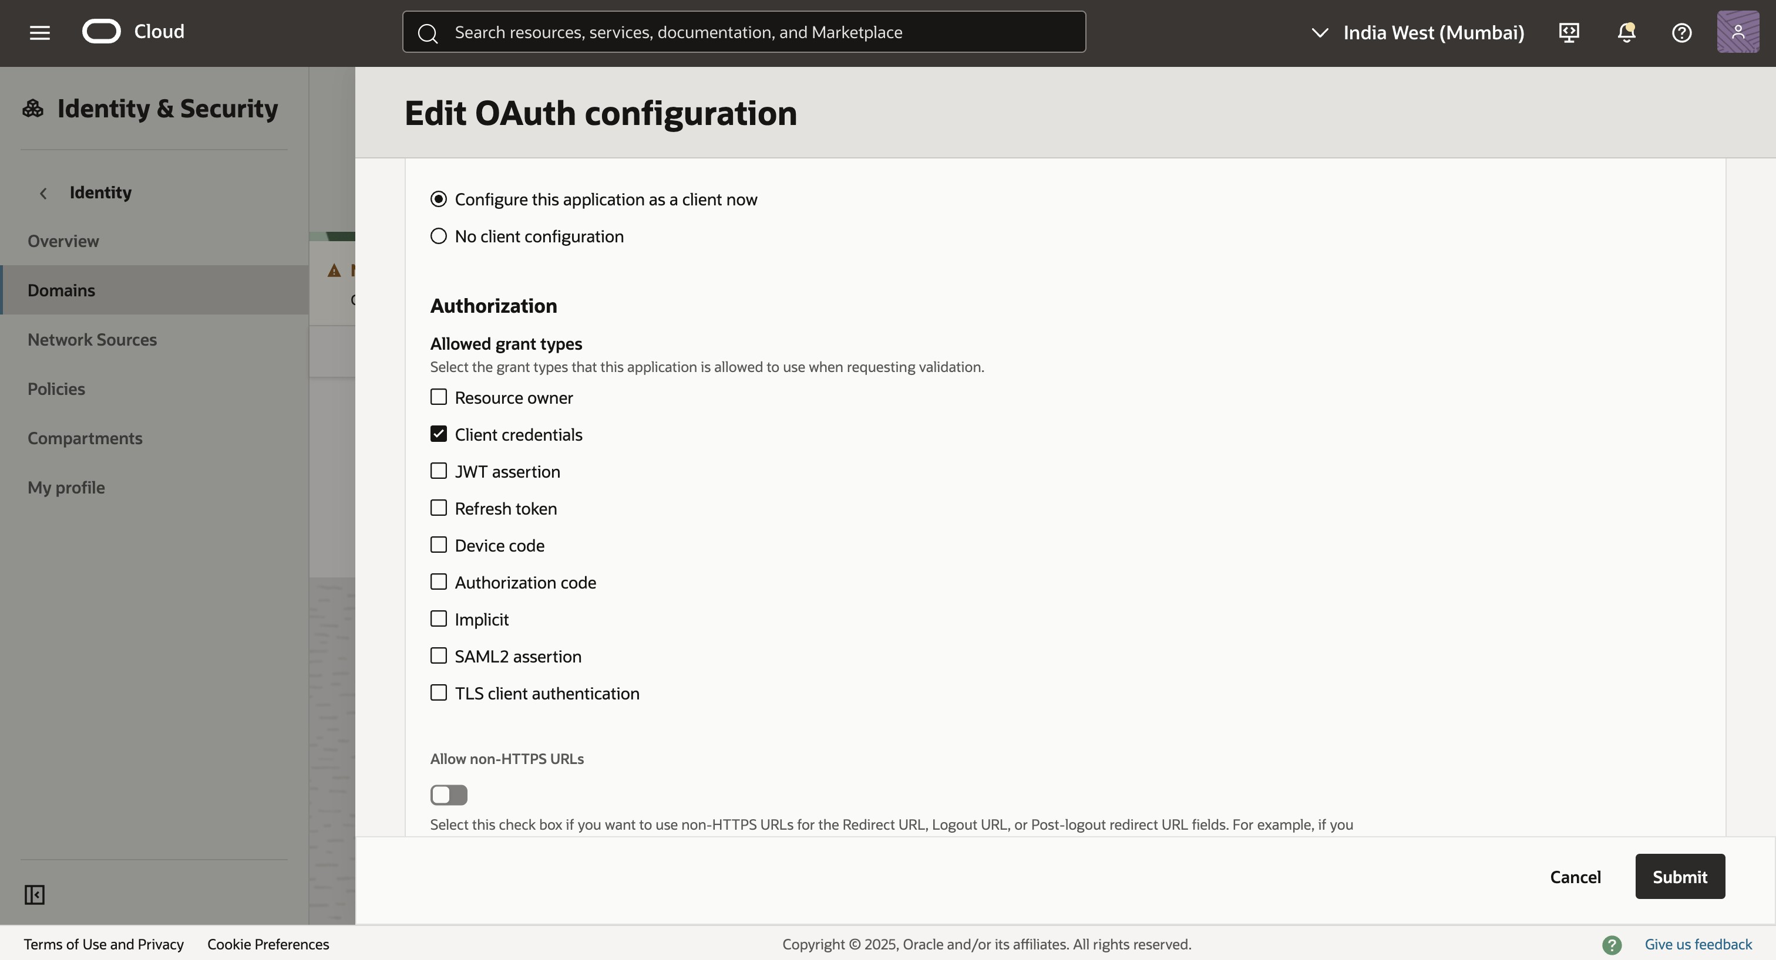

      - Enable the Add resources slider.
      - Add the scope from the Confidential app that is mentioned in the steps outlined in Getting Started with Oracle Banking Cloud Services.

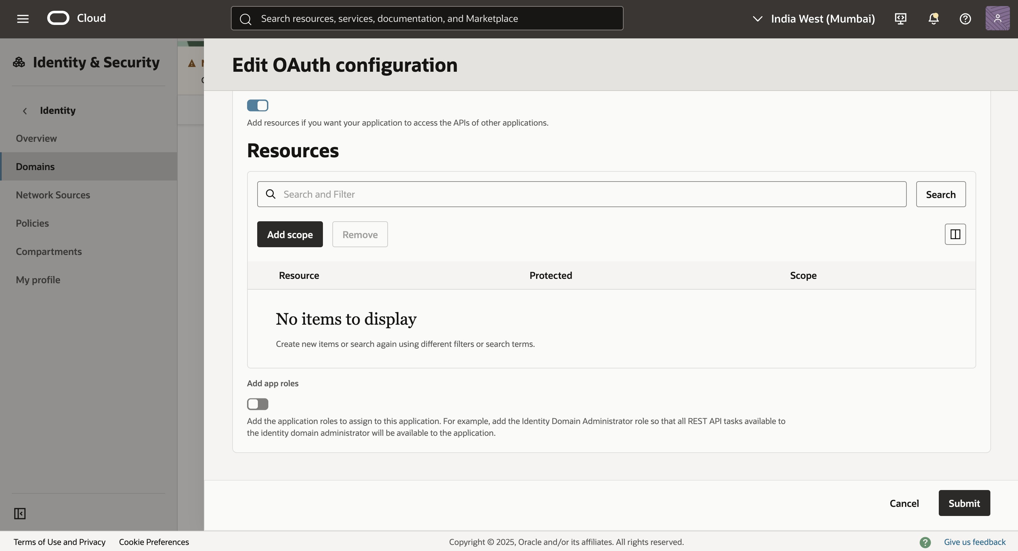
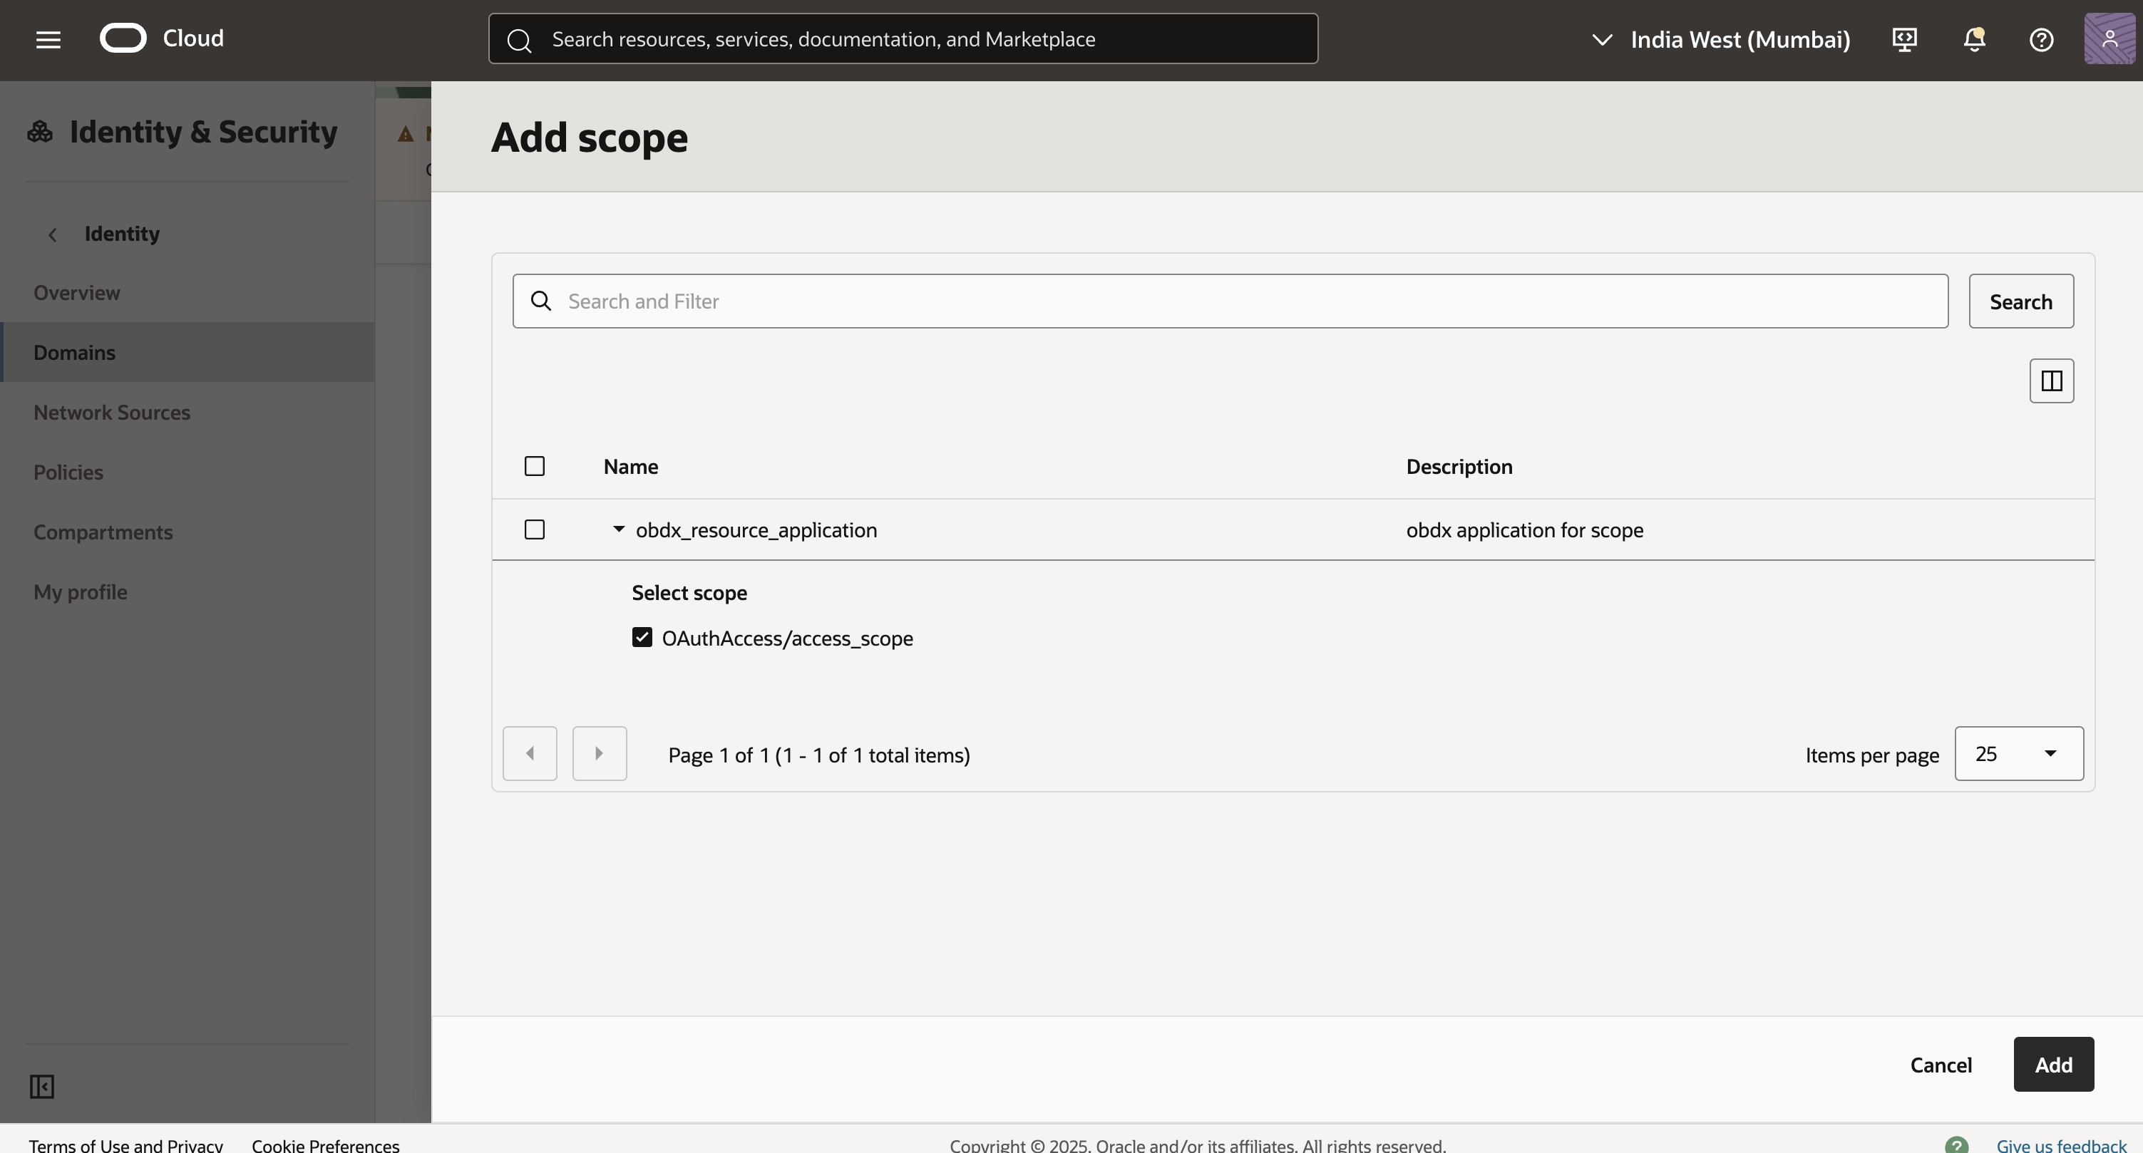

      - Ensure that App Role of "Identity Domain Administrator" is given
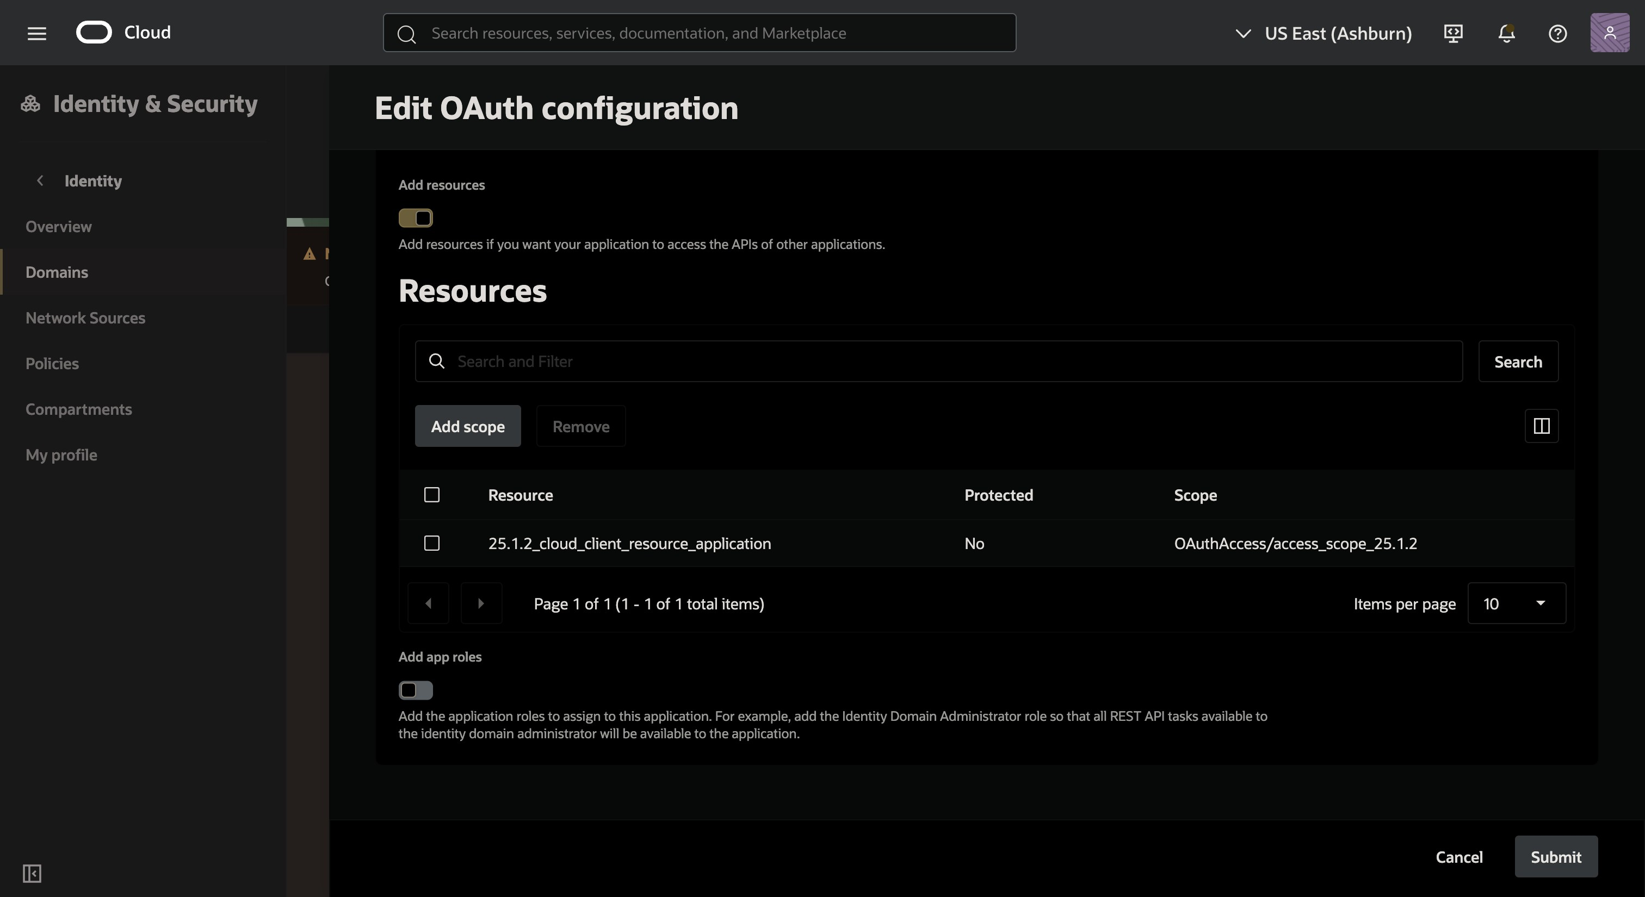
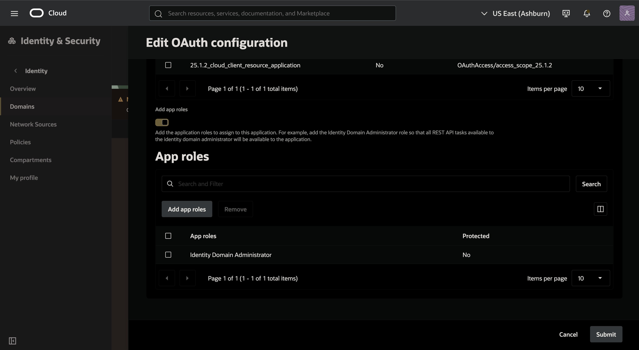

      - Click Save Changes.

      - After saving, navigate to the Client Details section to view or regenerate the client ID and client secret. Securely store these credentials as they will be used for authentication (e.g., generating Bearer Tokens).
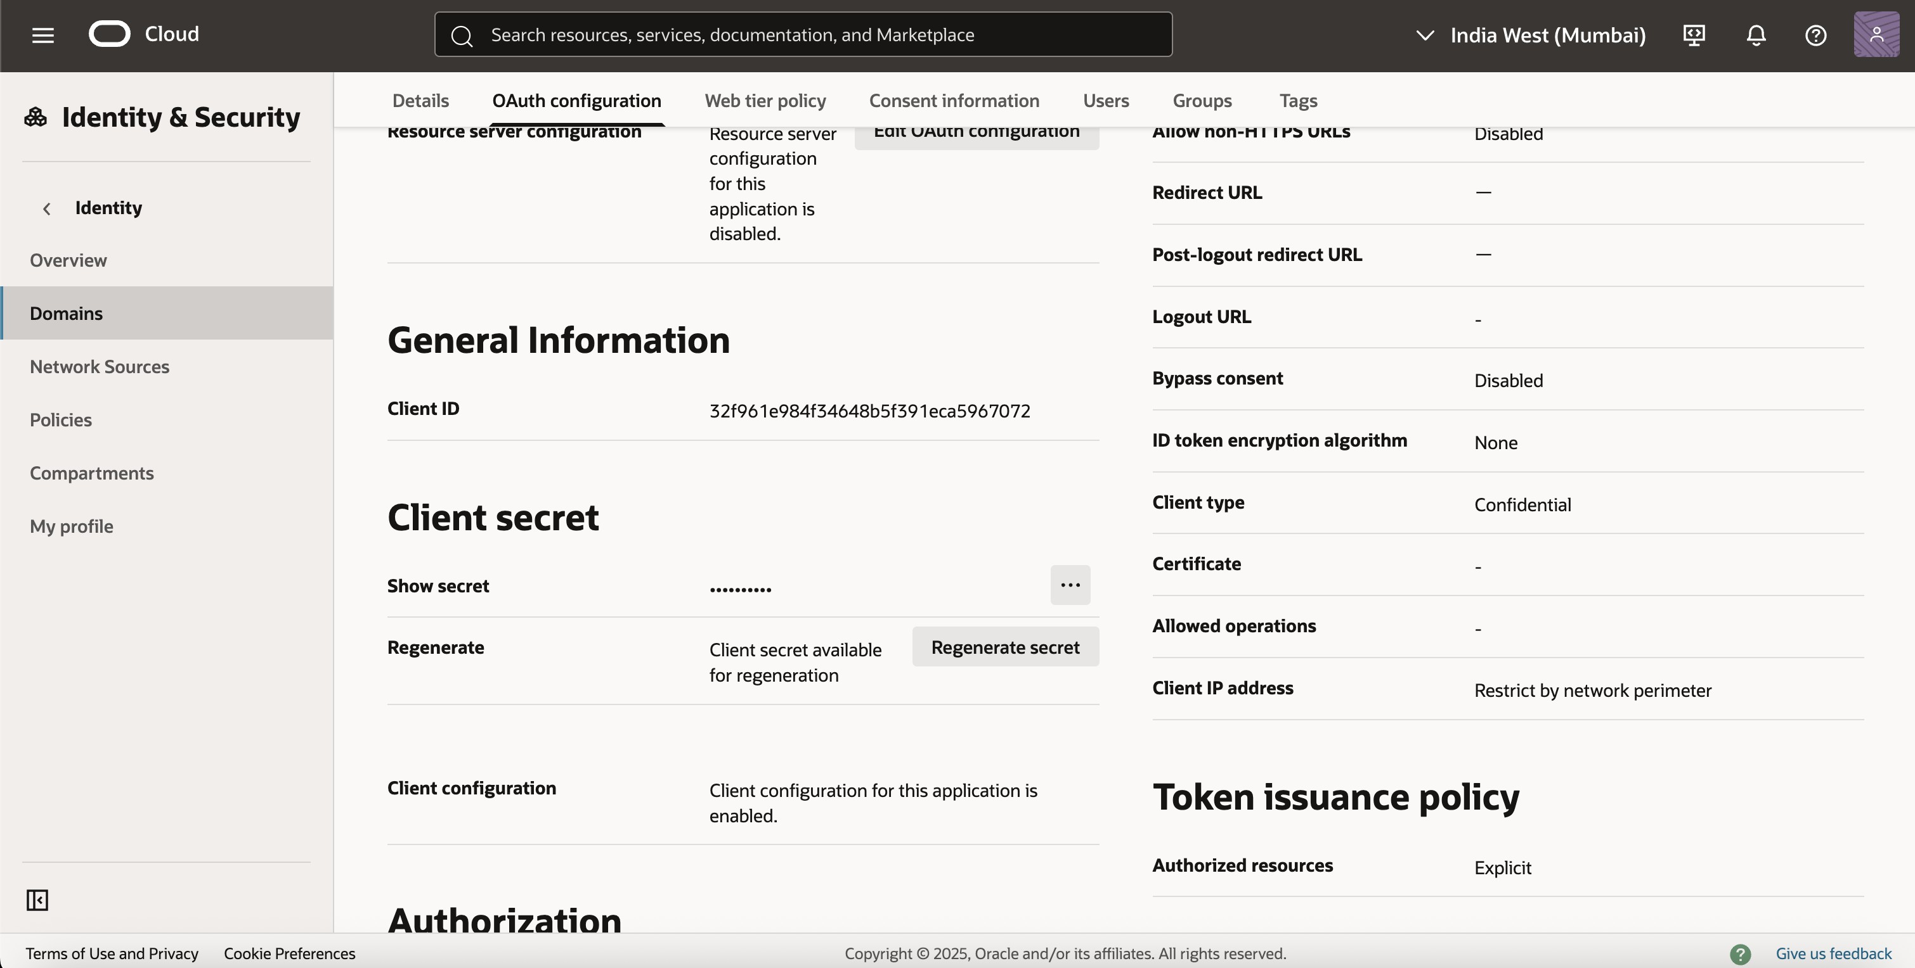

OBDX Side Configuration

    - Navigate to the Touch Point Maintenance Screen.
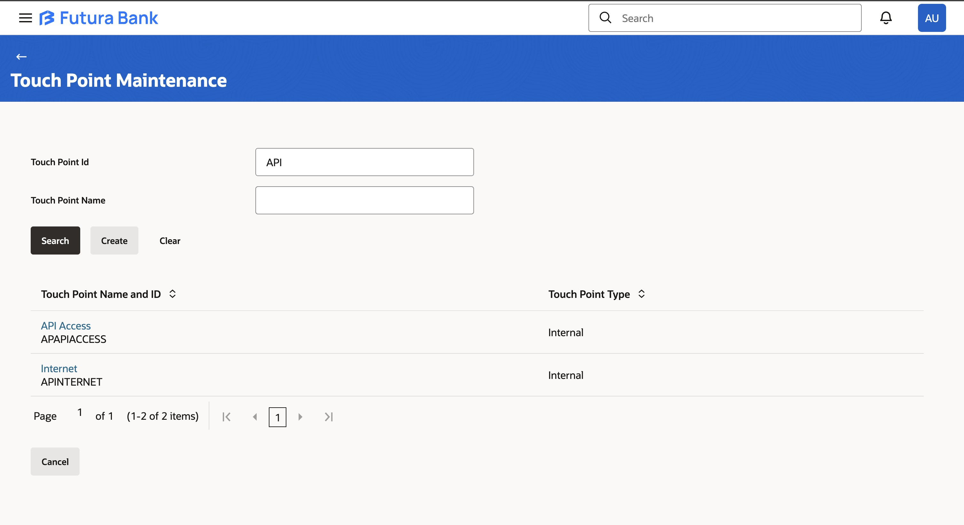

    - Click on the API Access touch point.

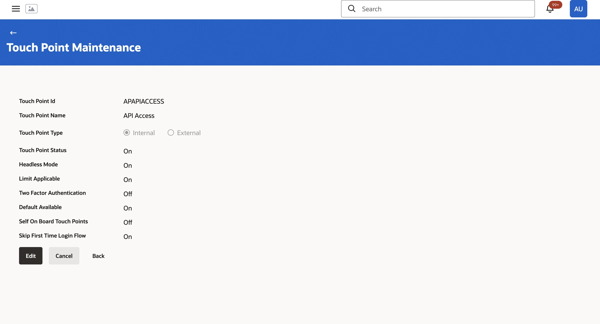

    - Edit and Add the client-id configured in the confidential application(Ensure that the touch point status is enabled).
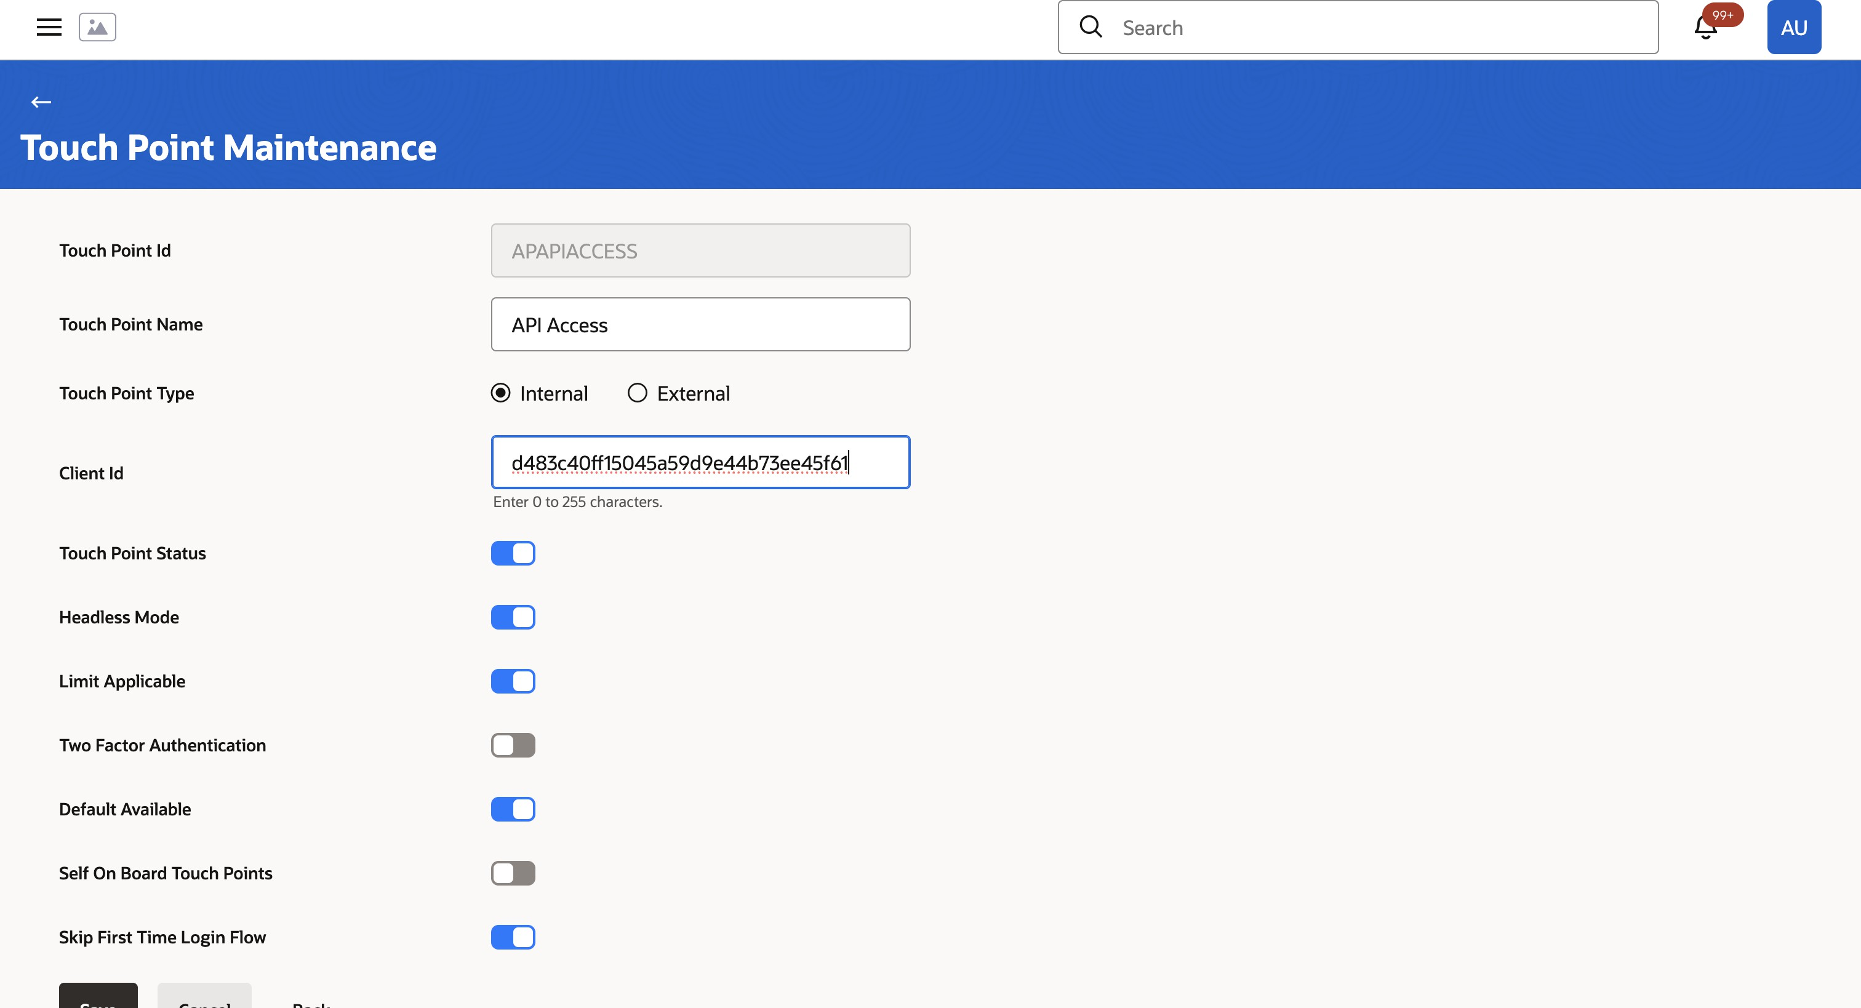
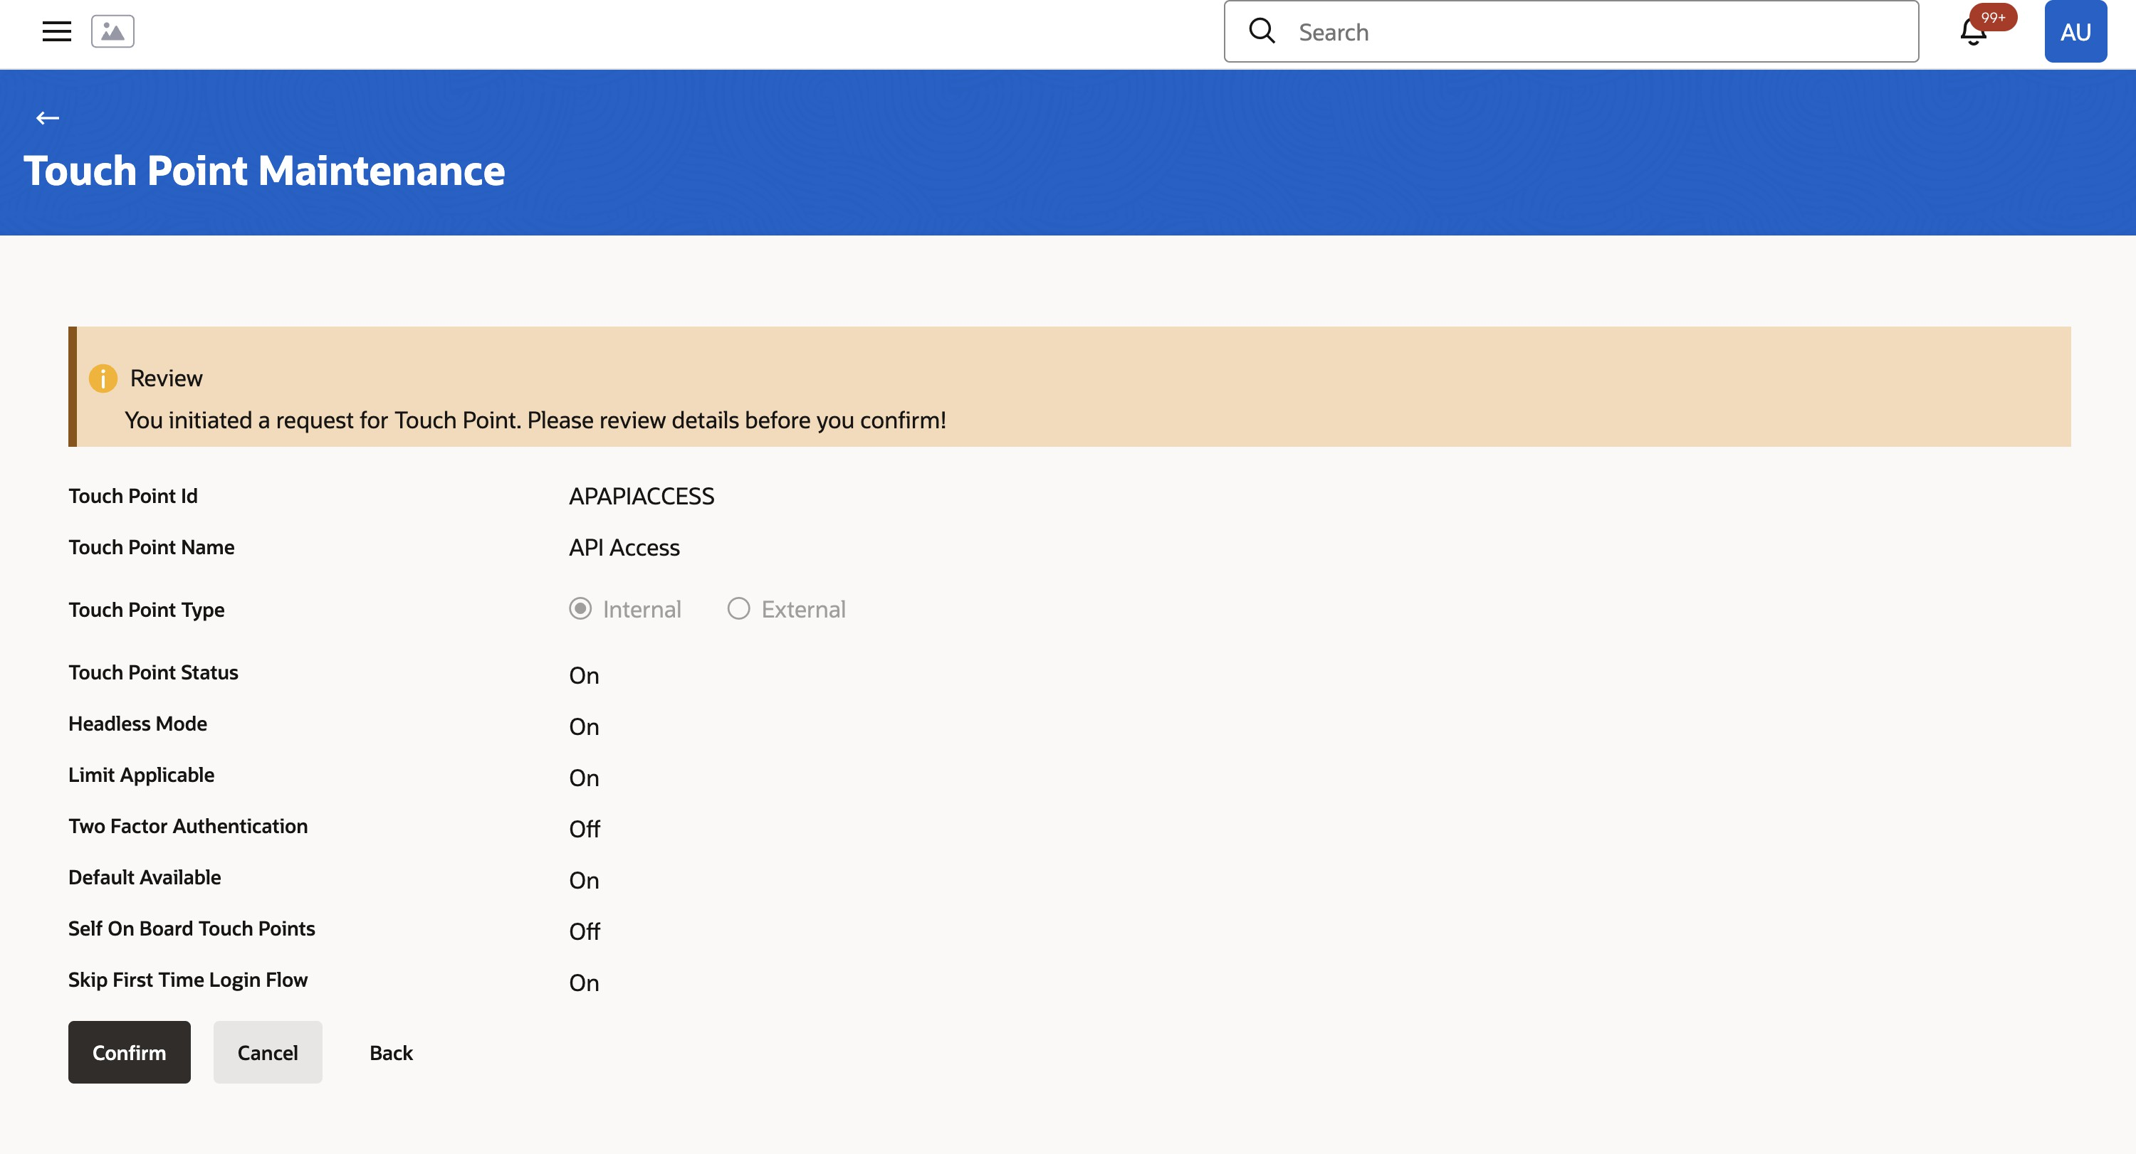
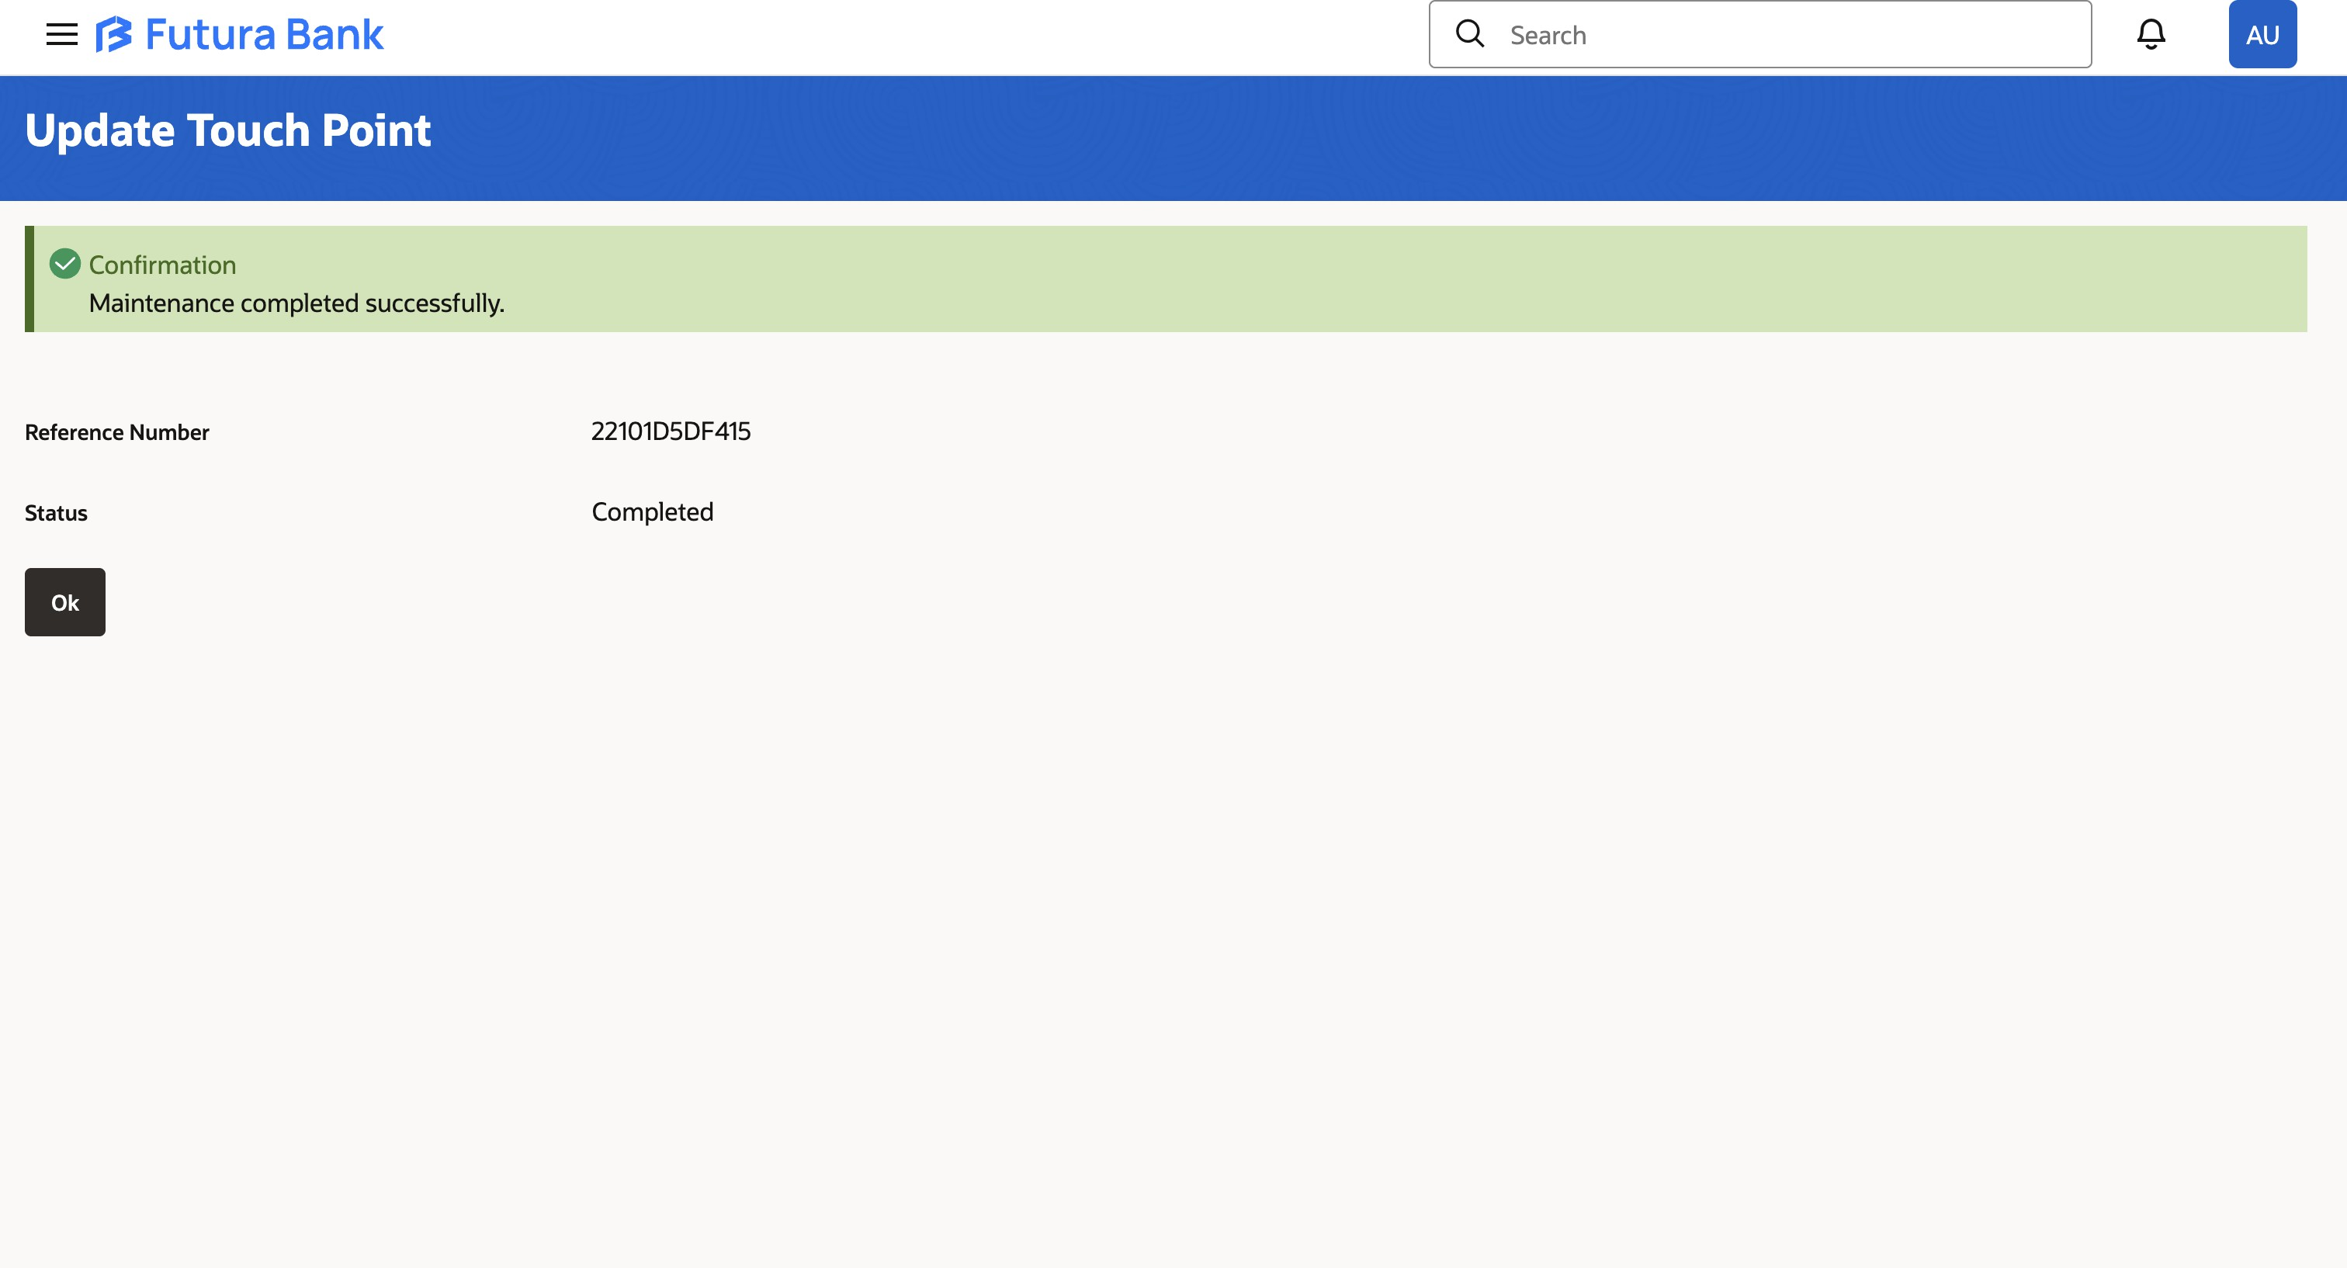

Configuring GenericSCIM - Client Credentials Application

    - Launch App Catalog:
      - From the Integrated Applications page in IDCS, click Add Application.
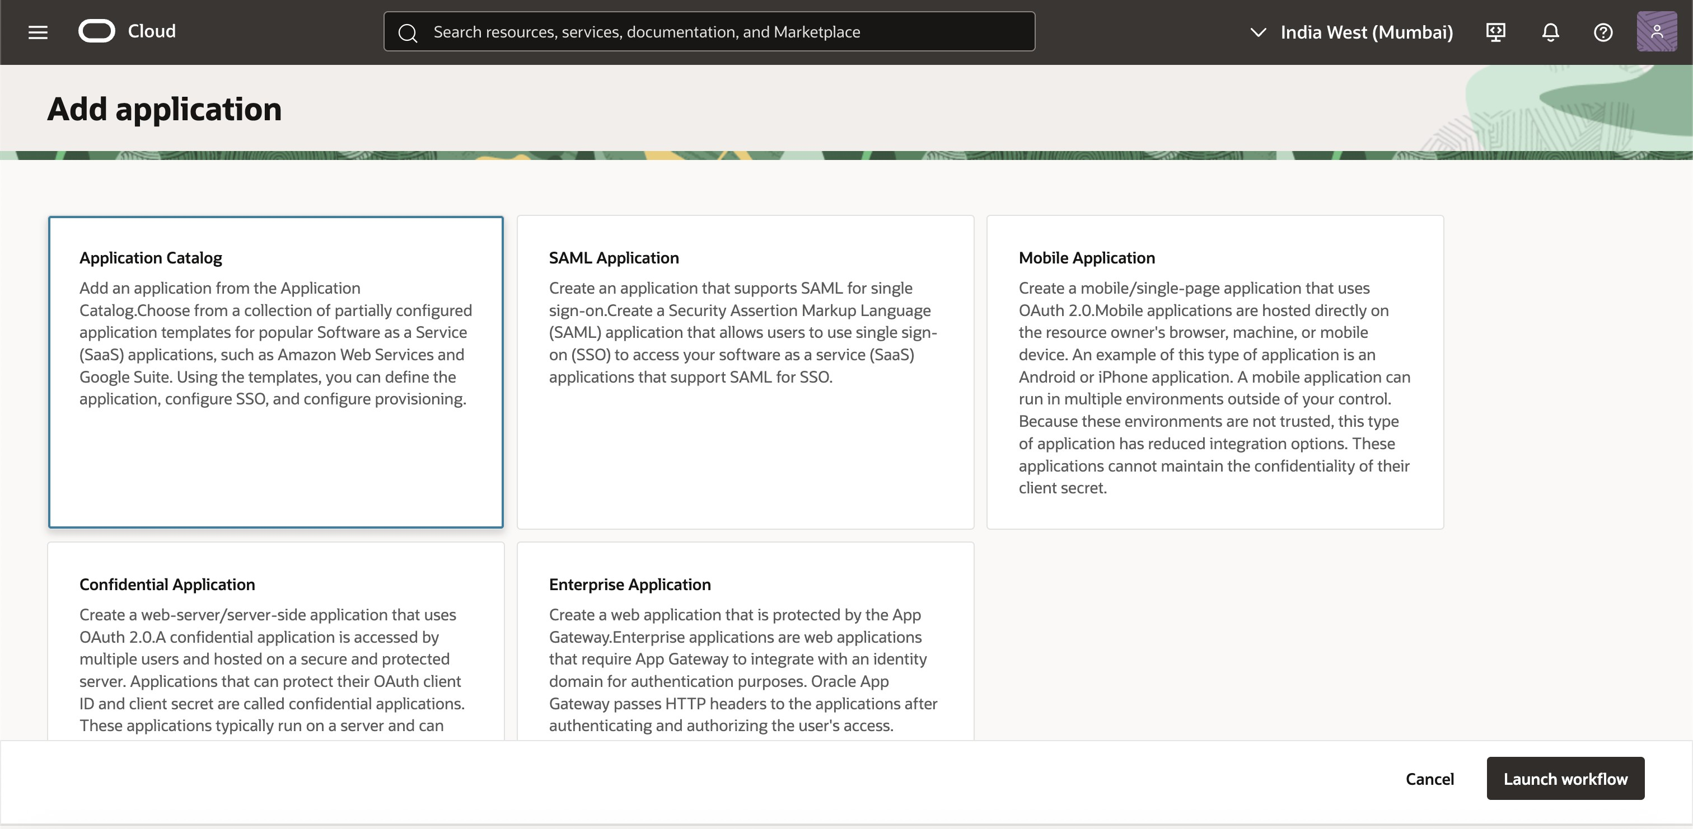

      - Click Launch App Catalog and search for GenericSCIM.
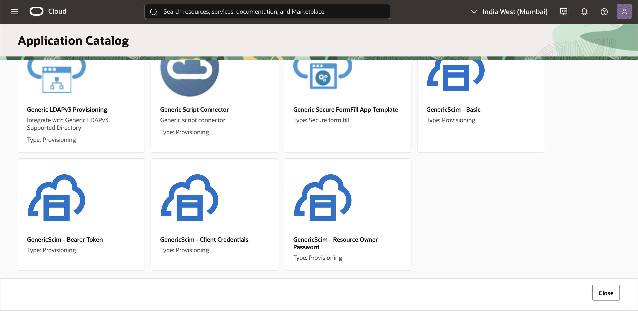

      - Select GenericSCIM – Client Credentials from the results and click Next.
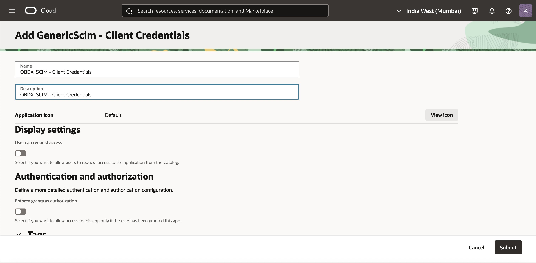

      - This should bring you to the details page for your SCIM Application
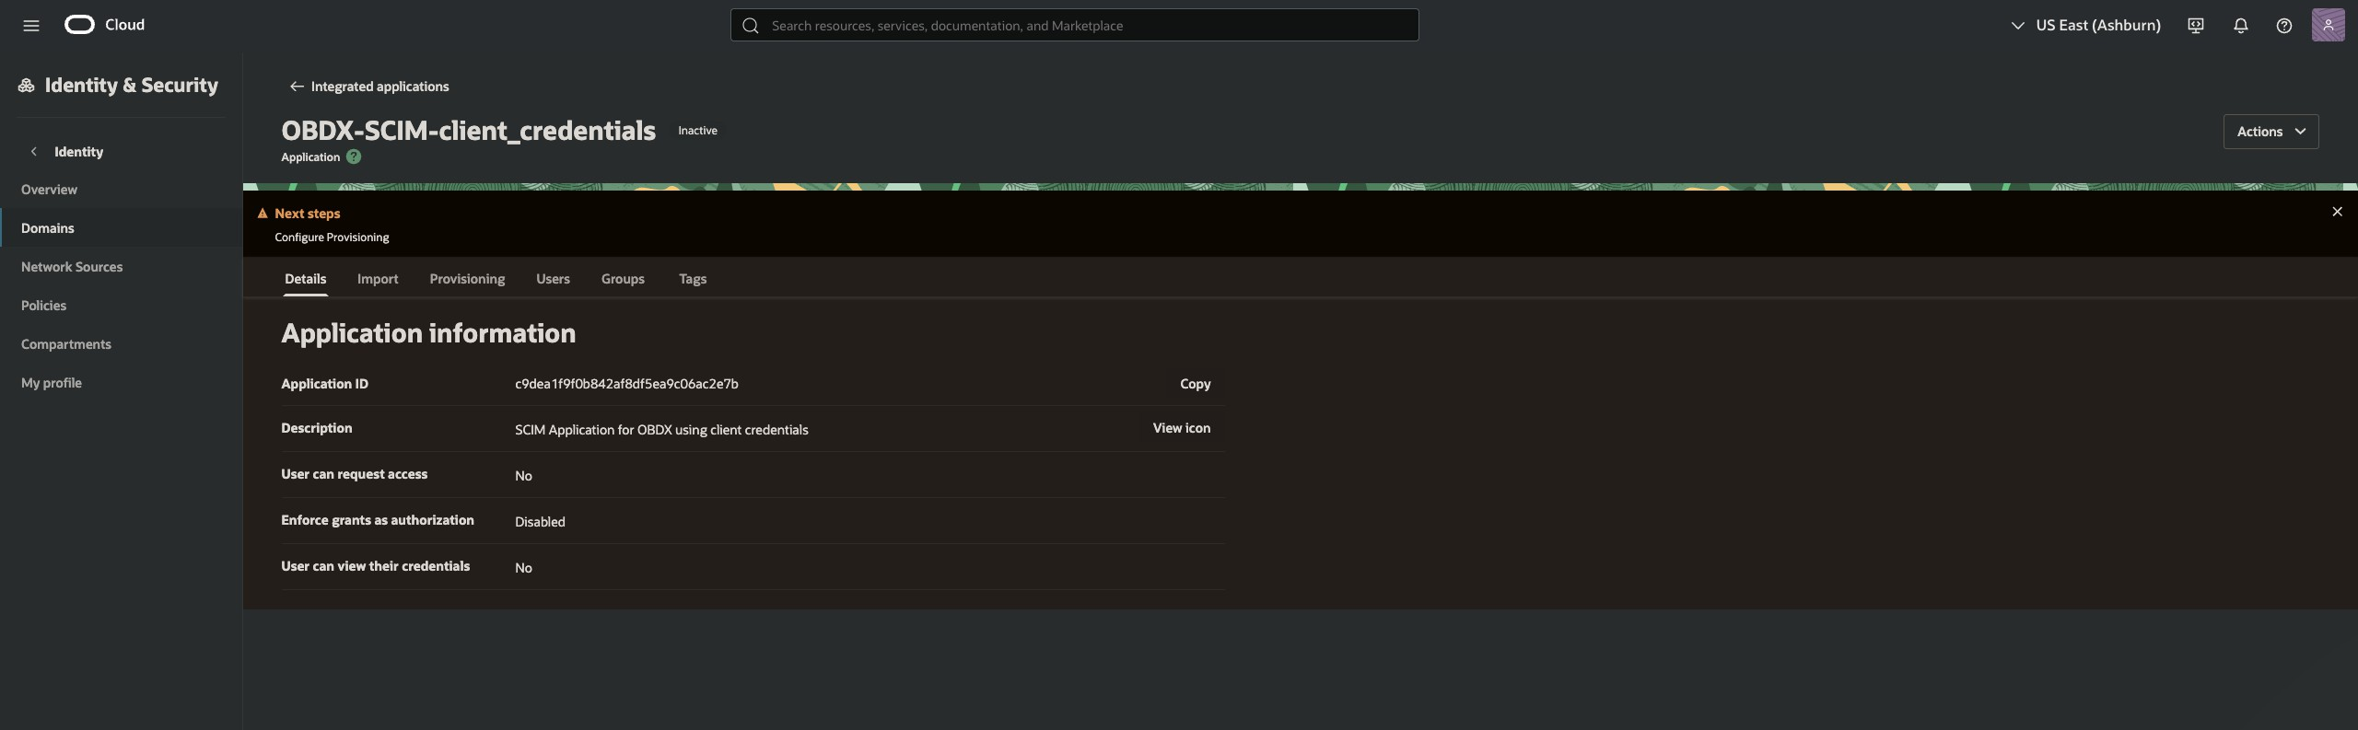

    - Here we will enable provisioning in the provisioning tab and fill in OBDX details as follows
      - Host Name: Enter the hostname for the target application (e.g., HostName).
      - Base URI: Specify the base URI for the SCIM endpoint, prefixed with the environment (e.g., /non-prod/digx-sms/v1/). In the target OBDX application, the SCIM endpoint path would begin with "/Users" as per SCIM standards.
      - Client ID: Enter the Client ID used for generating the Bearer Token.
      - Client Secret: Enter the corresponding Client Secret.
      - Scope: Define the access scope used for the Bearer Token(Add the scope previously generated).
      - Authentication Server URL: Combine the Domain URL (from Domain Overview) with /oauth2/v1/token (e.g., https://idcs- example.identity.oraclecloud.com/oauth2/v1/token).
Domain URL can be found in the view details section of your domain.
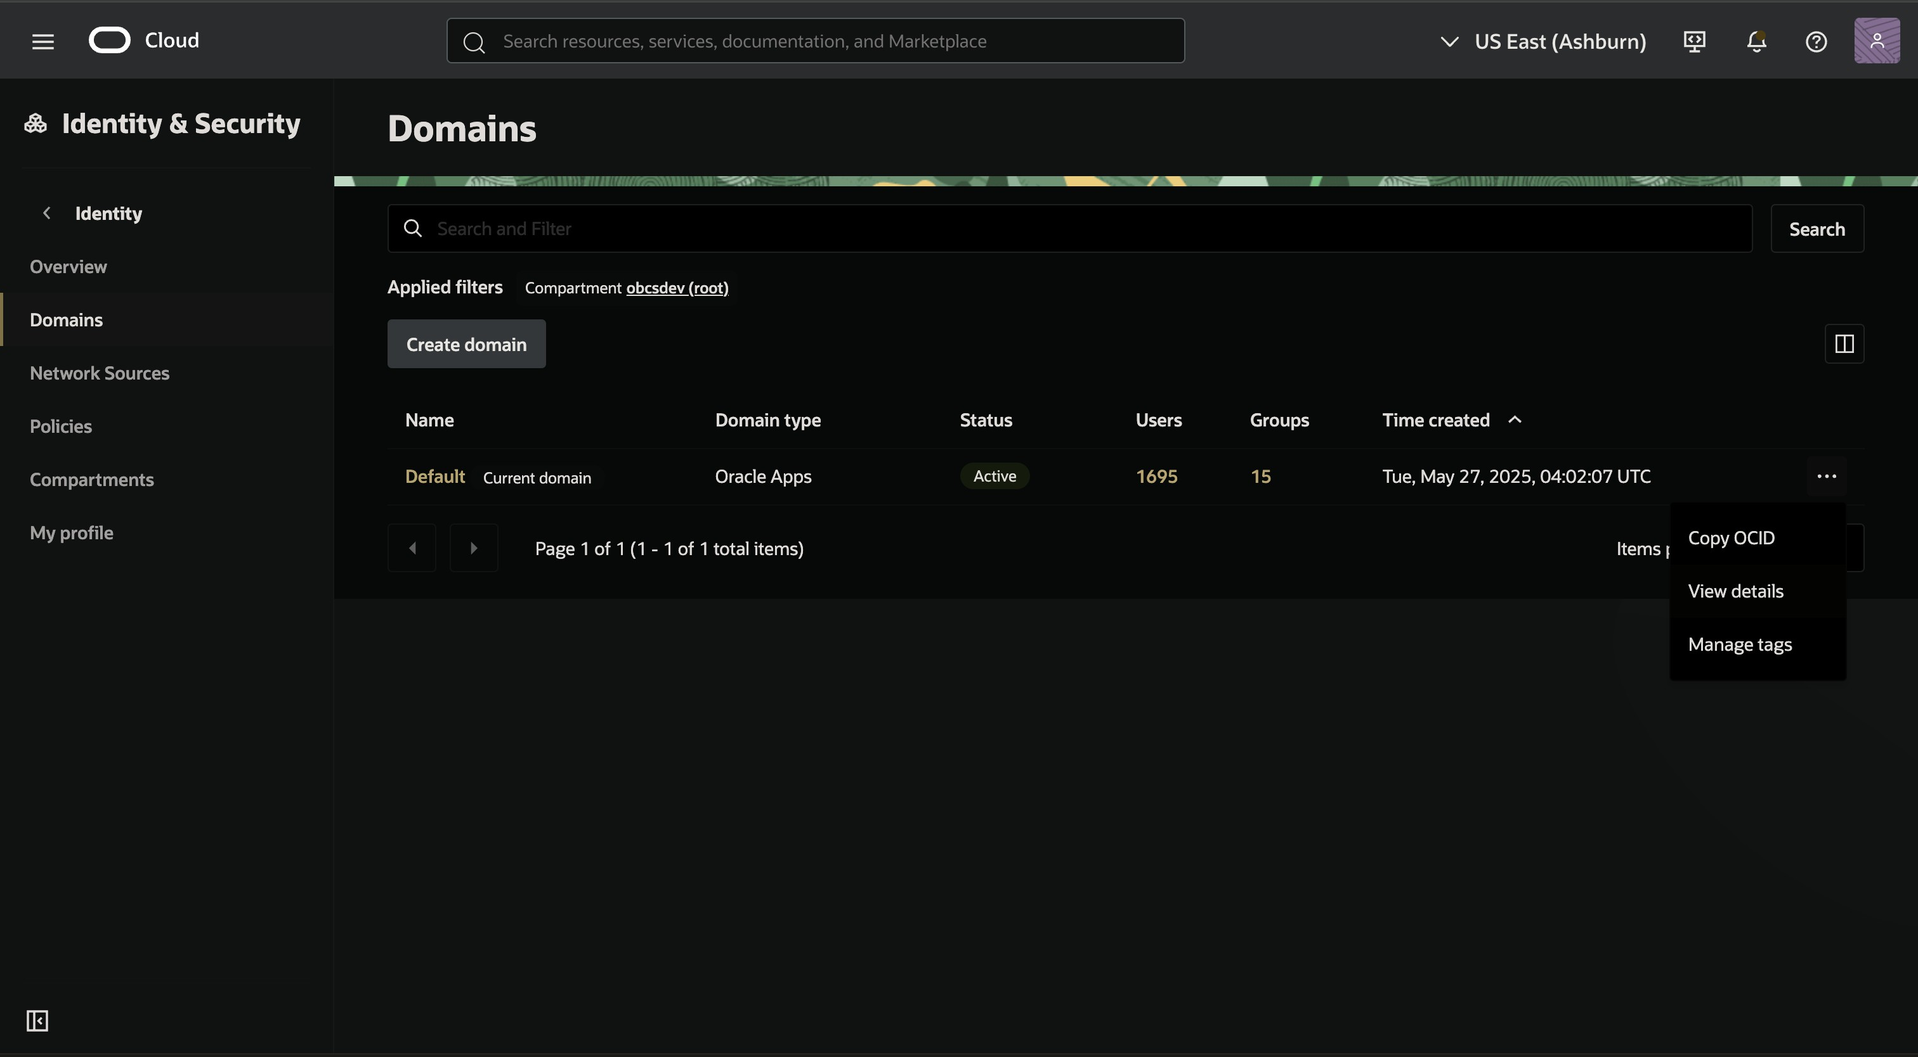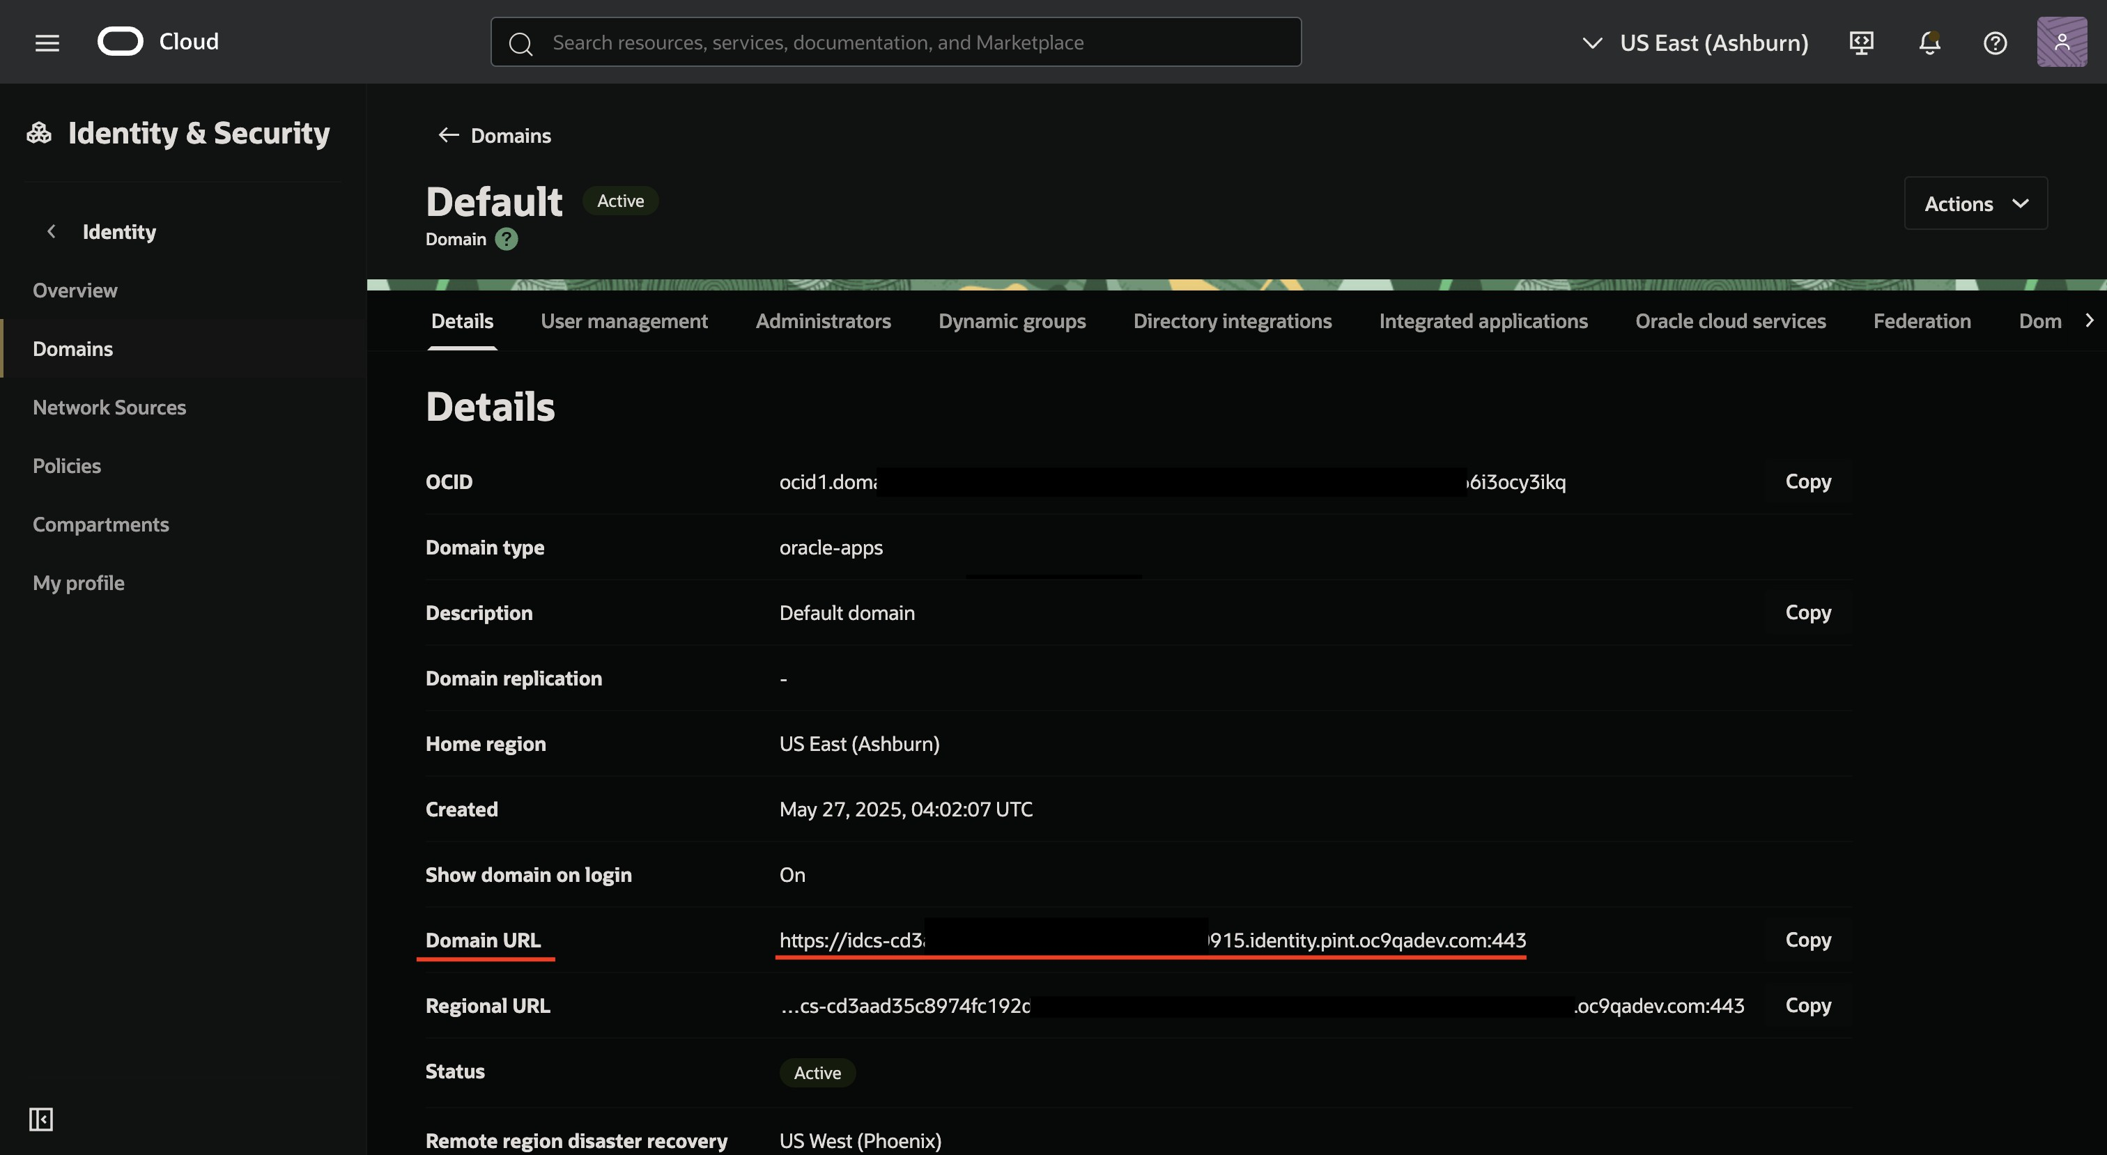

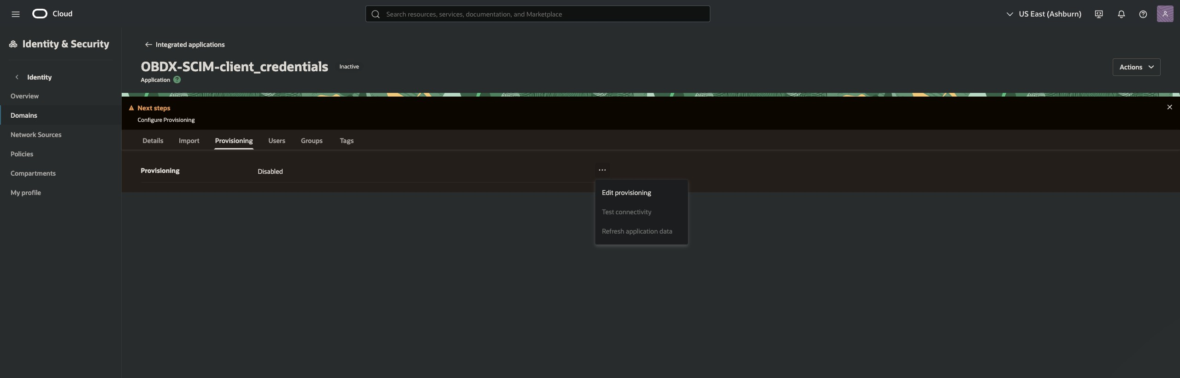
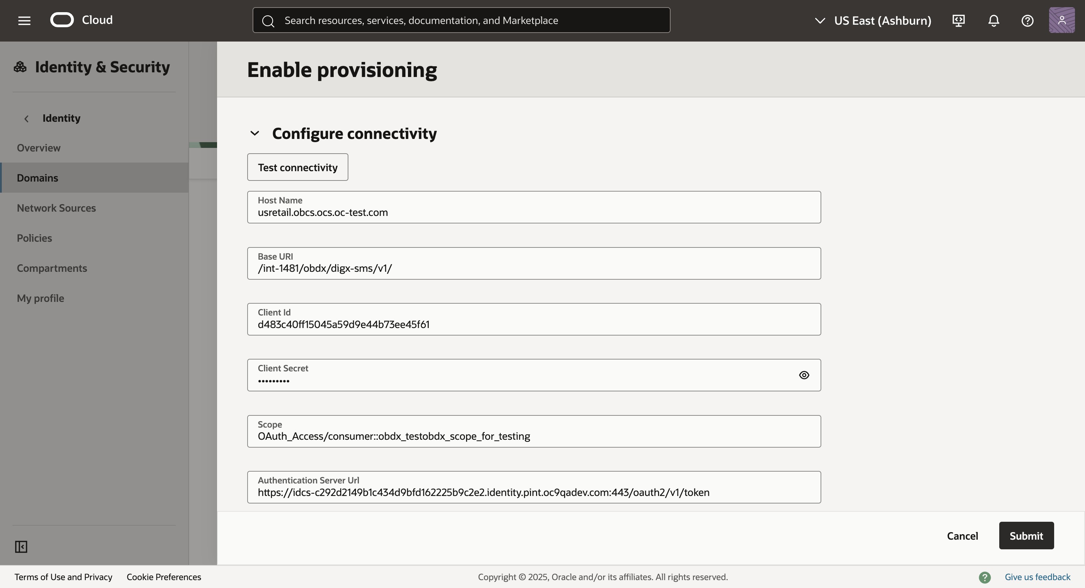

    - Test Connectivity to the application using correct details.
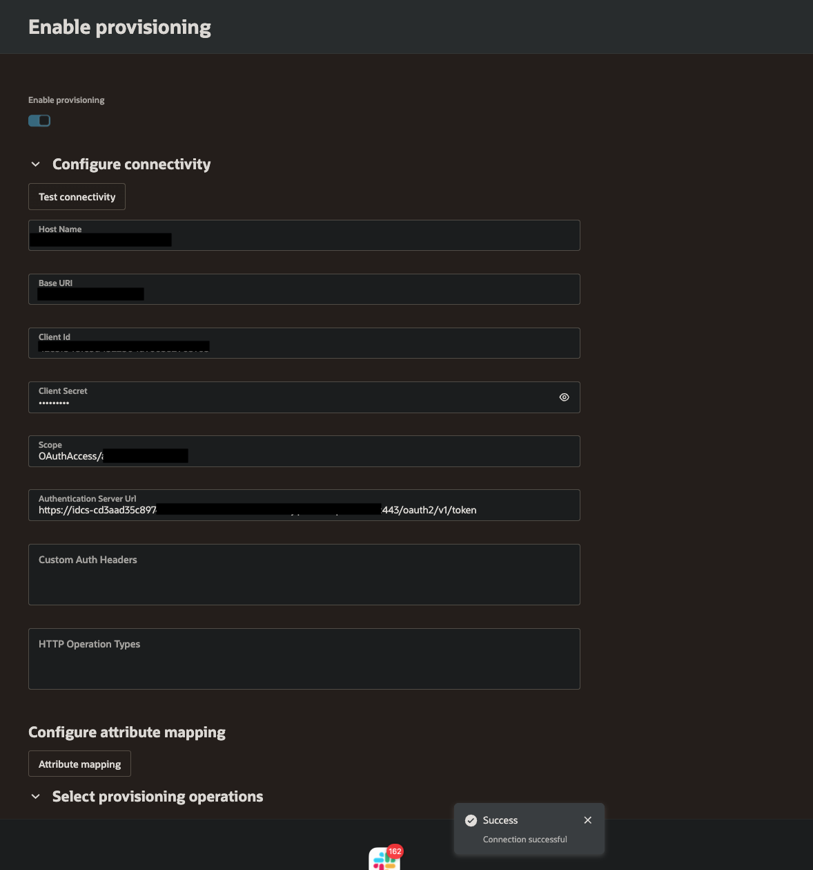
    - Scroll down a bit and Set Provisioning Operations:

      - In the Select Provisioning Operations section, configure the operations Create, Update, Delete.
Toggle Enable Synchronization and configure the synchronization settings as needed. Ensure that External ID is selected as the identifier.
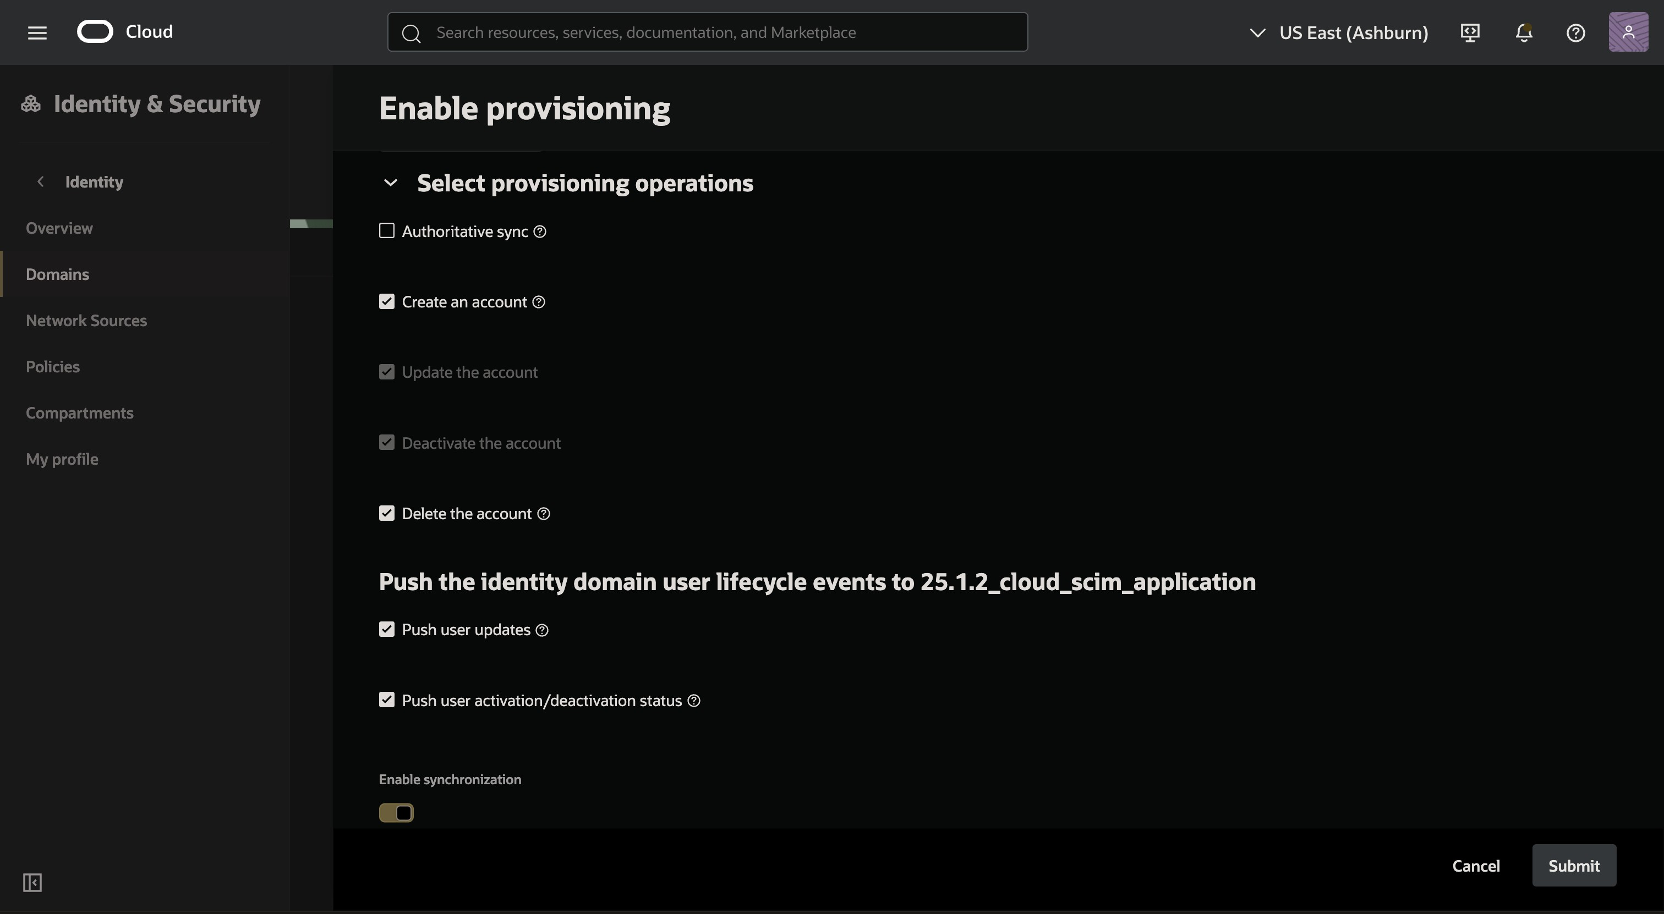

      - To Ensure externalId mapping, click on Attrtibute Mapping. In here, ensure that user.id is mapped to externalId.

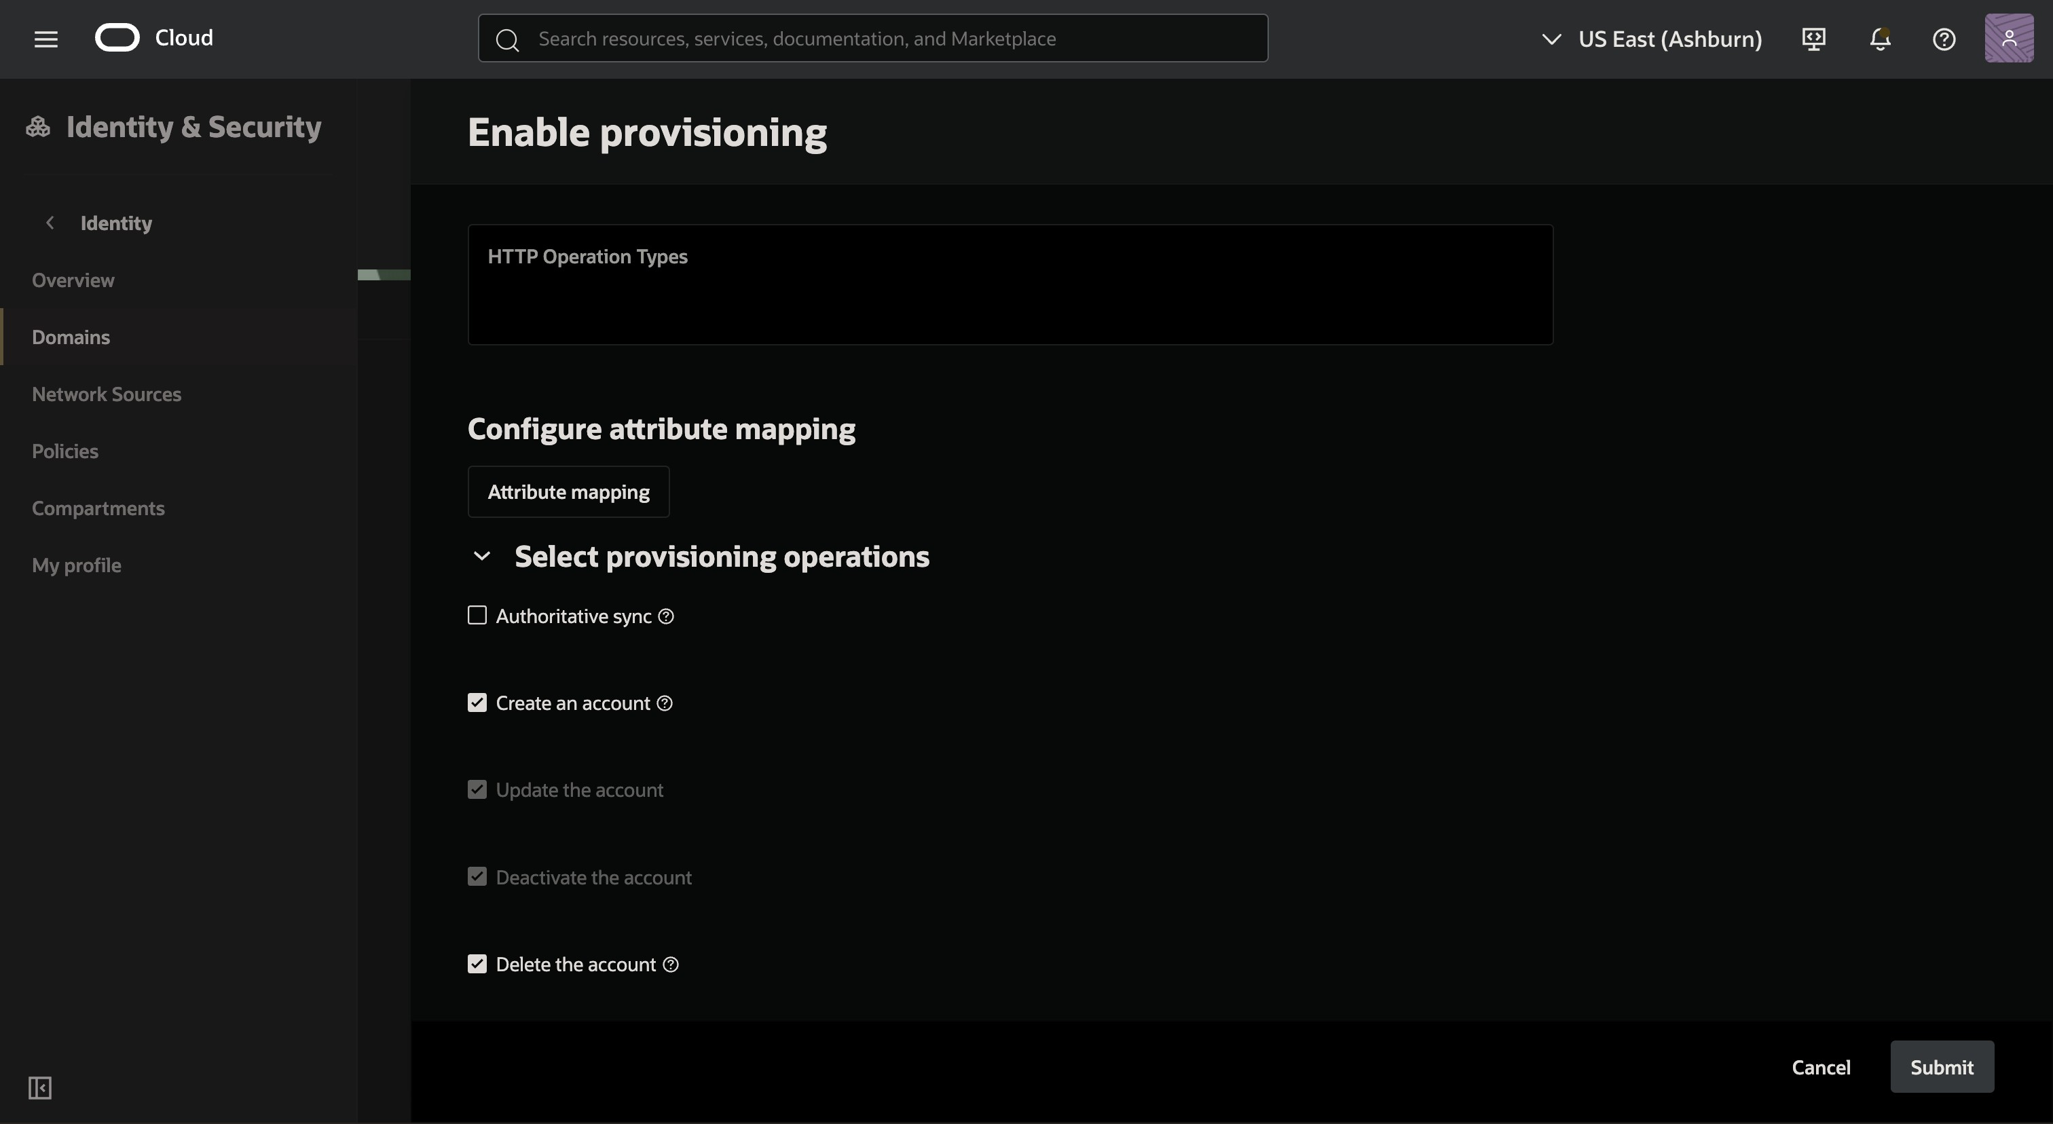
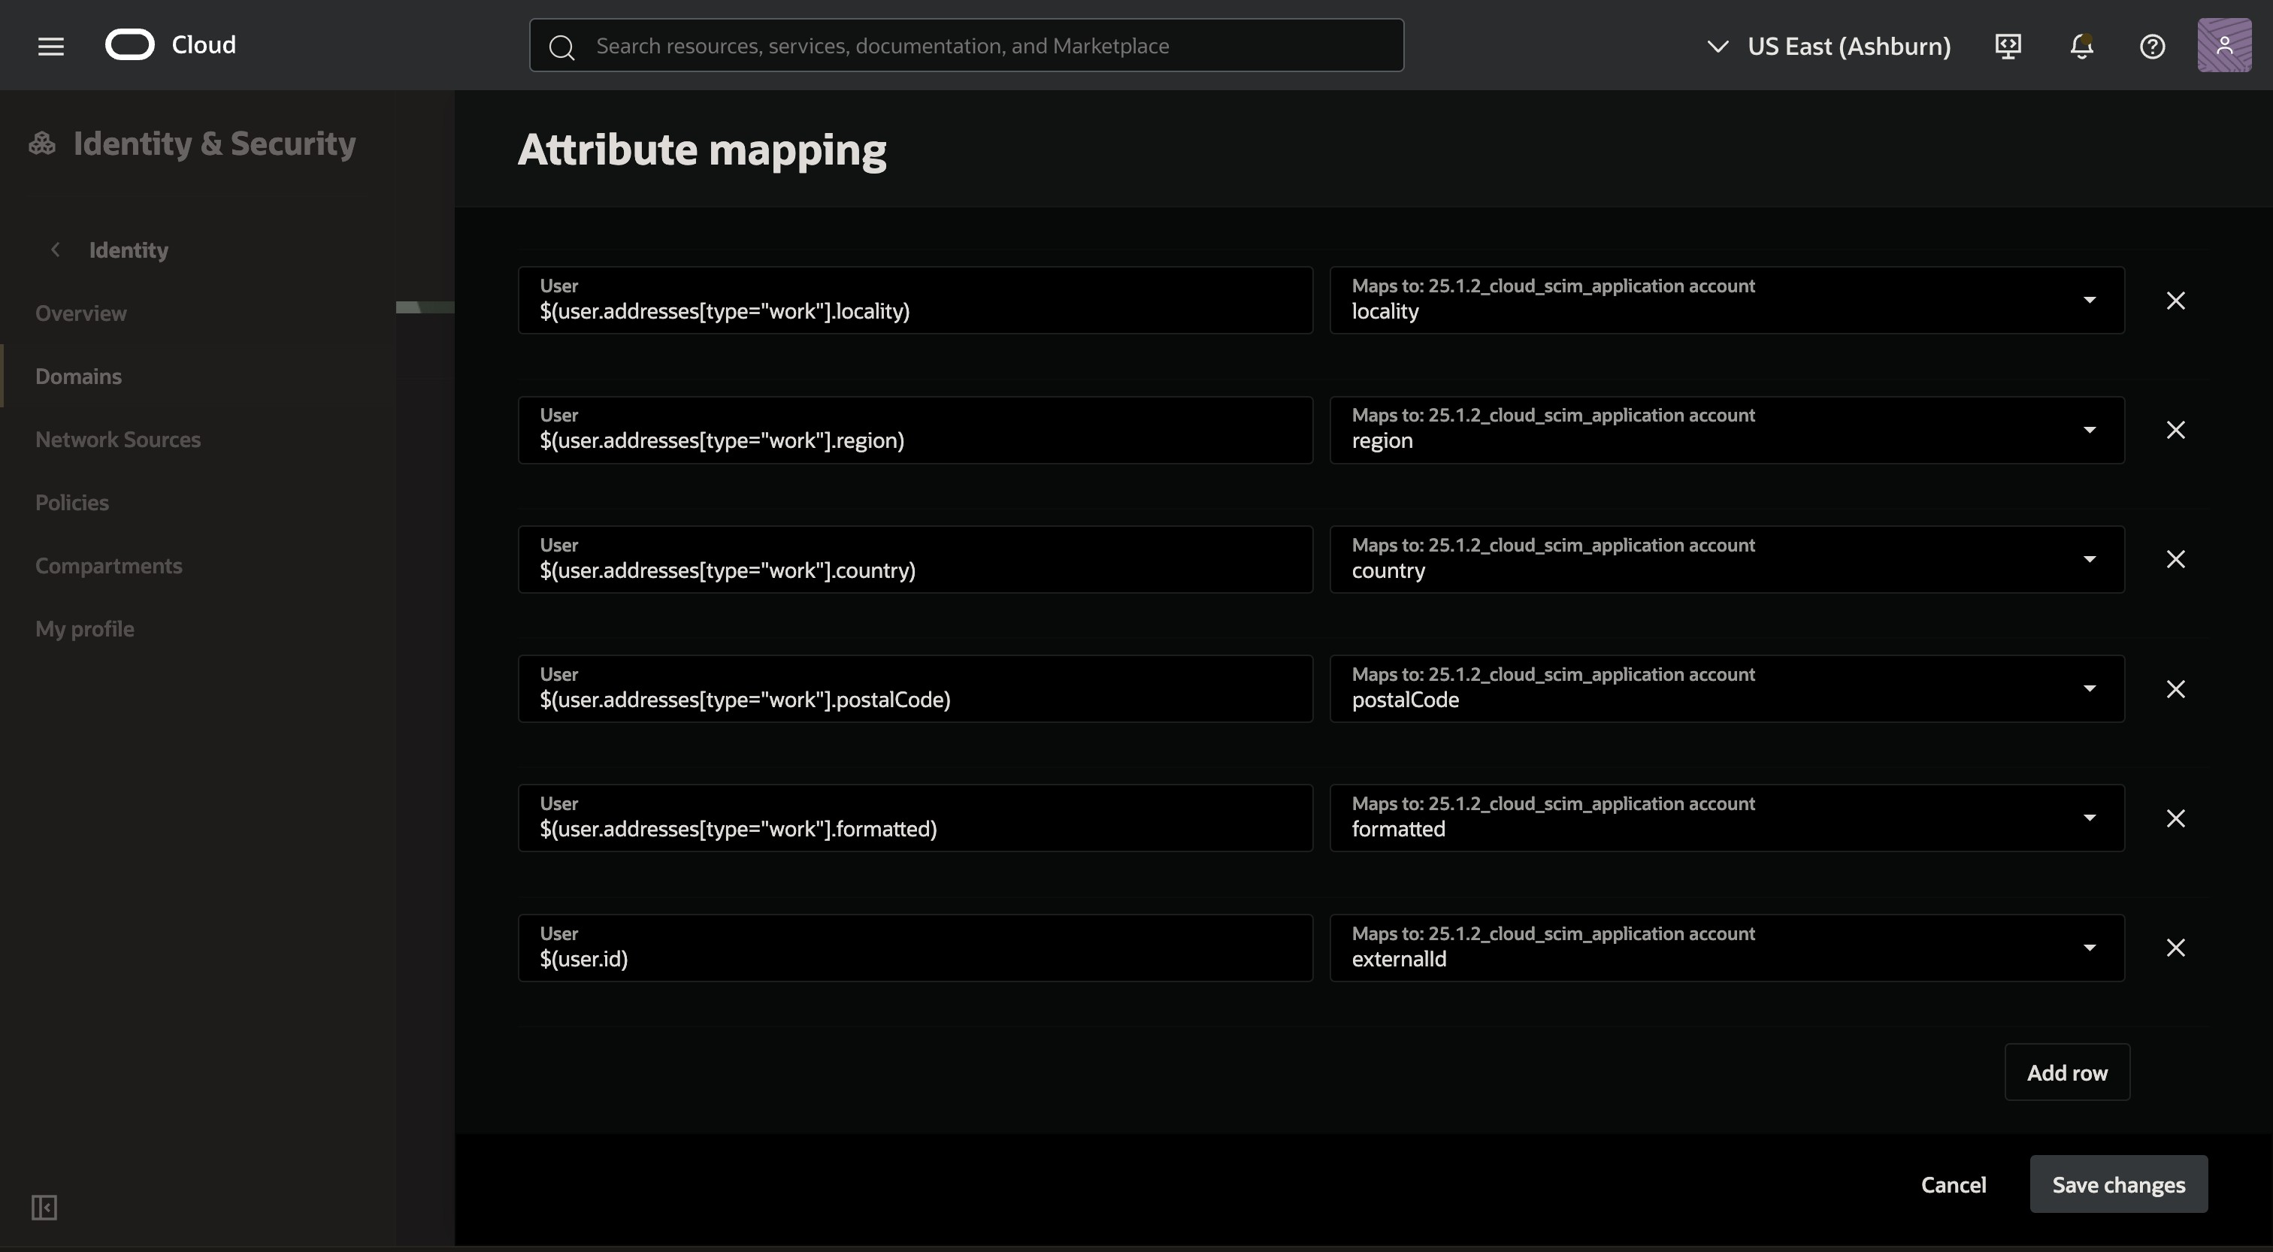

If you want the primary identifier of the users to be username instead of their userId i.e. you want the userId and username of all Users
      - to be the same change the value in the attribute mapping from '$(user.id)' to '$(user.userName)'.

- After this, ensure that this application has been activated. To do so, navigate to application and activate it

- This will configure your app and will be able to manually assign a user to the application in order to automatically assign a user to a scim application follow the configuration.

Configure Auto-Assignment by User Groups
    - Navigate to domains tab and click on the domain in which the application is configured in.
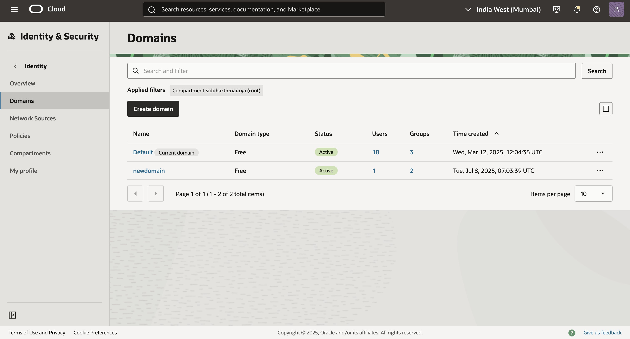

    - Navigate to user management tab and scroll down to groups section and click on create group.
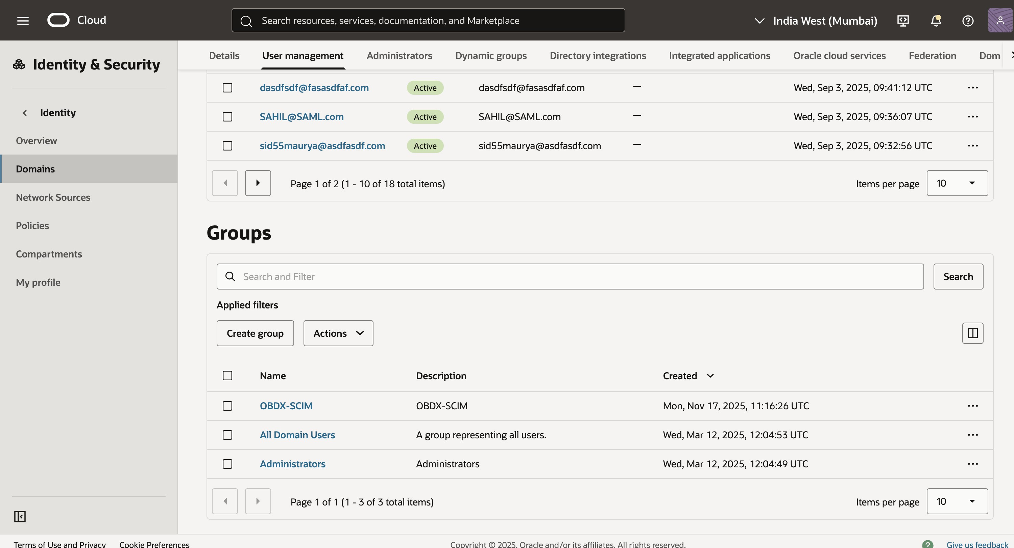

    - Add appropriate name and description and click on create.
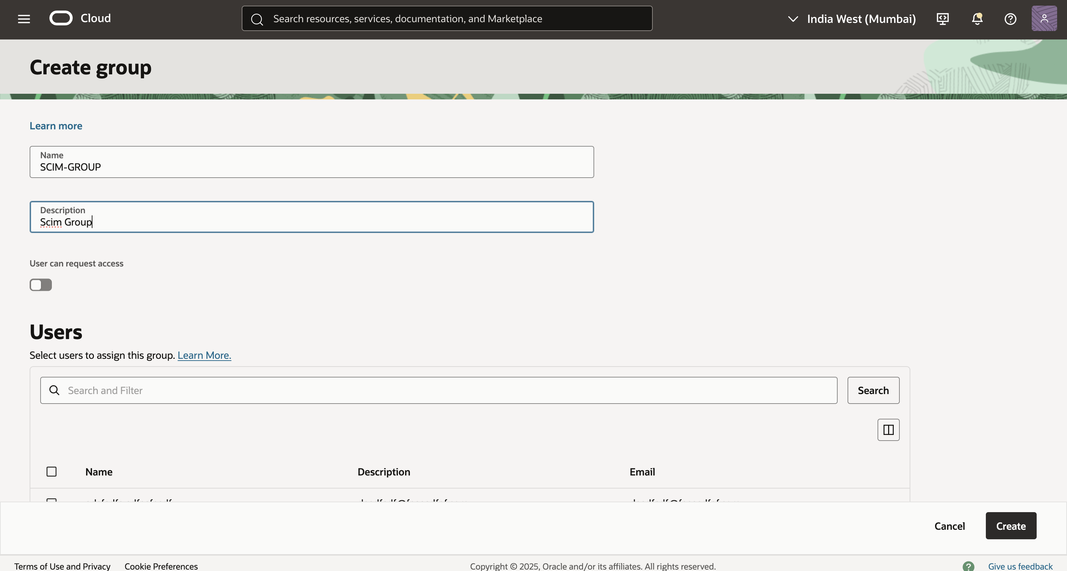

    - Navigate to the integrated applications tab of the group description and click on Assign applications.
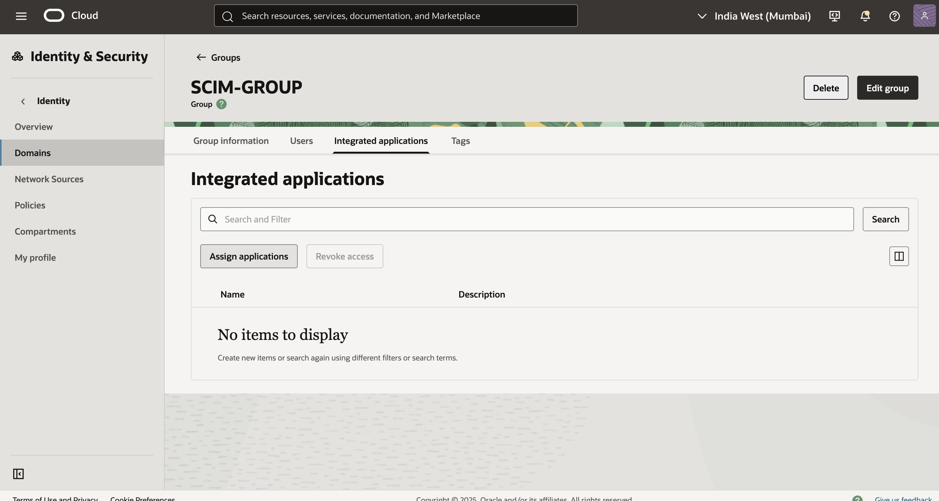

    - Click on the appropriate integrated application and choose fill form and assign.
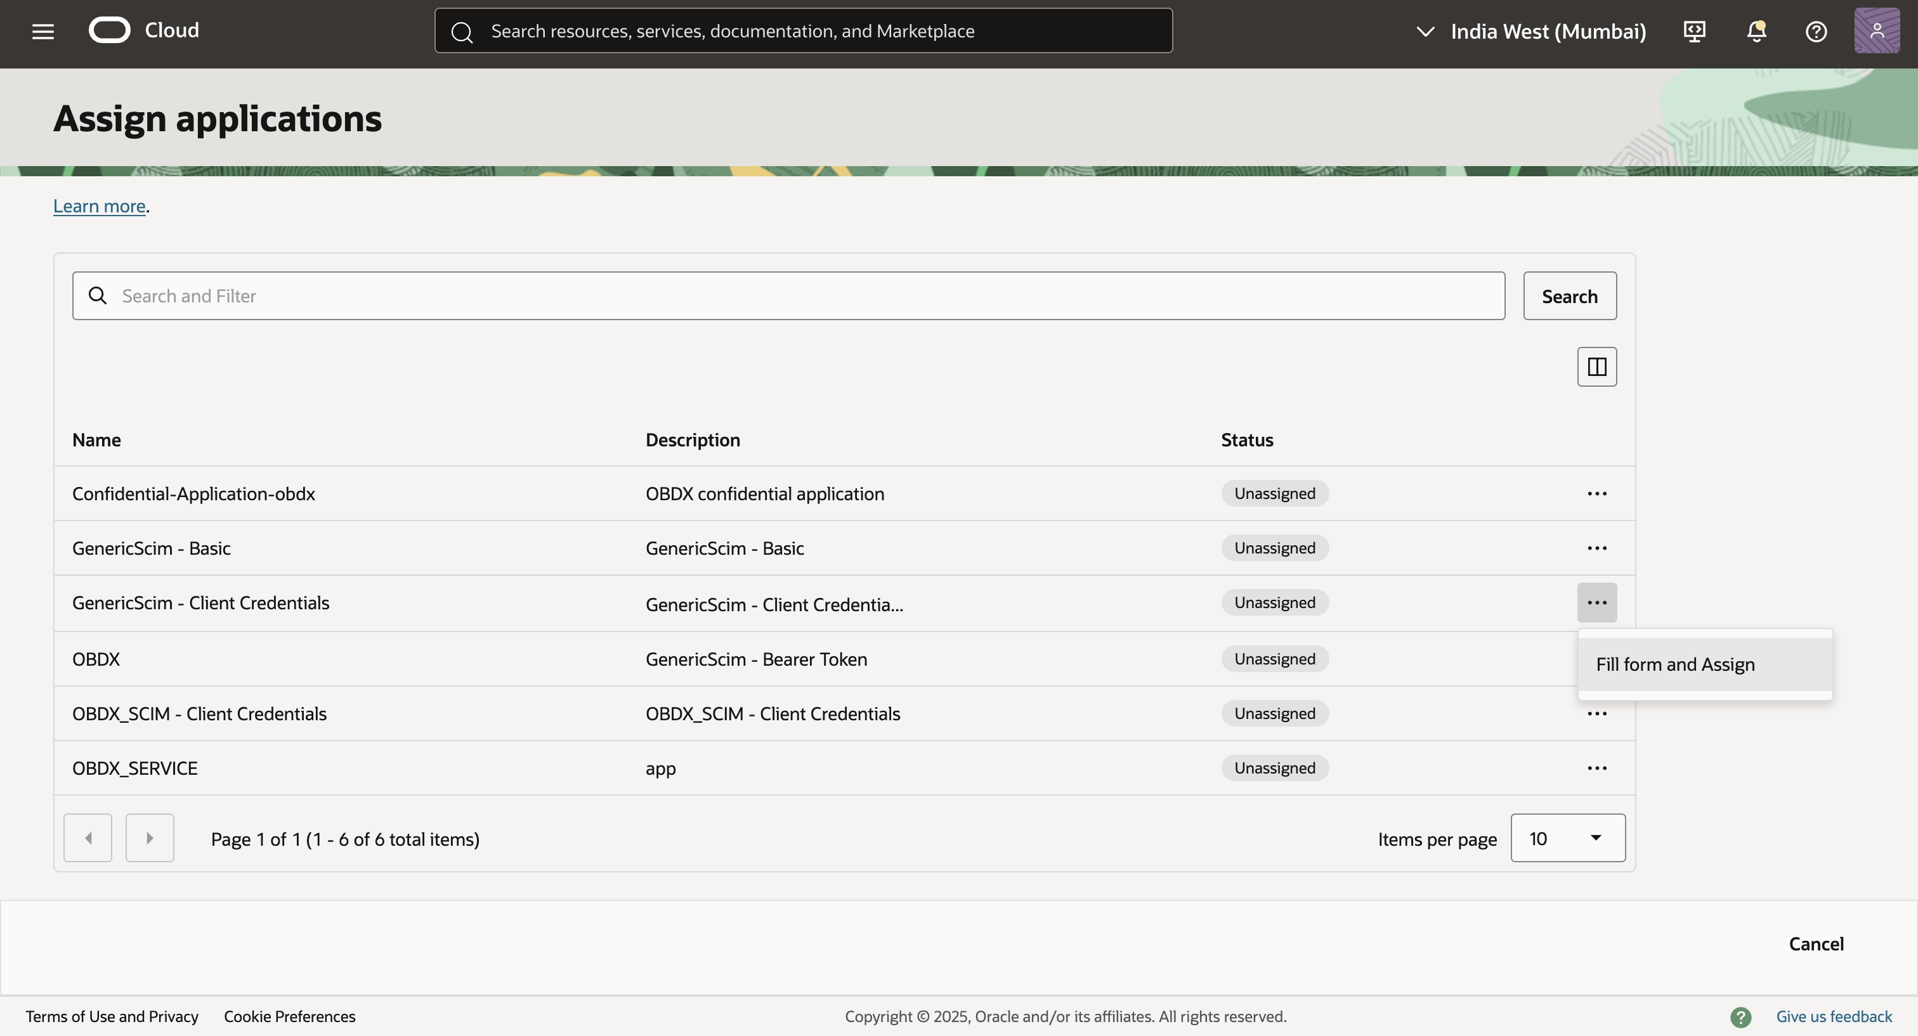

    - Click on assign application to assign the group to the application.
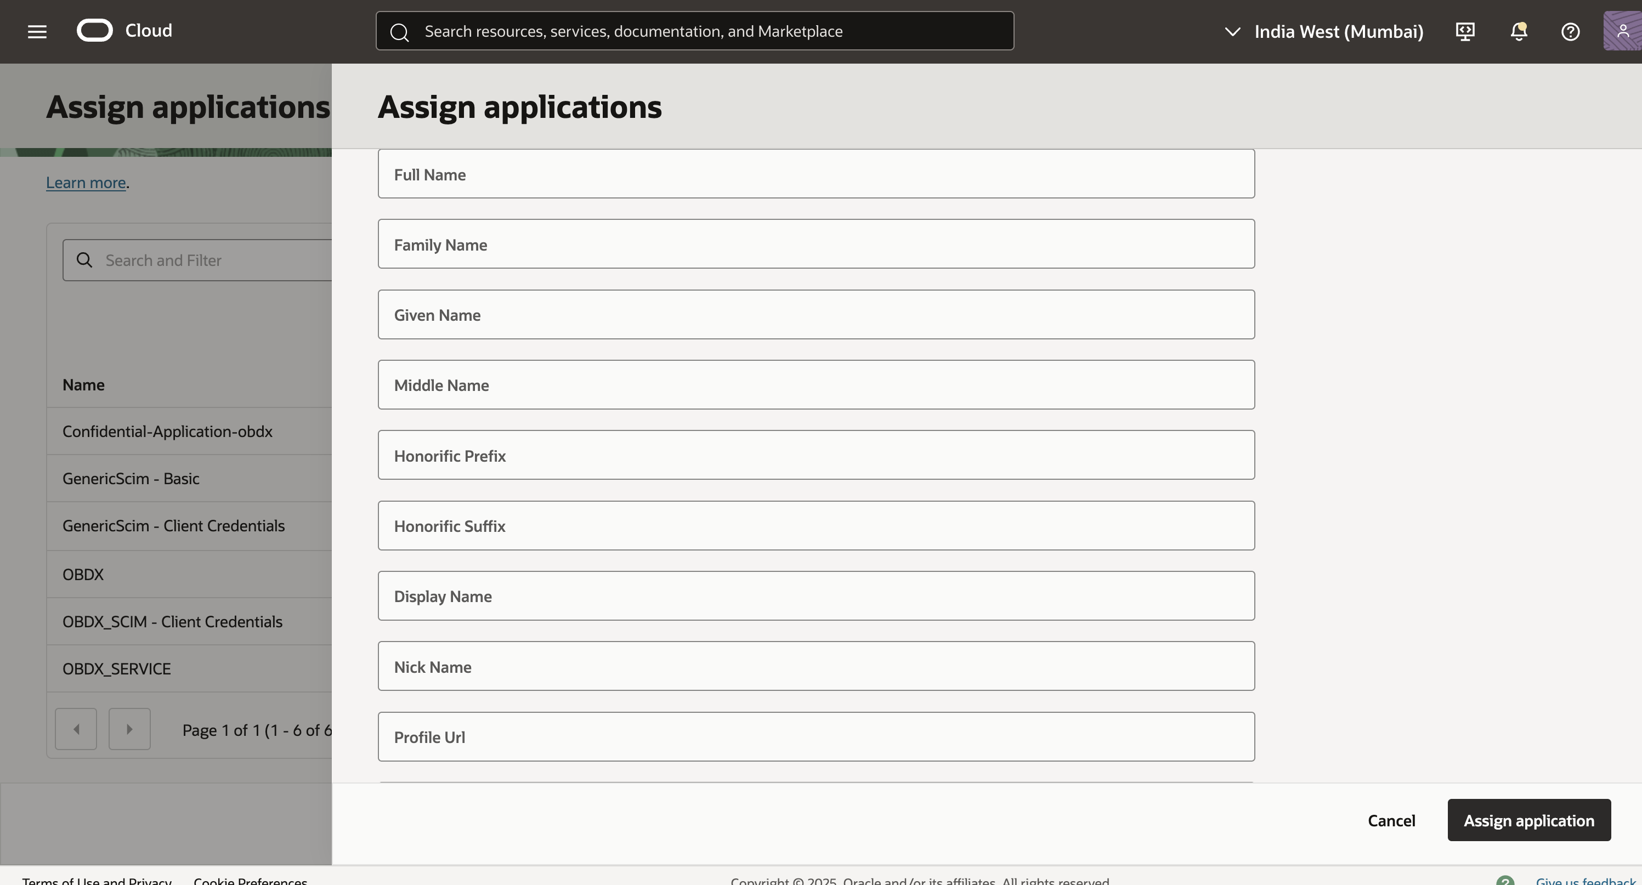

    - Subsequently when you create a user through API or through IDCS screen assign the group to the user and the user will be auto provisioned to the application.

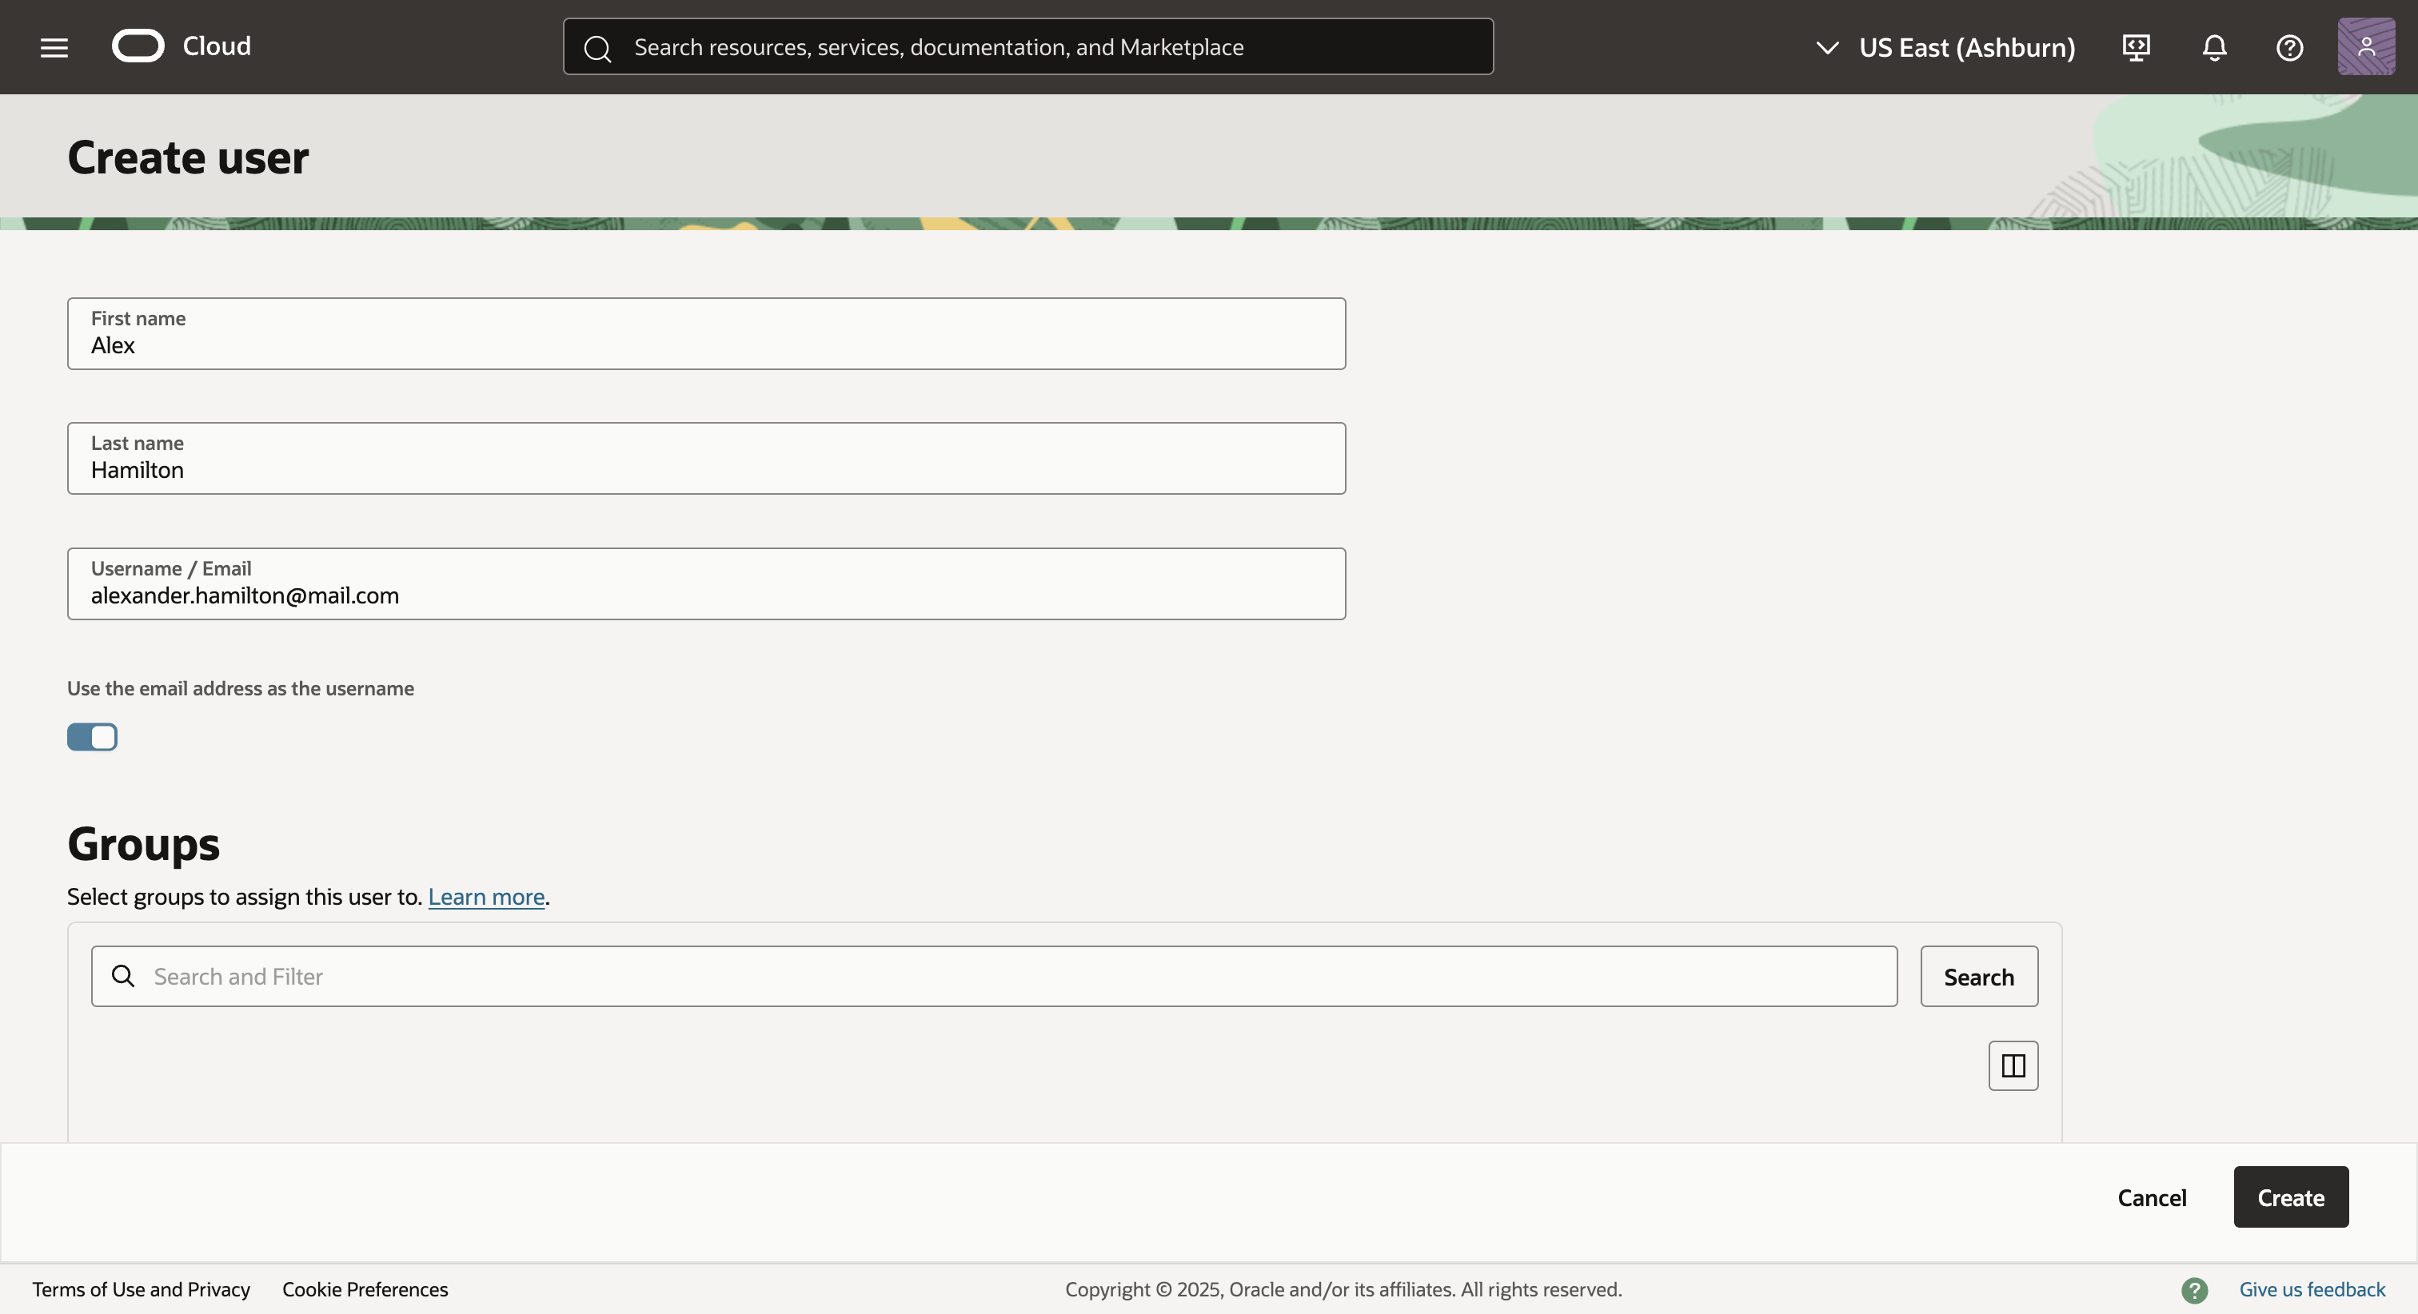
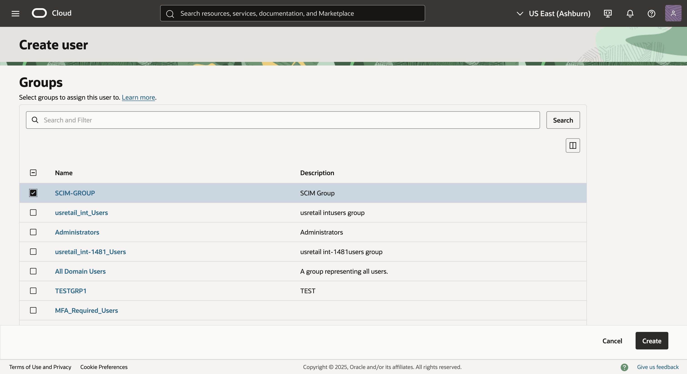

Refer to IDCS user create documentation to view how to assign the group.

IDCS Originated Flow

This describes the end-to-end data flow up to Oracle Banking Digital Experience 25.1.1.0.0. The required configuration is documented in the SCIM Configuration section above; no additional setup is needed to enable this flow. An additional COnfiguration has been added to toggle between onboarding flows (There being 2 now - IDCS Originated Flow and OBDX Originated Flow).

Configuring for IDCS Originated Flow
    - Set Onboarding Flow for required user types to IDCS.

Make sure that Onboarding Flow has been set to IDCS for the intended user type in System Configurations Global Settings Framework
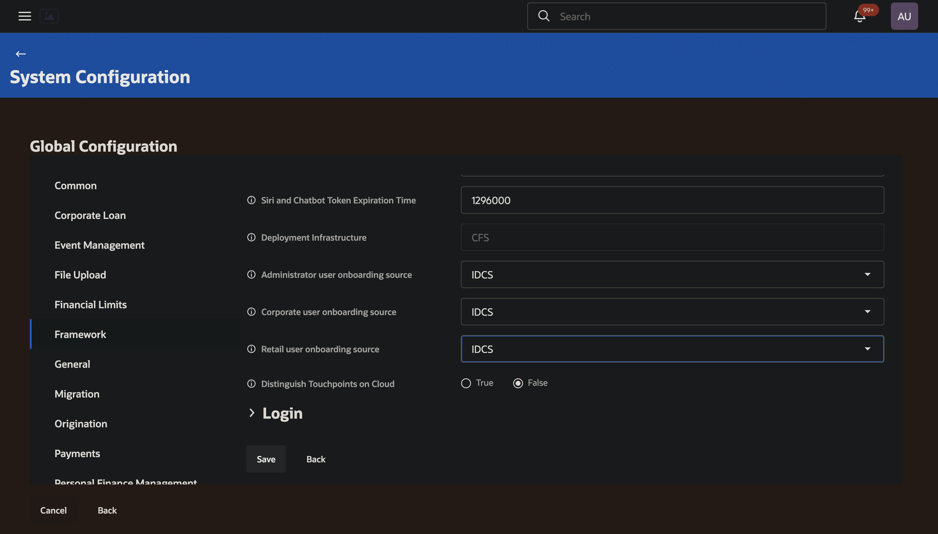

OBDX Originated Flow

User Creation originated in OBDX—such as through customer self-registration— is synced back into IDCS. In this flow, OBRH acts as the critical middleware, transforming and routing user data from OBDX to IDCS. This ensures that any user created locally in the banking platform is automatically provisioned in the identity cloud, enabling them to authenticate via the standard OAuth login flow moving forward.

OBRH Configuration

OBRH needs certain configuration for each operation (User - Create, Update, Assign Group etc). These are extensively explained in Integration Overview : OBRH setup for User Propagation into IDCS.
To ensure that OBDX-Originated Flow works we have to make sure OBRH is configured to send requests to the intended IDCS.
    - Host and Port configuration:

      - Get to OBDX_TRUNK Service Provider
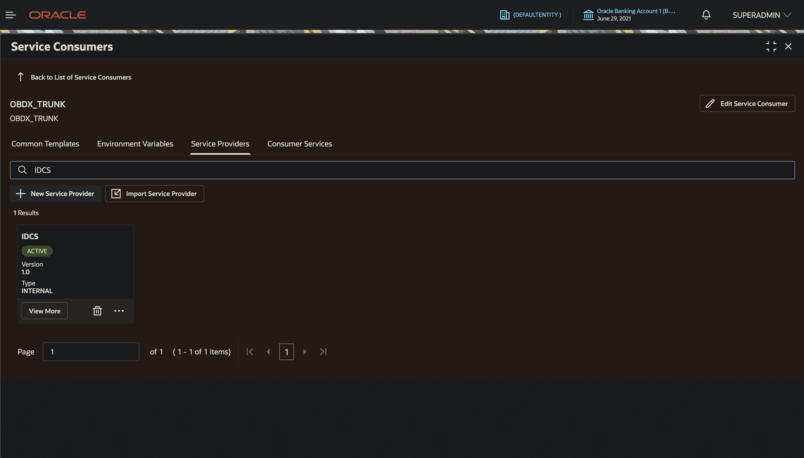

In the service provider, edit the individual
      - implementations
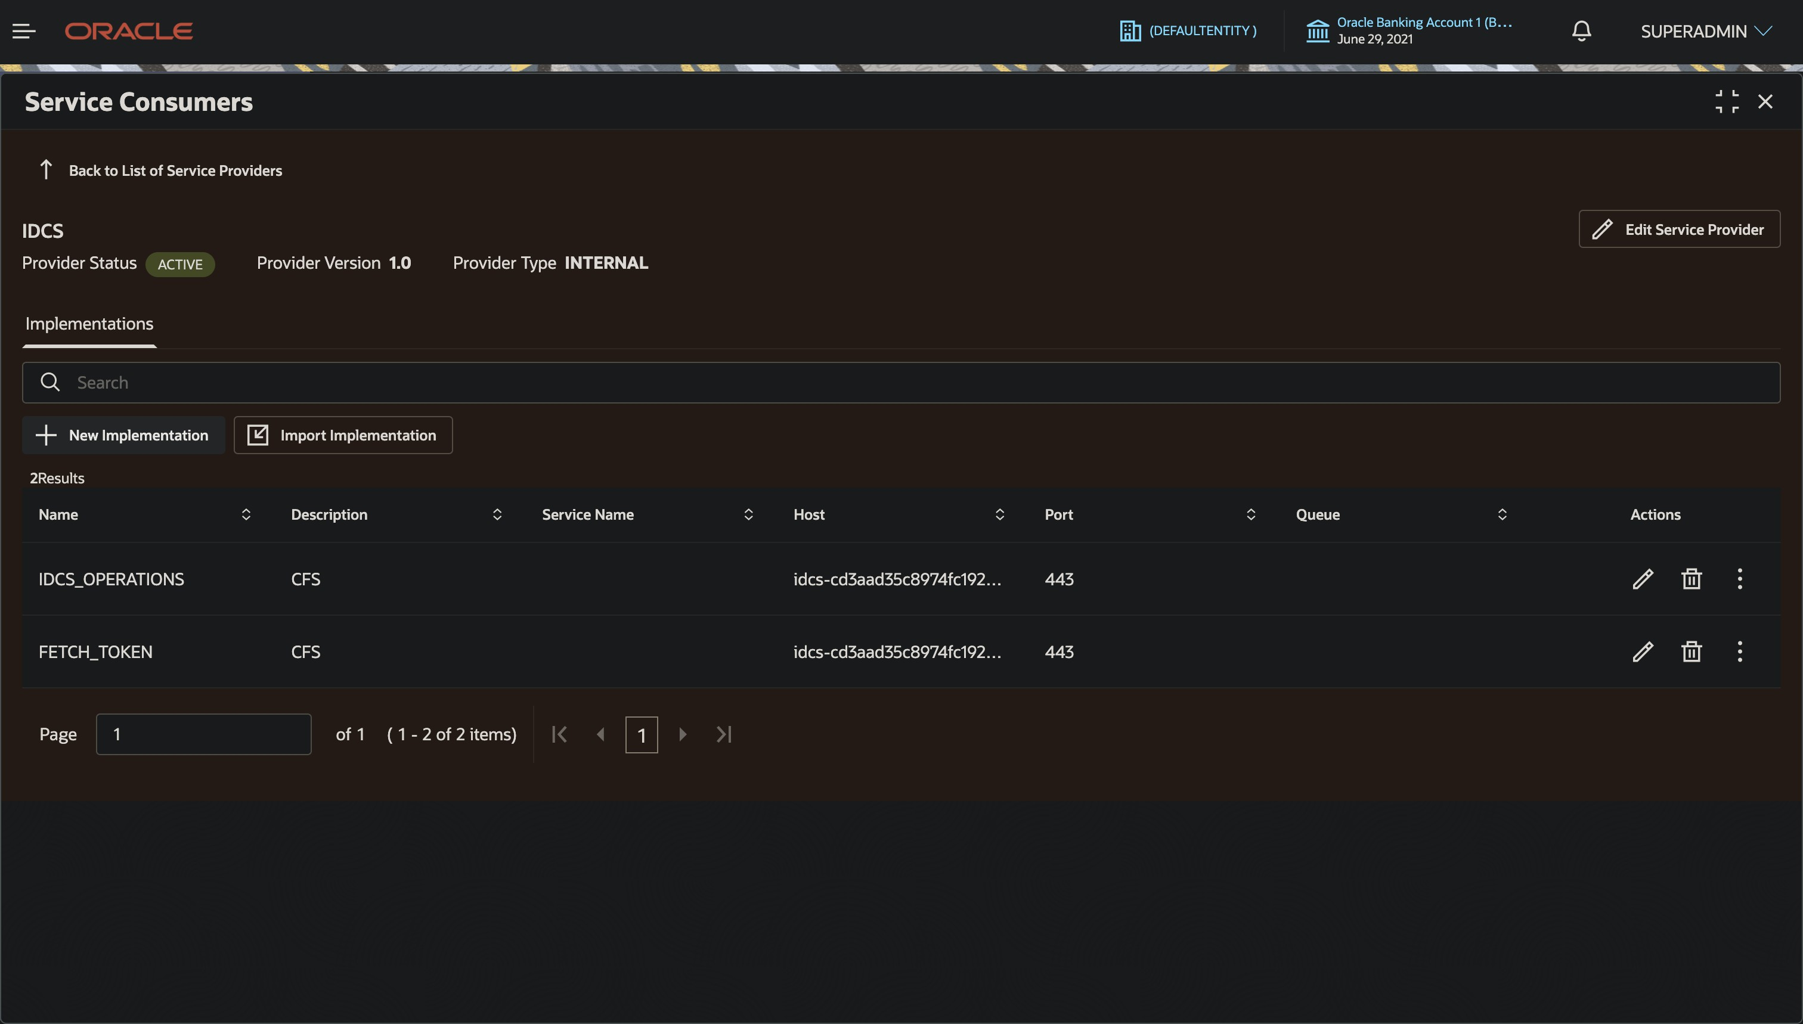

      - Configure the host and port for FETCH_TOKEN Implementation.
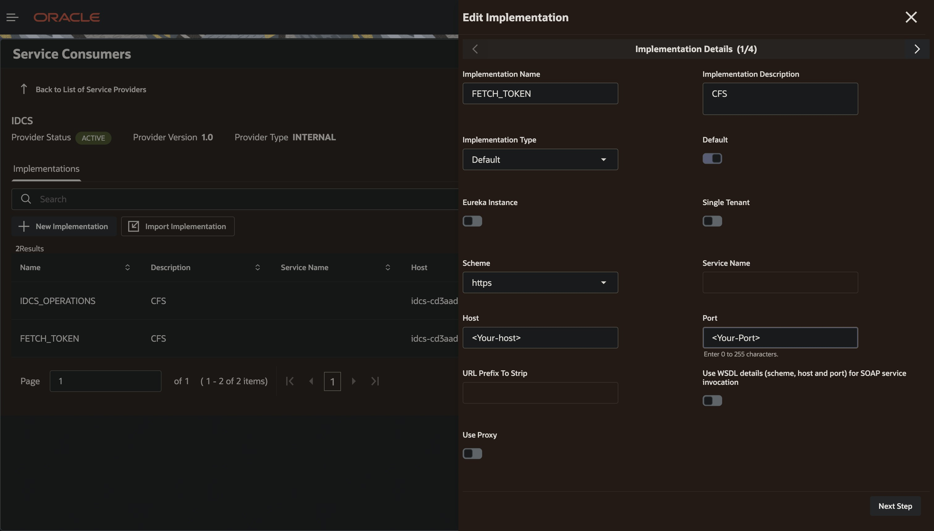

      - Do the same for the IDCS_OPERATIONS implementation.
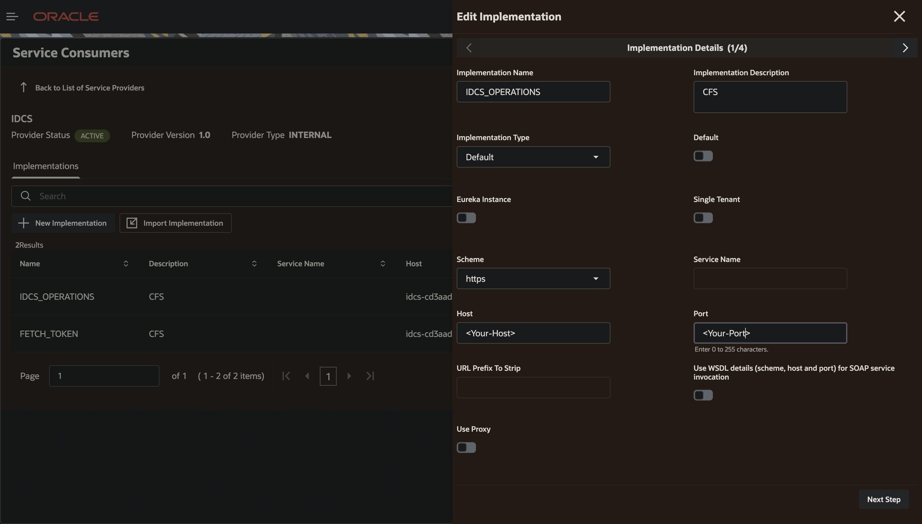

    - Configuring Token in OBRH

      - We head over to OBDX_TRUNK Environment Variables Here we have to edit the IDCS_VARIABLES
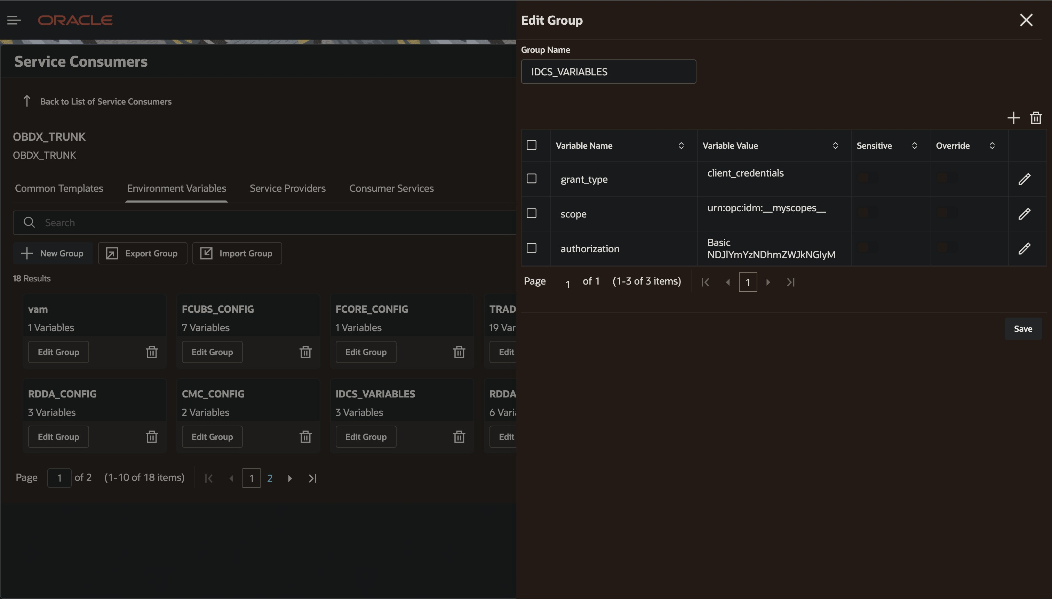

OBDX Side Configuration
Set Onboarding Flow for required user types to OBDX. Make sure that Onboarding Flow has been set to OBDX for the intended user type in Syst em Configurations Global Settings Framework
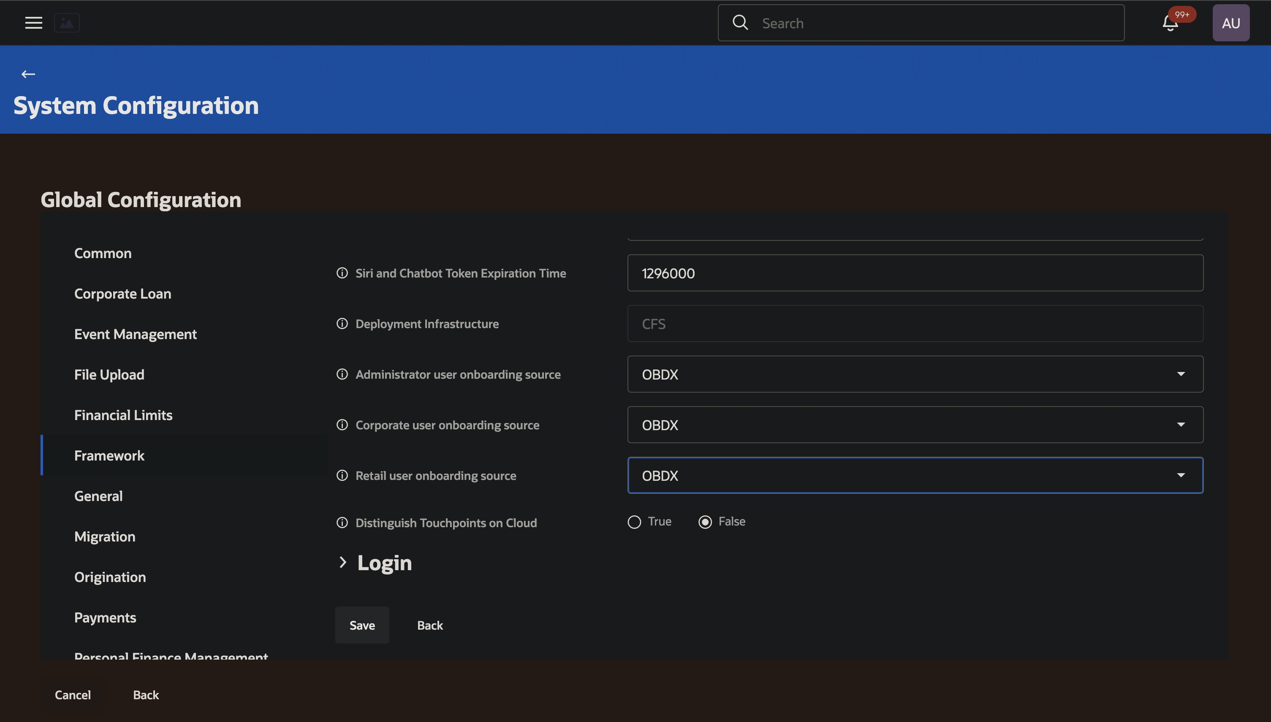

- ​

Set Group ID for the group the user belongs to. Also make sure that the correct Group Id has been set. You will find this Group OCID from the Group that was created in the SCIM Configuration steps.

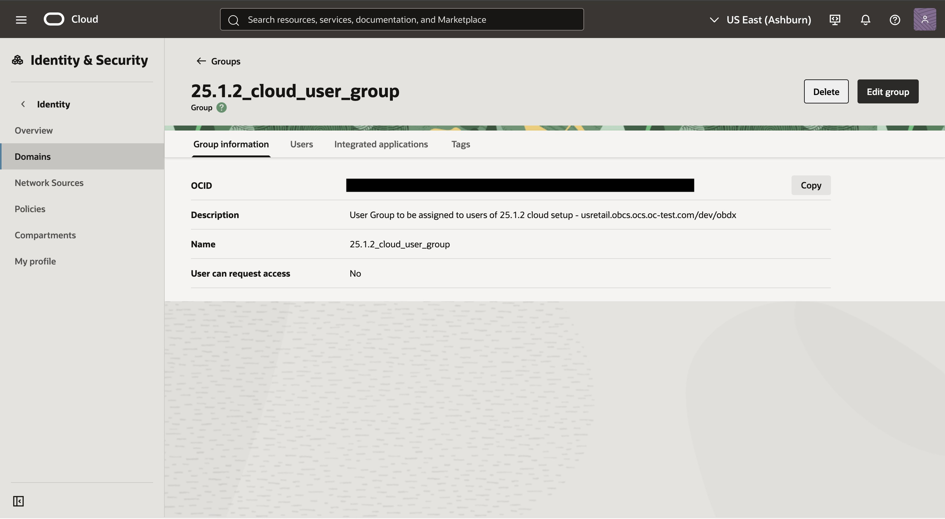

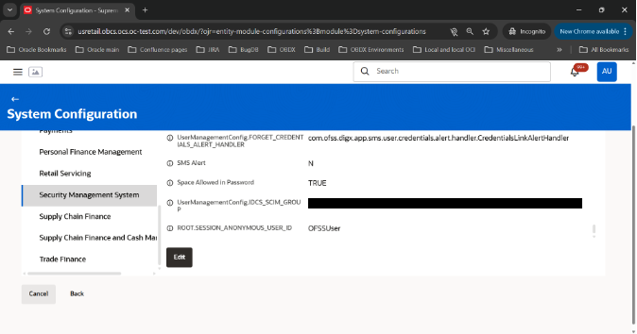
- ​

Now, any user created in OBDX will be propagated to IDCS via OBRH and Admin IDCS apis. Please Note : For Corporate User, GCIF needs to be submitted and approved
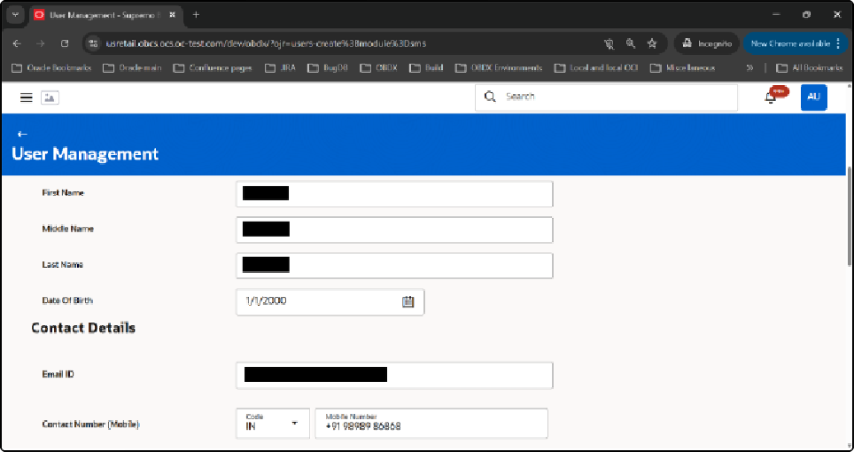
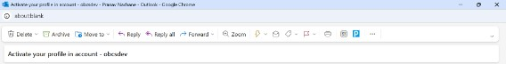

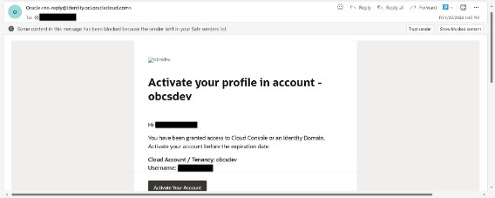
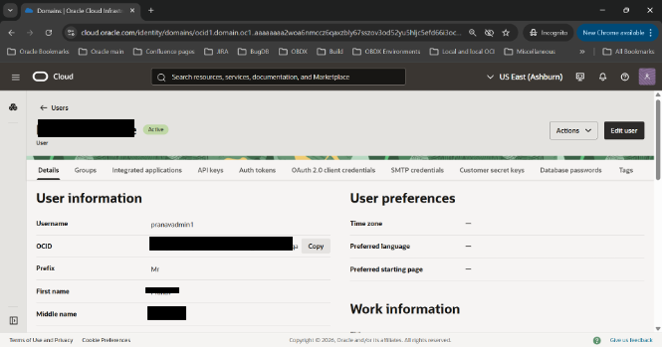
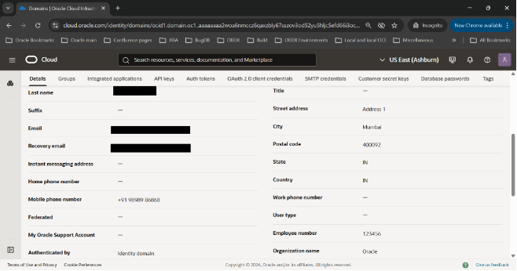

Make sure the user has the correct group assigned to it:
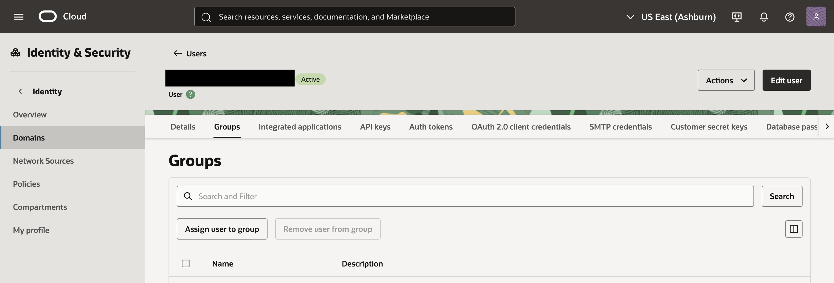

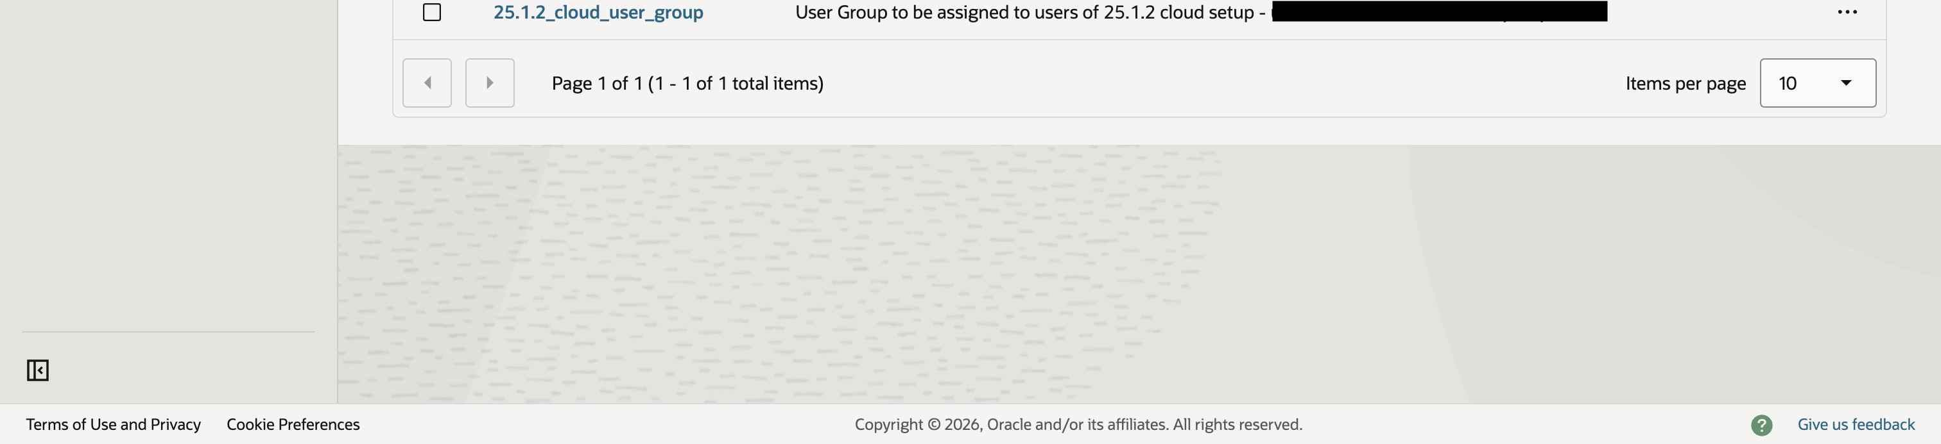

- Similarly all edits will also be propagated in IDCS.

